МІНІСТЕРСТВО ОСВІТИ І НАУКИ УКРАЇНИ
КИЇВСЬКИЙ НАЦІОНАЛЬНИЙ УНІВЕРСИТЕТ ІМЕНІ ТАРАСА ШЕВЧЕНКА



ISSN 3041-2323

ПРИКЛАДНІ ІНФОРМАЦІЙНІ СИСТЕМИ ТА ТЕХНОЛОГІЇ
В ЦИФРОВОМУ СУСПІЛЬСТВІ
7.07.26

Науковий збірник Випуск 3

За матеріалами
X Міжнародної науково-практичної конференції (Київ, 01 жовтня 2026 року)

Міжнародна конференція "Прикладні інформаційні системи та технології в цифровому суспільстві" (AISTDS-2026), що відбулася 1 жовтня 2026 року в Києві, стала платформою для обговорення наукових, технологічних, правових та економічних аспектів цифрової трансформації суспільства, впровадження прикладних ІТ, штучного інтелекту, великих даних і хмарових технологій у різних галузях, сприяючи обміну досвідом між наукою, освітою та бізнесом.
ГОЛОВНИЙ РЕДАКТОР | Плескач Валентина, д-р екон. наук, канд. техн. наук, проф. (Україна)
РЕДАКЦІЙНА КОЛЕГІЯ | Плескач Валентина, д-р ек.н. наук, проф. (Україна); Бармак Олександр, д-р техн. наук, проф.. (Україна), Зайцев Євген, д-р техн. наук, проф. (Україна); Крак Юрій, д-р фіз.-мат. наук, проф., чл.-кор. НАН України (Україна); Озюпак Йилдирим, д-р філос. (техн.), проф. (Туреччина); Пукас Андрій, д-р техн. наук, проф. (Україна); Пурський Олег д-р фіз.-мат. наук, проф., (Україна); Тумасонієне Інга, д-р філос. (техн.), доц. (Литва) Шкільняк Степан, д-р фіз.-мат. наук, проф., (Україна), Юзефович Роман, д-р техн. наук, проф. (Україна) Міністерством освіти і науки України (категорія Б) Наказ № 928 від 11.06.2026
Адреса редколегії | Факультет інформаційних технологій  вул. Богдана Гаврилишина, 24, к. 401, м. Київ, 04116   (38044) 481 44 82,  web: https://aistis.knu.ua,  е-mаil: aistis.conference@gmail.com
Затверджено | Вченою радою факультету інформаційних технологій  20.10.2024 (протокол № 4)
Зареєстровано | Національною радою Украı̈ни  з питань телебачення і радіомовлення Рішення № 2039 від 13.06.24  Ідентифікатор друкованого медіа: R30-05311
Засновник та видавець | Киı̈вський національний̆ університет імені Тараса Шевченка  Видавничо-поліграфічний центр "Київський університет" Свідоцтво про внесення до Державного реєстру  ДК № 1103 від 31.10.02
Адреса видавця | ВПЦ "Київський університет"  б-р Тараса Шевченка, 14, м. Київ, 01601   (38044) 239 32 22, 239 31 58, 239 31 28  е-mаil: vpc@knu.ua
Автори опублікованих матеріалів несуть повну відповідальність за підбір, точність наведених фактів, цитат, статистичних даних, власних імен та інших відомостей̆. Редколегія залишає за собою право скорочувати та редагувати подані матеріали.

© Київський національний університет імені Тараса Шевченка,
ВПЦ "Київський університет", 2026
MINISTRY OF EDUCATION AND SCIENCE OF UKRAINE TARAS SHEVCHENKO NATIONAL UNIVERSITY OF KYIV

ISSN 3041-2323

APPLIED INFORMATION SYSTEMS AND TECHNOLOGIES IN THE DIGITAL SOCIETY

Scientific Collection Issue 3

Proceedings of the
X International Conference
(Kyiv, 01 October, 2026)

The international conference "Applied Information Systems and Technologies in the Digital Society" (AISTDS-2026), held on 1 October 2026 in Kyiv, became a platform for discussing the scientific, technological, legal and economic aspects of the digital transformation of society, the introduction of applied IT, artificial intelligence, big data and cloud technologies in various industries, promoting the exchange of experience between science, education and business.
EDITOR‐IN‐CHIEF | Pleskach Valentyna, DSc (Econ.), PhD (Engin.), Prof. (Ukraine)
EDITORIAL BOARD | Valentyna Pleskach, D.Sc. (Econ.), Prof. (Ukraine); Olexander Barmak, D.Sc. (Eng.), Prof. (Ukraine); Ievgen Zaitsev, D.Sc. (Eng.), Prof. (Ukraine); Yurii Krak, D.Sc. (Phys. & Math.), Prof., Corresponding Member of the NAS of Ukraine (Ukraine); Yıldırım Özüpak, Ph.D. (Eng.), Prof. (Türkiye); Andriy Pukas, D.Sc. (Eng.), Prof. (Ukraine); Oleg Pursky, D.Sc. (Phys. & Math.), Prof. (Ukraine); Inga Tumasonienė, Ph.D. (Eng.), Assoc. Prof. (Lithuania); Stepan Shkilniak, D.Sc. (Phys. & Math.), Prof. (Ukraine); Roman Yuzefovych, D.Sc. (Eng.), Prof. (Ukraine).  Included in the List of Scientific Professional Publications of Ukraine by the Ministry of Education and Science of Ukraine (Category B), Order No. 928 dated 11 June 2026.
Address | Faculty of Information Technologies  24 Bohdan Havrylyshyn str., office 401, Kyiv, 04116   (+38044) 481 44 82  web: https://aistis.knu.ua  е-mаil: aistis.conference@gmail.com
Approved | the Academic Council of the Faculty of Information Technologies  on 20.10.2025 (Protocol № 4)
Registered by | the National Council of Ukraine  on Television and Radio Broadcasting Decision № 2039 dated 13.06.24 Identifier of printed media: R30-05311
Founder  and publisher | Taras Shevchenko National University of Kyiv Publishing and Printing Center "Kyiv University" Certificate of inclusion in the State Register  ДК № 1103 dated 31.10.02
Address | PPC "Kyiv University"  14, Taras Shevchenka blvd., Kyiv, 01601   (38044) 239 32 22, 239 31 58, 239 31 28  е-mаil: vpc@knu.ua
The authors of the published materials bear full responsibility for the selection, accuracy of the facts, quotes, statistical data, proper names, and other information provided. The Editorial Board reserves the right to shorten and edit the submitted materials.

© Taras Shevchenko National University of Kyiv,
Publishing and Polygraphic Center "Kyiv University", 2026

ЗМІСТ

 | 9
Дмитро ДВУХГЛАВОВ, Артур ЧЕЧУН, Олександр КУЛАБУХОВ  Підхід до оцінювання доцільності роздільного зберігання операційних та аналітичних даних вебзастосунків у різних системах керування базами даних | 30
Олена ФЕНДЬО, Вікторія ВОЄВОДА  Цифрові рішення для організації освітнього процесу в закладах освіти в умовах воєнного стану в україні | 58
 | 82
Михайло ХИМЧУК  Інтервальне калібрування оцінок трудомісткості та тривалості для ai-native програмних проєктів | 102
Кирило КОХАН, Олексій ТКАЧЕНКО  Оцінка ефективності вибору конфігурацій тестування на основі інтегрованого підходу та штучного інтелекту | 121
 | 140
Олександр ПАНКРАТОВ  Метод зіставлення як складова вердикту: умови вимірювання для прийняття рішень щодо перекваліфікації на основі журналів подій при зміні версій програмного забезпечення | 168
Валентина ПЛЕСКАЧ, Гліб КРИВОЛАПОВ, Ярослав КРИВОЛАПОВ  Структурно-адаптивний гібридний алгоритм побудови мінімального кістякового дерева в графах зі змінними вагами | 189
Валерій ЗДОРЕНКО, Кирило ШОЛУДЬКО  Математична модель ультразвукового контролю забруднення поверхні води | 212
Віктор СИНЄГЛАЗОВ, віктор ЧЕЛКОВАН  Статистична валідація трансформера з причинним зміщенням уваги на синтетичних тактичних задачах підтримки прийняття рішень | 236
 | 266
Нурал ГУЛІЄВ, Олексій НАЗАРОВ  Перевірка гіпотези комбінованого впливу гормонів щитоподібної залози на психологічний стан пацієнтів | 283
Павло КУДРИНСЬКИЙ, Олександр ЗВЕНІГОРОДСЬКИЙ  Умови достовірності порівняльного оцінювання прогнозного автомасштабування хмарних ресурсів | 305
Ігор РУДЬКО, Олексій СТОПАКЕВИЧ  Оцінювання нейронної стеганографії з розділенням даних за джерелами для різних розмірів навчальних фрагментів | 321
Дмитро ЧЕБОТАРЬОВ, Анатолій МАКАРЕНКО  Предиктивна оптимізація маршрутизації в інфокомунікаційних мережах iot на основі цифрових двійників | 344

CONTENTS

Denys DUBOVYTSKYI, Serhii ISHCHERIAKOV  Hydration mechanism for server-side rendered web-components | 9
Dmytro DVUKHHLAVOV, Artur CHECHUN, Oleksandr KULABUKHOV  An approach to evaluating the appropriateness of storing operational and analytical web application data separately in different database management systems | 30
Olena FENDO, Viktoria VOIEVODA  Digital solutions for organizing the educational process in educational institutions under martial law in ukraine | 58
Viacheslav IVASHCHUK, Safina OLGA  Hybrid optimization of information-based decision-making systems in production control tasks | 82
Mykhailo KHYMCHUK  Interval-based calibration of effort and duration estimates for ai-native software projects | 102
Kyrylo KOKHAN, Oleksii TKACHENKO  Evaluating the effectiveness of testing configuration selection based on an integrated approach and artificial intelligence | 121
Illia KORNIICHYK, Serhii PROKOPOV  A dependency-aware method for diagnostic check selection in small distributed network infrastructures | 140
Oleksandr PANKRATOV  The matcher is part of the verdict: measurement conditions of log-based re-qualification decisions across software versions | 168
Valentyna PLESKACH, Hlib KRYVOLAPOV, Yaroslav KRYVOLAPOV  Structure-adaptive hybrid algorithm for building a minimum spanning tree in graphs with varying edge weights | 189
Kyrylo SHOLUDKO, Valeriy ZDORENKO  Mathematical model of ultrasonic control of water surface pollution | 212
Viktor SINEGLAZOV, Viktor CHELKOVAN  Statistical validation of a transformer with causal attention bias on synthetic tactical decision-support tasks | 236
Oleksandra VOICHENKO, Olena Vashchilina  Comparative analysis of technologies and architectural approaches for android application development | 266
 | 283
Pavlo KUDRYNSKYI, Oleksandr ZVENIHORODSKYI  Validity conditions for the comparative evaluation of predictive autoscaling of cloud resources | 305
Ihor RUDKO, Oleksii STOPAKEVYCH  Evaluation of neural steganography with source-aware data splitting across training patch sizes | 321
 | 344

Denys DUBOVYTSKYI, PhD Student
ORCID ID: 0009-0004-2830-9197
e-mail: dubovitskydev@gmail.com
State University of Information and Communication Technologies, Kyiv, Ukraine

Serhii ISHCHERIAKOV, PhD
ORCID ID: 0009-0007-5961-8218
e-mail: ismismif@gmail.com
State University of Information and Communication Technologies, Kyiv, Ukraine

HYDRATION MECHANISM FOR SERVER-SIDE RENDERED WEB-COMPONENTS

Abstract. Web Components represent one of the latest iterations of the web development technology by extending browser capabilities to allow developers have isolated DOM trees, custom elements and inert templates. However, JavaScript driven development of web pages has its own intrinsic downsides, such as degraded indexing by search engines and poor key performance characteristics such as time to interactive and cumulative layout shift. Third-party frameworks have developed ways to minimise reduced performance in those metrics by employing technique such as server-side rendering and eventual hydration of the page. While previous studies have explored techniques to introduce server-side rendering to the web-components, this study focuses on the missing crucial hydration system. We have used native custom-elements registry to attach JavaScript to already rendered tags, with strategic embeddings of the attributes in the rendered HTML to avoid re-render on attachment to avoid flickering. Additionally we have developed algorithm to encode component state on server and then reinstate it on the client after render without interrupting initial business logic. Those extensions to the previous iterations of the web-component server side rendering technology allow components to have characteristics of the full hydration with additional resumability and avoid flickering on the JavaScript re-attachment.

Keywords: JavaScript engine, web-component, preprocessor, hydration, resumability.

Introduction
Most of the time when you see a website, it was either delivered to your browser as a ready-made HTML that browser can render without further processing, or it was loaded as a bundle of JavaScript code, that has to be executed to render website’s contents. There are merits to both approaches, but the second one currently dominates web-site development, even with all the downsides.
When website is rended from the loaded JavaScript, it cannot be indexed by search engines, except for rare occasions when search engines execute JavaScript in limited capacity. The fact that website requires JavaScript to be executed before it can present any meaningful content to the user means that overall time until website is visible to the user includes not only time it takes to load web-page, but also time that JavaScript has to be rendered. If we take performance measuring tool such as LightHouse, we can observe the specific metrics that highlight reduced performance in such approach: Cumulative Layout, Time To Interactive.
With such drastic downsides, to became dominant technology, benefits of rendering website on the server should outweigh decreased performance metrics.
The core reason for using JavaScript in the web site in the first place is to add some interactivity to the page. Ability to have interactions is what main characteristic that separates a web-site from a static PDF page. And since HTML originally wasn’t designed to have interactions, JavaScript was meant to be mostly add-on for some specific scenarios (Wirfs-Brock & Eich, 2020). The main scenario that has to be considered is following: website has some data which is displayed on the screen. After interaction with a web-site, data on the website should change. What this means from the JavaScript point of view, is that some data is stored as an object, and same data is rendered onto page. Then, when user performs action, we should update data in the object, locate element on the web-page and update it.

Introduction of server side rendering
This was reasonable amount of effort to achieve small interactions on the page. But the scale became main issue over time. There can be multiple elements that depend on the same data, as well as there can be collisions in the element locators. Those problems eventually resulted in the paradigm shift, where JavaScript was used not only to update some element on the screen, but to create whole element itself. This allowed to have much closer cohesion in the relationship between data and the content, since instead of data being replicated in two places: object and web-page. now web-page is just derived from the data. This was achieved with improvements in the JavaScript ecosystem, especially frameworks such as React (React, n.d.) and Angular.js, later Angular.
Those new frameworks not only changed the way website is displayed, but also how website itself is built. Previously website was built as a series of HTML-pages, where page itself was a smallest development unit. New frameworks brought with them new way to build websites, which is by composition of multiple components. This allowed to reduce overall complexity of the web-site and promoted reuse of the styles, logic and templates. Component-driven development was made possible by using JavaScript to build elements in the first place. When function renders an element, that means that we can reuse same function in a different place to render same element. Or even customise it by utilising native customisation behaviour from the functions such as function parameters.
This approach of using JavaScript-based components to build websites turned out to be pretty scaleable and now web-sites can be complex highly-interactive applications on par with desktop applications, all run in the browser using same familiar HTML, JavaScript and CSS. The benefits of using building web-sites through reusable components such as speed of development, consistency and reusability helped JavaScript-first approach to dominate previous HTML driven way of website development. And while those benefits are significant, there is nothing yet to mitigate downsides of this approach, such as search engine indexation, display time and related metrics.
Since web-site is rendered using JavaScript on the client, one of the main ways to improve website indexation and load-related metrics is to have JavaScript engine on the server execute all of the rendering first, and then ship only result to the client. The main technological bridge to make this possible is ability to execute JavaScript outside of browser environement, and thanks to development of the Node.js (Node.js, n.d.) which uses JavaScript engine V8 from the chromium, technology to execute JavaScript on the server was made available and developing technology to render web-site on the server, now called Server-Side Rendering was obvious to developers of the frameworks, and most of them did it.

Emerging web-components
The gap between what was possible using frameworks and what was possible without them began to close when multiple independent developments from the HTML standard converged into a technology that allowed to use component driven style of development without relying on the third-party frameworks. Those are custom elements, shadow-dom, and templates. Each of them solves different problems, but when combined together they form a cohesive unit known as a web-component today. As html page consists of HTML tamplate, css styles and javascript coding, components are built using same structure, by essentially being mini pages themselves. Therefore, web components require ability to combine layout, styling and JavaScript code together in a way that doesn’t put significant performance pressure and can be isolated from other elements on a page. One of the most prominent problems in creating independent component is the fact that in CSS, all of the styles are global and cannot be scoped to match only a particular subset of HTML. This leads to the style collision (Dalgleish, 2015), where button styled in one part of an application, can be changed by another independent component simultaneously using same selector to style its own button. Shadow dom was invented to tackle this particular problem by extending HTML standart to support isolated island where styles are contained and do not spill over to the global styles on the page. They do it by creating new shadow-tree, which scopes styles attached to it to be encapsulated only to the components that are part of this particular tree. Styling in shadow-trees is a robust mechanism that can be configured to behave in various ways and interactions with the styles outside of the scope.
Another invention is related to the HTML layout of the component, template fragments. Before template fragments were introduced, possibilities for the template reuse were limited and flawed. Either store chunk of HTML as a string and incur a performance penalty every time string is parsed into DOM, or attach html somewhere on page and clone it. Attaching living HTML and cloning it will also execute scripts and load styles even before this particular chunk is used. Template fragments represent an inert piece of HTML that is parsed only once, and then can be reused many times. When it’s parsed, it will not trigger execution of scripts, loading of images or styles. Those actions will be performed only when content is cloned and added to the actual HTML page.
Those technologies are useful by themselves, by they do not yet represent a web-component. to become a web-component, we need to tie them together with JavaScript, and attach a name handle, which we can later invoke in the template to render a component. Custom Element does exactly that: it provides us with ability to register a tag and bind it to the JavaScript class. This JavaScript class will have methods that correspond to the lifecycle events of the component, such as when it was mounted on page, removed from page, or had attributes changes. By reacting to those events and attaching shadow-dom, using template fragment and custom JavaScript code in the class, we can have fully fledged web-component.
This way native html component-driven development can be done using native html API’s without relying on third party technologies. However, drawback that were a characteristic of the framework framework-created web components still exists in the native apis. JavaScript execution still remain main driving mechanism of the web-component platform, which results in delayed website display, worse time to interactive metric and inability to be indexed by search engines, or limited ability to be indexed by some engines.
There are some studies that explored methods to introduce server-side rendering to the websites built on the native web-component technology (Miller & Freed, 2024). Main theme explored is preprocessor that emulates browser environment in the server, executes code, and then transform resulting page into declarative-style custom components and shadow dom in the HTML, which subsequently allows it to be transfered as a single document to the browsers, which can immediately parse and present HTML without additional code execution. Since page was originally created with JavaScript and was transformed to pure HTML on the server, it means that drawbacks like problematic search indexing and worsened metrics should be resolved.
And while ability to render page on the server may be enough for some subset of the applications, most of them require page to be interactive after page is loaded. Pages rendered on the server traded their dynamic interactivity for the speed of load and indexing. Now, after page has loaded, we should make it interactive again by downloading and re-attaching JavaScript to the displayed HTML. Rendered HTML doesn’t have attached handlers, and data that was loaded during server rendering is not accessible on the browser. In this study, we are going to introduce a way to re-add interaction to the web-component based pages that were rendered on server, also called as hydration.

Background
Hydration techniques
Every server side rendering essentially performs two distinct actions: first is to initialise website, fire JavaScript and wait until it renders page in the virtual environment, grab resulting page from emulation and encode it into HTML which is transferred to the browser. Then, when page is delivered to the browser in the rendered form, download JavaScript, re-attach handlers back to the components where they were initially attached and re-attach state that was at the moment of rendering back to the components. this should ensure that all actions that users makes from this point are logically continuation from the work that was done on the server. re-initialisation on the browser should not reset data and make additional calls, it should resume it’s behaviour as if it was rendered on the page itself.
This process is called hydration, taking dry HTML page and turning it into working interactive page with state. What makes hydration complex is inherent repeating of same work and transfer of redundant data from the server to the client, since we are transfering both: html, and code that produces said HTML. and ideally, we should transfer only 1 that would satisfy all use-cases. That seems to be not achievable yet, so the goal is to minimise amount of downloaded and executed data. Different frameworks have different solutions to the problem of hydration, but they seem to converge on the few popular working methods.
Full hydration is the first iteration of the hydration technology, but it is still popular and valid today. Full hydrations is relatively simple and straight forward, since it does not take into account whether user interacted with data in any way or whether user has seen component itself. The core principle is that after page was loaded and displayed in the browser, next step would be to load all of the JavaScript and re-build page from scratch. This allows us to achieve interactive page eventually, but with few significant downsides. First one is that page is not interactive until it rebuilds itself, so user sees just a pretty picture. All interaction would be lost until page is rebuilt which may lead to decreased user experience.
Another significant drawback is that page may flash on change as components initialise themselves and data re-loads. But the benefits are clear too: after initial penalty, page begins to behave as usual fast interactive web page.
Full hydration is the starting point for many other advanced hydration techniques, which have different solutions to tackle problems with full hydration, such as full-reload and rebuild.
Selective hydration is a route taken by the React (React, n.d.). Core principles of selective hydration allow developers to mark which parts of the page can be hydrated separately. Then, when page loads and displays itself, framework begins to load and hydrate page components utilising streaming, which will eventually hydrate everything same as full hydration. With one exception is that components that have not yet been hydrated have default event listeners attached to them. When interacted, those event is stored, and engine stops hydrating current component, begins to hydrate component that was interacted with. Since data is dynamically streamed, stream can be dynamically adjusted to stream JavaScript that is required to hydrate particular component. After successfull hydration, event is re-played so that intent of the user is preserved with one additional step in-between of hydrating component.
Progressive hydration relies on the beforehand splitting of the component code into chunks. Then, when browser displays page, only elements visible on the page begin to load and hydrate. When scrolling down the page, as elements come into view, their JavaScript code is automatically loaded and hydrated to make them fully interactive. Core distinctions between this approach and selective hydration consist of the different amount of code loaded, time of hydration, and handling of events. Selective hydration loads and automatically hydrates everything, where progressive hydrations loads only what is visible, which leads to different bandwith utilisation on the client and server. All events that have occured on not-yet hydrated components are lost.
Another example worth mentioning is islands architecture (Miller, 2020). In the islands architecture, static content is embedded with dynamic interactive components. This way, when page loads, all data is visible in the HTML. Then, depending on the condition, only elements that are specifically marked to be interactive load their JavaScript and hydrate. This approach is most useful for websites that are content-heavy and have interactive components embedded in them, compared to fully-interactive applications, since hydrating every component would be performance heavy in this approach.
One of the most recent advancements in this field are resumability popularized by framework Qwik (Vepsäläinen et al., 2024). From the loading perspective Qwik is similar to the islands architecture, since code for the components are loaded only when user interacts with a component. One notable optimisation qwik does, is that it’s preprocessor can analyze dependencies recursively, so even if particular component depends on some additional code, qwik will take it into account when splitting code into chunks. During rendering on server, it will embed current component state right into HTML, so that when JavaScript for the component eventually loads, it can continue working right from the place where server left it. Meaning that all the data that was produces as a part of the server execution, is now available to the client.
During build process, qwik runs static analysis of the code to derive dependencies between components and possible interactions. Then, when page is serialized to the html, each element that has click handler in the original code, is expanded to additionally contain identifier or link to the handler’s code. Qwik ships HTML together with a small JavaScript bundle that handles clicks and handler resolution. It works in the following way: when user interacts with a component, global handler can extract data using special pointers pointers (called QRLs) to the code chunks and keys to the state graph. When users clicks a button, the global handler reads the attribute to find out which code chunk to download and which object ID it needs. It then pulls the actual values out of that centralized <script type="qwik/json"> block to reconstruct the state for that specific action enough information to identify link by which it can load handler, then it loads handler. Handler itself contains code that can re-build component to update state, as well as event handler for the user’s event. Actions on such component can access data that was there at the moment of rendering, since framework extracts it from the attributes. From the developer’s point of view, it looks like data was always there and work continues right where it left, making transition from the server to client seamless.
In this study our goal is to extend previous works on the web-component rendering in the server environment, with ability for the resulting page to be hydrated. Goal is to make technology as close as possible native web-technologies, by reusing existing web specification when applicable, but adding precise custom logic in places where it’s required.

Hydration engine
JavaScript instantiation
To get basic server side rendering to work, we can start with environment emulation and generation from the initial study (Miller & Freed, 2024), and continue from that. To get our components to work interactively, we should load components code itself. One straightforward approach to do this is to attach code to the web-components themselves as a ES6 modules. Attaching scripts this way allows us to control flow of the downloading using native deferred or async attributes in the scripts, so that we can be sure that downloading of the script only begins after initial page has been loaded and rendered. And then we can control whether they should be downloaded in parallel, or one by one.
Second great characteristic of downloading modules this way, is that after loading, each component will register itself in the component registry. Browser automatically makes sure that each tag from the render will be attached to the actual component, and will trigger all necessary callbacks. This way, we can attach code to the rendered component without doing any work from our side, except for the attachment of the web-component scripts to the page and defining loading sequence.
However, this approach is not without its own downsides. Re-attachment on the client will re-trigger all of the callbacks and their rendering. This re-render will inevitably lead to the flashing on the page, where already rendered components re-build their dom. To avoid this, we can help components to know for themselves, whether they should render, or they are already rendered. To make this possible, during rendering of the components, we can add additional attribute “rendered” to the root element of the component, which will mark component as already rendered and specify that no additional rendering is required on component attachment, and will can attach all rendered nodes to the JavaScript component and provide a reference to that.
By combining native EcmaScript bundles, default custom registry behaviour and one additional attribute in the element root, we can achieve re-hydration with preservation of the displayed data without flashing with minimal effort and pre-processing steps.

State resumability
Another challenge ahead is that we need to find a way to preserve state. Previous studies (Miller & Freed, 2024) presented a technique where data can be loaded and resolved during server side rendering. But this data is accessible only during server side render and stored only in the finished processed view in the element itself. Re-hydrated component cannot access any data that was available during render and continue work from this point.
Taking into account that the only output of the server side rendering pipeline is an HTML file that is being loaded on the client, we will make HTML additionally carry all state that was present during render. HTML standard allows us to have custom attributes which are ignored during render. We can utilise this characteristic of the web browser engines, to encode components state as an additional attributes in the component root element.
Since component data resolution can be done using asynchronous processes, time of this state serialization is crucial. If we serialize state while component has ongoing processes, such as fetching data, our serialized state will be outdated the moment all asynchronous processes settle and finish their execution. To avoid this behaviour, our engine should make state serialization a final step of rendering that depends on the all started asynchronous processes, and only executes once they resolve themselves, as shown on figure 1.

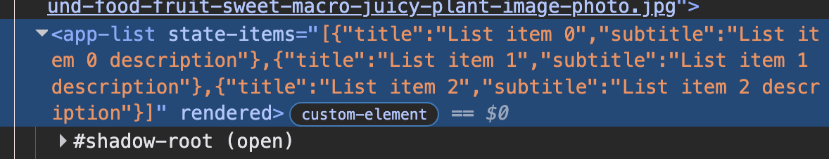
Figure 1: Serialized state as a part of attribute.

We can achieve that by utilising default promises mechanism with async/await keywords to streamline asynchronous behaviour into synchronous-like syntax. Additionally, complex objects can be serialized using the standard JSON format which is natively supported in the server environment since we use JavaScript, and on browser because of the web language.
Once state is encoded in the HTML as the last step of the rendering process per component, we can be sure that after transfer to the client data will be preserved in the encoded state as a part of the component HTML itself. Code of the component itself should not take part of the decoding process and embedding of the data to the component state itself. We want to encapsulate server-side rendering logic from the business logic that is contained inside of the components. This will have following benefits: framework for the rendering and hydration may evolve without change to the business logic, allowing for performance increases without costly changes in business logic. Business logic will be clearer and closer to the domain that is being solved when there is no need to worry about underlying rendering and transfer mechanism.
To preserve separation of concerns between framework and components themselves, we propose to include additional script to the rendered page that will be executed once page finishes its own loading and executing. This script will be responsible for the scraping of the stateful data from the attributes and assigning them as a properties to the specified components.
The general algorithm of the script is as following: scan page for the attributes that contain state. To do this effectively we can utilise native JavaScript selectors that allow us to find attributes by specifying their prefix. After each attribute was found, we can extract attribute name by removing prefix. At this point, value of the attribute is still encoded as a JSON string, so next course of action would be to decode JSON into parsed objects.
For each found attribute, we can get reference to the component instance by utilising native interface and references. Once reference is acquired, using we can assign properties to the component by simply using keyed object assignment. This will create new properties same as if they were declared as a part of the class, since internal JavaScript treats new properties that were added with arbitrary key the same as the ones that were declared during assignment in the constructor, as shown on the figure 2.

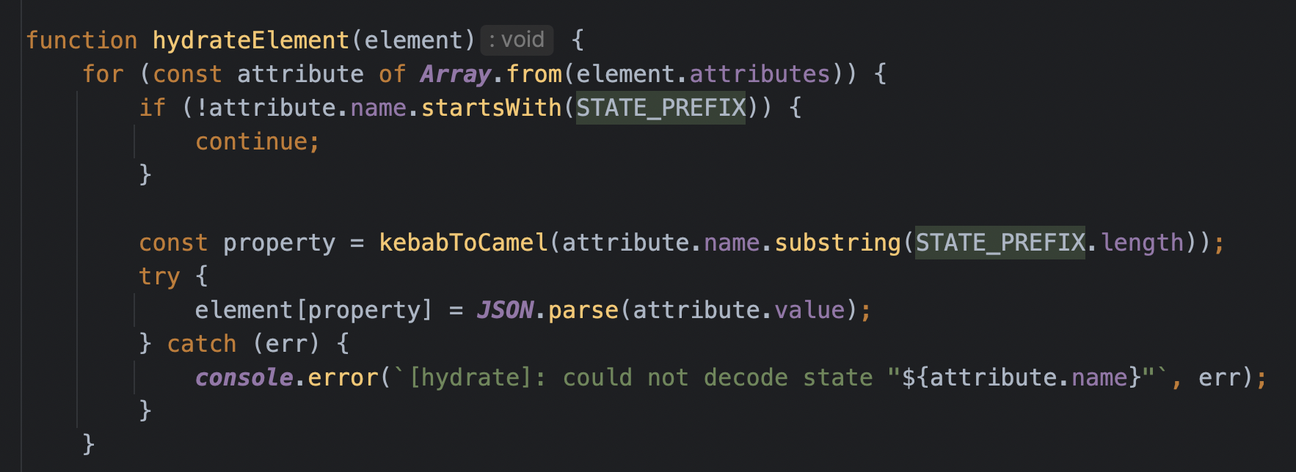
Figure 2: Core algorithm of state reinstation.

Full-hydration engine
When all of those techniques combined, we should be able to load components and attach them to the HTML tags using native browser api’s and control their loading using script attributes. Then, with additional attribute we can command that components shouldn’t re-render themselves on attachment in order to avoid flashing. And as a last step, uncomplicated algorithm will extract all of the encoded into attributes data and re-add them to the state of the components.
This system behaves as a usual full-hydration algorithm, but with optimisations that avoid flickering due to special attribute to ignore re-build, and additional this system gains resumability characteristic by encoding component state to the attributes, and then adding one pass of the algorithm on the client to decode state and re-set it to the components.
A document that is cut short mid-attribute yields a value that is not valid JSON. Because the attributes are read one at a time, the failure is naturally local: the parse is attempted per attribute inside a guarded block, a failure is reported and the remaining attributes are still restored. The component then holds the property it was declared with rather than a half-decoded value, which is the same situation it would be in had the server never resolved that datum. This is preferable to aborting the pass, since one unreadable attribute would otherwise leave every later component on the page unhydrated while the page continues to look complete.
The name of each attribute determines which property is written on the element, and the conversion from the attribute spelling back to a property name is mechanical. A crafted attribute therefore reaches properties the component never declared. Two cases are notable. The element's prototype chain carries accessor properties, so an attribute decoding to innerHTML or className performs a DOM write rather than a state restoration, which turns the state channel into a markup injection vector. Separately, JSON.parse preserves a __proto__ key as an own property of the parsed object, so a restored value can carry a payload that is inert on assignment but becomes a prototype-pollution gadget if the component later merges that object recursively. Both are avoided by treating the restoration as an allowlist rather than an assignment: only names the component itself declares are accepted, and keys named __proto__, constructor or prototype are stripped from parsed values before assignment. Neither check depends on the component's cooperation, so the separation of concerns argued for in Section 3.2 is preserved.
Failures during serialization. The serialization step is deferred until every asynchronous operation started during render has settled, and a rejected request is an operation that has settled. The engine must therefore distinguish a component whose state resolved from one whose fetch failed, and it does so by serializing only properties that hold a defined value: a component that never assigned its property emits no attribute for it, and the client restores nothing. The page degrades to the state it would have had under client rendering for that component alone, rather than emitting an attribute whose value is undefined and which no JSON parse can represent. A stricter policy — failing the render when any request rejects — is available, but it couples the availability of the whole document to that of every endpoint a component consults.
This is a significant improvement over previous iterations that lack ability to re-gain interactivity on the client after load of the rendered HTML page. Additional developments of this algorithm may include adding properties of the progressive hydration, such as loading components only after user interaction or after certain event on the page has happened, like component was scrolled into view.
In the end, we were able to achieve fully hydrated page using built in mechanism for as much as possible. Default script inclusion with matching by tag and ability to serialize and de-serialize state using JSON allowed us to have resumed state with minimal performance penalty due to native optimisations that exist in the browser and JavaScript engine on the server itself.

Evaluation
Experimental Setup
The proposed mechanism was evaluated using reference implementation of the engine proposed in the Section 3. The end page consists of following components: page shell, a header, a button, list, and list item, totalling to five distinct web-components. We incorporated element nesting to give the tree a depth of 3 layers instead of a flat structure, each component creates their own shadow dom as web-component architecture requires. Header, list, list item and button components make asynchronous requests to the server to load data, making four data round-trips total.
The testing page consists of the 1 root custom tag element, which contains additional tags in the template which build out the page. We served and measured 2 variants of this page: one original with JavaScript rendering, and one experimental page that was processed by our algorithm to be server-side rendered and re-hydrated on the client. Experimental page is rendered into declarative shadow roots with rendered attribute and serialized markers from Sections 3.1–3.2, followed by hydration pass that restores state.
Measurements were taken in Chrome 153 driven over the DevTools Protocol with the HTTP cache disabled, five navigations per page, and medians are reported. In addition to the standard navigation and paint timings, we instrumented a per-frame probe that records the moment the header's text content first appears inside its shadow tree. We refer to this quantity as time-to-content, because it captures the point at which the page becomes readable rather than the point at which the first pixel is painted, and it is the metric on which the two delivery strategies actually differ. Cumulative Layout Shift was collected with a PerformanceObserver over the whole session. Server and browser ran on the same host, so network latency is effectively zero.
Results
The hydrated page reached readable content in roughly half the time of the client-rendered baseline while eliminating every data request after load. Table 1 reports the medians of five runs.
Table 1
Client-rendered vs. server-rendered + hydrated page metrics (medians of five navigations).
Metric | Client-rendered | Server-rendered hydrated
HTML document, bytes | 612 | 3 208
HTML document, gzip, bytes | 251 | 936
Sub-resource requests | 11 | 8
Data round-trips after load | 4 | 0
Document response complete, ms | 4.1 | 3.3
Time-to-content, ms | 51.9 | 25.8
Cumulative Layout Shift | 0.0022 | 0

The document grows by a factor of 5.2 uncompressed and 3.7 after gzip. Of the 3 208 bytes of the rendered document, 632 bytes — 19.7 % — are the serialized state attributes themselves; the remainder is the rendered markup and the declarative shadow root templates. Compression absorbs most of this cost, because the serialized state largely repeats strings that already occur in the rendered text, and a gzip dictionary encodes the second occurrence cheaply.
The request count falls from eleven to eight. Three of the four eliminated requests are the data endpoints consumed during render; the fourth is absorbed because the hydration script replaces a module that the baseline loads on its own. The hydration pass itself adds one 1 875-byte script, 894 bytes compressed.
Cumulative Layout Shift falls to zero. In the baseline the header and list are empty when the document is first laid out and grow as each fetch resolves, producing a measurable shift; in the hydrated page the final text is present in the initial layout, and the hydration pass mutates no geometry.
Discussion
The first notable metric that is visible in the result is the page size, which increased from the 612 bytes to the 3208, which made initial page 5 times bigger. When gzip is utilised this drastic difference is diminished slightly, 251 byte of the original website gzipped to 936 bytes of processed gzipped, which takes us from 5x increase to the 3x increase of the size. The reason why gzip is so effective is explained by the source of the increased size in the first place. Of the 3208 bytes of processed page, 1875 is taken by the state resumability script. It is usual JavaScript code and so possibilities to compress are limited. Most of the compression comes from compressing processed HTML itself.
The reason why page size increased that much is that code that was producing page is sent to the client as well as content of the page that this code produces is also sent to the client together with state. This means that we send both: script that generates data, and data itself, which means to the duplication of the states, since we transfer derived data, and code that derives it too.
When page is processed from the JavaScript generated into the server-side rendering, HTML templates that were generated consist not only of the repeating tags, but also attributes. Either custom elements, or custom attributes, for each repeating component on the page they will consist of the exact same sequences of symbols, which means that only first occurrence will have impact on the taken space, while all additional re-occurences will make insignificant contribution to the overall size since gzip can compress them and re-use same stored bit in place of them all.
The benefits of the server side rendered content are significant as well, since rendered page can be indexed by search engines and has zero cumulative layout shift. Those are the usual benefits of the server side rendering and were expected. This particular study extends those benefits to additionally make page interactive after intialisation, which open opportunities for the interaction-heavy websites to achieve benefits of server side rendering without compromising on the page actions, cumulative layout shift or ability being indexed by server. Interaction is not the only improvement that have been gained by introducing hydration. Another benefit of improved hydration is that we have prevented flickering by utilising special attribute in the root tag of the rendered component.
Additionally to re-attaching handlers to make page interactive and preventing flickering, this mechanism also introduced some characteristics of resumability. Resumability can be easily verified by checking timestamp attribute. In the original page, it displays a timestamp that was calculated on the client when page was opened, but on server-side rendered page, timestamp is frozen in time when it was rendered. This is due to the fact that all JavaScript that was required to display page initially was performed on the server, while the only work left to client is to parse and display usual HTML content. But with resumability, additional actions performed on the client can access raw data that was present on the server during calculation and continue working from this state.
The state that is preserved comes not only from calculation, but various requests to the server that load data can be also stored in the attributes without being re-fetched by client on display. Depending on the amount of the calls original page has to make, this can be a significant performance increase. On our test page, amount of round-trips from 11 to 8, where most of the eliminated requests were for data, and the ones that were left are requests for the components itself. The four eliminated round-trips are the result most sensitive to the test conditions, and understate the benefit rather than overstate it. On the loopback interface each request costs a few milliseconds; over a network path with a 50 ms round-trip time, four dependent requests issued after the module graph has loaded would dominate the time-to-content figure entirely.
Related works
Studies commonly compared with this work optimize how JavaScript executes; our approach reduces how much of it must execute before a page is usable, and the two compose.
AOTC (Park et al., 2018) persists the output of the optimizing compiler, so that a later execution reuses optimized code instead of re-traversing the interpreter tiers. Concurrent parsing (Park, Cha, & Moon, 2016), deconstruction of the type system (Ahn et al., 2014), selective hot-spot compilation (Lee & Moon, 2011), and thread-level speculation (Martinsen & Grahn, 2011) likewise raise engine throughput, shorten startup or extract parallelism from sequential code. Each makes a given body of JavaScript run faster; none reduces the body that must run. Our approach acts on the second quantity, transferring the markup components would have produced together with the data they resolved; whatever executes after hydration still benefits from a faster engine.
Closest in intent is the snapshot technique (Yeo, Oh, & Moon, 2019), which saves the heap and DOM tree of a previous execution so later visits are restored rather than recomputed. It shares our premise that a result is cheaper to transfer than the execution that produced it. A snapshot, however, is a whole-engine image bound to the engine that wrote it and usable only on a repeat visit; our state is per-component JSON in ordinary attributes, consumed on a first visit by any browser, leaving the document indexable.
The work we extend directly, the preprocessor-based server rendering of Section 1.2, ends at delivery of the rendered document: no handlers, and no record of the data its components resolved. Qwik is closest in capability, but reaches it through build-time chunking, serialized handler references and a central state graph; we resume state with no build step, using the custom elements registry and the component root's attributes. Selective and progressive hydration are orthogonal: either could schedule our pass without altering how state is encoded.
Conclusion
This article proposed approach to re-hydrate static server-side-rendered website composed of the web-components. We adapted native browser technologies to perform in the capacity of the hydration framework by utilising their specific attributes as well as additional script that re-instates state from the encoded state during execution on the server. We overcame problems of flickering by using additional flag attribute and provided ability to control sequence of loading JavaScript components.
We made the following contributions in this article:
- Proposed approach of re-attaching JavaScript to component tags in the tree.
- We resolved issues with page flickering after re-hydration.
- We decreased necessary work on the client by effectively re-constructing state
- We demonstrated possible customizations of the loading sequence.
This approach requires as minimum compute as possible due to effective utilisation of the embedded APIs which are written in the high-performance language on which JavaScript engine runs in both: browser and server. Proposed techniques pave a way for the native server-side rendering support for the web-components as a natural extension of the re-usable native platform comparable to the industrial frameworks in capabilities.
We also identified possible areas for the improvement of said technology, which can be used to add unique characteristics on the behaviour of the hydration to optimise specific metrics, such as load time, user satisfaction or bandwith utilisation.
Declaration on Generative AI
During the preparation of this work, the author(s) used Claude in order to: Grammar, spelling check and formatting. After using this tool/service, the author(s) reviewed and edited the content as needed and take(s) full responsibility for the publication’s content.

References
Ahn, W., Choi, J., Shull, T., Garzarán, M. J., & Torrellas, J. (2014). Improving JavaScript performance by deconstructing the type system. ACM SIGPLAN Notices, 49(6), 496–507. https://doi.org/10.1145/2666356.2594332
Dalgleish, M. (2015). The end of global CSS. SEEK Blog. https://medium.com/seek-blog/the-end-of-global-css-90d2a4a06284
Lee, S.-W., & Moon, S.-M. (2011). Selective just-in-time compilation for client-side mobile JavaScript engine. In Proceedings of the 14th International Conference on Compilers, Architectures and Synthesis for Embedded Systems (pp. 5–14). Association for Computing Machinery. https://doi.org/10.1145/2038698.2038703
Martinsen, J., & Grahn, H. (2011). Thread-level speculation as an optimization technique in Web applications — Initial results. In Proceedings of the 6th IEEE International Symposium on Industrial Embedded Systems (pp. 83–86). https://doi.org/10.1109/SIES.2011.5953686
Miller, J. (2020). Islands architecture. jasonformat.com. https://jasonformat.com/islands-architecture/
Miller, J., & Freed, M. (2024). Declarative shadow DOM. web.dev. https://web.dev/articles/declarative-shadow-dom
Node.js. (n.d.). About Node.js. Retrieved September 25, 2026, from https://nodejs.org/en/about
Park, H., Cha, M., & Moon, S.-M. (2016). Concurrent JavaScript parsing for faster loading of web apps. ACM Transactions on Architecture and Code Optimization, 13(4), 1–24. https://doi.org/10.1145/3004281
Park, H., Kim, S., Park, J.-G., & Moon, S.-M. (2018). Reusing the optimized code for JavaScript ahead-of-time compilation. ACM Transactions on Architecture and Code Optimization, 15(4). https://doi.org/10.1145/3291056
React. (n.d.). React reference overview. Retrieved September 25, 2026, from https://react.dev/reference/react
Vepsäläinen, J., Hevery, M., & Vuorimaa, P. (2024). Resumability—A new primitive for developing web applications. IEEE Access, 12, 9038–9046. https://doi.org/10.1109/ACCESS.2024.3352891
web.dev. (n.d.-a). Cumulative Layout Shift (CLS). Retrieved September 25, 2026, from https://web.dev/articles/cls
web.dev. (n.d.-b). Time to Interactive (TTI). Retrieved September 25, 2026, from https://web.dev/articles/tti
WHATWG. (n.d.-a). Custom elements. In HTML Standard. Retrieved September 25, 2026, from https://html.spec.whatwg.org/multipage/custom-elements.html
WHATWG. (n.d.-b). Shadow trees. In DOM Standard. Retrieved September 25, 2026, from https://dom.spec.whatwg.org/#shadow-trees
WHATWG. (n.d.-c). The template element. In HTML Standard. Retrieved September 25, 2026, from https://html.spec.whatwg.org/multipage/scripting.html#the-template-element
Wirfs-Brock, A., & Eich, B. (2020). JavaScript: The first 20 years. Proceedings of the ACM on Programming Languages, 4(HOPL), Article 77. https://doi.org/10.1145/3386327
Yeo, J., Oh, J., & Moon, S.-M. (2019). Accelerating web application loading with snapshot of event and DOM handling. In Proceedings of the 28th International Conference on Compiler Construction (pp. 111–121). Association for Computing Machinery. https://doi.org/10.1145/3302516.3307355

УДК 004.65
DOI: https://doi.org/XX.XXXXX/XXXX-XXXX.2026.X-XX

Dmytro DVUKHHLAVOV, PhD (Tech.), assoc. prof.
ORCID ID: 0000-0002-3361-3212
e-mail: dmytro.dvukhhlavov@khpi.edu.ua
National Technical University
“Kharkiv Polytechnic Institute”, Kharkiv, Ukraine

Artur CHECHUN
ORCID ID: 0009-0000-3590-2993
e-mail: Artur.Chechun@cs.khpi.edu.ua
National Technical University
“Kharkiv Polytechnic Institute”, Kharkiv, Ukraine

Oleksandr KULABUKHOV
ORCID ID: 0000-0002-9836-6646
e-mail: nachlab@ukr.net
Ivan Kozhedub Kharkiv National
Air Force University, Kharkiv, Ukraine

AN APPROACH TO EVALUATING THE APPROPRIATENESS OF STORING OPERATIONAL AND ANALYTICAL WEB APPLICATION DATA SEPARATELY IN DIFFERENT DATABASE MANAGEMENT SYSTEMS

This paper presents an approach to evaluating the appropriateness of separately storing operational and analytical data for web applications. This task is relevant to information systems used in the digital economy, particularly online retail systems, banking systems, electronic document management systems, customer relationship management systems, and other systems that accumulate and process large volumes of historical data. The interfaces of such web applications typically provide users with dashboards displaying aggregated data, as well as reporting functionality designed to analyze accumulated data and support business operations. Under these conditions, a single relational database is forced to simultaneously handle both transactional and complex analytical queries. In a relational environment, analytical queries involving large datasets can execute slowly and consume a significant portion of shared computing resources. Furthermore, the simultaneous execution of these two query types leads to contention for shared resources, thereby increasing the execution time for operational queries. Based on a comparative analysis of existing approaches to ensuring efficient data processing in web applications, a polyglot persistence-based approach was selected. Drawing on an analysis of the specific characteristics of operational and analytical data processing, an approach is proposed for evaluating the necessity of storing this data separately. To determine the appropriateness of distributing data across different databases, an approach based on an integral indicator was developed. This indicator is calculated using specified base indicators. The resulting integral indicator reflects the overall appropriateness of data separation, allowing for an assessment of the necessity to separate analytical and operational data. Finally, directions for further research and validation of the proposed approach are outlined.
Keywords: separate storage of analytical and operational data, polyglot persistence, integral indicator for assessing the appropriateness of separate data storage.

Introduction.
The high popularity of web applications in the modern world proportionally increases the number of users and the amount of information that is processed and accumulated during their use. The growth of information volumes for many popular areas of web applications, in particular in the digital economy, necessitates the addition of functionality for data analysis and display of its results. Analytics is especially important for online stores and marketplaces, which constantly accumulate large amounts of data on orders, payments, product reviews and returns. Similar tasks arise when using banking systems, electronic document management systems, customer relationship management systems and other systems that accumulate and process significant amounts of historical data. The analytics functionality provides for the generation of reports, the construction of analytical dashboards, charts and visualization, which provides the ability to conduct analysis by analysts based on stored indicators. Based on them, specialists in the relevant industry will be able to determine the effectiveness of various processes, compare indicators over time, and assess trends, using all this information to conduct informed analysis (Swacha & Kulpa, 2023).
Adding analytical functionality to web applications introduces an additional workload for their database management systems (DBMSs), which must then process both operational and analytical queries. Such new features of web application functioning, as shown by the studies presented in (Raza et al., 2020), (Kang et al., 2022), (Archer, 2025), (ClickHouse, 2026), can increase execution time of queries to web application database.
This article aims to highlight shortcomings that may arise as a result of the simultaneous execution of queries for obtaining operational and analytical data in web applications that process large volumes of historical data; to present the results of the analysis of approaches to increasing the efficiency of performing operational and analytical workloads in DBMSs; to substantiate the appropriateness of applying the polyglot persistence approach to ensure proper efficiency of processing queries to the DBs of the specified web applications; to develop an approach to assessing the appropriateness of distributing operational and analytical data, provided for by the implementation of polyglot persistence, based on the calculation of an integral indicator that will take into account the current parameters of the web application's functioning together with the cost and complexity of implementing data separation between different DBMSs.
Scientific novelty consists in forming an approach to assessing the appropriateness of separate storage of operational and analytical data of web applications, which involves the formation of an integral indicator based on normalized estimates of the speed of analytical queries, the impact of analytical load on the execution of operational queries, the volume of data and its growth rate, as well as the cost and complexity of implementing separate storage. This allows taking into account both the technical efficiency and practical appropriateness of such a solution.
Unlike the approaches discussed in the article, which focus on optimizing specific aspects of query processing, the concurrent execution of OLTP and OLAP workloads, or selecting a DBMS based on data and query characteristics, the proposed approach aims to comprehensively evaluate the appropriateness of architectural data separation.
Practical significance lies in the possibility of using the proposed approach to increase the validity of decisions regarding the separate storage of operational and analytical data of web applications. Formalizing the calculations creates the prerequisites for automating the process of determining query processing characteristics in web application databases, specifically those involving the accumulation and processing of historical data, and for assessing the need to transition to separate processing for operational and analytical queries.
Main part and results
Databases (DBs) are used to perform organized information storage, and their management is carried out using a database management system (DBMS) (Amazon Web Services, n.d.). The main functionality provided by DBMSs is to create a database structure and perform operations on adding, reading, editing and deleting records with support for integrity and parallel user work (GeeksforGeeks, 2026). Currently, relational DBMSs are most often used for data management (Tang et al., 2023). This is due to the fact that implementations of this type of system occupy the first positions in the rating, which indicates their high prevalence and significant community support (DB-Engines, n.d.). DBMSs such as Oracle, MySQL, Microsoft SQL Server and PostgreSQL occupy the first four places according to DB-Engines data for August 2026 (DB-Engines, n.d.). Accordingly, it is these relational DBMSs that are of primary interest to specialists and the professional community, which reflects the very widespread use of these technologies.
The basis of their popularity is their efficient processing of operational workloads, while ensuring data integrity, scalability, data availability, and security for all types and sizes of organizations (Microsoft, n.d.). The concept that facilitates this is to organize data in the form of tables that are interconnected by relationships (Microsoft, n.d.). That is, the basis of the schema of relational databases is the logical structures of tables, columns, keys, and relationships.
Relational DBMSs also provide indexing methods that allow this type of system to provide high performance and speed of operations for retrieving data from database tables, taking into account possible extensions of data sets (Malviya, 2024). However, due to a number of features, this type of DBMS in most cases may become impractical for performing directly analytical workloads, as well as combining it with operational workloads.
The main feature of this statement is the difference between the transaction processing mode OLTP (Online Transaction Processing) and OLAP (Online Analytical Processing).
OLTP represents a transaction processing mode that works with operational information. It is usually based on the use of row-oriented environments and B-tree indexes to read and write rows in milliseconds. The basis of such a mode is the efficient execution of short operational queries that access individual records using corresponding identifiers and indices. This mode is the basis for the functioning of the relational DBMSs (ClickHouse, 2026).
OLAP is a processing paradigm designed for complex analytical queries that are often associated with performing aggregation. In this case, vectorized data processing is envisaged. With this type of processing, the system interacts with batches of values simultaneously, rather than processing them sequentially, one row at a time (ClickHouse, 2026).
This difference between OLTP and OLAP explains why relational DBMSs will read data from a row-oriented format when executing analytical queries, and may also read row attributes that may not be relevant to the required result. In the case when the database contains a large number of historical records, which may amount to millions of rows, which will be used by an analytical operation, there will be a deterioration in the efficiency of their execution.
Additional features that are available in many DBMSs can also slow down analytical queries. In the case of MySQL, this refers to internal temporary tables that are used by the system to store data for possible further processing of intermediate results (Oracle, n.d.-a). In the main cases, they arise during ORDER BY, GROUP BY, UNION and other operations (Oracle, n.d.-a). RAM is used to store them to provide fast processing of intermediate data (Oracle, n.d.-a). However, when the amount of data contained in it reaches a critical set size value, MySQL can perform their conversion into a type that will work at the expense of disk computing power (Oracle, n.d.-a). And accordingly, there will be a decrease in the speed of execution of analytical queries. Also, in cases of simultaneous operational load, such competition for RAM and disk resources will increase, as a result of which the system throughput may also decrease.
In addition, when many analytical and operational queries are executed simultaneously, operational queries may slow down and the overall throughput of the operational workload may decrease (Kang et al., 2022). This effect can be exerted by analytical queries, which, together with operational queries, will use the shared computing resources of the server and the DBMS buffer pool (Kang et al., 2022). This is due to the fact that analytical queries are more complex in their structure and process more data, which require more time to execute, than short and simple operational queries (Raza et al., 2020). As a result, the analytical workload may occupy a larger part of the resources, leaving less for operational queries and routine operational queries, which leads to a possible shortage of resources and transaction execution delays. This increases the time to execute operational queries and reduces the number of operations that the system could process per unit of time.
To improve the efficiency of executing queries to web application databases, various approaches are used. Their list, indicating the main effect and limitations of use, is given in Table 1. In general, these approaches can be divided into approaches that are aimed at query processing technology and approaches that take into account the specifics of executing operational and analytical workloads. This is because different types of queries can be processed by different DBMSs.
Defining covering indexes for database tables is one of the easiest ways to reduce query execution time. They can speed up filtering, searching, sorting, and grouping operations without having to access tables (Chakkappen et al., 2025; Oracle, n.d.-b). However, using indexes is less effective for large tables that require processing most of the rows, which is usually required when performing analytical tasks (Oracle, n.d.-b). In these cases, if they are misused to cover all fields, the space for their storage will increase significantly (Oracle, n.d.-c). Also, the load during insert, update, and delete operations will increase due to the fact that when performing them, it is also necessary to update the indexes (Oracle, n.d.-c). Taking into account the fact that although this approach solves certain shortcomings associated with the simultaneous execution of analytical tasks, it instead creates additional ones that lead to low efficiency of this approach.
Table 1
Possible approaches to reducing the processing time of web application database queries
Approach | Main effect | Limitation
Covering indexes | Speed up query execution without changing the system architecture | Increase storage and overhead when writing and updating data
Caching results | Reduces execution time of repetitive queries | Possible use of stale data; limited performance for dynamic and irregular queries
Pre-aggregation | Speeds up the generation of standard reports and calculation of aggregate indicators | Reduces query flexibility and requires regular updates of aggregated data
Vertical scaling | Increases performance without significant restructuring of the system | Has hardware limitations and requires significant financial costs
Using the HTAP system | Provides joint processing of OLTP and OLAP workloads based on current data | Requires complex transition; does not always provide complete resource isolation
Data separation between DBMSs | Isolates operational and analytical workloads; can accelerate analytical queries performance; allows the existing operational DBMS to remain in use | Requires data synchronization; causes duplication of some data and complexity of architecture

The next possible solution is to use caching. Its application will consist in storing the results of already executed queries in the RAM in order to obtain them directly from it without performing repeated operations. Thus, the time required to obtain the result of the query will be reduced, as well as the load on the DB will be reduced. However, this method has a series of drawbacks that make it not quite appropriate for many use cases. These are the risk of stale data and dynamic change of results. When changes are made to the DB records, the data relevance state in the cache may remain outdated for some time (Mao et al., 2024). To maintain the proper state of the data, it is necessary for some systems to implement a mechanism for performing data update operations, such as limiting the storage time, invalidating, or updating the cache (Mao et al., 2024). However, this drawback mostly concerns specific systems in which there is a need to obtain an up-to-date analytical result within a short
period of time (Mao et al., 2024).
In the case of using pre-aggregation, it is possible to reduce the execution time of analytical queries and their load on the system. This is achieved by storing pre-calculated intermediate results of indicators for analytical queries in specialized data structures (Tardío, Maté, & Trujillo, 2020). When forming the result, the system will use tables that will contain prepared values, respectively, the number of necessary records that would need to be processed and calculated will decrease, which will generally reduce the load on the database. However, a large number of indicators will also create a need for additional storage space and the need to constantly perform additional update operations for their values, which will also carry an additional load on the database (Tardío, Maté, & Trujillo, 2020). In addition, this structure is quite inflexible because when making changes to the query structure, it will be necessary to make them also for the tables in the database, performing their creation or editing, which creates a dependence of performance on predefined query templates (Tardío, Maté, & Trujillo, 2020). Also, its use does not solve resource competition between workloads. Thus, as with the use of caching, this approach is effective for a certain list of cases in which a predefined structure of analytical queries will be used.
The main drawback is the low efficiency of caching the results of analytical queries with dynamic structure and parameters. When constantly changing the filtering and grouping parameters, which is usually typical for analytical tasks, it will be necessary to separately execute a query to the database to obtain a new result and save it to the cache. This is due to the fact that the previous saved result in the cache was formed based on a different combination of parameters set for the old query and its result will not meet the conditions of the new query. Therefore, caching is effective only for a certain query pattern, but its application cannot fully cover complex dynamic analytical tasks.
Vertical scaling increases the number of computing resources, which increases the performance of the system (Alharthi et al., 2024). When using this approach, there is no need to make significant changes to the system architecture. However, such an improvement is temporary and requires a large amount of funds for its implementation. Thus, this approach does not solve the shortcomings, but only temporarily reduces their effect on the system.
The next option is to use HTAP (Hybrid Transactional/Analytical Processing) systems. This type of system was specifically designed to handle two types of workloads, namely analytical and operational (Song et al., 2024). This combination is made possible by the existence of many architectures of systems of this class, which combine row structures for the operational part and column structures for analytics (Song et al., 2024). However, some types of such systems do not always provide complete resource isolation due to the fact that they use shared hardware resources. This can degrade query performance and cause situations where analytical queries can block transaction execution and cause resource shortages (Song et al., 2024; Sirin, Dwarkadas, & Ailamaki, 2021). But when using such approach, the complexity of its implementation will significantly increase, because for this it will be necessary to migrate and adapt existing data to the new DBMS and to set up connections to new DBMS.
And the last option for reducing query execution time is to store operational and analytical data separately in different DBMSs. This approach involves using multiple DBMSs based on polyglot persistence, each of which will be selected based on the processing of a specific type of query, data model, and performance requirements (Roy-Hubara, Shoval, & Sturm, 2022). An example of implementing such a division is the use of MySQL for operational workloads and ClickHouse for analytical workloads (Archer, 2025). With such a structure, each type of query will be processed in the most suitable environment for this. The division of resources into independent parts that will be used by each DBMS will ensure a reduction in competition between resources for operational and analytical queries. In the case of using a columnar environment, the execution time of analytical queries will be significantly accelerated. At the same time, it will be possible to continue using the current MySQL relational database. With such a separation, there is a need to synchronize data for the analytical database, which, depending on the required level of relevance, may increase the overall system load. It will also be necessary to spend additional funds on supporting the analytical database.
The quantitative effects of the approaches considered depend strongly on DBMS and hardware configurations, the structure and volume of accumulated data, and query complexity. Therefore, results from different studies cannot be used directly to rank the alternatives numerically. They can, however, indicate how each approach affects performance and resource use.
A study of automatic indexing in Oracle reported a 15% performance improvement for one real-world workload and identified the potential to reclaim up to 60% of the space occupied by redundant indexes (Chakkappen et al., 2025). In a study of result caching with C-JDBC under a RUBiS workload of 450 clients, average response time fell from 801 to 284 ms, throughput rose from 3,892 to 4,184 requests per minute, and database server CPU utilization fell from 100% to 85%. With less stringent requirements for the freshness of cached data, average response time was 134 ms and CPU utilization was 20%.
Quantitative results have also been reported for precomputed structures and HTAP systems. In a study by Pang et al., materialized views reduced the total processing time for a set of queries over Wikidata logs by a factor of 9.73 compared with execution without materialized views. For modern HTAP systems under high update intensity, Boroumand et al. reported that transactional throughput fell to 74.6% and analytical throughput to 49.8% of the levels achieved when the workloads were executed in isolation.
A specialized column-oriented DBMS can reduce analytical query execution time compared with a row-oriented relational DBMS. For the scenarios examined by Archer (2025), individual analytical queries in ClickHouse were reported to perform 100–1,000 times faster than in MySQL, depending on data volume and query type.
The ability to independently process operational and analytical workloads while maintaining their efficiency in the future determines the appropriateness of using an approach based on data separation between analytical and operational DBMSs to increase the efficiency of query execution in web applications planned in an environment that requires the accumulation and statistical processing of historical data.
Another advantage is the possibility of selecting a DBMS that will provide a reasonable cost of implementation. This cost is provided, in particular, by the considered separation option between MySQL and ClickHouse. ClickHouse is an open source system, its license allows use without a license fee for direct application, modification and separation (ClickHouse, n.d.). The same applies to MySQL (Malviya, 2024). In addition, in ClickHouse, using special compression mechanisms, data volume compared to MySQL is reduced by 4 to 10 times (Archer, 2025). Thus, it may to consider the main costs may be associated with implementation and subsequent support.
But implementing a performance solution in some cases may not compensate for the complexity of the architectural changes. This can happen when the system has a small amount of data or low analytical intensity, which may not require separation or its monitoring. This is why an approach to assessing the appropriateness of distributing analytical and operational data is necessary. The proposed approach is presented in the form of a UML activity diagram in Fig. 1.
According to Fig. 1, it is assumed that a corresponding decision will be made based on the calculation of an integral indicator, which determines and allows assessing the appropriateness of distributing operational and analytical data (Ryjov et al., 2024). Thus, an integral indicator can be understood as some conditional numerical measure of the latent quality of the phenomenon under study, and the purpose of constructing an integral indicator in this case will be a compact description of some quality of the phenomenon under study while preserving the main properties of the structure of the objects under study (Hryhoruk & Tkachenko, 2012).

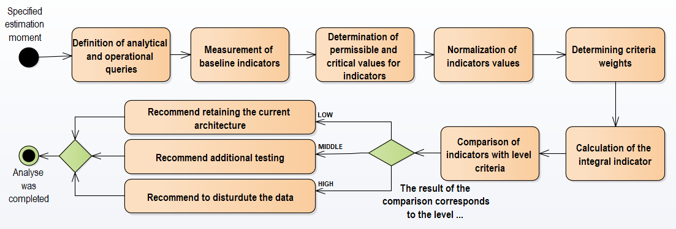
Fig.1. Stages of assessing the appropriateness of distributing operational and analytical data

The basic indicators that will be used to determine the integral indicator characterize the current state and performance of the system under study. Taking into account that the final and intermediate results obtained will have different units of measurement and ranges of values, normalization is used to reduce them to a dimensionless form, i.e., reduction to a unified scale (Hryhoruk & Tkachenko, 2012).
When conducting it, all indicators will be set in the range from 0 to 1 (Hryhoruk & Tkachenko, 2012). Such ranking will improve the meaningful interpretation of values, which allows for comparison of different characteristics (Hryhoruk & Tkachenko, 2012). In the general case, for the criterion of approximation of the normalized value of the indicator to 0, it will correspond to low expediency of the distribution, and to 1, to high. At the same time, increasing the values of the normalized indicators will indicate a low level of performance, which will reflect greater expediency of the distribution. For such values, direct normalization will be applied, which correspond to the sign of the stimulator (Hryhoruk & Tkachenko, 2012). For criteria that have the opposite effect and correspond to the sign of the destimulator, the inverse transformation will also be applied to the normalized value (Hryhoruk & Tkachenko, 2012). To determine
the minimum or critical values of the indicators, expert assessment or, if necessary and with the availability of data, objective assessment will be used.
To take into account the different levels of influence of the criterion on the appropriateness of data separation, weights are assigned to them. Each of weights will contain a non-negative value, and their total sum will be one (Weisstein, n.d.). A higher value of the weight correspond to a greater significance of this indicator for the criterion or the final result of the integral
indicator (Weisstein, n.d.). Thus, it will be possible to rationally distribute the degree of influence between individual components according to their importance for the assessment. The final obtained value of the integral indicator can be compared with the correspondingly defined intervals. With their help, the level of appropriateness of the separation will be established, which will be within the low, medium and high levels.
The following will serve as the main criteria:
- speed of analytical queries;
- the impact of analytical workload on routine and operational queries;
- the volume of data and its growth rate;
- the cost and complexity of implementing the separation.
Within the scope of the problem addressed, this set of criteria is sufficient for a comprehensive assessment of whether data separation is appropriate. Other considerations, including security, reliability, data consistency, and data freshness, are not treated as separate criteria because they are general requirements for the information system. Any additional costs and implementation complexity associated with meeting these requirements after data separation can be accounted for under the cost and implementation complexity criterion.
The first criterion reflects the speed of execution of analytical queries, which characterizes the system's ability to obtain analytical results in an acceptable period of time. For its calculation, a list of basic queries for analytics in the system is used. Before measurements, an initial "warm-up" of the system is performed to increase the accuracy of the results. Then, each of the queries during testing is executed several times, which gives a list of the obtained execution time results, which will later be formed into a final value based on the average time.
The second criterion characterizes the impact of the analytical load on the operational load. The main indicators for its calculation will be data on the query execution time and throughput of operational queries during and separately from the analytical load.
The third criterion involves considering the current data volume in the web application's database and its growth rate. Accounting for data volume can be achieved by determining the number of records in the database that may impact the execution of analytical operations. The data growth rate is used to project data volume over a specified time horizon; the projected volume is then compared with a threshold beyond which analytical query performance may degrade.
The last and no less important criterion is responsible for the complexity and cost of implementing the separation in the system. Its value affects the overall assessment of appropriateness, worsening its indicator with high complexity and cost for implementation and maintenance.
Now it is worth considering the mathematical formulation of the proposed approach and the sequence of calculating the indicators on the basis of which the integral indicator is calculated.
Analytical query performance  is evaluated using a set of representative analytical queries:
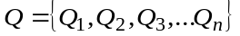,
where  – analytical query; – the number of queries on the basis of which the calculation will be made.
Since each query is executed several times, for a more accurate value after the system warms up, the average time to execute the i-th query is defined as follows:
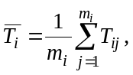
where  – average execution time -th analytical query; 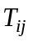 – query execution time during -th re-run; 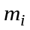 – number of re-runs.
Next, for each query, an allowable execution time 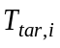 and a critical execution time 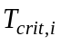 are set:
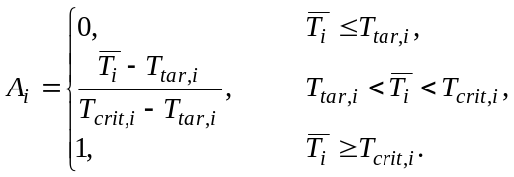
A value of 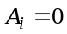 indicates acceptable execution time, whereas a value of 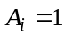 indicates critically poor performance.
Generalized indicator for the performance of analytical queries is defined as follows:
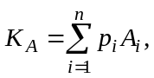
where 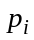 – weight for -th analytical query;
– the total number of analytical queries.
In this case, the following condition is fulfilled for the set of weights:
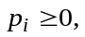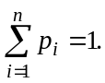
If necessary, the frequency of execution to set the weights may be used:
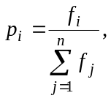
where 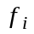 – number of executions -th analytical query within the specified period.
If all analytical queries are of equal importance to the system, then equal weights can be set for them:
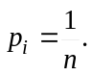
Indicator  is responsible for the level of speed of execution of analytical queries in the system. As its value approaches 1, the need to separately execution analytical queries increases.
An indicator that allows to assess the impact of analytics on operational workload 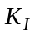 is formed from two components: the throughput loss of operational queries and the value of their slowdown at the 95th percentile. To calculate the indicator, it is first necessary to conduct basic testing, during which only operational queries are executed. After this, mixed testing is conducted, during which analytical and operational queries will be executed simultaneously.
Throughput loss 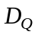 can be determined by the formula:
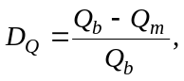
where  – throughput of operational queries without the influence of analytics;  – throughput of operational queries during simultaneous execution with analytical queries.
Normalized throughput loss estimate 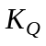 is defined as follows:
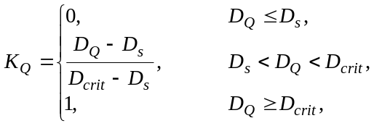
where  – permissible value of throughput reduction; 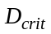 – critical value of throughput reduction.
Slowing down the operational query 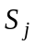 is determined by the ratio of P95 from the mixed load to the base P95:
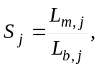
where 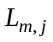 – 95th percentile of execution time -th operational query taking into account the impact of analytics; 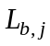 – 95th percentile of execution time -th operational query without the influence of analytics.
Normalized estimate of operational query slowdown 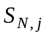 is defined as follows:
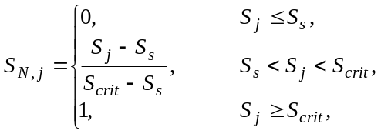
where 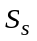 – permissible value of operational query slowdown; 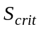 – critical value of operational query slowdown.
General slowdown of all operational queries 
is calculated as follows:
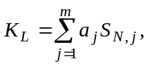
where – number of types of operational queries; 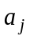 – weight of the -th query.
Weights must satisfy the following conditions:
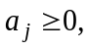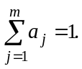
Provided that the operational queries in the loop contain one operation of each type, equal weights can be used:
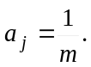
Total value of the analytical load impact indicator will be
calculated as follows:
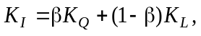
where  – reflects the relationship between the importance of throughput and P95.
When calculating the volume and growth rate of data 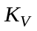 information about tables that directly belong to the analytical query execution process is used.
Current data volume 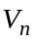 is determined by the formula:
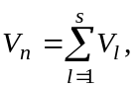
where  – the volume of a separate table; – the number of tables related to analytical queries.
For the predicted volume of data, various forecasting methods can be used, the choice of which is made depending on the nature of the data change and the available volume of historical data and the accuracy of the result. Thus, if the data changes by a relative amount each period, it is possible to use a compound growth model with a constant relative rate. (RunBook Academy, n.d.).
To calculate the average growth rate, the compound annual growth rate (CAGR) may be used (Fernando, 2026; Khojasteh et al., 2023). This model will take into account the compound nature of data growth, such as from the growth of the number of users in the system or other data. Looking for this the average relative growth rate of data according to the principles of calculating CAGR will be determined as
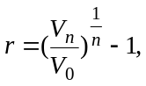
where 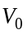 – initial volume; – volume at the end of the observation period; – number of periods.
Then the predicted data volume 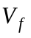 is defined as follows:
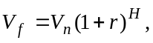
where  – forecasting horizon.
Next, the value of the predicted data volume is converted into a normalized score which is defined as follows:
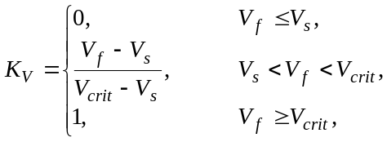
where  – the amount of data at which analytical queries meet the requirements; 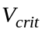 – the amount of data at which there will be a deterioration in the efficiency of query execution.
The indicator of necessary expenses is calculated at first to evaluate the cost and complexity of implementing the separation 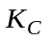. It consists of a list of necessary expenses to conduct and support the separation of:
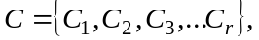
where 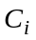 – consumption indicator; – the total number of components that belong to the costs.
This list is determined depending on the specifics of the technological aspects.
The total cost of data separation 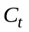 is calculated as the sum of the costs of implementing and supporting it over the specified period:
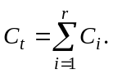
Next, this indicator is brought to a common range, thereby forming a normalized estimate of the cost of implementing
the separation 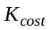:
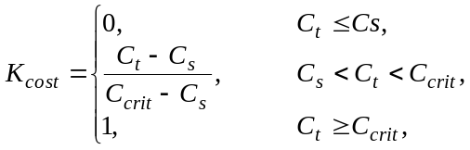
where 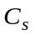 – allowable amount of expenses; 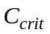 – critical amount of expenses.
Next, an assessment of the complexity of the implementation is carried out, which consists of a list of:
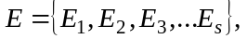
where 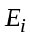 – component of the implementation of the separation element; – total number of components.
For each element  is defined assessment of the complexity 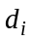 of its implementation, which is placed in the range 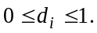
At 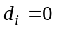 complexity is minimal, and with 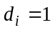 the complexity of implementation reaches unacceptable level.
A composite implementation complexity score 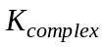 is then calculated as follows:
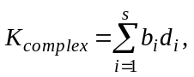
where – weight of the component.
At the same time, weights must satisfy the following conditions:
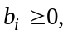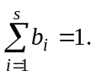
As a result, the overall value of the indicator of the cost and complexity of implementing the separation is formed :
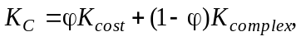
where – the importance of value.
With equal importance of weights for two components, this formula is presented in the following form:
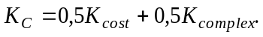
Accordingly, as the value 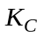 approaches 1, implementation becomes more complex and costly. Thus, in order for this value to lead to a decrease in the integral indicator of the appropriateness of the separation, the inverse value will be included in the formula:
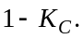
After normalizing all indicators to the range from 0 to 1, they can be combined into a final integral indicator. Such a combination is performed using the weighted sum method. Thus, the indicator of the appropriateness of the separation of operational and analytical data 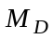 is calculated using the following expression:
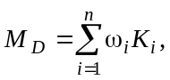
where 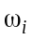 – weight of the indicator; 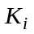 – normalized value of the corresponding indicator; – the total number of indicators.
In this case, the weights ω must meet the requirements:
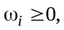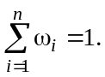
Since for calculation normalized values are used, subject to compliance with the requirements for weighting factors, the integral indicator will acquire values within:
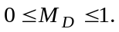
Because the criterion of cost and complexity of separation has a negative impact on the assessment of the appropriateness of separation, the indicator of its evaluation will correspond to the indicator of practical appropriateness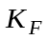:
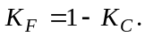
Thus, the final formula for the integral indicator of the evaluation of the separation of operational and analytical data takes the form:
Level of appropriateness will be determined according to a rule, a variant of which is stated as follows:
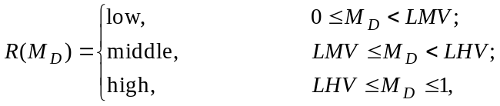
where LMV and LHV are the threshold values for the medium and high levels of separation appropriateness.
At a low level of appropriateness, data separation is unjustified, and simpler analogues can be used to improve performance. The average level of appropriateness reflects the presence of grounds for carrying out the separation, but before carrying it out, it is also necessary to additionally test the system and investigate various factors of reduced performance, and a decision can then be made. The last level reflects the existing shortcomings that are significant and relate to each of the criteria. In this case, the implementation of data separation is justified and may be considered for implementation.
Discussion and conclusions
The analysis showed that executing operational and analytical queries concurrently within the same relational DBMS can increase query execution times and reduce system throughput because the workloads compete for shared resources. Covering indexes, caching, pre-aggregation, and vertical scaling can mitigate these effects, although their benefits depend on the workload. HTAP systems can process both workloads using current data within a single system, but adopting such a system may require substantial changes and does not always ensure complete workload isolation. Separating operational and analytical data across DBMSs allows each workload to use a suitable DBMS and can reduce resource contention, but introduces synchronization and maintenance costs.
To support decisions about data separation, this paper proposes an approach based on an integral indicator. It combines normalized estimates of analytical query performance, the effect of analytical workloads on operational queries, projected data volume, and the cost and complexity of implementation. The resulting value classifies the appropriateness of separation as low, moderate, or high. Considering both technical and practical factors is an advantage of the approach, although the classification depends on the selected weights and thresholds. Formalizing the calculations also provides a basis for developing a software component to support the assessment.
The selection of weights, acceptable and critical indicator values, and thresholds for interpreting the integral indicator remains an issue for practical application. These parameters cannot be universal: they must be established for a specific web application before the assessment, considering its purpose, performance requirements, projected data growth, and allowable costs. The organization operating the application is responsible for selecting and documenting them. Load testing can inform performance-related values when sufficient operational requirements are unavailable; other parameters require input from the relevant stakeholders. Depending on the parameter, these stakeholders may include technical specialists, user representatives, and management. Future research should test the approach on web applications with different workload profiles, examine the sensitivity of its conclusions to weights and thresholds, develop a procedure for reconciling stakeholder assessments, and automate the collection of input measurements.

References
Alharthi, S., Alshamsi, A., Alseiari, A., & Alwarafy, A. (2024). Auto-scaling techniques in cloud computing: Issues and research directions. Sensors, 24(17), 5551. https://doi.org/10.3390/s24175551.
Amazon Web Services. (n.d.). What is a database management system (DBMS)? https://aws.amazon.com/what-is/dbms/.
Archer, C. (2025, October 17). ClickHouse® vs MySQL for analytics performance and use cases. Tinybird. https://www.tinybird.co/blog/clickhouse-vs-mysql-for-analytics.
Boroumand, A., Ghose, S., Oliveira, G. F., & Mutlu, O. (2022). Polynesia: Enabling high-performance and energy-efficient hybrid transactional/analytical databases with hardware/software co-design. In 2022 IEEE 38th International Conference on Data Engineering (ICDE) (pp. 2997–3011). IEEE. https://doi.org/10.1109/ICDE53745.2022.00270.
Cecchet, E., Marguerite, J., & Zwaenepoel, W. (2004). C-JDBC: Flexible database clustering middleware. In Proceedings of the 2004 USENIX Annual Technical Conference, FREENIX Track (pp. 9–18). USENIX Association. https://www.usenix.org/conference/2004-usenix-annual-technical-conference/c-jdbc-flexible-database-clustering-middleware
Chakkappen, S., Kunjibettu, S., McGreer, D., Kishi, M. J., Su, H., Ziauddin, M., Zait, M., Li, Z., & Zhang, Y. (2025). Automatic indexing in Oracle. Proceedings of the VLDB Endowment, 18(12), 4924–4937. https://doi.org/10.14778/3750601.3750616.
ClickHouse. (2026, May 27). OLTP vs OLAP. https://clickhouse.com/resources/engineering/oltp-vs-olap.
ClickHouse. (n.d.). The fastest open-source analytical database. Retrieved September 2, 2026, from https://clickhouse.com/clickhouse.
DB-Engines. (n.d.). DB-Engines ranking. Retrieved September 2, 2026, from https://db-engines.com/en/ranking.
Fernando, J. (2026, February 13). Compound annual growth rate (CAGR) formula and calculation. Investopedia. https://www.investopedia.com/terms/c/cagr.asp.
GeeksforGeeks. (2026, May 14). Introduction of DBMS. https://www.geeksforgeeks.org/dbms/introduction-of-dbms-database-management-system-set-1/.
Hryhoruk, P. M., & Tkachenko, I. S. (2012). Methods for constructing an integral indicator. Business Inform, (4), 34–38. https://www.business-inform.net/export_pdf/business-inform-2012-4_0-pages-34_38.pdf [in Ukrainian].
Kang, G., Wang, L., Gao, W., Tang, F., & Zhan, J. (2022). OLxPBench: Real-time, Semantically Consistent, and Domain-specific are Essential in Benchmarking, Designing, and Implementing HTAP Systems. In 2022 IEEE 38th International Conference on Data Engineering (ICDE) (pp. 1822–1834). IEEE. https://doi.org/10.1109/ICDE53745.2022.00182.
Khojasteh, D., Shamsipour, A., Huang, L., Tavakoli, S., Haghani, M., Flocard, F., Farzadkhoo, M., Iglesias, G., Hemer, M., Lewis, M., Neill, S., Bernitsas, M. M., & Glamore, W. (2023). A large-scale review of wave and tidal energy research over the last 20 years. Ocean Engineering, 282, 114995. https://doi.org/10.1016/j.oceaneng.2023.114995.
Malviya, S. (2024, November 15). What is relational database (RDMS)? Talent500. https://talent500.com/blog/what-is-relational-database-rdms/.
Mao, Z., Iyer, R. R., Shenker, S., & Stoica, I. (2024). Revisiting cache freshness for emerging real-time applications. In Proceedings of the 23rd ACM Workshop on Hot Topics in Networks (pp. 335–342). Association for Computing Machinery. https://doi.org/10.1145/3696348.3696858.
Microsoft. (n.d.). What is a relational database? Microsoft Azure. https://azure.microsoft.com/en-au/resources/cloud-computing-dictionary/what-is-a-relational-database.
Oracle. (n.d.-a). MySQL 8.4 Reference Manual: 10.4.4 Internal temporary table use in MySQL. Retrieved September 2, 2026, from https://dev.mysql.com/doc/refman/8.4/en/internal-temporary-tables.html.
Oracle. (n.d.-b). MySQL 8.4 Reference Manual: 10.3.1 How MySQL uses indexes. Retrieved September 2, 2026, from https://dev.mysql.com/doc/refman/8.4/en/mysql-indexes.html.
Oracle. (n.d.-c). MySQL 8.4 Reference Manual: 10.3 Optimization and indexes. Retrieved September 2, 2026, from https://dev.mysql.com/doc/refman/8.4/en/optimization-indexes.html.
Pang, Y., Zou, L., Yu, J. X., & Yang, L. (2024). Materialized View Selection & View-Based Query Planning for Regular Path Queries. Proceedings of the ACM on Management of Data, 2(3), Article 152, 1–26. doi: 10.1145/3654955.
Raza, A., Chrysogelos, P., Anadiotis, A. C., & Ailamaki, A. (2020). Adaptive HTAP through elastic resource scheduling. In Proceedings of the 2020 ACM SIGMOD International Conference on Management of Data (pp. 2043–2054). Association for Computing Machinery. https://doi.org/10.1145/3318464.3389783.
Roy-Hubara, N., Shoval, P., & Sturm, A. (2022). Selecting databases for polyglot persistence applications. Data & Knowledge Engineering, 137, 101950. https://doi.org/10.1016/j.datak.2021.101950.
RunBook Academy. (n.d.). Forecasting growth: Turning a trend into a date. Retrieved September 2, 2026, from https://runbook.academy/courses/linux/lessons/linux-capacity-forecasting/.
Ryjov, A., Kazaryan, V., Golub, A., & Egorova, A. (2024). Towards enhanced creativity in fashion: Integrating generative models with hybrid intelligence. Frontiers in Artificial Intelligence, 7, 1460217. https://doi.org/10.3389/frai.2024.1460217.
Sirin, U., Dwarkadas, S., & Ailamaki, A. (2021). Performance characterization of HTAP workloads. In 2021 IEEE 37th International Conference on Data Engineering (ICDE) (pp. 1829–1834). IEEE. https://doi.org/10.1109/ICDE51399.2021.00162.
Song, H., Zhou, W., Cui, H., Peng, X., & Li, F. (2024). A survey on hybrid transactional and analytical processing. The VLDB Journal, 33(5), 1485–1515. https://doi.org/10.1007/s00778-024-00858-9.
Swacha, J., & Kulpa, A. (2023). Evolution of Popularity and Multiaspectual Comparison of Widely Used Web Development Frameworks. Electronics, 12(17), 3563. https://doi.org/10.3390/electronics12173563.
Tang, C., Wang, Z., Zhang, X., Yu, Q., Zang, B., Guan, H., & Chen, H. (2023). Ad Hoc Transactions: What They Are and Why We Should Care. ACM SIGMOD Record, 52(1), 7–15. https://doi.org/10.1145/3604437.3604440.
Tardío, R., Maté, A., & Trujillo, J. (2020). A new big data benchmark for OLAP cube design using data pre-aggregation techniques. Applied Sciences, 10(23), 8674. https://doi.org/10.3390/app10238674.
Weisstein, E. W. (n.d.). Weighted mean. MathWorld—A Wolfram Resource. Retrieved September 2, 2026, from https://mathworld.wolfram.com/WeightedMean.html.

Отримано редакцією журналу / Received: 24.09.26
Прорецензовано / Revised: 25.09.26
Схвалено до друку / Accepted: 01.10.26

Дмитро ДВУХГЛАВОВ, канд. техн. наук, доц.
ORCID ID: 0000-0002-3361-3212
e-mail: dmytro.dvukhhlavov@khpi.edu.ua
Національний технічний університет
«Харківський політехнічний інститут», Харків, Україна

Артур ЧЕЧУН
ORCID ID: 0009-0000-3590-2993
e-mail: Artur.Chechun@cs.khpi.edu.ua
Національний технічний університет
«Харківський політехнічний інститут», Харків, Україна

Олександр КУЛАБУХОВ
ORCID ID: 0000-0002-9836-6646
e-mail: nachlab@ukr.net
Харківський національний університет
Повітряних Сил імені Івана Кожедура, Харків, Україна

ПІДХІД ДО ОЦІНЮВАННЯ ДОЦІЛЬНОСТІ РОЗДІЛЬНОГО ЗБЕРІГАННЯ ОПЕРАЦІЙНИХ ТА АНАЛІТИЧНИХ ДАНИХ ВЕБЗАСТОСУНКІВ У РІЗНИХ СИСТЕМАХ КЕРУВАННЯ БАЗАМИ ДАНИХ

Представляється підхід до оцінювання доцільності роздільного зберігання операційних та аналітичних даних вебзастосунків. Це завдання є актуальним для інформаційних систем цифрової економіки, зокрема систем інтернет-торгівлі, банківських систем, систем електронного документообігу, систем управління взаємовідносинами із клієнтами та інших систем, у яких накопичуються й обробляються значні обсяги історичних даних. Інтерфейс таких вебзастосунків надає користувачам панелі із узагальненими даними, а також надає функціонал формувань звітів, призначених для аналізу накопичених даних та підтримки процесу ведення бізнесу. В таких умовах одна реляційна база даних змушена одночасно обробляти як операційні, так і складні аналітичні запити. Аналітичні запити при обробці великого обсягу даних в реляційному середовищі можуть виконуватися повільно та використовувати велику частину спільних обчислювальних ресурсів. Також при одночасному виконанні двох типів запитів виникає конкуренції за спільні обчислювальні ресурси, що буде збільшувати час виконання операційних запитів. На основі результатів порівняльного аналізу існуючих підходів до забезпечення належної оперативності обробки даних вебзастосунків обрано підхід на основі поліглотної персистентності. На основі аналізу особливостей оброблення операційних та аналітичних даних у вебзастосунках пропонується здійснювати оцінювання необхідності роздільного зберігання операційних та аналітичних даних. Для визначення доцільності розподілу даних по різним базам сформовано підхід на основі інтегрального показника, який обчислюється на основі визначених базових показників. Визначення значення інтегрального показника відображає загальний рівень доцільності розподілу даних. Кінцеве значення дозволяє визначити рівень необхідності розподілу аналітичних та операційних даних. Також сформоване бачення щодо подальших досліджень щодо використання підходу.
Ключові слова: роздільне зберігання аналітичних та операційних даних, поліглотна персистентність, інтегральний показник оцінювання доцільності роздільного зберігання даних вебзастосунку.

Автори заявляють про відсутність конфлікту інтересів. Спонсори не брали участі в розробленні дослідження; у зборі, аналізі чи інтерпретації даних; у написанні рукопису; в рішенні про публікацію результатів.
The authors declare no conflicts of interest. The funders had no role in the design of the study; in the collection, analyses, or interpretation of data; in the writing of the manuscript; or in the decision to publish the results.

UDC 004.9:378.4
DOI: https://doi.org/

Olena FENDO, Candidate of Technical Sciences (PhD),
Associate Professor
ORCID ID: 0000-0001-9197-6399
e-mail: olena1.fendyo@knu.ua
Taras Shevchenko National University of Kyiv
Kyiv, Ukraine

Viktoria VOIEVODA, student
ORCID ID: 0009-0005-5437-837X
e-mail: viktoria_voievoda@knu.ua
Taras Shevchenko National University of Kyiv
Kyiv, Ukraine

DIGITAL SOLUTIONS FOR ORGANIZING THE EDUCATIONAL PROCESS IN EDUCATIONAL INSTITUTIONS UNDER MARTIAL LAW IN UKRAINE

The article examines a conceptual approach to the planning and organization of the educational process in institutions under martial law in Ukraine. Based on a comparative analysis of analogous systems, functional gaps in existing digital solutions were identified, which formed the basis for the requirements of the designed software system. The choice of architecture is substantiated, and two complementary models of its implementation are presented. A functional prototype of the “Digital Campus” software system has been developed. The use of the developed system ensures the personalization of the educational process through an individualized approach and contributes to increasing the resilience and continuity of the educational process under the challenges of martial law.

Keywords: software system, educational process, digitalization.

Introduction
The current stage of societal development is characterized by large-scale digital transformation, which encompasses virtually all spheres of life, including education. The educational process is actively changing under the influence of information and communication technologies, which necessitates rethinking traditional approaches to organizing learning, shaping the educational environment, and the interaction between its participants. At the same time, the intensification of contemporary societal challenges — including globalization processes, the risks of martial law in Ukraine, and socio-economic instability — brings to the fore the issue of ensuring the efficiency, adaptability, and resilience of educational systems (Shevchuk, 2026; Ozerova et al., 2024).
Despite the active implementation of digital technologies in education, a considerable number of unresolved problems remain, including the fragmentation of digital solutions, uneven access to educational resources, an insufficient level of digital competence among participants in the educational process, and the absence of a holistic, scientifically grounded approach to the digital transformation of education. This necessitates a comprehensive study of the specifics of transforming the educational process under conditions of digitalization and the impact of contemporary societal challenges (Shevchuk, 2026).
Digitalization is both a significant challenge and, at the same time, an opportunity for the integration of the national education system into the European educational space through the involvement of additional resources, the modernization of IT infrastructure, the improvement of education quality, and a focus on the individualization and flexibility of the educational process (Prima et al., 2023). The digitalization of education and science has also been recognized as a priority task for the effective development of the digital society and digital economy in Ukraine, which is enshrined at the state level in such legislative documents as the “Digital Agenda of Ukraine – 2020” (n.d.) and “Ukraine 2030E – a Country with a Developed Digital Economy” (n.d.).
One of the promising directions of the digital transformation of higher education is the implementation of networked digital technologies, in particular distance learning and massive open online courses, which provide access to quality educational resources regardless of the learner's location, promote the individualization of learning, and expand opportunities for self-directed study (Hedzyk, 2024). At the same time, the effective implementation of such solutions requires coordinated interaction among educational institutions, educators, and developers of digital tools within a unified information space (Hrybiuk et al., 2024).
The educational process in its various forms (school education, higher education, tutoring, self-directed learning, professional development, etc.) requires modern digital solutions that make it possible to automate educational processes, including communication among participants in the educational environment, class attendance tracking, performance monitoring, deadline management, and dynamic schedule updates.
The COVID-19 pandemic, and, from February 24, 2022, the full-scale invasion of Ukraine by the aggressor state, forced educational institutions to shift to distance learning, which required the technological transformation of traditional methods and approaches (Education under Pandemic Conditions in 2020/2021, n.d.). The full-scale war caused significant educational losses and learning gaps, overcoming which requires the development of digital tools capable of ensuring uninterrupted access to learning for every learner under conditions of martial law (Kravchenko & Rostok, 2025; Ozerova et al., 2024). This has created a need to build an open and secure online educational environment that actively employs modern technologies ensuring flexibility, adaptability, personalization, and mobility (Hrybiuk et al., 2024). In the post-war period, the transformation of educational paradigms envisages fulfilling the social mandate in accordance with the needs of the information society, intensifying all levels of the educational process, and developing the personality of the learner, preparing them for life in a digital society (Ozerova et al., 2024).
The purpose of the article is to analyze modern digital solutions and substantiate approaches to implementing the “Digital Campus” software system for organizing the educational process of educational institutions under martial law. The proposed architecture should ensure a convenient presentation of educational data for each user role, accessibility from various types of devices, as well as integration with other digital educational services, in particular the Microsoft Teams remote communication service.
Analysis of recent research. At present, considerable attention is paid to the digitalization of education in Ukraine: at the state level, the projects “Strategy for the Development of Higher Education in Ukraine for 2021–2031” and “Concept for the Digital Transformation of Education and Science until 2026” have been developed (Morze et al., 2019). The development of digital tools for higher education institutions amid the emergence of EdTech is addressed in the research of T. Taradaskina and A. Reklitska (2023), while the Association for Innovative and Digital Education, which unites domestic and international EdTech platforms (“Diia.Osvita”, Laba, Coursera, Khan Academy), plays an important role in coordinating the efforts of various stakeholders to standardize approaches to digital learning (Hrybiuk et al., 2024).
The scientific novelty lies in substantiating an approach to ensuring the continuity of the educational process in educational institutions under martial law. The proposed approach encompasses a sequence of stages: a comparative analysis of existing digital solutions to identify their functional gaps, the formulation of system requirements taking into account the needs of different categories of users and the specifics of wartime, and the design of a role-differentiated architecture of the software system with an integrated statistical performance forecasting module. For this module, mathematical modeling was carried out based on weighted regression analysis, forecast correction using the attendance indicator, recurrent exponential updating of the estimate, and standardized metrics for evaluating its quality (MAE, MSE, RMSE). The obtained results were confirmed through the practical implementation and verification of a functional prototype of the "Digital Campus" software system.
The practical significance lies in the possibility of increasing the efficiency of organizing the educational process, ensuring its continuity under martial law, and personalizing the educational trajectory of learners through automated performance tracking and the early forecasting of academic risks.
Main Part and Results
The digitalization of education is one of the key factors in ensuring the continuity of the educational process and implementing the didactic principles of systematicity and consistency, accessibility of learning, and the durability of acquired knowledge, skills, and abilities. These principles are priorities, and their observance therefore has a primary influence on the educational process (Kravchenko & Rostok, 2025).
At present, updating the content of education involves implementing the latest information and interactive technologies, Internet technologies, and other digital tools that increase the efficiency of the educational process and open up new possibilities for different forms of learning (online education, distance learning, blended learning, dual education) (Taradaskina & Reklitska, 2023). At the same time, the full-scale war, the air-raid alerts associated with it, and the need to continue the educational process amid power outages and lack of access to the Internet necessitate the creation of innovative digital solutions capable of functioning and meeting educational needs under crisis conditions (Ozerova et al., 2024).
The modern market of educational services is represented by a variety of platforms and tools for automating the learning process. Among the best-known domestic solutions are “Novi Znannia”, “E-school”, “Yedyna Shkola”, “Smart School”, and “Prosvita”. Despite having universal functions and overall similarity, each software system has its own specific architectural design, depth of integration into the educational environment, and interface usability.
Table 1 presents the results of an analysis of the competitive landscape, which made it possible to identify functional gaps in the market of software systems for the comprehensive digitalization of planning and organizing the educational process and to propose the authors' own solution.
Table 1
Analysis of the Competitive Landscape and Functional Gaps
Software system |  | Novi Znannia | E-school |  | Yedyna Shkola |  | Smart School |  |  | Prosvita
Type of software system |  | Web-based information system | Online platform |  | Digital ecosystem |  | Management information system |  |  | Educational information system
Purpose |  | Digital transformation of learning | Electronic document management for distance learning |  | Full digitalization of the educational process |  | Management of learning processes |  |  | Implementation of an electronic gradebook and diary
Integration | EDEBO,  Excel import/export |  |  | Google Classroom, Google  Meet |  | EDEBO, notification services |  | Excel export, notifications | Data export, notifications
Mobile version / responsiveness | Responsive interface |  |  | Responsive interface |  | Responsive interface + mobile app |  | Responsive interface | Responsive interface + mobile application
Configuration flexibility | Medium |  |  | Medium |  | High |  | Medium | Basic
Source: [compiled by the authors]

The analysis conducted in Table 1 shows that the main goal of each of the analogous systems reviewed is to ensure the integration of software solutions into the educational environment in the context of the digital transformation of the education sector. At the same time, none of the existing systems offers a comprehensive, flexible solution that is resilient to crisis conditions and capable of combining educational analytics, planning, and communication within a single environment. This is precisely why the development of the “Digital Campus” software system should become an alternative, innovative product capable of filling these functional gaps.
The correlation between user needs and the functionality of the software system is presented in Table 2.
Table 2
Correlation Between User Needs and Software System Functionality
User needs | Proposed function
A unified space for all participants in the educational process | The system delineates access rights according to user roles and enables information exchange between them based on a single database
The ability for learners to track their own progress | A personal learner dashboard displaying grades, deadlines, and other necessary information
The ability for the head of an educational institution to track performance statistics | The institution head's dashboard includes a separate window displaying overall institutional performance statistics
Combining all necessary functions in a single application | A unified system with access to the schedule, grades, attendance, learning materials, and announcements
Rapid exchange of information among participants in the educational process | Announcements, assignments, and grades from teachers are automatically displayed in the learner's personal dashboard
Convenient planning of learning activities | The system supports an electronic schedule that automatically displays classes relevant to each user according to their role
The ability for teachers to monitor learning outcomes | The system provides tools for assigning tasks, entering grades, and monitoring attendance
Secure storage of personal data | The authentication and authorization process is carried out using Spring Security, which employs JWT tokens, ensuring the protection of users' personal data
The need for forecasting and analytics of academic performance for decision-making | A statistical assistant for forecasting final grades based on current results, with dynamic reports for teachers and administration
The need for stable operation under martial law (power outages, air-raid alerts) | A lightweight, minimalist interface with low traffic consumption, local storage of draft notes and completed assignments with subsequent synchronization upon connection restoration
Source: [compiled by the authors]
Software system architecture. When developing the “Digital Campus” software system, a key aspect is the choice of an appropriate architecture, which must guarantee reliability, scalability, flexibility in development, and ease of further maintenance and expansion of functional capabilities (Main Types of Software Architecture, n.d.).
The “Digital Campus” software system employs a multi-tier architecture, since the system requires a high degree of flexibility and modularity due to the significant number of separate functional components (gradebook, schedule, homework, attendance, announcements, notes, statistics), as well as a high level of security, driven by the need to register and store users' personal data. This approach simplifies and clarifies the system design, ensures effective interaction between users with different roles, and makes it possible to develop each layer of the system independently, which is critically important for the further scaling of the educational service.
For a comprehensive presentation of the developed system, two complementary models are proposed: a structural model, which reflects the division of the system into a presentation layer, a business logic layer, and a data storage layer (Fig. 1), and a structural-functional model, which details the interaction of system users with its functional modules and the database through the graphical user interface (Fig. 2).
The presentation layer of the software system (Fig. 1) is implemented as a Single Page Application on the Angular framework using TypeScript, which provides a dynamic, fast, and intuitive interface for learners, teachers, administrators, and tutors without page reloads.
The business logic layer (Fig. 1) is implemented on the basis of Java and the Spring Boot framework: the @RestController layer processes HTTP/REST requests from the client, the @Service layer implements the rules for processing and storing data, and the Spring Security module, together with JWT tokens, ensures the authentication, authorization, and delineation of user access rights, which prevents unauthorized access to grades or administrative resources.
The data storage layer (Fig. 1) is provided by the MySQL relational database management system, which guarantees data integrity through transaction support; to optimize the load on the database and speed up access to static or frequently requested data (in particular, user profiles and class schedules), a Redis caching mechanism has been integrated into the system.

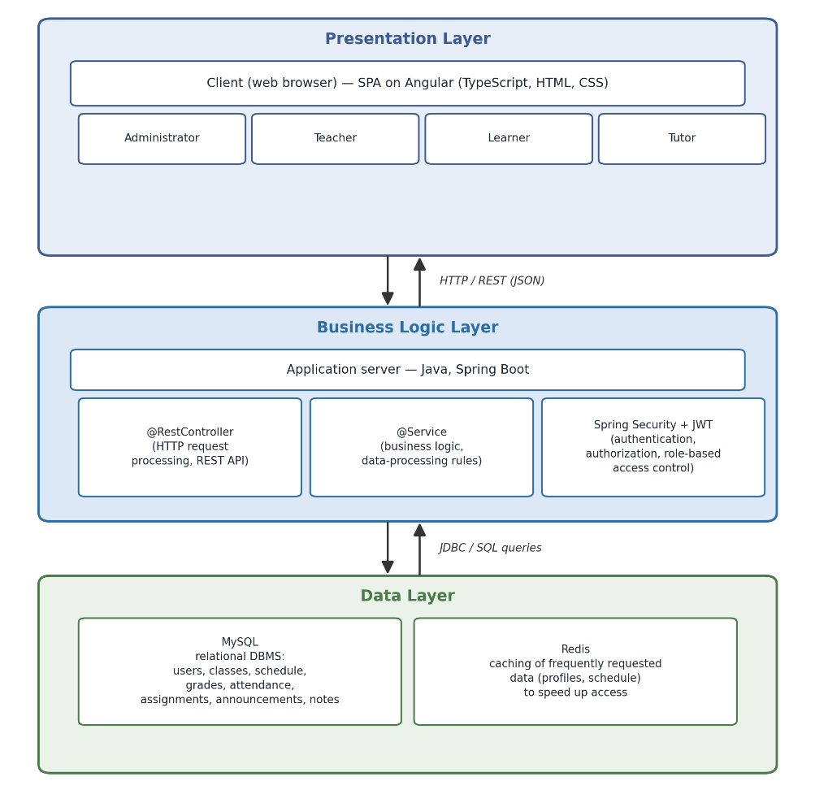
Fig. 1. Architecture of the “Digital Campus” software system
(three-tier structural model)
The software system, shown in Fig. 2, consists of a graphical user interface and four functional modules, each of which interacts with a centralized database:
- The General module, in which users are registered and their roles are delineated;
- The Schedule and Assignments module is responsible for the dynamic formation and editing of the class schedule and homework assignments;
- The Grades and Attendance module is responsible for maintaining the gradebook, recording attendance, and publishing announcements;
- The Statistical Performance Forecasting module is responsible for analyzing the results accumulated in the database and generating a forecast of the learner's final grades.
At the user's request, the corresponding information is transmitted from the database through the graphical interface, and updated information is written back to the database.
The database, in turn, stores structured data on users, classes, schedules, grades, attendance, assignment history, and notes. The relational database structure encompasses a number of interrelated entities (including Users, Classes, Schedule, Hometasks, Marks, Attendance, Advertisement, Notes), which ensures the integrity, consistency, and centralized storage of educational information.
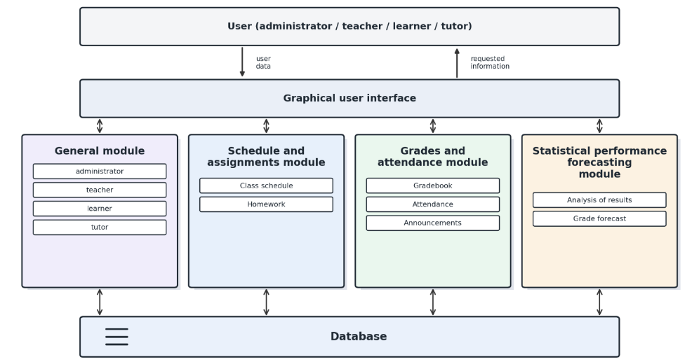
Fig. 2. Structural-functional model of user interaction with the “Digital Campus” software system
Four types of users work with the software system's modules through the graphical interface:
– Administrator, who is responsible for creating groups of pupils/students (classes), assigning teachers to a given class, managing the schedule, collecting overall performance statistics, publishing announcements, and managing user access rights within the created classes (for example, a class monitor will have more administrative rights than the rest of the students);
– Teacher, who provides materials and assignments to students, is responsible for grading submitted work, and monitors attendance. The teacher can also manage announcements within their assigned class;
– Learner, who completes and submits assignments, receives grades, tracks their own deadlines, can monitor their own performance statistics, forecast final grades, and communicate with the teacher. In addition, every user has a notes module for entering personal notes in a convenient format;
– Tutor, who creates classes for the relevant academic subject, manages access to them for the corresponding learners, organizes the educational process by adding assignments and materials, and evaluates their completion; this role is intended for using the system to organize alternative forms of learning.
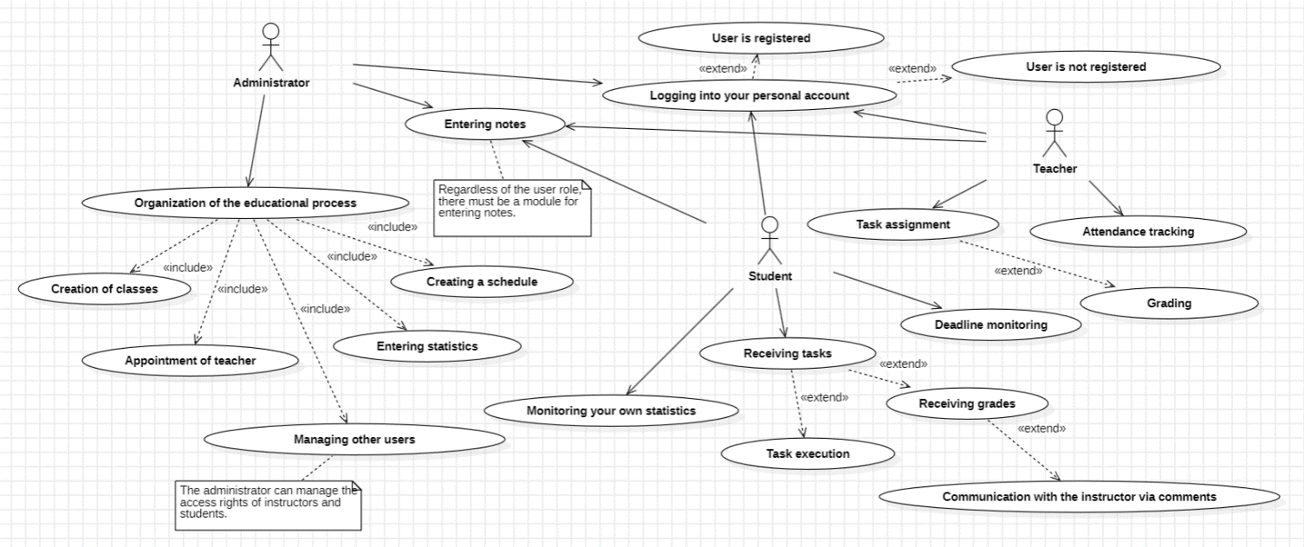
The logic of user interaction with the software system is presented using a use-case diagram (Fig. 3), which illustrates the functional capabilities of each role.

Fig. 3. Use-case diagram for the “Digital Campus” software system
Mathematical modeling of statistical performance forecasting. The Statistical Performance Forecasting module generates a forecast of a learner’s final grade based on the current-assessment results and attendance indicators accumulated in the database. Since the system operates in real time with a response-time requirement of no more than 1 s per request, the module is based not on machine learning methods that require prior training of a model on large samples (Random Forest, support vector machines, neural networks), but on a computationally lightweight statistical apparatus based on weighted regression analysis, which makes it possible to form and promptly update the forecast directly at the moment of the user’s request to the system.
Let the database record, for a learner over the course of studying an academic discipline, a sequence of grades for the completed types of work {x₁, x₂, …, x_{n}}, each characterized by a weighting coefficient wi reflecting the significance of the corresponding type of assessment (test, homework assignment, independent work, etc.) and a time stamp ti indicating the ordinal number of the assessment event within the semester. The learner’s current performance at the moment of the request is calculated as a weighted average:
$S=\frac{\sum_{i=1}^{n}{w_{i}x_{i}}}{\sum_{i=1}^{n}{w_{i}}}$ i = 1, n (1)
where n is the number of work types assessed as of the time of the request;
$x_{i}$ – the grade for the $i$-th type of work;
$w_{i}$ – the weighting coefficient reflecting the significance of that type of work;
$n$ – the number of work items assessed as of the time of the request;
$\sum_{i=1}^{n}{w_{i}}x_{i}$ – the sum of the products of the grades and their weights;
$\sum_{i=1}^{n}{w_{i}}$ – the sum of all weighting coefficients.
Since the forecast should reflect not only a static average value but also the dynamics of material mastery, a linear regression model that approximates the dependence of the grade on the time stamp of the assessment event is applied to extrapolate the final grade:
x̂(t) = a + bt (2)
The regression coefficients a and b are determined by the least squares method, from the condition of minimizing the sum of the squared deviations of the empirical values from the modeled ones:
$b=\frac{n\sum_{i=1}^{n}{t_{i}x_{i}-(\sum_{i=1}^{n}{t_{i})(\sum_{i=1}^{n}{x_{i})}}}}{n\sum_{i=1}^{n}{t_{i}^{2}-}{(\sum_{i=1}^{n}{t_{i}})}^{2}}$ (3)
$a=\frac{\sum_{i=1}^{n}{x_{i}-b\sum_{i=1}^{n}{t_{i}}}}{n}$ (4)
The forecasted final grade is calculated by substituting into formula (2) the time stamp of the discipline’s final assessment event T:
F = a + bT, F ∈ [F_{min}; F_{max}] (5)
where F_{min}, F_{max} are the bounds of the grading scale adopted by the educational institution.
The findings of the study establish a stable relationship between a learner’s activity in the educational environment and their level of performance. Therefore, forecast (5) is additionally adjusted to account for the attendance indicator:
$A=\frac{N_{a}}{N_{з}}$ (6)
where Na is the number of classes attended; Nз is the total number of classes in the discipline as of the time of the forecast. The adjusted forecast is calculated as:
F_{adj} = F(1 − β(1 − A)) (7)
where β ∈ [0; 1] is the coefficient of sensitivity of the forecast to attendance, whose value is set empirically when configuring the module for a specific educational institution.
Since grades are entered into the database sequentially throughout the semester, a full recalculation of the regression (2)–(4) on every user request is computationally redundant. To update the forecast promptly without reprocessing the entire history of grades, a recurrent exponential smoothing formula is applied:
F_{t} = αx_{t} + (1 − α)F_{t−1} (8)
where F_{t} is the forecast value after accounting for the t-th grade; x_{t} is the just-entered grade; α ∈ (0; 1) is the smoothing constant that determines the weight of the new observation relative to the accumulated history; F0 is taken as the weighted average grade (1) calculated at the beginning of the semester. This approach makes it possible to update the forecast in O(1) time regardless of the number of grades already entered, which is consistent with the system’s non-functional requirement for response time.
To evaluate the quality of the forecasting module, the calculation of standard error metrics on retrospective data from completed disciplines is provided – the MAE (Mean Absolute Error), the MSE (Mean Squared Error), and RMSE (Root Mean Squared Error), which are used in related studies on performance forecasting based on data mining methods (Savenko, 2026):
$MAE=\frac{1}{N}\sum_{i=1}^{N}{\left|y_{i}-ŷ_{i}\right|}$ (9)

$MSE=\frac{1}{N}\sum_{i=1}^{N}{{(y_{i}-ŷ_{i})}^{2}}$ (10)

$RMSE=\sqrt{\frac{1}{N}\sum_{i=1}^{N}{{(y_{i}-ŷ_{i})}^{2}}}$ (11)
where y_{i} is the learner’s actual final grade; ŷ_{i} is the value forecasted by the model; N is the number of learners in the retrospective sample. As a sufficient volume of training data accumulates, the proposed statistical apparatus can be supplemented with ensemble machine learning methods, which is identified as one of the directions for further improvement of the performance forecasting module.
Software implementation. The process of developing the software system involved database design, the implementation of business logic, and the development of the user interface. The Angular (TypeScript) web framework was used to develop the user interface, enabling the creation of dynamic single-page applications with convenient modal windows (the MatDialog service of the Angular Material library). The server side was implemented on the basis of Java and Spring Boot using the @Entity, @Repository, @Service, and @RestController layers in accordance with the principles of Spring Data JPA. Security functions are implemented using the Spring Security framework, which authenticates the user by intercepting HTTP requests with filters before they reach the server side.
In addition to the functional requirements, a number of non-functional requirements were established for the system, defining the quality of the software product: performance (request redirection time to the required service of no more than 1 s), interface responsiveness for personal computers, tablets, and smartphones, web content accessibility for users with visual impairments (support for ARIA attributes, a target Lighthouse accessibility score of at least 85 points), confidentiality (password encryption when saving to the database), compatibility with the Windows, macOS, and Linux operating systems and major browsers, as well as SEO optimization of pages. Compliance with these requirements ensures comfortable and secure interaction between users of different roles and the system.
For the software system, a graphical user interface was developed that includes the home page, displayed when the system is launched, and separate dashboards for each of the four user roles. The overall appearance of the implemented interface is shown in Figs. 4–8.
User interface. The home page displays basic information about the “Digital Campus” software system, describes its capabilities and the available user roles, and also allows the user to log in to their own dashboard or, if they do not yet have one, to register (Fig. 4).
The algorithm of user interaction with the “Digital Campus” software system is as follows: after registration or authorization, the user selects the class and academic subject they plan to work with. If needed, they can view the information available in the database (schedule, grades, assignments) or proceed to perform an action: recording grades, forming the schedule, assigning homework, publishing an announcement, or recording attendance.
If the purpose of the session is solely to view the statistical performance forecast, the system generates it based on the accumulated results and stores it in the database. Otherwise, the entered or edited data undergoes a correctness check: in the event of an error, the user is prompted to re-enter the data, and upon successful validation, the learner's statistical performance forecast is updated automatically. The updated information is displayed in the user interface and recorded in the database, after which the user can continue working with another action or end the session.

Fig. 4. Home page of the “Digital Campus” software system
The administrator dashboard (Fig. 5) displays the schedule, notes, and subjects created by the current user; the administrator creates teacher dashboards for their institution, receiving an automatically generated password, and flexibly manages the dependencies between subjects, classes, and teachers.

Fig. 5. Administrator dashboard of the “Digital Campus”
The teacher dashboard (Fig. 6) displays the current schedule, assigned classes and subjects, and also provides the ability to assign tasks, grade submitted work, and publish announcements for the class.

Fig. 6. Teacher dashboard of the “Digital Campus” software system
The learner dashboard displays the schedule, announcements from teachers, assignments, and grades with the ability to filter by class and subject, and also allows the learner to submit a completed assignment by attaching a file (Fig. 7).

Fig. 7. Learner dashboard of the “Digital Campus” software system
The tutor dashboard (Fig. 8) provides tools for independently managing classes (groups) and subjects, assigning tasks, and evaluating their completion.

Fig. 8. Tutor dashboard of the “Digital Campus” software system
Manual testing based on usage scenarios was applied to verify functionality, which made it possible to check the core functionality: maintaining the gradebook, forming classes and schedules, assigning tasks, user authorization, processing requests to the server, and the correctness of data display in the user interface. The Postman platform was used to verify HTTP requests and server responses. The testing results confirmed that the system meets the established technical specifications, operates correctly and consistently, and is therefore ready for further deployment and practical use.
Business model of the system. The Lean Canvas methodology was used to describe the business model of the “Digital Campus” software system, which makes it possible to systematically present the key aspects of the product's value for the market — from the problems of the target audience to the cost structure and revenue streams. The developed business canvas is presented in Fig. 9.
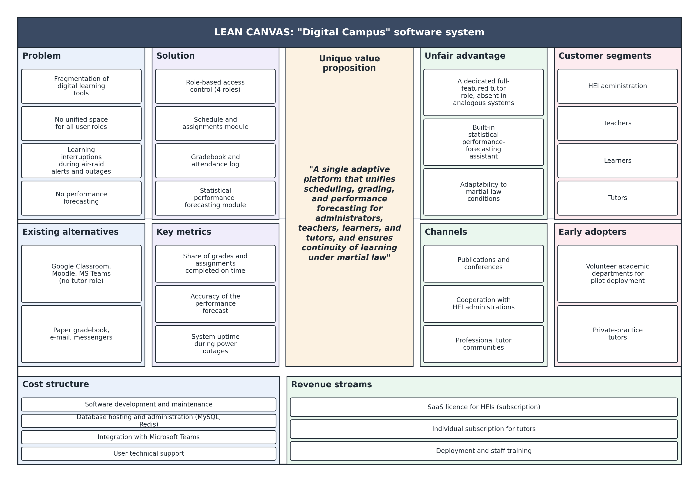
Fig. 9. Lean Canvas of the “Digital Campus” software system
The presented business canvas reflects the coherence between the key elements of the model: the identified problems of the target audience (fragmentation of digital tools for organizing learning, the absence of a unified information space, and interruption of the educational process under martial law) correspond to the customer segments and existing alternatives, while the proposed solution and unique value proposition correspond to the selected promotion channels and revenue streams. The system's unfair advantage is the combination of role-based tutor access with a statistical performance-forecasting tool, which was identified as a functional gap during the analysis of analogous systems. Key metrics — the share of assignments completed on time, the accuracy of performance forecasting, and the system's uptime — make it possible to assess the effectiveness of its practical implementation.
Discussion and Conclusions
The article presents a conceptual approach to developing the “Digital Campus” software system for organizing and planning the educational process under conditions of the digital transformation of education. Based on a detailed analysis of existing analogous platforms, a list of system requirements was formed, the choice of a multi-tier architecture was substantiated, structural and functional models of the system were proposed, the database structure was designed, and a functional prototype was implemented. The developed “Digital Campus” software system has the functionality necessary to meet users' educational needs, complies with the established information security requirements, and, according to the testing results, demonstrated full compliance with the defined requirements, correctness, and integrity of operation, and is therefore ready for practical implementation.
The main scientific contribution of the article lies in substantiating a conceptual approach to integrating, within a single "Digital Campus" software system, role-differentiated access for different categories of users, a statistical performance forecasting module, and integration with remote communication services (Microsoft Teams). For the forecasting module, a mathematical apparatus was developed based on weighted regression analysis, forecast correction using the attendance indicator, and recurrent exponential updating of the estimate, together with standardized metrics for evaluating its quality (MAE, MSE, RMSE), which ensures computationally lightweight and prompt forecast generation in real time. This approach fills the functional gap identified in existing domestic solutions during the comparative analysis.
The practical significance of the work lies in the possibility of personalizing learners' educational process through individual and group planning of learning activities, as well as in increasing motivation for educational activity. The developed system can be integrated into educational institutions and also used to organize alternative forms of learning, including tutoring.
A prospect for the further development of the software system is the creation of a mobile application with integration of a push-notification system, the automatic generation of reports for the administration of educational institutions, the expansion of the statistical assistant with data analysis methods for more accurate performance forecasting, as well as conducting pilot testing of the system in a real educational environment with subsequent adaptation of its functionality according to end-user requests.
References
Braslavska, O., & Ozerova, L. (2024). Tsyfrovizatsiia osvity: danyna chasu chy potreba suchasnoho suspilstva [Digitalization of education: a tribute to the times or a need of modern society]. Problemy pidhotovky suchasnoho vchytelia, 1(29), 74–82. https://doi.org/10.31499/2307-4914.1(29).2024.305098
Hedzyk, A. A. (2024). Suchasni tendentsii vykorystannia merezhevykh tsyfrovykh tekhnolohii u vyshchii osviti: viddalene navchannia ta masovi vidkryti onlain-kursy (MOOC) [Current trends in the use of networked digital technologies in higher education: remote learning and massive open online courses (MOOC)]. Pedahohichna akademiia: naukovi zapysky, (6). https://doi.org/10.57125/pedacademy.2024.05.29.03
Hrybiuk, O. O., Dziuba, S. M., Kovalenko, V. V., Marienko, M. B., Osadchyi, V. V., Semerikov, S. O., Shyshkina, M. P., & Yatsyshyn, A. V. (2024). Vykorystannia vidkrytoho osvitnoho seredovyshcha z elementamy shtuchnoho intelektu dlia profesiinoho rozvytku vchyteliv: metod. rekomendatsii [The use of an open educational environment with elements of artificial intelligence for teachers' professional development: methodological recommendations] (M. P. Shyshkina, Ed.). ICO NAPS of Ukraine.
Kravchenko, Yu. A. (Comp.), & Rostok, M. L. (Ed.). (2025). Tsyfrovi instrumenty dlia podolannia osvitnikh vtrat i rozryviv v umovakh viiny ta vidnovlennia Ukrainy: analitychnyi ohliad [Digital tools for overcoming educational losses and gaps under conditions of war and Ukraine's recovery: an analytical review]. Informatsiino-analitychni resursy DNPB Ukrainy im. V. O. Sukhomlynskoho. https://dnpb.gov.ua/wp-content/uploads/2025/05/ER1_vniaso-dtolg-2025.pdf
Morze, N. V., Vember, V. P., & Hladun, M. A. (2019). 3D kartuvannia tsyfrovoi kompetentnosti v systemi osvity Ukrainy [3D mapping of digital competence in the education system of Ukraine]. Informatsiini Tekhnolohii i Zasoby Navchannia, 70(2), 28–42.
Osnovni typy arkhitektury prohramnoho zabezpechennia [Main types of software architecture]. (n.d.). ART of Business Analysis. https://www.artofba.com/uk/post/main-types-of-software-architecture
Osvita v umovakh pandemii u 2020/2021 rotsi: analiz problem i naslidkiv [Education under pandemic conditions in 2020/2021: an analysis of problems and consequences]. (n.d.). Cedos. https://cedos.org.ua/researches/osvita-v-umovah-pandemiyi-analiz-problem-i-naslidkiv/
Ozerova, L. A., Zapotichna, M. I., & Horvat, H. T. (2024). Peretvorennia osvitnikh paradyhm u pisliavoiennyi period: otsinka vplyvu tsyfrovykh tekhnolohii na navchannia ta dostup do osvity [Transformation of educational paradigms in the post-war period: assessing the impact of digital technologies on learning and access to education]. Akademichni vizii, 28. https://academy-vision.org/index.php/av/article/view/932
Prima, R., Honcharuk, O., Prima, D., & Roslavets, R. (2023). Tsyfrovizatsiia osvity – trend, stratehiia y vyklyk chasu [Digitalization of education – a trend, strategy, and challenge of the times]. Pedahohichni nauky: teoriia, istoriia, innovatsiini tekhnolohii, 3(127), 183–191. https://doi.org/10.24139/2312-5993/2023.03/183-191
Savenko, V. D., Yarema, O. R., & Babichev, S. A. (2026). Stratehii ansamblevoho navchannia dlia prohnozuvannia uspishnosti studentiv: porivnialna ta interaktyvna struktura [Ensemble learning strategies for forecasting student performance: a comparative and interactive framework]. Prykladni pytannia matematychnoho modeliuvannia, 9(1), 327–339. https://doi.org/10.32782/mathematical-modelling/2026-9-1-30
Shevchuk, H. Y. (2026). Transformatsiia osvitnoho protsesu v umovakh tsyfrovizatsii ta suspilnykh vyklykiv [Transformation of the educational process under conditions of digitalization and societal challenges]. Naukovyi chasopys Ukrainskoho derzhavnoho universytetu imeni Mykhaila Drahomanova. Seriia 5. Pedahohichni nauky: realii ta perspektyvy, 110, 215–220. https://doi.org/10.31392/UDU-nc.series5.2026.110.39
Taradaskina, T. M., & Reklitska, A. O. (2023). Suchasnyi tsyfrovyi instrument dlia zakladiv vyshchoi osvity v umovakh rozvytku EdTech [A modern digital tool for higher education institutions amid the development of EdTech]. Ekonomika ta suspilstvo, 55, 48–52. https://doi.org/10.32782/2524-0072/2023-55-51
Tsyfrova adzhenda Ukrainy [Digital Agenda of Ukraine]. (n.d.). https://ucci.org.ua/uploads/files/58e78ee3c3922.pdf
Ukraine 2030E – kraina z rozvynutoiu tsyfrovoiu ekonomikoiu [Ukraine 2030E – a country with a developed digital economy]. (n.d.). Hvylia. https://hvylya.net/uk/special-projects/177938-ukraina-2030e-kraina-z-rozvinutoju-cifrovoju-ekonomikoju

Отримано редакцією журналу / Received: 24.09.26
Прорецензовано / Revised: 26.09.26
Схвалено до друку / Accepted: 01.10.26

Олена ФЕНДЬО, канд. техн. наук, доц.
ORCID ID: 0000-0001-9197-6399
e-mail: olena1.fendyo@knu.ua
Київський національний університет
імені Тараса Шевченка, Київ, Україна

Вікторія ВОЄВОДА, здобувачка освіти
ORCID ID: 0009-0005-5437-837X
e-mail: viktoria_voievoda@knu.ua
Київський національний університет
імені Тараса Шевченка, Київ, Україна

ЦИФРОВІ РІШЕННЯ ДЛЯ ОРГАНІЗАЦІЇ ОСВІТНЬОГО ПРОЦЕСУ В ЗАКЛАДАХ ОСВІТИ В УМОВАХ ВОЄННОГО СТАНУ В УКРАЇНІ

У статті розглянуто концептуальний підхід до планування та організації навчального процесу в закладах освіти в умовах воєнного стану в Україні. На основі порівняльного аналізу систем-аналогів визначено функціональні прогалини існуючих цифрових рішень, на основі чого сформульовано вимоги до проєктованої програмної системи. Обґрунтовано вибір архітектури, представлено дві взаємодоповнюючі моделі її реалізації. Розроблено функціональний прототип програмної системи «Цифровий кампус». Використання розробленої системи забезпечує персоналізацію навчального процесу завдяки індивідуальному підходу та сприяє підвищенню стійкості й безперервності освітнього процесу в умовах викликів воєнного стану.

Ключові слова: програмна система, освітній процес, цифровізація.

Автори заявляють про відсутність конфлікту інтересів. Спонсори не брали участі в розробленні дослідження; у зборі, аналізі чи інтерпретації даних; у написанні рукопису; в рішенні про публікацію результатів.
The authors declare no conflicts of interest. The funders had no role in the design of the study; in the collection, analyses, or interpretation of data; in the writing of the manuscript; or in the decision to publish the results.

УДК 004.9: 519.8
DOI: https://doi.org/

Viacheslav IVASHCHUK, DSc., Assoc. Prof.
ORCID ID: 0000-0002-9678-0990
e-mail: v.ivashchuk@nubip.edu.ua
National University of Life and Environmental
Sciences of Ukraine, Київ, Україна

Safina OLGA, канд. техн. наук, доц.
ORCID ID: 0009-0007-4063-5501
e-mail: safina.olha@tnu.edu.ua
Kyiv Professional College of Urban Economy of the
V.I. Vernadsky Tavrichesky National University, Kyiv, Ukraine

Hybrid Optimization of Information-Based Decision-Making Systems in Production Control Tasks

The article discusses key approaches to develope making-decision (MD) support information systems integrated into technological control systems by manufacturing processes. Particular attention is paid to the architecture of MD support system based on models and methods, which applies multi-parameter optimization, artificial intelligence, heuristic evaluation and learning algorithms. A significant part of that work focuses on problem dimensionality that arises from changing circumstances during the decision optimization process. The solution to this problem is linked to a range of tasks associated with the "Industry 4.0" that initiative for industrial sector development.

Key words: Decision-making system, Industry 4.0, technological system, hybrid optimization.

Introduction
Globalization and dynamic growth have resulted act to accuracy of speed paced supply of raw materials and supply chain planning cycles, making it increasingly challenging as well as essential to create accurate and stable forecasts for mutual subsystem in task of optimizing production value, excessive inventory costs, worthless. The satisfaction of customers’ demands gets a top priority for wishes-driven companies. The chain technologies of infrastructure planning confronts a fundamental temporal asymmetry in which capacity decisions must be accepted before uncertainty materializes and yet must remain robust across all future operational changes and exogenous factors. As a result of increasing competition, sustainability, leading technologies, rhythmically sequences, quality and minimize of cost issues in produce are gaining importance. In that conditional race, Industry 4.0 technologies provide a great advantage for plants that connect the intelligent competencies with the feature plan, advance meaningful sources from big data and prevent observation.
Since planning tasks require human-machine interaction for efficiency of planning and to increase performance of decision, which investigation focuses on forms of interaction to coordinate the right way of collaboration.
Industry 4.0 has a flexible structure to meet a wide range of customer requirements. The system can be automatically reconstructed by change parameterical reglament of product is desired to be produced.
Many failures and malfunction may result integration error problems by supervision, where incurring significant expenses due to an operator’s subjective analysis and hardware topology failures. So that, the integration error problem in supervision in terms of reliability.
In article (Elibal, K., & Özceylan, E. 2021) for the benefit of the concept, a fuzzy inference system is used with “if-then” rules to consider the expected benefit where as in (Yıldızbaşı, A., & Ünlü, V. 2020) the Fuzzy Analytic Hierarchical Process and Fuzzy Technique for Order Preference by Similarity to Ideal Solution was named as maturity model that prioritizes the Industry 4.0 concepts to construct an accurate roadmap according to the specific needs of an organization.
For flexibale characteristics of production system are easily integrated into the system in the plug and play for production continues, without defects for system by interruption of change products chain. Looking at the smart factory by Industry 4.0, it will be seen that batch products are produced more efficiently by reducing servicing times. Suitable Big Data source to change the amount to be produced and the feedstock needs can be determined by suitable scheme.
Decision-making is a herein processes of human life, and decision making becomes more difficult as growth the system complexity. Where that single goal was basically obstacles for stable decision, it is not enough for the purpose in modern condition. As advanced technologies and complexity of environmental product factors of businesses change, biggest of businesses model wait for multi-parametrical decisions. Until the engineering search try to have the way for optimize of multiple goals, businesses trying to minimize service price are having trouble deciding by model deciding complexity.
So as the domain knowledge for every unique situation must be the cornerstone to achieve, the revised extrapolation forecasts tries to adjust each single forecast with their own peculiarities. Often the choice is on regression models due to being able to consider multi-variate parameter dependencies and able to accumulation relevant domain knowledge, since the human is a component of forecasting is an essential element to make of decision (Lauer, T. 2019). Thus, that information as feedback or as explanation can improve builds trust between humans and machines and as result to improve forecast accuracy with the restriction that every case has peculiarities.
The efficient and safe process operations change speed of decision-making processing; this is more important than ever as the irreversible processes of industry gets demands of markets, greater feedstock variability, and increasingly time-sensitive availability of resources such as perishable raw materials and return the investment from renewable energy. Many online decision-making frameworks, including real-time optimization or model predictive scheme and involve the solving of mathematical optimization problems.
The flexible model should be guarantee the functional correctness and also reliability of the plant supervision system, as a result may be appropriate for the growth of operational speed and can be used for other types of variable-demands systems, bringing all the benefits of this methodology to the context in which it will be applied.
The Game theory that use desirable rules to identify the circumstances under which all actors can flow with demand side management for decision making system (Palanisamy, M., Samuel, A. M. R., Manickam.Malu, Y. D., & Baldoss, P. 2026).
The decision-makers must account for mitigate space of uncertainties to ensure reliable system performance. Forecasting of external source reduction and sales order can be beneficial. For instance, the change of project plane can be modeled using of statistical data of change for that produce element. Data-drive metod can be used to optimize models that predict adjuscent subsystem of product line, aiding in the design and scheduling of future-ready plant. While such frameworks offer valuable insights about of system behavior as for a groupe adjuscent operations, but it does not inherently ensure against uncertainties, as the actual realizations can differ considerably from forecasts as for limited space of parameters for that forecate will been done.
In many times the computational complexity of the optimization task presents a major challenge such that the long solution time renders it ineffective in online applications. A common approach to solve this challenge is to perform the optimization with a hybrid model of supervising, which is an approximation of original behaviour system that can be more adequate to uncertainties chahges.
Typically in hybrid modeling, one tries to replace disadvantages ones. This approach is widely used in process systems engineering, where the complicating functions are often associated with process units that exhibit complex nonlinear behavior. Over the years, the process engineering community has developed a numerous of hybrid process models that include truncated and lumped models derived from first principles and engineering assumptions, reduced-order dynamic models constructed using model reduction methods such as data-driven models aproximation and singular perturbation analysis based on, for example, some type of parametrical distribution and artificial neural networks.
Here, a major underlying assumption is that a hybrid model that provides a more closely approximation of the original functions will, once incorporated in the optimization problem, also lead to solutions that are close to the global optimal solutions. However, it is unclear whether or under what conditions this assumption holds and how type the hybridization of model will be. In fact, one can easily find examples in which the original optimization problem has not obsacles to appliance of hybridization of model and calculation of problem achieve very different optimal solutions despite having a highly accurate embedded hybrid model.
In this article, we propose a some other framework that explicitly aims to construct hybrid models that minimize the decision prediction error defined as the difference between the optimal solutions of the original and the hybrid optimization problems; we hence refer to it as decision-focused hybridization. The data-driven approach in which the original optimization problem is solved offline with different model inputs, resulting in a dataset where each data point is an input-decision pair. We then develop an inverse optimization methods that directly discent of error from the given data a hybrid optimization model that has a simpler (predefinded) form and minimizes the decision prediction error subject to the restrictions on the form of hybrid model. Results from computational applies show that the proposed approach have advice in direct of hybritization in decision accuracy, data and computational efficiency of the resulting hybrid optimization model.
Relations It's formally describe the different approaches to make clear the main conceptual differences, which will help us motivate the proposed decision-focused hybrid modeling framework and highlight its unique features in Section 3.
Firstly, focus to direct on data-driven approaches but refer to other related methods wherever appropriate. Without loss of generality, we assume the original optimization problem to be of the following form private conditioning model that complexity by human supervisori data.
There exist a large number of statistical learning methods that are used to get those embedded hybridization of model.
For example, the using formal methods, as was pointed in work(Lisboa, L. A. C., Melo, T. R., Campos, I. G. S. A., Aragão, M. B., Ribeiro, A. S., Silva, L. C., da Silva, V. L., Lima, A. M. N., & Santos, A. A. B. 2024) a formulation and solution to this problem through structured, scalable, and compact mathematical representations are possible.
The scheduling scheme of decision making of forklifts in warehouses under multi-tasking conditions for multi-source factors of dangerous was represented in (Li, X., Lin, X., Zhang, F., Tang, X., Qiu, R., & Sun, X. 2020) by multiple attribute decision making, simulation and optimization theory. The model-driving approaches in several industrial areas, including smart grid automation, was facilitate the production of executable software from high-level models (Neis, P., Wehrmeister, M. A., Mendes, M. F., & Pesente, J. R. (2023) and is a viable approach to developing mission-critical applications. The goal is to parametrize a model that returns an optimal (or in some circle space about) solution for a given input by solving the following expected risk minimization problem which arrives at the solution through a function evaluation rather than by solving an optimization problem. This approach explicitly aims to minimize the decision prediction error. While the development of the machine learning approaches described above is a more recent trend, exact methods for the construction of optimization aproxies have been studied in the area of multiparametric programming for a long time (Ivashchuk, V., & Korobiichuk, I. 2022). In multiparametric programming, optimal solutions are derived as explicit functions of the model parameters; these functions (or policies) can change depending on the region in which in the specific parameter vector lies. The goal is to determine these so-called trigger conditons and the optimal policy associated with each condition as a system.
For specific problems, there are often structural properties that can be used to find cardinality bounds or develop specialized algorithms. The main challenge in parametric optimization is intractability by intractable because of the cardinality of optimal solution sets. Still, some problems admit an optimal solution set of polynomial size. For to make a problem tractableby often the restrict of parameter coefficients as integers is a way. Also intractable problems as a way to still achieve polynomial running time is to find an approximation set by change an optimal solution set and adaptions of general strategies in next steps (Nemesch, L., Ruzika, S., Thielen, C., & Wittmann, A. 2025). Optimization of resulting cost function by geometric programming, yielding closed-form solutions for the optimal order quantity(Amrudeen, S. Y., & Kalaichelvan, K. 2026).
In paper(Tavakoli, A. 2020), where a multi-criteria optimization problem was represented was pointed the problem is one the nondeterministic polynomial complex problems, for which no comprehensive solution has been presented.
So as not only the positions of the Pareto-optimal solutions in the search space change over time, but also the complexity of the problem, then the dynamic multiobjective optimization problem is adjustable dynamically by dynamic Distance Minimization Problem (Zille, H. Kottenhahn, A. & Mostaghim, S. 2017).
In work (Shah, H. B., Kakodkar, R., Kenefake, D., Sahinidis, N. V., & Pistikopoulos, E. N. (2026) was proposed uncertainty-aware design and scheduling via a bilevel formulation by Long Short-Term Memory neural networks with Monte Carlo Dropout forecasting pipeline generate data-driven prediction intervals that are embedded directly into a multilevel robust optimization framework, as the first stage captures investment decisions, which prepare base for second stage models operational constraints and uncertainty for scheduling.
Alternatives of strong model in work (Novák, V., & Burda, M. (2021). was proposed use linguistic summarization as a means to derive and specify soft key performance indicators that describe performance characteristics of specific make decision model designs, which theory of intermediate quantifiers on partial fuzzy sets, where the elements of fuzzy sets can have undefined membership degree
Using tailored deep learning architectures, this approach to optimizie by data-driven can achieve highly accurate and fast surrogate models (Gupta, R., & Zhang, Q. (2024) as for an inverse optimization to constructing such class of models for a certain set of problems.
Domain knowledge can be effectively leveraged since for someone familiar with the physical system, it is usually easy to identify the part of the model that needs to be replaced as well as determine a suitable structure for the corresponding hybridization of model.
Often, only a small number of constraints are complicating; in that case, simply keeping the remaining constraints can help ensure feasibility.
In the following, the introducing of decision-focused hybrid modeling concept will been represent.
Therefore, as given an observed decision made by some agent, that the goal of inverse optimization is to determine an optimization problem whose optimal solution matches and hence best explains the agent's decision
In the following, the introducing of decision-focused hybrid modeling concept will been represent.
Therefore, as given an observed decision made by some agent, that the goal of inverse optimization is to determine an optimization problem whose optimal solution matches and hence best explains the agent's decision.
Objectives Our solution approach involves reformulating the bilevel problem into a single-level optimization problem by replacing the lower-level problems with optimality conditions.
The object of research is the support of decision-making processes of operational personnel. Also necessary will have defined of evaluation for further changes of algorithm those are depending at the vector characteristics of produce plant.
Methods and result An analysis of the operational staff's performance during dairy product manufacturing yielded an estimate of the number of operator errors by operators during a work shift. The errors related to the adjustment of parameter settings that were not essential for an effective state change; the results were averaged across a series of night shifts(Ladaniuk, A., Ivashchuk, V., Kisała, P., Askarova, N., & Sagymbekova, A. (2015).
The operator's response to a product change was similar to that observed during subsequent shifts worked by other operators. Throughout the shift, error accumulation was driven by an increase in oversights regarding the refinement of limits and algorithm parameters during state assessment and mode control 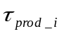 whereas, under the conventional approach, operators rely merely on intuition to integrate changes in state coordinates from 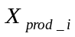 to operating mode state coordinates with the need to monitor changes in characteristics 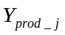machines of technological system(TS). It is necessary to incorporate interface information units in accordance with the information model of the subsystems for to ensure the flexible adaptation to changing tasks of multi-product manufacturing (Pic 1).
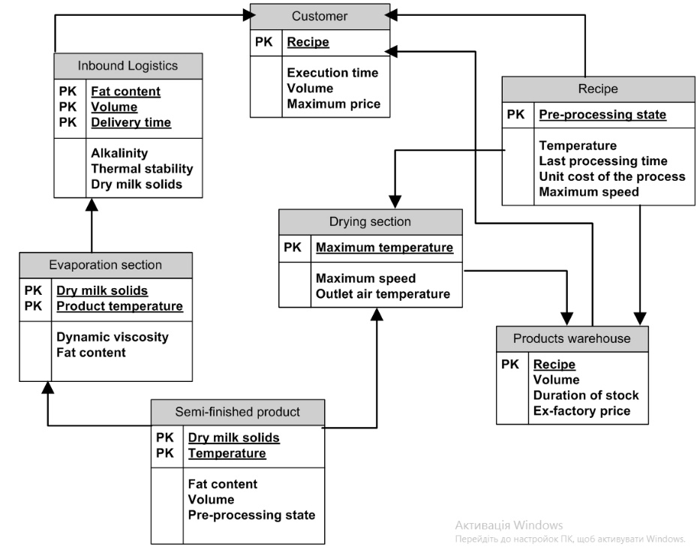
Fig. 1. Model of information links for a dairy production operator station
The updated model structure defines the strategy for operational intervention in solving tasks of TS and is therefore responsible for the quality of tasks performed. Thus, to facilitate the development of alternatives for synthesizing flexible TS strategies, we incorporate relevant information into the analysis, in particular: the operational procedures of the immediate environment (responsibilities associated with job duties) that shape the motivated behavior of the decision-maker(DM); characteristics of operational processes (time, costs, and a priori determined variability); tasks and requirements for each functional unit within the technological process, down to the level of elementary processes (operations). The task assigned to the operator is to further define the model and the technological situation, as well as the direction of the control implementation vector 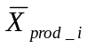. Thus, to modify the information model based on the technological process (Pic. 1) for assortment-based production, we anticipate the following situations (Pic. 2): modification of the set of connections for routine
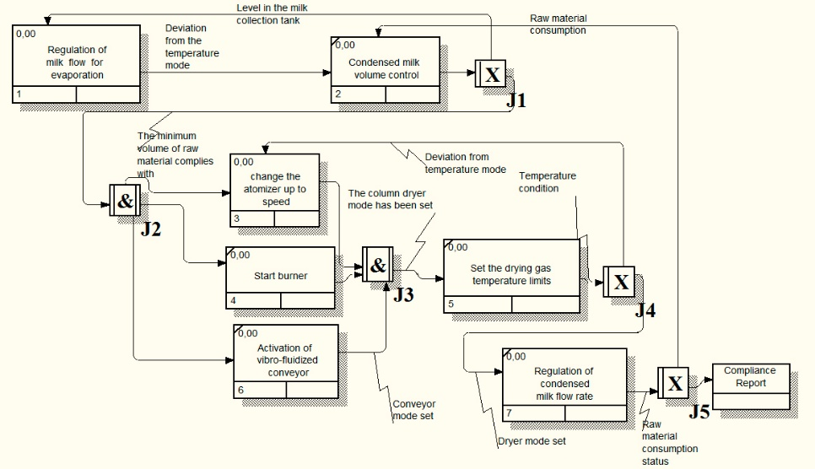
Fig. 2. Process flow model of TS for dry dairy product production
product introduction and production stoppage; emergency response procedures; support for routing operations.
In most production tasks for TS, decisions are made sequentially (on a situational basis) at the supervisory control level based on empirical estimates of time points 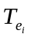 and state-space coordinates 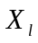 to address local subsystem problems as partial solutions.
Since the specified decisions require the fulfillment of conditions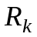 within the chain of transitions 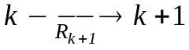, then their formalization is determined by the solution to multi-stage decision-making problems. Based on the foregoing, the application of fuzzy control enables the implementation of complex relationships using simple methods. Specifically, we employ rules for fuzzy sets to encapsulate operator skills. We anticipate that human involvement is justified in cases where: the criterial system creates challenges regarding the methodology for effectively combining their importance; due to the need to combine multiple assessments of quantitative and qualitative criteria.
According to decision-making theory, any choice can be characterized by a set of loss functions 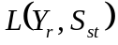, where 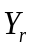- set of conclusions; - a set of object states defined a priori.
When using the cognitive approach, the dimensionality of control alternatives for a dynamic situation takes on the value 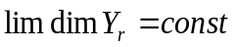and the addition of a new alternative does not necessitate additional expert work.
Based on the timeframes 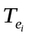 for obtaining the conclusion and evaluating as membership defined states function 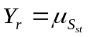relative to object state 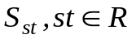, which had being assessed, a strategy to adopt with minimal reconfiguration complexity regarding pessimism
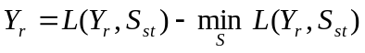
as the most successful in terms of the difference between the obtained criterion value and the closest possible value according to the chosen metric; then, the subsequent removal from the set of worst alternatives leads to the selection of the optimal solution
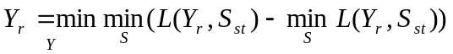
The development of situational procedural knowledge entails implicit dependencies that elude rigorous logical description. Ащк increase of dimensionality 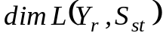, a rise in the volume of expert work in form manifesting as a multitude of pairwise comparisons is to be expected, driven by the prevalence of errors in expert forecasting and the ambiguous nature of transitivity in expert reasoning.
Since the TS of multi-product manufacturing involve changes in operating modes and connection structures when the product mix changes, we will initiate the supervisory control system preparation functions based on the change in the composition of technological units (Fig.3). We carry out the reassignment of the set of alternatives 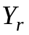 and the object's coordinate states 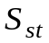 based on situational assessments, treating this as the training of an artificial neural network, wherein the following are identified to define cognitive behavior within the decision-making system: sets of coordinates involved in executing TS functions 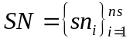; situational agents 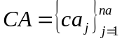 represented as a set of incidence matrices obtained through training; and effectors 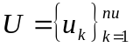, which acting as control devices driven by the root-cause structure 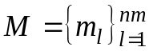. Moreover, each coordinate that involved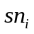 is formed by an observable property that constitutes an element of the object model and assumes a fuzzy state characteristic (activity) defined by the boundaries of the state membership function and the situational element 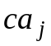 of the context chain is characterized by a fuzzy situation prototype 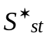 and a fuzzy control prototype for . For multi-product manufacturing, we employ "situation–control strategy–action" models, in which the choice of solution is determined by the quality of situational agents 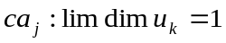 for drawing conclusions. We use the state of functional transitions 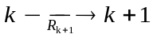 and the corresponding operator actions to train the system. An analysis of the actions required to bring the object's state into compliance with technological requirements is performed during the system's preparation for production. By analyzing the structure of the TS information links, we define the set of subsystem states acting as elements of a cognitive map for the fuzzy logic governing advisory actions within the "situation – supervisory control – action" class.
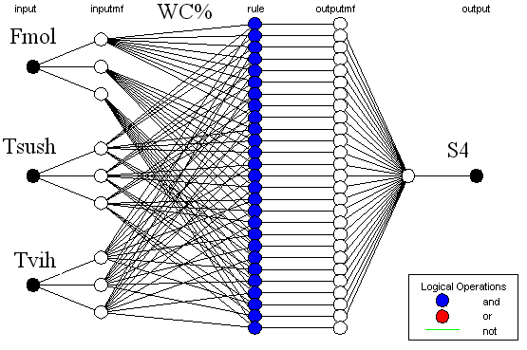
Fig. 3. Advisory situational network for optimizing alternatives in multi-product manufacturing
The advisory situational network takes the form of a transition graph, featuring reference situations represented as situational samples and accounting for the initial state. The algorithm is configured by the operator-technologist on duty, who oversees the process with subsequent adjustment of situational rules based on empirical state assessments. Thus, the system, which remains in a continuous learning mode, increases the probability of correct operation
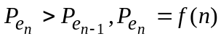
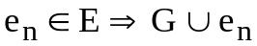
where 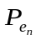– probability of the state estimate at the -th step; 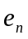– An event not rejected by the operator as false contributes the sequence and number of executed operations to the support of the technological route defined by the graph . Upon returning to the event observation mode, the weight coefficients in the nodes are normalized as
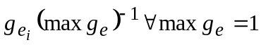
The human operator can clearly confirm or exclude the proposed event. The adjacent incident matrix, which is formed as a cognitive model of the human operator's behavior, will be called the technological map of the operator's behavior.
We single out a set of factors for (Table1) which are caused by technological deviations from the states of technological equipment prescribed by the technological mode (in accordance with consumption norms), for the purpose of assessing a set of situations, which defined for subsystems of TS.
We determine the assignment of a state to the corresponding technological situations 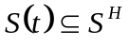 as the intersection of membership estimates across the set of experiments based on samples for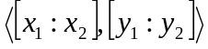. In this case, the maximum duration of decision adequacy is ensured 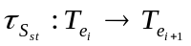 subject to constraints on raw materials, energy resources, and product volumes and characteristics. Membership in the set of defined states 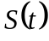 for the current situation 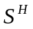 and the known initial (standard) situation is determined by evaluating coordinates from the set selected for monitoring products within the TS:
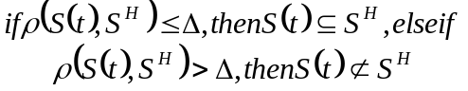
Since the operator merely refines the problem solution, we anticipate an assessment of the solution based on the behavioral variability of the lower-level system, which given a successful refinement attains a stable state 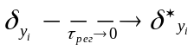.
Targeted configuration of interface parameters (Fig.4) tailors decision-support functions to specific job responsibilities and qualifications, where the operator makes assessments based on their own judgment.
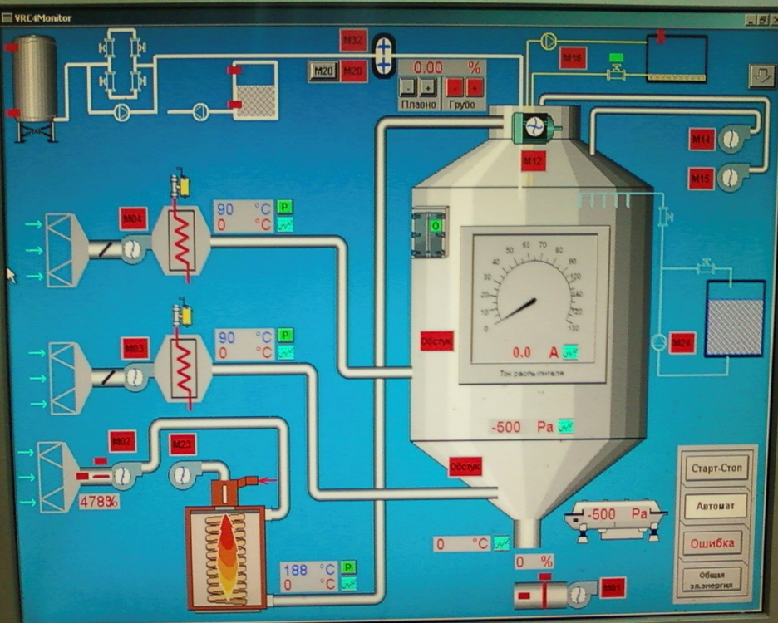
Fig. 4. Decision-maker's workstation
Based on the established assessment of states, tasks are initiated as default assignments for a specific situation 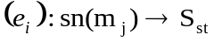. In cases where the user does not intervene by creating alternative states, advisory suggestions will be offered. Default values ​​are considered "safe" for the state relative to which they are defined a priori—meaning they do not pose a risk of losing stability
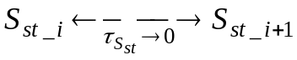
of the operating characteristics of the TC for the product for which they are defined. The application of default values ​​requires operator intervention for a set of items sharing the same effect-based influence and situational agent determinant, where the latter requires further specification based on additional coordinates (Table 1).

Table 1
Set of primary situations based on functional aspects
Marking | Subject | Limitation of change | Description of situation
S1 | Inbound Logistic | Towards a norm reduction | Reduction of supplies in the planned volume
S2 | Evaporation section | Towards a norm reduction | Reduction of the time until the next unscheduled service
S3 | Evaporation section | Towards a norm reduction | Loss of vacuum in the unit
S4 | Drying section | Outside the specified range | Atomizer speed not reached
S5 | Intermediate product collection tank | Outside the specified range | The temperature does not match
S6 | Products warehouse | Towards a norm reduction | The volume of finished products does not comply with the agreements
S7 | Drying section | Towards a norm reduction | The outlet temperature of the drying column is out of specification

Conclusion The errors caused by inappropriate operator actions or unpredictable equipment behavior are detected through state variable re-estimation using alternative observers, leveraging model-based relationships between indirectly observable variables and apriori constraints on the variables of TS. Specifically, a disruption in the cause-and-effect relationship serves as the necessary condition for state re-estimation, while the loss of model validity, which links the specified set of variables serves as the sufficient condition. The concept for the decision-making task within the context of multi-product technologies is defined as the development of a logical support system for the operator. We formalize the definition of a specific situation based on the consequences of events occurring within the system, the state of which is defined by a set of corresponding coordinates. The multi-faceted structure of the decision-making network is significant due to the nature of the mathematical model; this model determines solutions for lower control levels and eliminates the possibility of deadlocks within the set of alternative inferences, similar to the Petri net-based model.. Given that the nature of fuzzy inference implies the existence of a class of real-world objects subject to differentiated performance assessment, the behavior of such objects cannot be defined by a deterministic characteristic. Thus, it is entirely natural that the use of social stochasticity resolves the issues of uncertainty and multitasking involved in selecting definitive conclusions.
The task entails supporting the selection of an alternative course of action during stressful situations, changes in the product range or production objectives. Consequently, the proposed algorithm is in no way intended to uncover absolute knowledge regarding the functions of the controlled object; rather, its purpose is to reinforce the operational personnel's choice of an alternative.

References
Elibal, K., & Özceylan, E. (2021). Industry 4.0 road mapping: A fuzzy linguistic approach. Journal of Fuzzy Logic and Modeling in Engineering, 01. https://doi.org/10.2174/2666294901666210713142801
Yıldızbaşı, A., & Ünlü, V. (2020). Performance evaluation of SMEs towards Industry 4.0 using fuzzy group decision making methods. SN Applied Sciences, 2(3). https://doi.org/10.1007/s42452-020-2085-9)
Lauer, T. (2019). Behavioral analysis of human-machine interaction in the context of demand planning decisions. In Advances in Artificial Intelligence, Software and Systems Engineering (pp. 130–141). Springer. https://doi.org/10.1007/978-3-030-20454-9_13
Palanisamy, M., Samuel, A. M. R., Manickam.Malu, Y. D., & Baldoss, P. (2026). Game theoretic approach for energy scheduling in demand side management for smart grid applications. Archives of Control Sciences, 1–21. https://doi.org/10.24425/acs.2026.158419
Lisboa, L. A. C., Melo, T. R., Campos, I. G. S. A., Aragão, M. B., Ribeiro, A. S., Silva, L. C., da Silva, V. L., Lima, A. M. N., & Santos, A. A. B. (2024). The Development of a Malleable Model for Critical System Supervision Integration. Energies, 17(16), 4094. https://doi.org/10.3390/en17164094
Li, X., Lin, X., Zhang, F., Tang, X., Qiu, R., & Sun, X. (2020). Warehousing operation optimization model of one storey new dangerous goods warehouse based on warehousing chain and its application. Current Chinese Computer Science, 01. https://doi.org/10.2174/2665997201999200724154048
Neis, P., Wehrmeister, M. A., Mendes, M. F., & Pesente, J. R. (2023). Applying a model-driven approach to the development of power plant SCADA/EMS software. International Journal of Electrical Power & Energy Systems, 153, 109336. https://doi.org/10.1016/j.ijepes.2023.109336
Ivashchuk, V., & Korobiichuk, I. (2022). The Multivariable Control for Dynamic Partially Observable Objects. У Advances in Intelligent Systems and Computing (pp. 106–115). Springer International Publishing. https://doi.org/10.1007/978-3-031-03502-9_11)
Nemesch, L., Ruzika, S., Thielen, C., & Wittmann, A. (2025). A survey of exact and approximation algorithms for linear-parametric optimization problems. Journal of Global Optimization. https://doi.org/10.1007/s10898-025-01512-6
Amrudeen, S. Y., & Kalaichelvan, K. (2026). Optimization for Emergency Inventory Planning under CycloneUncertainty Using Neutrosophic Trapezoidal Fuzzy Modelingand Geometric Programming. The Scientific Temper, 17(08), 6750–6756. https://doi.org/10.58414/scientifictemper.2026.17.8.2519
Tavakoli, A. (2020). Multi-criteria optimization of multi product assembly line using hybrid Tabu-SA algorithm. SN Applied Sciences, 2(2). https://doi.org/10.1007/s42452-019-1863-8
Zille, H., Kottenhahn, A.& Mostaghim, S. (2017) Dynamic Distance Minimization Problems for dynamic multi-objective optimization, IEEE Congress on Evolutionary Computation (CEC), Donostia, Spain, 2017, pp. 952-959, doi: 10.1109/CEC.2017.7969411.
Shah, H. B., Kakodkar, R., Kenefake, D., Sahinidis, N. V., & Pistikopoulos, E. N. (2026). Multiparametric optimization based decision making approach in energy systems planning under uncertainty. Applied Energy, 426(Part C), Article 128714. https://doi.org/10.1016/j.apenergy.2026.128714
Novák, V., & Burda, M. (2021). Partial fuzzy quantifiers and their computation. Journal of Fuzzy Logic and Modeling in Engineering, 01. https://doi.org/10.2174/2666294901666210105141618
Gupta, R., & Zhang, Q. (2024). Data‐driven decision‐focused surrogate modeling AIChE Journal, 70(4), Article e18338. https://doi.org/10.1002/aic.18338
Ladaniuk, A., Ivashchuk, V., Kisała, P., Askarova, N., & Sagymbekova, A. (2015). Algorithm for decision support as the tool for control system of industries with variable assortment of products. У R. S. Romaniuk, W. Wojcik & A. Smolarz (Ред.), 16th Conference on Optical Fibers and Their Applications. SPIE. https://doi.org/10.1117/12.2229186

Отримано редакцією журналу / Received: 26.09.25
Прорецензовано / Revised: 28.09.25
Схвалено до друку / Accepted: 01.10.25

Автори заявляють про відсутність конфлікту інтересів. Спонсори не брали участі в розробленні дослідження; у зборі, аналізі чи інтерпретації даних; у написанні рукопису; в рішенні про публікацію результатів.
The authors declare no conflicts of interest. The funders had no role in the design of the study; in the collection, analyses, or interpretation of data; in the writing of the manuscript; or in the decision to publish the results.

UDC 004.41
Mykhailo KHYMCHUK, PhD student
ORCID ID: 0009-0001-7433-4738
e-mail: m.khymchuk@st.wunu.edu.ua
West Ukrainian National University,
Ternopil, Ukraine
INTERVAL-BASED CALIBRATION OF EFFORT AND DURATION ESTIMATES FOR AI-NATIVE SOFTWARE PROJECTS
In AI-native software delivery a conventional effort estimate is systematically wrong: measured effort on commercial projects has been three to five times lower than estimated, while calendar duration compressed by a much smaller factor. Practitioners correct for this by dividing the estimate by an assumed "AI multiplier" chosen by judgement. This paper replaces the assumed multiplier with an interval of boost coefficients calibrated on completed projects and evaluates it as a prediction tool. Using five commercial projects and leave-one-out evaluation, the range-based interval contained the actual value in 11 of 15 predictions and its upper bound in 14 of 15, with mean relative width of 0.25 for development effort and 0.24 for duration. Every miss occurred when the held-out project was the sample extreme, in agreement with the distribution-free expectation (n − 1)/(n + 1) for a range of n observations; the same expression shows that about 19 calibration projects are needed for 90 % expected coverage.
Keywords: interval analysis, effort estimation, AI-native software development, calibration, leave-one-out evaluation, tolerance interval, software project planning.
Introduction
Effort estimation has been a central problem of software engineering for four decades, and its accuracy has improved little. Systematic reviews report that expert judgement remains the dominant method in practice (Jørgensen, 2004), that formal models rarely outperform it consistently (Jørgensen & Shepperd, 2007), and that many published estimation techniques do not generalise across datasets (Menzies et al., 2017). The estimation problem is therefore not solved even for conventional delivery.
AI-native delivery changes the problem rather than solving it. Field studies of AI coding assistants report task-level speed-ups from about 26 % (Cui et al., 2025) to 55 % (Peng et al., 2023), controlled experiments on mature open-source codebases report a slowdown of 19 % (Becker et al., 2025), and project-level measurements under a fully restructured AI-native methodology report effort reductions of three to five times (Khymchuk et al., 2026). These figures are not contradictory; they measure different units of work under different delivery models. But they leave an estimator with no defensible single multiplier to apply to a conventional estimate.
In commercial practice the gap is closed informally: the team produces a conventional estimate and divides it by a factor chosen by judgement — three, four, sometimes more. The result is a point estimate resting on an assumption that is neither measured nor stated. When the project is priced as fixed scope, this assumption carries the entire commercial risk.
Previous work by the author introduced an interval representation for productivity gains in AI-native delivery and showed, on five commercial projects, that technical effort and calendar duration compress by structurally different factors (Khymchuk et al., 2026). That work was descriptive: it measured what had happened. The present paper asks the prospective question. Given the intervals observed on completed projects, how well do they predict the next project, and how many completed projects are needed before the prediction can be trusted?
The paper makes three contributions. First, it formulates interval calibration of estimates as a procedure that maps a conventional estimate to an interval of AI-native outcomes using only planned and actual values from completed projects. Second, it evaluates the procedure by leave-one-out prediction on five commercial projects, reporting coverage and width separately for development effort, quality-assurance effort and calendar duration. Third, it connects the observed coverage to a distribution-free result on sample ranges, which gives an explicit rule for the number of calibration projects required.
The work belongs to the broader research direction of optimising software development processes on the basis of interval data analysis, in which quantities that cannot be measured as points are represented and propagated as intervals (Moore et al., 2009).
Results
Materials and Methods
The dataset consists of five commercial enterprise-scale projects (P1–P5) delivered between 2025 and 2026 by a Ukrainian IT services company for North American and European clients. The projects span web-based enterprise systems, mobile products and a data-integration platform, and range from roughly 1,300 to 6,700 planned person-hours. All five projects were estimated with the company's conventional AI-assisted estimation procedure before start and were then delivered under a common AI-native methodology: a centralised project knowledge base, AI access to that context through the Model Context Protocol, parallel execution of definition, build and validation, and human validation at every stage. The dataset was first reported in Khymchuk et al. (2026), where its collection is described in detail; Table 1 reproduces the values used here.
For each project three dimensions are recorded as planned and actual values: development effort D (person-hours), quality-assurance effort Q (person-hours) and calendar duration T (months, recorded to the nearest half month). The boost coefficient for dimension i on project p is
$B_{i}\left(p\right) = \frac{V_{i}^{planned}\left(p\right)}{V_{i}^{actual}\left(p\right)}, i ∈ \left\{D, Q, T\right\}$ (1)
Table 1
Planned and actual values and boost coefficients for the five projects
Project | Dimension | Planned | Actual | Boost
P1 | Development | 4,033 h | 990 h | 4.07
P1 | QA | 1,861 h | 380 h | 4.90
P1 | Duration | 6.0 mo | 4.5 mo | 1.33
P2 | Development | 1,920 h | 460 h | 4.17
P2 | QA | 160 h | 32 h | 5.00
P2 | Duration | 4.0 mo | 3.0 mo | 1.33
P3 | Development | 1,120 h | 290 h | 3.86
P3 | QA | 160 h | 60 h | 2.67
P3 | Duration | 3.5 mo | 2.0 mo | 1.75
P4 | Development | 1,140 h | 370 h | 3.08
P4 | QA | 160 h | 40 h | 4.00
P4 | Duration | 3.0 mo | 2.0 mo | 1.50
P5 | Development | 6,400 h | 1,560 h | 4.10
P5 | QA | 320 h | 120 h | 2.67
P5 | Duration | 4.0 mo | 3.0 mo | 1.33
Source: Khymchuk et al. (2026).
Interval calibration of an estimate
Let C be a calibration set of n completed projects with known boost coefficients. For each dimension i, the calibration interval is the range of observed coefficients:
$B_{i}\left(C\right) = \left[\min_{p∈C}B_{i}\left(p\right), \max_{p∈C}B_{i}\left(p\right)\right] = \left[b_{i}^{-}, b_{i}^{+}\right]$ (2)
For a new project with conventional estimate V_{i}^{planned}, the calibrated interval estimate of the AI-native actual value is obtained by interval division (Moore et al., 2009):
${V̂}_{i} = \frac{V_{i}^{planned}}{B_{i}\left(C\right)} = \left[\frac{V_{i}^{planned}}{b_{i}^{+}}, \frac{V_{i}^{planned}}{b_{i}^{-}}\right]$ (3)
The lower bound of (3) corresponds to the highest acceleration seen so far and the upper bound to the lowest. For planning purposes the upper bound is the conservative value: it is the effort or duration that the project will not exceed if its boost falls within the calibrated range. The corresponding point estimate, used only as a comparison baseline, divides the conventional estimate by the mean boost of the calibration set.
The procedure is deliberately a bounding analysis rather than a statistical model. It assumes no distribution of boost coefficients and no independence between dimensions; it states only that the next project's coefficient is expected to fall within the range already observed. The price of this simplicity is that the interval can be no wider than the data that produced it, which is the property examined in the following subsections.
Leave-one-out evaluation protocol
With five projects, the calibration procedure was evaluated by leave-one-out cross-validation. For each project k ∈ {P1, …, P5} in turn, the calibration set was C_{k} = {P1,…,P5} \ {k}, so n = 4. Calibration intervals (2) were computed on C_{k} for each dimension, the held-out project's conventional estimate was mapped through (3), and the resulting interval was compared with the held-out project's actual value. This yields 5 × 3 = 15 predictions, each made without any information from the project being predicted.
The same protocol was applied to a second interval construction for comparison: the mean of the calibration coefficients plus or minus two sample standard deviations, truncated below at zero. This construction is common in practice and is included to show the trade-off between coverage and width; its statistical assumptions are not appropriate for n = 4 and it is not proposed as the method.
Evaluation metrics
Three quantities are reported for each dimension and each construction.
Coverage is the number of held-out projects whose actual value falls inside the predicted interval, inclusive of the bounds. Two-sided coverage uses both bounds; one-sided coverage uses only the upper bound of (3), and reflects whether the conservative planning value would have been sufficient.
Relative width is the interval width divided by its midpoint,
$RW = \frac{{V̂}_{i}^{+} - {V̂}_{i}^{-}}{\left({V̂}_{i}^{+} + {V̂}_{i}^{-}\right)/2}$ (4)
and measures how informative the interval is: an interval covering the actual value with RW = 3 is of little planning use.
Relative error of the point estimate is |V̂_{i}^{point} - V_{i}^{actual}| / V_{i}^{actual}, reported for the mean-boost point estimate and, as a reference, for the conventional estimate applied without any adjustment. Shepperd and MacDonell (2012) caution against summarising estimation accuracy with a single relative-error statistic; the values are therefore reported per project as well as in aggregate, and the interval metrics carry the main argument.
Expected coverage of a range-based interval
The interval (2) is a sample range. For a new observation drawn from the same continuous distribution as n independent calibration observations, the probability that it falls between the sample minimum and maximum does not depend on the distribution and equals
$P\left(b^{-} ≤ B_{new} ≤ b^{+}\right) = \frac{n - 1}{n + 1}$ (5)
and the probability that it does not exceed the sample maximum is n/(n+1). This is the classical distribution-free tolerance result of Wilks (1941); see Krishnamoorthy and Mathew (2009) for a modern treatment. For n = 4, (5) gives 0.60 for two-sided and 0.80 for one-sided coverage. Equation (5) also gives the number of calibration projects required for a target coverage γ: n ≥ (1+γ)/(1-γ), i.e. 9 projects for 80 %, 19 for 90 % and 39 for 95 %.
These expectations assume that the calibration projects and the new project are exchangeable, which in practice means that they are delivered by the same organisation under the same methodology and estimated by the same conventional procedure. The five projects in Table 1 satisfy this condition; whether a project from another organisation would is an open question addressed in the Discussion.
Calibration and Evaluation Results
Calibration intervals
On all five projects, the boost intervals are B_{D} = [3.08, 4.17], B_{Q} = [2.67, 5.00] and B_{T} = [1.33, 1.75], with means 3.86, 3.85 and 1.45 and sample standard deviations 0.45, 1.14 and 0.18 respectively. In leave-one-out mode each calibration set has four projects, and the interval depends on which project is held out: when the held-out project holds the sample extreme, the interval shrinks. This happens for P4 in development (the lowest B_{D}), for P2 in QA (the highest B_{Q}) and for P3 in duration (the highest B_{T}).
Leave-one-out predictions
Table 2 lists the fifteen predictions. Figure 1 shows the same results with the predicted bounds divided by the actual value, so that a covered prediction is an interval crossing the line at 1.0.
Table 2
Leave-one-out interval predictions from the range-based calibration (3)
Held out | Dimension | Calibration interval | Predicted interval | Actual | Covered | RW
P1 | Development, h | [3.08, 4.17] | [966, 1,309] | 990 | yes | 0.30
P2 | Development, h | [3.08, 4.10] | [468, 623] | 460 | no (below) | 0.28
P3 | Development, h | [3.08, 4.17] | [268, 364] | 290 | yes | 0.30
P4 | Development, h | [3.86, 4.17] | [273, 295] | 370 | no (above) | 0.08
P5 | Development, h | [3.08, 4.17] | [1,533, 2,077] | 1,560 | yes | 0.30
P1 | QA, h | [2.67, 5.00] | [372, 698] | 380 | yes | 0.61
P2 | QA, h | [2.67, 4.90] | [33, 60] | 32 | no (below) | 0.59
P3 | QA, h | [2.67, 5.00] | [32, 60] | 60 | yes | 0.61
P4 | QA, h | [2.67, 5.00] | [32, 60] | 40 | yes | 0.61
P5 | QA, h | [2.67, 5.00] | [64, 120] | 120 | yes | 0.61
P1 | Duration, mo | [1.33, 1.75] | [3.43, 4.50] | 4.5 | yes | 0.27
P2 | Duration, mo | [1.33, 1.75] | [2.29, 3.00] | 3.0 | yes | 0.27
P3 | Duration, mo | [1.33, 1.50] | [2.33, 2.63] | 2.0 | no (below) | 0.12
P4 | Duration, mo | [1.33, 1.75] | [1.71, 2.25] | 2.0 | yes | 0.27
P5 | Duration, mo | [1.33, 1.75] | [2.29, 3.00] | 3.0 | yes | 0.27
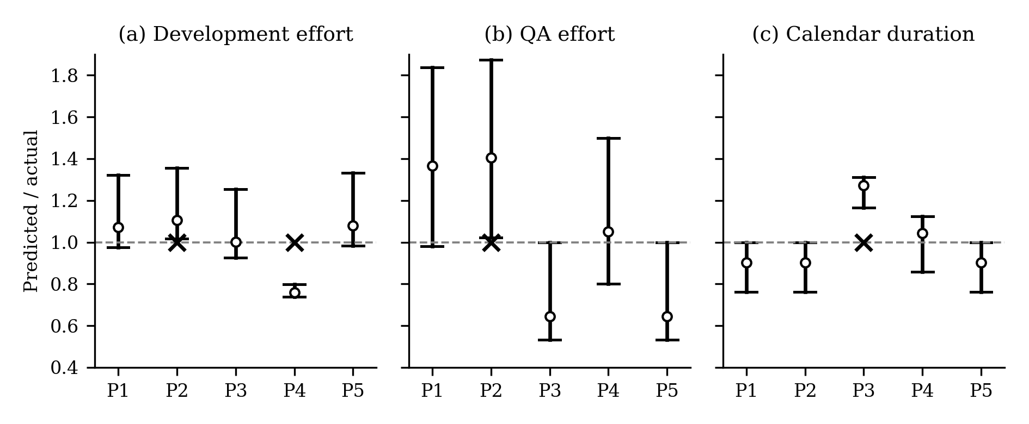
Figure 1. Leave-one-out predictions relative to actual values: (a) development effort, (b) QA effort, (c) calendar duration. Bars are predicted intervals divided by the actual value; the dashed line marks the actual value; the circle marks the mean-boost point estimate; a cross marks a prediction whose interval does not contain the actual value.
Two-sided coverage is 3 of 5 for development effort, 4 of 5 for QA effort and 4 of 5 for duration — 11 of 15 overall, or 0.73. All four misses occur on the project that held the sample extreme for that dimension, which is the case where the leave-one-out interval is by construction too narrow. Three of the four misses are on the favourable side: the actual value was below the predicted lower bound (P2 development by 2 %, P2 QA by 3 %, P3 duration by 14 %), meaning the project did better than the calibrated range. One miss is unfavourable: P4 development effort was 370 h against a predicted upper bound of 295 h, an under-prediction of 20 %.
One-sided coverage by the upper bound is 4 of 5 for development, 5 of 5 for QA and 5 of 5 for duration — 14 of 15, or 0.93. The single failure of the conservative planning value is the P4 development case.
Five of the eleven covered predictions are exact boundary cases, in which the actual value coincides with the upper bound of the predicted interval (P3 and P5 in QA; P1, P2 and P5 in duration). They arise because several projects share identical boost coefficients — three have B_{T} = 1.33 and two have B_{Q} = 2.67 — so that the held-out project's coefficient reappears in the calibration set. These cases are counted as covered under the inclusive definition, but they are not evidence that the interval anticipated a new value.
Interval width and comparison with point estimates
Mean relative width of the range-based interval is 0.25 for development effort, 0.60 for QA effort and 0.24 for duration. In absolute terms, the development effort of P1 was predicted as [966, 1,309] h from a conventional estimate of 4,033 h: the calibration replaced an estimate that was off by a factor of four with an interval about 30 % wide that contained the actual value.
The QA interval is more than twice as wide as the other two. This follows directly from the QA coefficients in Table 1, which range from 2.67 to 5.00 and were attributed in the source study to differences in the automatability of test scope between projects (Khymchuk et al., 2026). For QA, the range-based interval is honest about what the calibration set does not know.
Table 3 compares constructions and baselines. The mean-boost point estimate has a mean relative error of 0.10 for development, 0.31 for QA and 0.12 for duration, with worst cases of 0.24, 0.41 and 0.27. The conventional estimate applied without adjustment has a mean relative error of 2.86 for development effort and 2.85 for QA effort — it over-predicts effort by a factor of almost four — and 0.45 for duration. The mean ± 2 s construction raises two-sided coverage to 4/5, 5/5 and 4/5 but roughly doubles relative width in every dimension (0.44, 1.19, 0.48), and still misses P4 development and P3 duration, because with four points the sample standard deviation is itself unreliable.
Table 3
Summary of leave-one-out results by construction and dimension
Quantity | Development | QA | Duration
Range interval, two-sided coverage | 3/5 | 4/5 | 4/5
Range interval, one-sided (upper) coverage | 4/5 | 5/5 | 5/5
Range interval, mean RW | 0.25 | 0.60 | 0.24
Mean ± 2 s interval, two-sided coverage | 4/5 | 5/5 | 4/5
Mean ± 2 s interval, mean RW | 0.44 | 1.19 | 0.48
Mean-boost point estimate, mean relative error | 0.10 | 0.31 | 0.12
Mean-boost point estimate, max relative error | 0.24 | 0.41 | 0.27
Conventional estimate, mean relative error | 2.86 | 2.85 | 0.45
Observed versus expected coverage
For n = 4, equation (5) predicts two-sided coverage of 0.60 and one-sided coverage of 0.80. The observed values are 0.73 (11/15) and 0.93 (14/15). With fifteen non-independent trials the agreement is as close as can be expected, and the observed values are on the favourable side of the expectation. Figure 2 places the observed points on the theoretical curves and shows how coverage grows with the number of calibration projects.
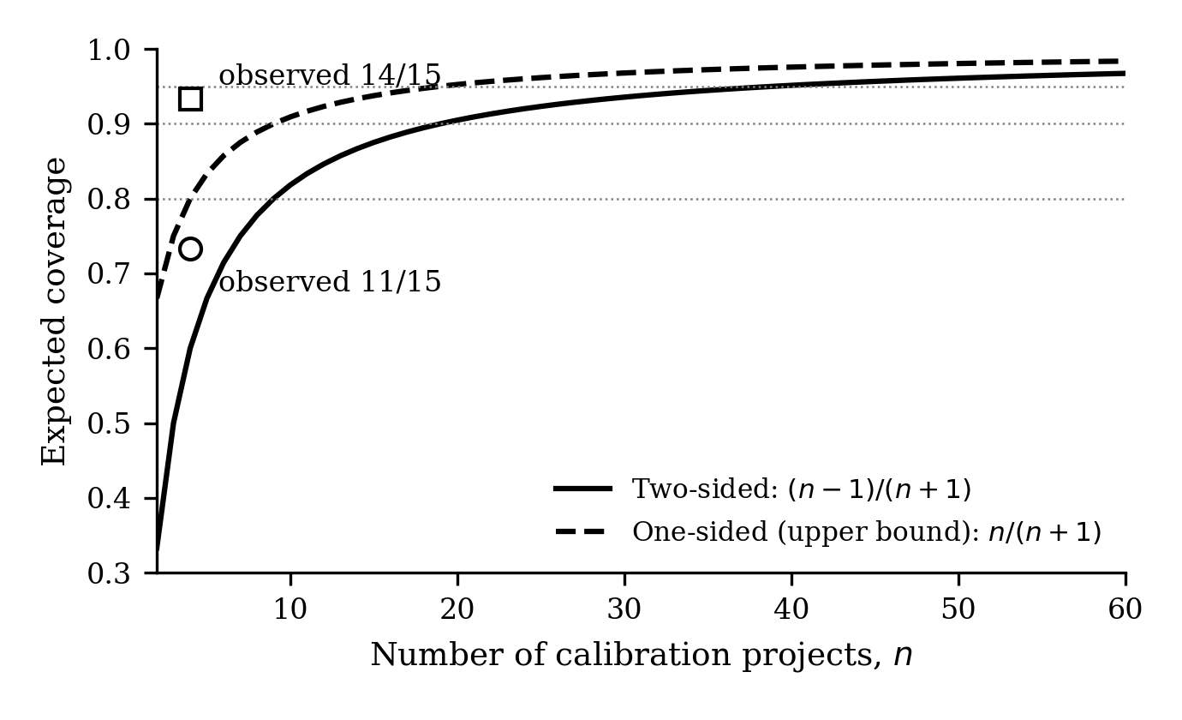
Figure 2. Expected coverage of a range-based interval as a function of the number of calibration projects n, from equation (5), with the two observed leave-one-out values for n = 4. Dotted lines mark 80 %, 90 % and 95 %.
Discussion and Conclusions
What the calibration does and does not deliver
The result that matters for practice is the pair of numbers 0.25 and 3.86. A conventional estimate of development effort for an AI-native project was wrong by a factor of almost four; the calibrated interval built from four earlier projects was about a quarter as wide as its own midpoint and contained the actual value in three cases of five, with the upper bound sufficient in four of five. Nothing in the procedure required more than the planned and actual hours of completed projects. This is the difference between an assumed multiplier and a measured one.
The result that matters for method is that the misses are not random. Every miss occurred when the held-out project was itself the extreme of the sample, which is exactly the situation in which a range-based interval cannot succeed: the interval is defined by the data, and a project outside the data will be outside the interval. Equation (5) turns this from an anecdote into an expectation. With four calibration projects the interval should miss about 40 % of the time on two sides and 20 % on the upper side; it missed 27 % and 7 %. A team using this procedure with five completed projects should therefore expect the interval to be exceeded on roughly one project in five, and should hold contingency accordingly — a statement the procedure can make about itself, which an assumed multiplier cannot.
How many projects are enough
Equation (5) gives a direct answer that does not depend on the shape of the boost distribution: 9 calibration projects for 80 % expected coverage, 19 for 90 %, 39 for 95 %. For an organisation delivering tens of AI-native projects a year these numbers are reachable within one planning cycle, and they define the point at which interval calibration becomes a reliable commercial instrument rather than an early indication. Until then, the one-sided upper bound is the value to plan on, since it reaches the same coverage with roughly half as many projects (n/(n+1) against (n-1)/(n+1)).
The condition attached to (5) is exchangeability. Boost coefficients are ratios of a conventional estimate to an AI-native actual; they therefore depend on the estimating procedure as much as on the delivery methodology. A calibration set is valid for projects estimated and delivered the same way. Mixing projects from different methodologies, or recalibrating after a substantial change in tooling, breaks the condition and should be treated as starting a new calibration set. This also means the intervals in Table 1 are not transferable to other organisations as numbers; the procedure is transferable, the values are not.
Asymmetry of the commercial risk
For fixed-scope pricing the two bounds of (3) carry different consequences. If actual effort falls below the lower bound, the project is delivered under budget; if it exceeds the upper bound, the margin is consumed. Of the four misses in Table 2, three were on the favourable side and one — P4 development, 20 % over the upper bound — was not. P4 is also the project with the lowest development boost in the set (3.08 against a mean of 3.86), and its QA boost was unremarkable, so the shortfall was specific to development. The data do not say why. The source study noted that development boost is moderated by codebase maturity (Khymchuk et al., 2026), and controlled experiments have found the smallest or even negative gains on mature, complex codebases (Becker et al., 2025), which is consistent with P4 but not established by it.
The practical consequence is that the upper bound of the calibrated interval, not its midpoint, is the quantity to carry into a fixed price, and that the contingency added to it should reflect the expected one-sided miss rate 1/(n+1) rather than a conventional percentage.
Relation to existing estimation practice
The procedure is closest in spirit to analogy-based estimation and to calibration of parametric models on local data (Trendowicz & Jeffery, 2014), and it inherits the finding that local calibration matters more than model choice (Menzies et al., 2017). It differs in two respects. First, it does not attempt to estimate effort from project attributes; it takes the organisation's existing conventional estimate as input and corrects it, so it can be inserted into an existing estimation process without replacing it. Second, it produces an interval whose reliability is stated by (5) rather than a point whose accuracy must be inferred after the fact. In agile settings, where estimation is iterative and relative (Usman et al., 2014), the same procedure applies to the conversion of a conventional sprint or release estimate into an AI-native one.
The wider literature on AI productivity is dominated by task-level measurements — pull-request throughput, time to complete a bounded task, acceptance rates of suggested code (Peng et al., 2023; Ziegler et al., 2024; Weber et al., 2024; Moradi Dakhel et al., 2023). Those measurements are the right instrument for evaluating a tool, but they do not transfer to project-level estimation, because a project is not a sum of bounded tasks. The 2025 DORA report, based on nearly 5,000 respondents, finds that AI adoption is now near-universal and is associated with higher individual effectiveness and higher delivery throughput, but also with higher delivery instability, with no change in friction or burnout, and it attributes the gap to the organisational system in which the individual gains are nested: AI shows up at the keyboard, while coordination, verification and stability are properties of the wider system (DORA, 2025). The duration coefficients in Table 1, stable at 1.33–1.75 while effort coefficients ranged from 2.67 to 5.00, are the project-scale form of the same observation. Calibrating on completed projects rather than on task studies is what makes the interval usable for planning; it is also consistent with DORA's own guidance to plan AI investments as a range of scenarios rather than a single figure (DORA, 2026).
Limitations
The study has four limitations, and they are the same as those of the dataset it rests on. First, five projects allow only four-project calibration sets; the coverage results are consistent with theory but are themselves based on fifteen non-independent trials and should be read as an illustration of the method, not as a validation of specific coverage figures. Second, all projects come from one organisation with one methodology and one estimation procedure; the exchangeability condition holds within the set, and its violation outside the set is untested. Third, durations are recorded to the nearest half month, which limits the resolution of the duration coefficients and of any conclusion about them; together with the identical coefficients noted in the Results, this rounding produces tied values, whereas equation (5) is derived for a continuous distribution without ties, so the observed coverage of 0.73 is inflated relative to the expectation of 0.60 by the five boundary cases and should not be read as the interval performing better than theory predicts. Fourth, the conventional estimates are taken as competent; if they contain systematic bias, the boost coefficients inherit it, and the calibration would correct for that bias together with the AI-native gain without being able to separate the two.
A fifth limitation is inherent to the range-based construction: it cannot produce a bound outside the data. This is a feature for transparency and a cost for coverage, and (5) states the cost. Constructions that extrapolate — parametric tolerance intervals, or intervals widened by a factor tied to n — trade transparency for coverage and become defensible only when n is large enough for their assumptions to be checked.
The paper set out to turn a descriptive result — that AI-native delivery compresses effort and duration by structurally different, variable factors — into an estimation procedure, and to state how reliable that procedure is with the data available.
The procedure maps a conventional estimate to an interval of AI-native outcomes by dividing it by the range of boost coefficients observed on completed projects. On five commercial projects evaluated leave-one-out, the interval contained the actual value in 11 of 15 predictions and its upper bound was sufficient in 14 of 15, with relative widths of 0.25 for development effort and 0.24 for duration against a conventional estimate that over-predicted effort by a factor of almost four. Every miss occurred when the predicted project was the extreme of the sample, and the miss rate agrees with the distribution-free expectation (n − 1)/(n + 1) for a range built from n observations.
That expression is the second result. It states, without assumptions about the distribution of gains, that about 19 completed projects are needed before the two-sided interval can be expected to cover 90 % of new projects, and 9 for the upper bound alone to do so. It gives an organisation adopting AI-native delivery a concrete target for its calibration base and a concrete contingency rule until that target is reached.
Future work follows from the limitations. The calibration set will be extended as further projects complete under the same methodology, which will test the coverage prediction directly rather than by leave-one-out. The moderating variables suggested by the one unfavourable miss — codebase maturity, degree of test automation — will be examined as candidate stratification criteria for the calibration set. Finally, the procedure will be integrated into the estimation workflow of an AI-native delivery unit so that its predictions and their outcomes are recorded prospectively.
Declaration on the use of artificial intelligence
The author used Claude (Anthropic) as a writing and analysis assistant: to run the leave-one-out computations from the data in Table 1, to produce the figures, and to draft and edit the text. All computations were verified by the author against the source data; all interpretations, claims and conclusions are the author's. No AI tool is an author of this work.
References
Becker, J., Rush, N., Barnes, E., & Rein, D. (2025). Measuring the impact of early-2025 AI on experienced open-source developer productivity. METR. https://doi.org/10.48550/arXiv.2507.09089
Cui, Z., Demirer, M., Jaffe, S., Musolff, L., Peng, S., & Salz, T. (2025). The effects of generative AI on high-skilled work: Evidence from three field experiments with software developers. Management Science. Advance online publication. https://doi.org/10.1287/mnsc.2025.00535
DORA. (2025). State of AI-assisted software development 2025. Google Cloud. https://dora.dev/dora-report-2025/
DORA. (2026). The ROI of AI-assisted software development. Google Cloud. https://dora.dev/ai/roi/report/
Jørgensen, M. (2004). A review of studies on expert estimation of software development effort. Journal of Systems and Software, 70(1–2), 37–60. https://doi.org/10.1016/S0164-1212(02)00156-5
Jørgensen, M., & Shepperd, M. (2007). A systematic review of software development cost estimation studies. IEEE Transactions on Software Engineering, 33(1), 33–53. https://doi.org/10.1109/TSE.2007.256943
Khymchuk, M., Sysoieva, I., Spivak, I., Pukas, A., Voytyuk, I., & Onyshchuk, A. (2025). Enhancing the efficiency of software development through industry knowledge. In 2025 15th International Conference on Advanced Computer Information Technologies (ACIT) (pp. 673–677). IEEE. https://doi.org/10.1109/ACIT65614.2025.11185757
Khymchuk, M., Pukas, A., Krepych, S., Spivak, I., Voytyuk, I., & Onyshchuk, A. (2026). Interval-based assessment of productivity gains in AI-native software development. In 2026 16th International Conference on Advanced Computer Information Technologies (ACIT) (pp. 1444–1447). IEEE. https://doi.org/10.1109/ACIT69831.2026.11699954
Krishnamoorthy, K., & Mathew, T. (2009). Statistical tolerance regions: Theory, applications, and computation. Wiley.
Menzies, T., Yang, Y., Mathew, G., Boehm, B., & Hihn, J. (2017). Negative results for software effort estimation. Empirical Software Engineering, 22(5), 2658–2683. https://doi.org/10.1007/s10664-016-9472-2
Moore, R. E., Kearfott, R. B., & Cloud, M. J. (2009). Introduction to interval analysis. SIAM. https://doi.org/10.1137/1.9780898717716
Moradi Dakhel, A., Majdinasab, V., Nikanjam, A., Khomh, F., Desmarais, M. C., & Jiang, Z. M. (2023). GitHub Copilot AI pair programmer: Asset or liability? Journal of Systems and Software, 203, 111734. https://doi.org/10.1016/j.jss.2023.111734
Peng, S., Kalliamvakou, E., Cihon, P., & Demirer, M. (2023). The impact of AI on developer productivity: Evidence from GitHub Copilot. arXiv. https://doi.org/10.48550/arXiv.2302.06590
Shepperd, M., & MacDonell, S. (2012). Evaluating prediction systems in software project estimation. Information and Software Technology, 54(8), 820–827. https://doi.org/10.1016/j.infsof.2011.12.008
Trendowicz, A., & Jeffery, R. (2014). Software project effort estimation: Foundations and best practice guidelines for success. Springer. https://doi.org/10.1007/978-3-319-03629-8
Usman, M., Mendes, E., Weidt, F., & Britto, R. (2014). Effort estimation in agile software development: A systematic literature review. In Proceedings of the 10th International Conference on Predictive Models in Software Engineering (PROMISE '14) (pp. 82–91). ACM. https://doi.org/10.1145/2639490.2639503
Weber, T., Brandmaier, M., Schmidt, A., & Mayer, S. (2024). Significant productivity gains through programming with large language models. Proceedings of the ACM on Human-Computer Interaction, 8(EICS), Article 256. https://doi.org/10.1145/3661145
Wilks, S. S. (1941). Determination of sample sizes for setting tolerance limits. The Annals of Mathematical Statistics, 12(1), 91–96. https://doi.org/10.1214/aoms/1177731788
Ziegler, A., Kalliamvakou, E., Li, X. A., Rice, A., Rifkin, D., Simister, S., Sittampalam, G., & Aftandilian, E. (2024). Measuring GitHub Copilot's impact on productivity. Communications of the ACM, 67(3), 54–63. https://doi.org/10.1145/3633453

Михайло ХИМЧУК, аспірант
ORCID ID: 0009-0001-7433-4738
e-mail: m.khymchuk@st.wunu.edu.ua
Західноукраїнський національний університет,
Тернопіль, Україна
ІНТЕРВАЛЬНЕ КАЛІБРУВАННЯ ОЦІНОК ТРУДОМІСТКОСТІ ТА ТРИВАЛОСТІ ДЛЯ AI-NATIVE ПРОГРАМНИХ ПРОЄКТІВ
В AI-native розробці програмного забезпечення традиційна оцінка трудомісткості систематично хибна: фактична трудомісткість комерційних проєктів виявилась у три–п'ять разів нижчою за оцінку, тоді як календарна тривалість скоротилась значно менше. На практиці це коригують діленням оцінки на припущений "коефіцієнт AI", обраний експертно. У роботі припущений коефіцієнт замінено інтервалом коефіцієнтів приросту, відкаліброваним на завершених проєктах, і оцінено його як інструмент прогнозування. На даних п'яти комерційних проєктів за схемою перехресної перевірки з виключенням одного інтервал на основі розмаху містив фактичне значення в 11 з 15 прогнозів, а його верхня межа — у 14 з 15; середня відносна ширина становила 0,25 для трудомісткості розробки та 0,24 для тривалості. Усі промахи припали на випадки, коли виключений проєкт був екстремумом вибірки, що узгоджується з безрозподільною оцінкою (n − 1)/(n + 1) для розмаху n спостережень; той самий вираз показує, що для очікуваного покриття 90 % потрібно близько 19 калібрувальних проєктів.
Ключові слова: інтервальний аналіз, оцінювання трудомісткості, AI-native розробка програмного забезпечення, калібрування, перехресна перевірка з виключенням одного, толерантний інтервал, планування програмних проєктів.

Автор заявляє про відсутність конфлікту інтересів. Проаналізовані проєкти виконані роботодавцем автора; спонсори не брали участі в розробленні дослідження; у зборі, аналізі чи інтерпретації даних; у написанні рукопису; в рішенні про публікацію результатів.
The author declares no conflict of interest. The projects analysed were delivered by the author's employer; the funders had no role in the design of the study; in the collection, analyses, or interpretation of data; in the writing of the manuscript; or in the decision to publish the results.

UDC 004.415.538
DOI: https://doi.org/

Kyrylo KOKHAN, PhD Student
ORCID ID: 0009-0002-8878-8527
e-mail: kokhan.kyrylo@gmail.com
National University of Life and Environmental Sciences of Ukraine, Kyiv, Ukraine

Oleksii TKACHENKO, PhD Associate Professor
ORCID ID: 0000-0002-9514-516X
e-mail: oleksii.tkachenko@gmail.com
Taras Shevchenko National University of Kyiv, Kyiv, Ukraine

EVALUATING THE EFFECTIVENESS OF TESTING CONFIGURATION SELECTION BASED ON AN INTEGRATED APPROACH AND ARTIFICIAL INTELLIGENCE

The article presents a comprehensive theoretical and experimental study of the scientific and applied problem of selecting optimal test configurations while ensuring the operational quality of distributed multi-component information systems. A thorough comparative analysis of the author's adaptive integrated approach (which combines deterministic combinatorial Pairwise Testing and Orthogonal Arrays methods, an evolutionary genetic algorithm, and seamless integration into CI/CD continuous integration pipelines) with modern optimization methods based on artificial intelligence was conducted. As alternative approaches, machine learning models based on the Random Forest ensemble for risk-based configuration prioritization, deep Long Short-Term Memory (LSTM) recurrent neural networks for pruning redundant parameter sequences, and reinforcement learning algorithms (Q-learning) under conditions of no prior training were investigated.

Keywords: automated testing, multi-component information systems, optimal configurations, Pairwise Testing, genetic algorithms, machine learning, reinforcement learning, hybrid methods.

Introduction
The rapid development of the modern software industry has driven a transition from monolithic architectures to distributed multi-component information systems (IS) built on microservice and serverless architectural patterns (Soldani et al., 2018; Taibi et al., 2020), the conceptual analysis and theoretical foundations of configuration selection for which were established in earlier studies by the author (Kohan & Tkachenko, 2025a). Enterprise e-commerce platforms, financial and banking systems, distributed cloud storage facilities, and high-load analytical portals function through the synchronous and asynchronous interaction of dozens and hundreds of autonomous functional components (Bogner et al., 2019; Waseem et al., 2020). The architecture of such systems encompasses heterogeneous client web and mobile interfaces, backend business logic microservices, polyglot storage layers (combining relational DBMS, document-oriented, and in-memory databases), message brokers, and distributed application programming interfaces (API gateways).
The principle of independent component deployment ensures high development agility, yet poses severe challenges for automated testing and quality assurance (QA) processes (Ponce et al., 2025). The reliability of a distributed system depends not only on the isolated correctness of a single service's code, but also on the stability of the entire complex across the full spectrum of possible infrastructure environments. To guarantee system resilience, the software complex must be verified for compatibility across diverse operating systems, backend runtime environments, database management system engines, client browsers, and network configurations.
The aggregation of values for all specified parameters constitutes a single test configuration, and their full Cartesian product forms a multi-dimensional test configuration space (Kuhn et al., 2013). The mathematical nature of this space causes the phenomenon of combinatorial explosion. Even in the presence of only five architectural parameters with three admissible versions each, the exhaustive space comprises three to the fifth power, that is, 243 unique configurations. In industrial systems with 10–15 parameters, the cardinality of the state space rapidly escalates to hundreds of thousands and millions of combinations.
Under modern engineering paradigms of continuous integration and continuous delivery (CI/CD), where the scheduled feedback cycle (Lead Time for Changes) should not exceed 10–15 minutes, exhaustive testing becomes physically and economically unfeasible (Vassallo et al., 2016; Zampetti et al., 2017). Mass execution of redundant test suites overloads compute instances, exceeds rate limits on external services, exhausts database connection pools, and generates immense financial costs for cloud infrastructure leasing (Bansal, 2022; De Sousa Ribeiro Filho, 2024). Furthermore, repeatedly executing test scripts across hundreds of environments drastically increases the probability of false failures due to stochastic infrastructure fluctuations and network jitter, resulting in unstable ("flaky") tests. Table 1 systematizes the key challenges and constraints encountered when configuring automated testing within CI/CD pipelines.
Table 1
Challenges and infrastructural constraints of automated testing of configurations in CI/CD
Challenge Category | Specific Engineering Constraints | Impact on Testbed Architecture
Combinatorial Complexity | Exponential growth of the state space due to the Cartesian product of factor versions | Requires specialized combinatorial matrix compression and routing techniques
CI/CD Timeframes | Strict pipeline execution budget (Lead Time for Changes) within 10–15 minutes | Precludes exhaustive search, requiring sub-second execution times from the selection algorithm itself
Infrastructural Limits | DBMS connection pool exhaustion, third-party API rate limiting | Demands strict regulation of the maximum number of concurrently provisioned testbeds
Economic Cost | Pay-As-You-Go cloud resource billing under massive parallelization (FinOps) | Requires minimizing environmental deployments without compromising verification reliability
Stochastic Stability | False test failures caused by network latency jitter ("flaky tests") under excessive runs | Requires eliminating redundant test runs and enforcing execution determinism
Source: developed by the author based on an analysis of quality assurance practices in distributed systems (Bansal, 2022; Vassallo et al., 2016).
The theoretical foundations for resolving the combinatorial explosion problem were established in classical works on combinatorial testing. Research by the National Institute of Standards and Technology (NIST) confirmed that 70% to 90% of software fault interactions (SFI) are triggered by the interaction of no more than two parameters (Kuhn et al., 2004). This led to the widespread adoption of Pairwise Testing methods based on greedy In-Parameter-Order heuristics (Lei & Tai, 1998) and Orthogonal Latin Squares (Mandl, 1985). Comprehensive surveys of combinatorial methods demonstrate their ability to reduce test suite sizes by an order of magnitude while maintaining guaranteed pairwise coverage (Grindal et al., 2005; Nie & Leung, 2011). For addressing more complex multi-criteria test generation problems, evolutionary algorithms are widely employed (Anand et al., 2013; Cohen et al., 2003).
Concurrently, during 2024–2025, the application of artificial intelligence and machine learning methods in software engineering experienced rapid acceleration (Durelli et al., 2019). Studies by Mehmood et al. (2024) and Sharma (2024) explored test suite optimization and prioritization using predictive models. Segall and Tzoref-Brill (2018) demonstrated the feasibility of using machine learning models to identify relevant parameter combinations. In the latest NIST recommendations (2025), combinatorial methods were adapted specifically for the verification of complex AI systems. Karnam (2025) highlighted the potential of predictive models for dynamic test environment selection within CI/CD pipelines. Modern code review and automated auditing practices in large-scale corporations also underscore the critical necessity of regression suite optimization (Sadowski et al., 2018).
Despite an extensive body of literature, the problem of directly benchmarking combinatorial-genetic approaches against artificial intelligence methods on identical configuration samples under realistic CI/CD execution constraints remains insufficiently addressed. Most existing studies evaluate machine learning models in isolation, focusing exclusively on theoretical classification accuracy without accounting for model inference latency in CI/CD pipelines and without verifying combinatorial coverage invariants. The fundamental question remains open: can pure probabilistic machine learning models, recurrent neural networks, and reinforcement learning agents entirely replace classical combinatorial approaches, or is maximum efficiency achieved through targeted hybridization?
The objective of this article is to evaluate the effectiveness of a hybrid combination of the proposed integrated approach with modern artificial intelligence methods (Random Forest, LSTM recurrent neural networks, Q-learning reinforcement learning), as well as to conduct a multi-criteria comparative analysis based on a unified system of normalized weighting coefficients within a realistic automated testing environment.
The scientific novelty lies in the theoretical substantiation and empirical confirmation of the synergistic effect of a hybrid optimization architecture that couples initial deterministic combinatorial reduction to 100% pairwise coverage with subsequent Random Forest risk-oriented re-ranking, achieving the highest integral efficiency score while reducing the test suite to 4.6–9.3% of the exhaustive space.
The practical significance consists in the development and implementation of high-performance console middleware (CLI Middleware) within the Node.js runtime environment, integrated directly into GitHub Actions and Jenkins pipelines, which reduces cloud regression testing execution times without pipeline bottlenecks or the risk of missing component compatibility defects.
Main Part and Results
The methodological foundation of this research is a combination of combinatorial analysis, graph theory, heuristic evolutionary algorithms, and applied machine learning. The configuration state of a multi-component system is formalized as a parameter vector, where each element corresponds to a separate functional or infrastructural tier: client interface type, backend runtime environment, database engine, client browser, and target environment. The exhaustive theoretical configuration space of the system is formed as the direct Cartesian product of the value sets of all identified factors.
The optimization problem consists in finding a minimal configuration subset that guarantees 100% coverage of all possible two-factor parameter value combinations (pairwise combinatorial coverage) with minimal execution time and computing resources. The optimization objective is formulated as a multi-criteria additive convolution accounting for test suite cardinality, fault detection completeness, adaptability to architectural modifications, seamlessness of CI/CD integration, algorithmic computational resource consumption, and resilience to stochastic infrastructure noise.
To ensure an objective and independent experiment, a two-tier software framework was designed and deployed, as schematically illustrated in Fig. 1.

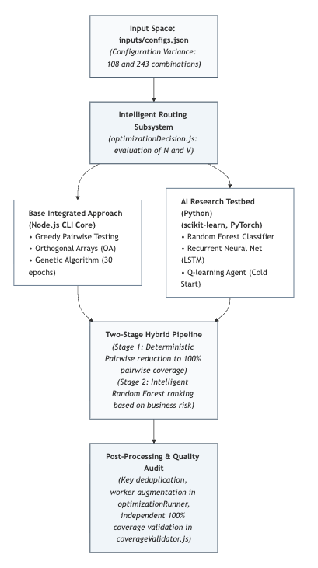
Fig. 1. Structural block diagram of the experimental comparative analysis framework
A pivotal architectural decision of the framework is implementing the core computational engine as console middleware (CLI Middleware) on Node.js, the practical testing and integration of which into automation pipelines was established by the author in (Kohan & Tkachenko, 2025b). Eschewing an external cloud microservice communicating over HTTP/REST API in favor of a local CLI utility is dictated by CI/CD execution constraints (Jenkins, GitHub Actions). Launching a separate network server inside an ephemeral runner container incurs startup delays for port binding, packet serialization, and introduces pipeline timeout failure risks. Executing optimization as a native CLI step prior to test execution grants direct access to V8 process memory, eliminates network latency, and delivers sub-second calculation speeds.
The auxiliary AI research testbed was implemented in Python using the scikit-learn and PyTorch libraries, serving as an isolated environment for model training and inference on identical synthetic data samples.
Empirical verification was conducted on two synthetic benchmark datasets reflecting different scales of configuration complexity in distributed systems:
- Dataset 1 (Small Dimensionality): A 5-factor parameter space where two factors have two levels and three factors have three levels (the product of 2, 3, 2, 3, and 3), yielding 108 exhaustive combinations.
- Dataset 2 (Medium Dimensionality): A symmetric 5-factor space where each factor takes three discrete values (3 to the 5th power), forming 243 exhaustive combinations.
All performance benchmarks were conducted on unified hardware: an Apple M1 Pro workstation (10 cores, 16 GB unified RAM) running macOS Sonoma, Node.js 22 LTS, and Python 3.11. Algorithmic runtime was measured using high-resolution system timers averaged over 50 iterative executions to eliminate stochastic OS overhead.
The study implemented and compared five algorithmic approaches:
- Integrated Approach of the Author (Base Core). Governed by an intelligent routing module (optimizationDecision.js) that assesses space dimensionality and average factor variability prior to optimization. For small and medium spaces, it executes a greedy Pairwise Testing algorithm that selects the configuration covering the maximum number of uncovered pairs at each step, guaranteeing mathematical completeness of interaction defects (Kohan & Tkachenko, 2025c). For symmetric low-variability spaces, it executes Orthogonal Arrays with accumulated pair frequency penalty tracking. For large spaces, it activates an adaptive genetic algorithm running for exactly 30 generations with a population of 50 individuals without early stopping, ensuring deterministic execution time and preventing V8 event loop blocking. Pair indexing utilizes Set hash structures for O(1) access, and output integrity is audited by an independent validator (coverageValidator.js).
- Machine Learning Prioritization (Random Forest). An ensemble classifier of 100 decision trees trained on synthetic component complexity graphs and business scenario weights. It predicts the probability of integration failure for each configuration, subsequently selecting the top configurations with the highest risk scores.
- Recurrent Neural Network (LSTM). A two-layer deep architecture with Long Short-Term Memory mechanisms that treats configurations as sequential parameter vectors, identifying non-linear dependencies to prune structurally redundant combinations.
- Reinforcement Learning (Q-learning). An autonomous agent operating under cold-start conditions without historical defect data. The agent receives rewards for discovering new uncovered pairs and penalties for step counts and computing time.
- Hybrid Approach (Integrated + ML). A two-stage pipeline:
  - Stage 1 (Deterministic Combinatorial Reduction): The greedy Pairwise algorithm rapidly reduces the input space to a mathematically complete subset guaranteeing 100% pairwise interaction coverage.
  - Stage 2 (Risk-Oriented Re-ranking): The trained Random Forest classifier evaluates and ranks the selected configurations according to business criticality (e.g., production environments and primary database engines receive higher priority). Lower-ranked configurations are pruned provided that 100% pairwise coverage remains uncompromised.
The final operation of the pipeline is performed by the post-processing module (optimizationRunner.js), which removes duplicate configurations by generating composite keys and prevents the underutilization of parallel CI/CD workers by verifying a minimum suite size threshold of at least five configurations.
The routing subsystem operates across six sequential steps:
- Step 1 (Configuration Loading): Reads inputs/configs.json, validates schemas, and filters invalid combinations.
- Step 2 (Topological Metric Calculation): Computes space dimensionality N and average factor variability V.
- Step 3 (Selector Decision Making): If the space dimensionality is small (less than or equal to 100 states), pairwise testing is assigned; if the dimensionality is medium (from 101 to 250 states) and the average variability is low (not exceeding 2.5), orthogonal arrays are assigned; if the dimensionality is medium with high variability (greater than 2.5), pairwise testing is assigned; if the dimensionality is large (exceeding 250 states), the genetic algorithm is assigned.
- Step 4 (Candidate Set Generation): Executes the assigned optimization method.
- Step 5 (Post-Processing & Augmentation): Deduplicates configurations via composite hash keys and guarantees the minimum worker threshold.
- Step 6 (Coverage Audit & Reporting): Validates 100% coverage via coverageValidator.js and outputs execution metadata to results/serverResultsOpt.json.
The aggregated experimental results averaged across 50 iterations on both datasets (108 and 243 configurations) are summarized in Table 2.
Table 2
Comparative performance results of the investigated configuration space optimization methods
Optimization Method | Number of Configurations Post-Optimization | Space Reduction, % | Pairwise Coverage, % | Algorithm Execution Time, ms | Final Integral Score
Integrated (Base Core) | 12–15 | 88,9–93,8 | 100,0 | 6–12 | 0,962
ML (Random Forest) | 22–28 | 74,0–88,0 | 94,0–96,0 | 145–210 | 0,709
LSTM (Neural Network) | 19–25 | 79,0–90,0 | 93,0–95,0 | 320–450 | 0,681
Reinforcement Learning | 28–35 | 68,0–86,0 | 91,0–94,0 | 890–1200 | 0,623
Hybrid (Integrated + ML) | 10–12 | 90,7–95,4 | 100,0 | 18–25 | 0,978

Source: calculated by the author based on 50 iterative benchmark runs on synthetic datasets.
Analysis of the empirical data in Table 2 reveals critical regularities:
- Random Forest and LSTM models provide 74–90% space reduction but exhibit a severe defect: inability to mathematically guarantee complete pairwise coverage (coverage remained bounded between 93% and 96%). This occurs because machine learning loss functions minimize average prediction error across frequent patterns, discarding rare parameter intersections that frequently harbor critical interaction defects (Kuhn et al., 2004).
- AI inference latency significantly exceeds combinatorial execution times, requiring 145 to 450 ms due to matrix vectorization and tensor evaluations.
- Q-learning demonstrated the lowest overall efficiency (91–94% coverage with execution times up to 1200 ms) due to the cold-start exploration phase.
- The base integrated core achieved deterministic runtimes of 6–12 ms with 100% pairwise coverage and 88.9–93.8% space reduction.
- The two-stage hybrid approach delivered the best metrics: combining combinatorial guarantees with Random Forest re-ranking reduced the suite to 10–12 configurations (90.7–95.4% compression) while retaining strict 100% coverage at a runtime of 18–25 ms.
To perform an objective multi-criteria comparison, an additive convolution of normalized parameters was calculated using Thomas Saaty's Analytic Hierarchy Process (AHP) weighting system:
- test suite reduction degree (weight 0.20);
- coverage of critical scenarios and pairwise interactions (weight 0.25 — highest priority);
- algorithmic adaptability to architectural changes (weight 0.15);
- seamlessness of CI/CD integration (weight 0.15);
- computational resource efficiency and runtime (weight 0.10);
- framework maintenance and implementation complexity (weight 0.05).
Table 3 presents the normalized scores and final integral evaluation.
Table 3
Comparative multi-criteria evaluation of testing approaches based on Saaty weighting coefficients
Evaluation Criterion | Criterion Weight | Integrated Approach (Base) | Artificial Intelligence (Average) | Hybrid Approach (Integrated + ML)
Suite Reduction Degree | 0,20 | 1,00 | 0,80 | 1,00
Critical Scenario Coverage | 0,25 | 1,00 | 0,85 | 1,00
Architectural Adaptability | 0,15 | 0,95 | 0,98 | 0,99
CI/CD Integration Seamlessness | 0,15 | 1,00 | 0,65 | 1,00
Computational Resource Efficiency | 0,10 | 1,00 | 0,45 | 0,95
Implementation Complexity | 0,05 | 0,80 | 0,60 | 0,75
Final Integral Score | 1,00 | 0,962 | 0,709 | 0,978
Source: calculated by the author based on experimental benchmark runs.
The empirical integral score calculation for the hybrid approach is derived as the sum of products of weights and parameter ratings: 0.20 multiplied by 1.00, plus 0.25 multiplied by 1.00, plus 0.15 multiplied by 0.99, plus 0.15 multiplied by 1.00, plus 0.10 multiplied by 0.95, plus 0.05 multiplied by 0.75, yielding an integral score of 0.978.
The evaluation confirms that isolated AI methods score lowest (0.709) due to coverage gaps and compute overhead. The author's base integrated approach demonstrates high efficiency (0.962), while the hybrid pipeline achieves the highest rating (0.978), confirming the hypothesis regarding combinatorial and machine learning synergy.
From a DevSecOps perspective, the CLI Middleware operates within the runner without listening on network ports, processes sanitized metadata without exposing credentials, and reduces test instances, significantly mitigating data leakage risks in cloud build logs.

Discussion and Conclusions
The experimental findings challenge the assumption that artificial intelligence models can universally supersede classical testing algorithms. Pure machine learning models remain probabilistic approximations unable to provide strict mathematical guarantees against interaction defects at rare infrastructure intersections. In production microservices, missing even 4% of interaction faults can trigger cascading outages.
Conversely, the proposed hybrid approach overcomes the limitations of both paradigms:
- Reducing configuration spaces to 4.6–9.3% of the initial volume brings integration testing within the 5–10 minute CI/CD window, restoring rapid developer feedback.
- Retaining deterministic 100% pairwise interaction coverage ensures the detection of the vast majority of compatibility defects.
- Achieving a multi-criteria integral score of 0.978 outperforms both standalone combinatorial and isolated AI approaches.
- Node.js core execution maintains runtimes within 18–25 ms, preventing build pipeline delays.
For practical deployment, a two-tier strategy is recommended: executing the lightweight Pairwise core (6–12 ms) on regular Pull Requests, while reserving the full Random Forest hybrid pipeline for nightly regression builds and production release candidates.
Future research will investigate deeper integration with Kubernetes cloud orchestrators (ArgoCD) for ephemeral environment provisioning, incorporating Explainable AI (SHAP values) to provide QA engineers with automated textual explanations for configuration selection, and leveraging large language models (LLMs) for automated test failure log analysis.

References
Anand, C., Hasan, K., Li, J., & Anatoliy, A. (2013). An orchestrated survey of methodologies for automated software test case generation. Journal of Systems and Software, 86(8), 1978–2001. https://doi.org/10.1016/j.jss.2013.02.061
Bansal, S. (2022). Empirical studies on automated software testing practices (Doctoral dissertation). University of Southern California.
Bogner, J., Fritzsch, J., Wagner, S., & Zimmermann, A. (2019). Microservices in industry: Insights into technologies, characteristics, and software quality. In 2019 IEEE International Conference on Software Architecture Companion (ICSA-C) (pp. 187–196). IEEE. https://doi.org/10.1109/ICSA-C.2019.00041
Cohen, M. B., Gibbons, P. B., Mugridge, W. B., & Colbourn, C. J. (2003). Constructing test suites for interaction testing. In Proceedings of the 25th International Conference on Software Engineering (pp. 38–48). IEEE. https://doi.org/10.1109/ICSE.2003.1201186
De Sousa Ribeiro Filho, F. (2024). Automated security testing in DevSecOps pipelines. World Journal of Advanced Research and Reviews, 22(1), 2083–2093. https://doi.org/10.30574/wjarr.2024.22.1.1083
Durelli, V. H. S., Durelli, R. S., Borges, S., Endo, A. T., Eler, M. M., Dias, D. R. C., & Guimarães, M. P. (2019). Machine learning applied to software testing: A systematic mapping study. IEEE Transactions on Reliability, 68(3), 1189–1212. https://doi.org/10.1109/TR.2019.2892517
Grindal, M., Offutt, J., & Andler, S. F. (2005). Combination testing strategies: A survey. Software Testing, Verification and Reliability, 15(3), 167–199. https://doi.org/10.1002/stvr.319
Karnam, V. S. P. (2025). AI and machine learning driven test automation: Revolutionizing software testing practices. World Journal of Advanced Engineering Technology and Sciences, 15(2), 1560–1571.
Kohan, K. O., & Tkachenko, O. M. (2025a). Review and proposal for optimization of optimal configurations for automated testing of multi-component information systems. Information Technologies and Society, 3(18), 83–87 [in Ukrainian]. [Кохан, К. О., & Ткаченко, О. М. (2025a). Огляд та пропозиція оптимізації оптимальних конфігурацій для автоматизованого тестування багатокомпонентних інформаційних систем. Інформаційні технології та суспільство, 3(18), 83–87]. https://doi.org/10.32689/maup.it.2025.3.11
Kohan, K. O., & Tkachenko, O. M. (2025b). Implementation and testing of the configuration optimization module for automated testing of multi-component information systems. Computer-Integrated Technologies: Education, Science, Production, 61, 18–23 [in Ukrainian]. [Кохан, К. О., & Ткаченко, О. М. (2025b). Впровадження та апробація модуля оптимізації конфігурацій для автоматизованого тестування багатокомпонентних інформаційних систем. Комп’ютерно-інтегровані технології: освіта, наука, виробництво, 61, 18–23]. https://doi.org/10.36910/6775-2524-0560-2025-61-03
Kohan, K. O., & Tkachenko, O. M. (2025c). Pairwise Testing method for optimizing configurations of automated testing of multi-component information systems. In Collection of materials of the XVI International Scientific and Practical Conference of Young Scientists "Information Technologies: Economics, Engineering, Education '2025" (pp. 74–75). NULES of Ukraine [in Ukrainian]. [Кохан, К. О., & Ткаченко, О. М. (2025c). Метод Pairwise Testing для оптимізації конфігурацій автоматизованого тестування багатокомпонентних інформаційних систем. У Збірник матеріалів XVI Міжнародної науково-практичної конференції молодих вчених «Інформаційні технології: економіка, техніка, освіта ‘2025» (с. 74–75). НУБіП України].
Kuhn, D. R., Wallace, D. R., & Gallo, A. M. (2004). Software fault interactions and implications for software testing. IEEE Transactions on Software Engineering, 30(6), 418–421. https://doi.org/10.1109/TSE.2004.24
Kuhn, R., Kacker, R., & Lei, Y. (2013). Introduction to combinatorial testing. CRC Press. https://doi.org/10.1201/b14957
Lei, Y., & Tai, K. C. (1998). In-parameter-order: A test generation strategy for pairwise testing. In Proceedings of the 3rd IEEE International High-Assurance Systems Engineering Symposium (pp. 254–261). IEEE. https://doi.org/10.1109/HASE.1998.731623
Mandl, R. (1985). Orthogonal Latin squares: An application of experiment design to compiler testing. Communications of the ACM, 28(10), 1054–1058. https://doi.org/10.1145/4372.4375
Mehmood, A., Ilyas, Q. M., Ahmad, M., & Shi, Z. (2024). Test suite optimization using machine learning techniques: A comprehensive study. IEEE Access, 12, 168645–168671. https://doi.org/10.1109/ACCESS.2024.3490453
Nie, C., & Leung, H. (2011). A survey of combinatorial testing. ACM Computing Surveys, 43(2), 1–29. https://doi.org/10.1145/1883612.1883618
NIST. (2025). Combinatorial testing for AI-enabled systems (CT4AIES). National Institute of Standards and Technology. https://csrc.nist.gov/projects/combinatorial-testing-for-ai-enabled-systems
Ponce, F., Verdecchia, R., Miranda, B., & Soldani, J. (2025). Microservices testing: A systematic literature review. Information and Software Technology, 188, Article 107870. https://doi.org/10.1016/j.infsof.2025.107870
Sadowski, C., Söderberg, E., Church, L., Sipko, M., & Bacchelli, A. (2018). Modern code review: A case study at Google. In Proceedings of the 40th International Conference on Software Engineering: Software Engineering in Practice (pp. 181–190). ACM. https://doi.org/10.1145/3183519.3183525
Segall, I., & Tzoref-Brill, R. (2018). Using machine learning to improve test case generation. In 2018 IEEE International Conference on Software Testing, Verification and Validation (ICST) (pp. 45–53). IEEE.
Sharma, A. (2024). Test suite optimization using machine learning techniques: A comprehensive study. DSU Publishing.
Soldani, C., Tamburri, D. A., & Kruten, I. (2018). The pains and gains of microservices: A systematic grey literature review. Journal of Systems and Software, 146, 215–232. https://doi.org/10.1016/j.jss.2018.09.082
Taibi, D., Lenarduzzi, V., & Pahl, C. (2020). Microservices anti-patterns: A taxonomy. In Microservices (pp. 111–128). Springer, Cham. https://doi.org/10.1007/978-3-030-31646-4_5
Vassallo, C., Zampetti, F., Romano, D., Belleri, C., Panichella, A., Di Penta, M., & Zaidman, A. (2016). Continuous delivery practices in a large financial organization. In 2016 IEEE International Conference on Software Maintenance and Evolution (ICSME) (pp. 519–528). IEEE. https://doi.org/10.1109/ICSME.2016.72
Waseem, M., Liang, P., & Shahin, M. (2020). A systematic mapping study on microservices architecture in DevOps. Journal of Systems and Software, 170, Article 110798. https://doi.org/10.1016/j.jss.2020.110798
Zampetti, F., Scalabrino, S., Oliveto, R., Canfora, G., & Di Penta, M. (2017). How open source projects use static code analysis tools in continuous integration pipelines. In Proceedings of the 14th International Conference on Mining Software Repositories (MSR) (pp. 234–244). IEEE. https://doi.org/10.1109/MSR.2017.2

Отримано редакцією журналу / Received: 25.09.2026
Прорецензовано / Revised: 27.09.2026
Схвалено до друку / Accepted: 27.09.2026

Кирило КОХАН, аспірант
ORCID ID: 0009-0002-8878-8527
e-mail: kokhan.kyrylo@gmail.com
Національний університет біоресурсів і природокористування України, Київ, Україна
Олексій ТКАЧЕНКО, канд. техн. наук, доц.
ORCID ID: 0000-0002-9514-516X
e-mail: oleksii.tkachenko@gmail.com
Київський національний університет імені Тараса Шевченка, Київ, Україна

ОЦІНКА ЕФЕКТИВНОСТІ ВИБОРУ КОНФІГУРАЦІЙ ТЕСТУВАННЯ НА ОСНОВІ ІНТЕГРОВАНОГО ПІДХОДУ ТА ШТУЧНОГО ІНТЕЛЕКТУ

У статті представлено комплексне теоретичне та експериментальне дослідження науково-прикладної проблеми вибору оптимальних тестових конфігурацій при забезпеченні якості функціонування розподілених багатокомпонентних інформаційних систем. Здійснено всебічний порівняльний аналіз запропонованого автором адаптивного інтегрованого підходу (що поєднує детерміновані комбінаторні методи попарного тестування Pairwise Testing та ортогональних масивів Orthogonal Arrays, еволюційний генетичний алгоритм та безшовну інтеграцію у конвеєри безперервної інтеграції CI/CD) із сучасними методами оптимізації на основі штучного інтелекту. У ролі альтернативних підходів досліджено моделі машинного навчання на основі ансамблю випадкових лісів Random Forest для пріоритизації конфігурацій за ризиками, глибокі рекурентні нейронні мережі довгострокової короткочасної пам'яті LSTM для відсікання надлишкових послідовностей параметрів та алгоритми навчання з підкріпленням Q-learning в умовах відсутності попереднього навчання

Ключові слова: автоматизоване тестування, багатокомпонентні інформаційні системи, оптимальні конфігурації, Pairwise Testing, генетичні алгоритми, машинне навчання, навчання з підкріпленням, гібридні методи.
Автор заявляє про відсутність конфлікту інтересів. Спонсори не брали участі в розробленні дослідження; у зборі, аналізі чи інтерпретації даних; у написанні рукопису; в рішенні про публікацію результатів.
The author declares no conflicts of interest. The funders had no role in the design of the study; in the collection, analyses, or interpretation of data; in the writing of the manuscript; or in the decision to publish the results.

UDC: 004.7:004.052
DOI:

Illia KORNIICHYK, PhD student
ORCID ID: 0009-0006-4426-7614
e-mail: illyakorn88@gmail.com
State University of Information and Communication Technologies, Kyiv, Ukraine

Serhii PROKOPOV, Candidate of Technical Sciences, Associate Professor
Department of Computer Science
State University of Information and Communication Technologies, Kyiv, Ukraine
ORCID ID: 0009-0008-6033-3225
e-mail: s.prokopov@duikt.edu.ua

A DEPENDENCY-AWARE METHOD FOR DIAGNOSTIC CHECK SELECTION IN SMALL DISTRIBUTED NETWORK INFRASTRUCTURES

Abstract. Small distributed network infrastructures often combine heterogeneous network devices, servers, point-of-sale terminals, printers, wireless access points, video-surveillance equipment, and external services. When an incident is reported, checking all available infrastructure elements introduces unnecessary diagnostic effort. This paper presents a dependency-aware method for selecting diagnostic checks relevant to a reported incident. The infrastructure is represented as a directed dependency graph linking business functions to the devices, services, network components, power elements, and external dependencies on which they rely. After an incident is mapped to the affected business function, an incident-specific dependency subgraph is extracted and used to select associated automatic and manual diagnostic actions. A lightweight Python prototype was evaluated on two anonymized restaurant infrastructures using six reconstructed incident scenarios. The method selected between 7 and 17 diagnostic actions per incident and reduced the modeled diagnostic action space by 76.71–90.41%, with an average reduction of 82.13%. The evaluation is preliminary and concerns check selection rather than measured troubleshooting time or root-cause accuracy.
Keywords: network infrastructure, dependency graph, diagnostic checks, incident diagnosis, network monitoring, fault localization, small distributed sites.
1. INTRODUCTION
Small distributed business facilities such as restaurants, clinics, retail stores, and service offices rely on network infrastructure for routine operations. A typical site may include an Internet gateway, switches, wireless access points, local or remotely hosted servers, point-of-sale (POS) terminals, receipt printers, video-surveillance equipment, and remote-access services. Although such infrastructures are relatively small, a single business function may depend simultaneously on several network, service, power, and external components.
Incidents in these environments are usually reported in terms of an affected function rather than a failed component. Users may report, for example, that several receipt printers are unavailable, the POS application cannot be accessed, video surveillance has stopped working, or remote access to a server has failed. Troubleshooting therefore requires translating an observable symptom into the infrastructure elements that may contribute to it. This becomes particularly important when several affected endpoints share the same upstream switch, server, power source, or external service. Dependency-based fault localization has long been used to relate observed symptoms to possible underlying causes (Bahl et al., 2007; Steinder & Sethi, 2004).
Monitoring systems can provide many kinds of diagnostic information, including ICMP reachability, TCP service availability, SNMP data, DNS responses, and device-specific API results. Yet the availability of these mechanisms does not determine which checks are relevant to a particular incident. Running the complete set of available checks for every reported problem creates unnecessary diagnostic work, whereas manual selection depends heavily on an administrator's knowledge of the infrastructure and its dependencies. Current incident-management and AIOps research addresses the collection and correlation of operational data, but much of it assumes environments with extensive logs, metrics, traces, and observability pipelines (Yu et al., 2024). Small distributed sites often provide a much more limited and heterogeneous set of diagnostic interfaces.
This work treats diagnostic check selection as a distinct stage of incident diagnosis. A reported problem is first mapped to the affected business function. The dependency graph is then traversed to identify the relevant infrastructure elements and extract an incident-specific subgraph. Diagnostic actions associated with the nodes and physical links of this subgraph form the initial candidate set. The resulting actions are classified by execution mode, while their actual execution order is left for future work.
The method is intended for small distributed infrastructures where diagnostic information can be obtained through relatively accessible mechanisms such as ICMP and TCP checks, SNMP, DNS queries, router APIs, and administrator observations. It does not depend on a large-scale observability platform or a trained diagnostic model. Its purpose is narrower: to reduce the diagnostic search space by excluding actions unrelated to the dependency paths of the reported incident.
The evaluation uses two anonymized restaurant infrastructures that differ in server placement, switching structure, endpoint distribution, and external dependencies. Reconstructed incident scenarios are used to compare the complete enabled action registry with the subset selected for each incident. The evaluation focuses on the reduction of the diagnostic action space and on the distribution of selected actions between automatic and manual modes.
The study makes three contributions. First, it defines a diagnostic-action model that associates automatic-mode checks and manual operations with elements of a typed dependency graph. Second, it introduces a procedure for extracting an incident-specific dependency subgraph and selecting the actions associated with it. Third, it provides a preliminary two-site evaluation of action-set reduction and execution-mode distribution using reconstructed network-infrastructure incidents.
2. RELATED WORK
Network monitoring and incident diagnosis rely on operational information ranging from basic reachability and service checks to telemetry, logs, traces, and application-level metrics. In large service environments, these data are increasingly incorporated into automated alert and incident-management pipelines. Yu et al. (2024) review intelligent management of alerts and incidents and identify complex inter-service dependencies as one of the factors that complicate failure analysis. Diaz-de-Arcaya et al. (2024), in a broader survey of AIOps and MLOps, likewise highlight automation as an important direction for managing increasingly complex IT infrastructures. Much of this work, however, assumes environments with extensive observability data and mature telemetry pipelines.
Root-cause analysis has been studied extensively in service-oriented and cloud-native systems. Soldani and Brogi (2023) survey anomaly detection and failure root-cause analysis in multi-service cloud applications, showing how the growing number of interacting services makes it difficult to connect observed symptoms with their underlying causes. This has motivated approaches that consider relationships among components rather than analyzing monitoring observations in isolation.
Graph-based methods provide a natural way to represent such relationships. Brandón et al. (2020) use system topology and component relations as part of a graph-based root-cause analysis framework for service-oriented and microservice architectures. MicroRCA follows a similar principle, representing services and machines as an attributed graph and combining application-level symptoms with resource information to localize performance problems (Wu et al., 2020). More recent work has moved toward causal structures derived from monitoring data. CausalRCA, for example, constructs weighted causal graphs to identify metrics associated with anomalous microservice behavior (Xin, Chen, & Zhao, 2023).
These approaches demonstrate the value of structural and causal dependencies, but their operating assumptions differ from those of small distributed sites. A restaurant, clinic, retail outlet, or service office may contain only a few dozen relevant infrastructure elements, yet those elements are heterogeneous and expose very different diagnostic interfaces. Some can be queried through standard network mechanisms, others require vendor-specific APIs or application-level checks, and some dependencies can only be verified manually. Power supply, physical cabling, Internet-provider connectivity, and remotely hosted services may also affect business functions without being directly observable through network telemetry.
A further distinction concerns the role of the diagnostic operations themselves. Most root-cause analysis approaches begin with monitoring data that are already available and focus on identifying the most probable source of an anomaly. In a small distributed infrastructure, however, there is an earlier practical question: which checks should be considered for the incident in the first place? Applying the complete set of available actions to every reported problem is unnecessary, while choosing them manually depends on detailed knowledge of the site.
The present study addresses this earlier stage. A reported incident is first associated with the affected business function, after which the dependency graph is used to extract the corresponding incident-specific subgraph. Only diagnostic actions associated with its nodes and relevant physical links are retained. The method is therefore complementary to monitoring and root-cause analysis techniques: it acts as a dependency-aware preprocessing step that reduces the diagnostic action space and separates automatic-mode checks from actions that require administrator intervention.
3. PROBLEM FORMULATION
Let the infrastructure of a small distributed site be represented by a directed dependency graph
$$G = (V, E, τ, σ)$$
where V denotes the set of infrastructure elements, E is the set of directed dependency relations, τ assigns a type to each node, and σ(v,t) represents the current state of node v at time t. A directed edge
$$v_{i} → v_{j}$$
indicates that the operation of v_{i} directly depends on v_{j}.
The node-type set T_{V} includes the principal classes required for incident diagnosis in small distributed infrastructures:
$$\begin{aligned}T_{V} = \{device, network segment, network service, \\ application service, business function, external dependency\}\end{aligned}$$
Power-related elements can be represented either as infrastructure devices or as separate dependency nodes when their state is relevant to diagnosis. This makes it possible to capture, within the same graph, dependencies such as a switch relying on a UPS or an application service relying on a remotely hosted server.
Each infrastructure element may have one or more diagnostic actions associated with it. Here, diagnostic action is the general term covering automatic-mode diagnostic checks and manual operations. For a node v ∈ V, let
$$C(v) = \{c_{1,} c_{2,} …, c_{k}\}$$
denote the set of diagnostic actions associated with that node. A diagnostic action is represented as
$$c = ⟨target, type, mode, cost, result⟩$$
where target identifies the node or physical link being verified, type specifies the diagnostic mechanism, mode identifies the automatic or manual execution mode, cost represents relative verification effort, and result is reserved for a diagnostic outcome. In the present evaluation, actions are selected but not executed, so no observed outcome is recorded.
Let R_{site} denote the complete action registry, including node-oriented and link-oriented actions. The complete enabled set for a site is
$$C_{site} = \{c ∈ R_{site} : enabled(c) = true\}$$
The registry may contain network-level, service-level, device-specific, and manual actions. Typical examples are ICMP reachability and TCP service checks, configured DNS queries, SNMP or RouterOS API requests, device-status observations, UPS output verification, and inspection of explicitly identified physical links.
Let an incident be described as
$$I_{i} = ⟨o_{i,} s_{i,} t_{i}⟩$$
where o_{i} identifies the affected site or object, s_{i} represents the reported symptom, and t_{i} is the incident time. The reported symptom is mapped to one or more affected business-function nodes:
$$B_{i} ⊆ V$$
Starting from B_{i}, the dependency graph is traversed in the direction of the required dependencies. The resulting incident-specific dependency subgraph is defined as
$$G_{i} = (V_{i,} E_{i})$$
where
$$V_{i} ⊆ V$$
contains the affected business-function nodes and the infrastructure elements located on dependency paths relevant to the reported incident, while
$$E_{i} ⊆ E$$
contains the corresponding dependency relations.
The structural candidate set relevant to incident I_{i} is
$$C_{i}^{0} = \{c ∈ R_{site} : relevant(c, G_{i})\}$$
Here, relevant(c, G_{i}) requires a node-oriented target to belong to V_{i}; for a link-oriented action, both endpoints and the corresponding dependency must belong to G_{i}. Not every candidate is enabled under the modeled configuration. Duplicate or unavailable actions are removed to obtain
$$C_{i} ⊆ C_{i}^{0}$$
The selected actions retain the enabled, nonduplicate operations associated with the relevant dependency subgraph.
As a general design objective, the selection problem can be expressed as minimizing the number of diagnostic actions:
$$min |C_{i}|$$
subject to
$$Coverage(C_{i,} G_{i}) ≥ θ$$
where Coverage(C_{i}, G_{i}) expresses a conceptual diagnostic-coverage requirement and θ denotes its required level. This formulation motivates the selection problem; coverage and optimality are not measured or proven in the present evaluation.
The current prototype does not solve a numerical optimization problem. Instead, it applies deterministic selection rules: the dependency context first limits the set of candidate actions, after which irrelevant, duplicate, or disabled actions are removed.
The selected diagnostic actions are additionally divided into automatic-mode and manual subsets:
$$C_{i} = C_{i}^{auto} ∪ C_{i}^{manual}$$
with
$$C_{i}^{auto} ∩ C_{i}^{manual} = ∅$$
Automatic-mode checks represent operations that can be performed programmatically once the required live targets are configured. Manual actions cover cases in which the relevant state or dependency must be verified by an administrator. The resulting set C_{i} is an input to a future execution stage; no live checks were performed in this evaluation.
Thus, the problem addressed in this study can be summarized as
$$I_{i} → B_{i} → G_{i} → C_{i}$$
that is, transforming a reported incident into a reduced, dependency-aware set of diagnostic actions.
4. DEPENDENCY-AWARE DIAGNOSTIC CHECK SELECTION METHOD
The method uses the reported incident together with explicit infrastructure dependencies to narrow the set of diagnostic operations that should be considered. It is not intended to determine the final root cause directly; instead, it identifies the infrastructure elements and checks that are relevant before detailed failure localization begins.
The method receives an incident description I_{i}, the dependency graph G, and the site action registry R_{site}. Its output is an incident-specific set C_{i} containing enabled actions associated with the infrastructure elements relevant to the reported problem.
The overall processing sequence is
$$I_{i} → B_{i} → G_{i} → C_{i}^{0} → C_{i}$$
where B_{i} denotes the affected business-function nodes, G_{i} is the corresponding dependency subgraph, C_{i}⁰ is the structural candidate set, and C_{i} is the final selected set. Figure 1 summarizes the workflow; the final block denotes the evidence sought through the selected actions, not evidence collected during this evaluation.
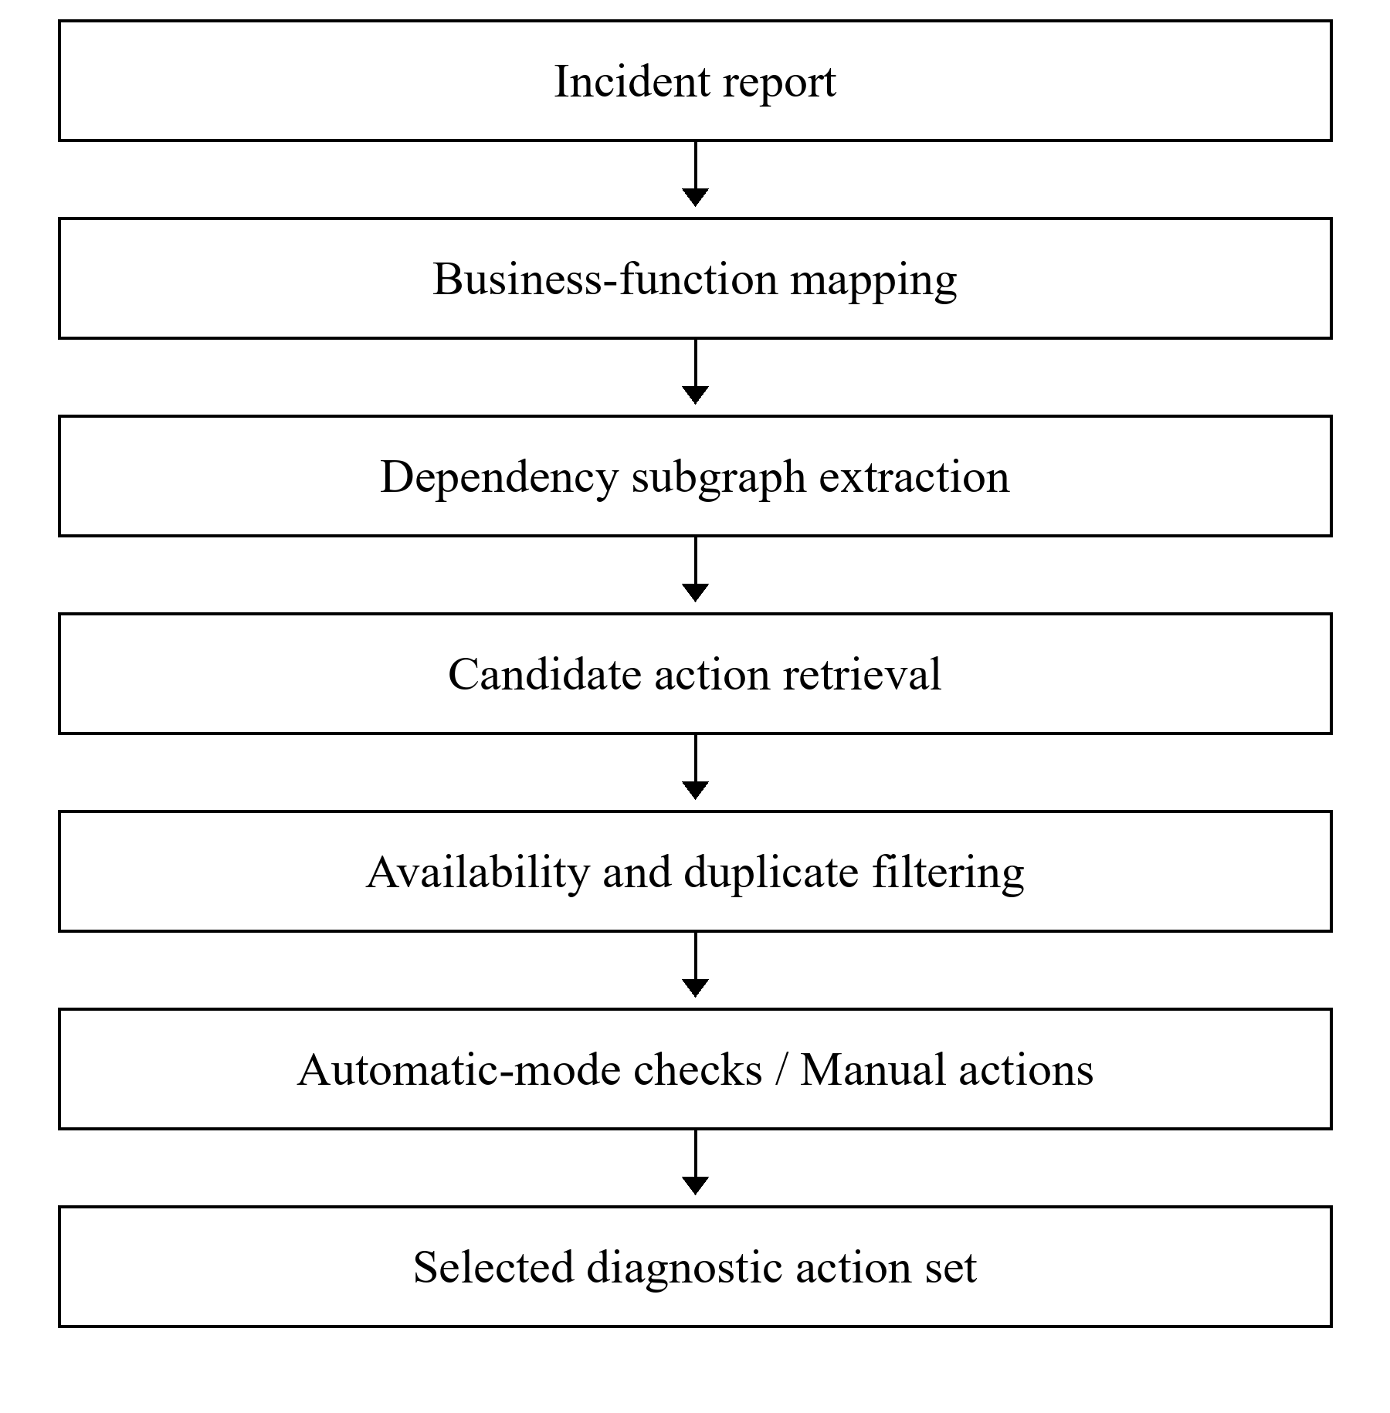
Fig. 1. Dependency-aware diagnostic check selection workflow.
4.1. Diagnostic Check Model
Diagnostic actions differ both in the information they provide and in the way they are performed. Each action is assigned to a specific infrastructure node or physical link, so the selection procedure can retrieve only the operations associated with the relevant part of the dependency structure.
For a node v, the associated diagnostic set is
$$C(v) = \{c_{1,} c_{2,} …, c_{k}\}$$
Each action is described by the tuple
$$c = ⟨target, type, mode, cost, result⟩$$
The attribute target identifies the node or physical link being verified. The type field specifies the diagnostic mechanism. The mode field distinguishes automatic and manual operations, while cost represents relative verification effort. The result field is reserved for the diagnostic outcome. The implementation additionally records explicit action scope and manual-action prerequisites.
For the considered infrastructures, diagnostic actions are grouped into four practical categories.
Table 1
Diagnostic action categories used in the proposed method
Check category | Typical mechanisms | Example target
Reachability checks | ICMP, TCP connection | Router, switch, server, printer
Service checks | TCP service, DNS query, application response | POS service, RDP service, DNS
Management and telemetry checks | SNMP, RouterOS API, controller query | Router, managed switch, access point
Manual actions | Device status, link inspection, PoE output, UPS output | UPS, PoE injector, unmanaged switch
Reachability checks establish whether an element can be contacted over the network, whereas service checks target a particular application or network service. Management and telemetry mechanisms provide more detailed device information when the equipment and its configuration support them. Manual actions are retained where no suitable programmable interface exists or where the physical state of the infrastructure must be verified directly.
Conventional monitoring tools can support ICMP and TCP checks (Zabbix LLC, n.d.), while MikroTik devices can expose SNMP and RouterOS API interfaces when enabled and configured (MikroTik, n.d.-a, n.d.-b).
Several checks may be associated with the same infrastructure element. A managed router, for example, may support ICMP, SNMP, and RouterOS API checks. These operations are not necessarily redundant because they expose different kinds of diagnostic information. Repeated instances of the same operation against the same target, however, are treated as duplicates and retained only once.
The execution mode is represented as
$$mode(c) ∈ \{automatic, manual\}$$
Automatic-mode checks are intended for programmatic execution once the required configuration is available. Manual actions instead describe the verification that must be carried out by an administrator or support engineer. In the present prototype, both types are selected, but no live checks are executed.
The diagnostic outcome belongs to the state set
$$result(c) ∈ \{available, unavailable, degraded, unknown\}$$
The unknown state is used when a check has not been executed, cannot be completed, or does not provide a reliable result.
4.2. Selection Procedure
Selection starts by relating the reported symptom to the affected business function. For example, a report that kitchen receipt printing is unavailable is mapped to the corresponding printing function, whereas failure to access the POS application is mapped to the POS service function.
Starting from the affected business functions B_{i}, the dependency graph is traversed along outgoing dependency edges. This traversal identifies the infrastructure elements whose operation may influence the reported function.
The incident-specific node set can be expressed as
$$V_{i} = B_{i} ∪ Dep(B_{i})$$
where Dep(B_{i}) denotes the set of infrastructure elements reachable from the affected business functions by following dependency relations.
The corresponding subgraph is
$$G_{i} = (V_{i,} E_{i})$$
Only actions whose node or link targets are relevant to G_{i} are initially considered:
$$C_{i}^{0} = \{c ∈ R_{site} : relevant(c, G_{i})\}$$
The candidate set C_{i}⁰ is then processed using deterministic selection rules.
First, actions whose targets are outside the incident-specific subgraph are excluded. Node-oriented actions require their target node to belong to V_{i}. Link-oriented actions require both endpoints and the corresponding dependency to belong to G_{i}.
Second, duplicate actions are removed. Actions with the same target, diagnostic mechanism, scope, and relevant parameters are treated as a single operation. For a physical connection, this means that one link inspection is recorded rather than separate inspections for its two endpoints.
Third, checks that are unavailable under the current infrastructure configuration are excluded. For example, an SNMP query is not selected when SNMP access has not been configured for the target device.
Manual actions remain distinct where they verify physical state that cannot be established by a network check. Selecting an ICMP check does not replace a link inspection, PoE output test, or UPS output-status observation.
The final selected set can therefore be represented as
$$C_{i} = Select(C_{i}^{0}, G_{i})$$
where Select denotes the deterministic filtering procedure described above.
The resulting action set is partitioned into automatic-mode and manual subsets:
$$C_{i} = C_{i}^{auto} ∪ C_{i}^{manual}$$
with
$$C_{i}^{auto} ∩ C_{i}^{manual} = ∅$$
The partition identifies the intended execution mode of each selected action. It does not prescribe an execution sequence or indicate that an action was performed during the evaluation.
A future execution stage could prioritize inexpensive checks before more detailed queries. One possible sequence is:
ICMP → TCP / DNS → SNMP / API → application-specific check
This ordering is illustrative only and was neither implemented nor evaluated in the present prototype. Execution policy and its effect on practical diagnostic effort remain subjects for future work.
Manual actions are accompanied by explicit verification instructions, such as checking UPS output, testing a PoE injector, inspecting a specific physical link, or observing device status indicators.
The complete selection procedure can therefore be summarized as follows:
Receive the incident I_{i}.
Map the reported symptom to the affected business-function set B_{i}.
Traverse the dependency graph and construct G_{i}.
Collect node-oriented and link-oriented actions relevant to G_{i}.
Remove irrelevant, duplicate, and unavailable checks.
Separate the remaining checks into automatic and manual subsets.
Return the selected action set with its targets, scopes, and execution-mode counts.
Retain action outcomes as unknown; no live checks are executed in this evaluation.
The method consequently reduces the diagnostic search space at two levels. First, the dependency graph restricts analysis from the entire infrastructure V to the incident-specific node set V_{i}. Second, the check-selection rules restrict the complete site check set C_{site} to the subset C_{i} required for the reported incident.
This relationship can be summarized as
$$|V_{i}| ≤ |V|$$
and
$$|C_{i}| ≤ |C_{site}|$$
with a greater reduction expected for localized incidents and a smaller reduction for incidents involving shared core dependencies.
5. PROTOTYPE IMPLEMENTATION
A lightweight Python prototype was developed to reproduce the dependency-aware check-selection procedure. It relies only on the Python standard library and does not use a database, web framework, or external monitoring platform. Infrastructure models, incident descriptions, diagnostic actions, and dependency annotations are stored in structured JSON files.
The prototype performs five main tasks: loading the infrastructure graph, mapping reported incidents to affected nodes, extracting the incident-specific dependency subgraph, retrieving the associated diagnostic actions, and filtering the resulting candidate set. Its purpose is to reproduce the selection logic rather than to serve as a production monitoring system.
Each site model defines the infrastructure nodes and their directed dependency relations. Diagnostic actions are stored separately from the graph itself. Automatic-mode actions are linked to supported node capabilities, whereas manual actions are defined explicitly for particular devices or physical links.
In the revised model, every diagnostic action has an explicit target and scope. Manual actions also specify the expected observation and any prerequisite needed to perform them. Generic power or cabling checks are not assigned automatically to every physical node; instead, each manual action represents a distinct diagnostic operation that can be identified independently.
Node-oriented manual actions include observing device status indicators, checking UPS output, and testing the PoE output of an injector. Physical connections are represented separately as link-oriented diagnostic actions. A cable between two endpoints therefore produces one inspection action rather than two checks counted independently at each end.
For a physical link between nodes v_{a} and v_{b}, its diagnostic target is represented conceptually as
$$L_{ab} = \{v_{a,} v_{b}\}$$
The endpoint pair is treated as unordered, so that the same physical link cannot be counted twice simply by reversing the endpoint order. Parallel physical links would require port-level identifiers, which are not available in the current site descriptions.
Camera connections follow the actual physical arrangement in which each camera is connected directly to a PoE port of its NVR. Each camera therefore has an ICMP check and one manual PoE/Ethernet inspection of the camera-to-NVR link. Separate generic camera power and cabling actions are not included.
Wireless access points follow the same principle. The PoE source and the physical cable are treated as separate diagnostic targets: the injector can have a PoE output test, while the AP-to-injector cable is represented by a single PoE/Ethernet link inspection. No additional generic AP power action is added.
The remotely hosted server in Restaurant A is not assigned local power or cabling actions because there is no corresponding physical target available to the site administrator. Its diagnostic actions are therefore limited to the network- and service-level operations represented in the model.
The prototype distinguishes between the complete structural candidate set and the enabled set available under the modeled configuration. For incident I_{i}, a node-oriented action is included in the candidate set if its target node belongs to V_{i}. A link-oriented action is included only if both endpoints and the corresponding dependency are part of the incident-specific subgraph.
The structural candidate set is denoted by
$$C_{i}^{0}$$
and the enabled incident-specific set is
$$C_{i} = \{c ∈ C_{i}^{0} : enabled(c) = true\}$$
The complete enabled check set for a site is defined similarly:
$$C_{site} = \{c ∈ R_{site} : enabled(c) = true\}$$
where R_{site} denotes the complete registry including both enabled and disabled diagnostic actions.
SNMP and RouterOS API actions require both declared device capability and the corresponding configuration parameters. These actions remain disabled in the evaluated models because the required configuration is not available. ICMP and TCP actions are retained as modeled automatic-mode checks, but the prototype does not send network requests to the real infrastructures. The execution-status counters therefore remain configured_automatic = 0 and executed = 0. This distinction separates model-enabled actions from configured live checks and makes clear that the evaluation concerns action selection rather than observed network states or execution time.
After revision of the check boundaries, the enabled site registry contains 61 diagnostic actions for Restaurant A and 73 for Restaurant B. Restaurant A contains 20 automatic-mode and 41 manual actions, while Restaurant B contains 25 automatic-mode and 48 manual actions.
The output of the prototype for each incident includes the relevant dependency subgraph, the structural candidate set C_{i}⁰, the enabled selected set C_{i}, and the number of automatic-mode and manual actions. These outputs are used directly in the evaluation presented in the following sections.
6. CASE STUDY
The case study uses two anonymized restaurant infrastructures, referred to as Restaurant A and Restaurant B. In both sites, network availability directly affects point-of-sale operations, receipt printing, wireless connectivity, video surveillance, and remote administration. The two infrastructures differ in server placement, endpoint distribution, and local switching structure, providing distinct dependency patterns for the evaluation.
Restaurant A connects to the Internet through an optical network terminal and a MikroTik router. A 24-port switch forms the main local-network distribution point, while an 8-port and a 4-port edge switch extend connectivity to endpoint groups outside the main equipment rack.
Wireless coverage is provided by three UniFi access points, each powered through an individual PoE injector in the equipment rack. The access points are managed through a UniFi controller hosted in the remote server environment.
The POS subsystem includes four POS terminals, a main cash-desk workstation, and four network receipt printers distributed across the main and edge-switch branches. Video surveillance is handled by a Dahua-type NVR with four cameras connected directly to its PoE ports.
Application services used by Restaurant A are hosted in a remote Windows Server environment. Consequently, the operation of the POS application and remote administrative access depends not only on the local router and switching infrastructure but also on the Internet connection, hosting environment, and corresponding remote services.
The router and main switch are protected by a dedicated network UPS, while the main cash-desk workstation uses a separate UPS. This introduces power dependencies that are relevant to incidents affecting several network or business functions simultaneously.
Restaurant B has a similar functional layout but a different local distribution structure. Its network includes a MikroTik router, a 24-port main switch, and three 4-port distribution switches. Four UniFi access points are powered through four PoE injectors. The POS subsystem contains five POS terminals, a main cash-desk workstation, and five network receipt printers.
Unlike Restaurant A, Restaurant B hosts its principal Windows Server component on premises. POS application and remote-access incidents can therefore involve the local server as well as the surrounding network path. Video surveillance is provided by a Hikvision-type NVR with five cameras connected directly to its PoE ports. The router and main switch share a network UPS, while the main cash-desk workstation uses a separate UPS.
The principal characteristics of the two infrastructures are summarized in Table 2.
Table 2
Characteristics of the case-study infrastructures
Characteristic | Restaurant A | Restaurant B
Internet gateway | MikroTik router | MikroTik router
Main switch | 24-port switch | 24-port switch
Additional switches | 1 × 8-port, 1 × 4-port | 3 × 4-port
Wireless access points | 3 UniFi APs | 4 UniFi APs
PoE injectors | 3 | 4
POS terminals | 4 | 5
Main cash-desk workstation | 1 | 1
Network receipt printers | 4 | 5
Server placement | Remotely hosted Windows Server | On-premises Windows Server
Video recorder | Dahua-type NVR | Hikvision-type NVR
Cameras | 4 | 5
Network UPS | Router and main switch | Router and main switch
Additional UPS | Main cash desk | Main cash desk
Camera connections | Direct to NVR PoE ports | Direct to NVR PoE ports
For the purposes of the diagnostic-check model, infrastructure elements were associated only with checks that are technically meaningful for their role. IP-addressable endpoints such as routers, servers, printers, access points, and network video recorders can be associated with reachability checks. Service dependencies such as the POS application, remote desktop access, and name resolution can additionally be associated with TCP, application-level, or DNS checks where applicable.
The MikroTik routers represent the most extensively observable infrastructure elements in the case study. In addition to basic reachability verification, they can potentially provide management information through SNMP and the RouterOS API (MikroTik, n.d.-a, n.d.-b). These interfaces are represented separately in the action registry, but their actions remain disabled in the evaluation because the required configuration is absent.
Network printers are associated with basic reachability and, where applicable, service-level checks. A failed printer check does not by itself establish that the printer is the source of the problem, because connectivity may also depend on an edge switch, the main switch, or the associated network and power path. These upstream elements are included through the dependency graph when they belong to the incident context.
Wireless access points are treated similarly. Their availability depends on the local switching path and PoE power supply. A failed access point may therefore require both an automatic network check and, if necessary, manual verification of the corresponding PoE injector.
Video-surveillance incidents are represented through dependencies between the business function, the NVR, cameras, network connectivity, and power-related elements. An incident affecting all surveillance channels differs diagnostically from the failure of a single camera because the former makes shared upstream dependencies more relevant.
Server placement creates one of the clearest differences between the two sites. In Restaurant A, a POS application incident may extend from the local network through the Internet gateway and provider connection to the remote hosting environment. In Restaurant B, the corresponding path reaches an on-premises server instead. The same user-visible symptom can therefore lead to different dependency subgraphs and different selected action sets.
6.1. Diagnostic Check Assignment
For the case-study evaluation, each relevant infrastructure element is associated with one or more diagnostic operations according to its type and available management interface. The assignment follows the check model introduced in Section 4.
The principal mapping used for the case study is shown in Table 3.
Table 3
Diagnostic checks/actions associated with case-study infrastructure elements
Infrastructure element | Diagnostic check/action | Mode
IP-addressable node, including each camera | ICMP reachability | Automatic
Application or printing service | TCP/application service check | Automatic
DNS dependency | DNS query | Automatic if configured
Capable managed device | SNMP query | Automatic if configured
MikroTik router | RouterOS API query | Automatic if configured
Device with local status indicators | Device status observation | Manual
Identified physical network link | Network link inspection | Manual
Camera–NVR or AP–injector link | PoE/Ethernet link inspection | Manual
PoE injector | PoE output test | Manual
UPS | UPS output status | Manual
Provider dependency | Provider status check | Manual
Automatic denotes the modeled execution mode, not a performed operation. DNS requires explicit configuration; SNMP and RouterOS API also require declared capability and remain disabled in the evaluated models. Each camera has an ICMP check and one camera–NVR PoE/Ethernet link inspection. Manual link inspections are counted once per physical link. No local physical power or cabling actions are assigned to HostedServer-1.
The assignment does not imply that the listed actions are executed. The complete registry includes structural candidates, including disabled interfaces; availability filtering produces the enabled site set and incident-specific selected set. The evaluation reports selection only.
Consider the failure of two kitchen printers in Restaurant A. Checks of the video-surveillance subsystem or unrelated access points add no useful information to this incident. The relevant actions instead follow the printers' dependency paths and cover the printers themselves together with the network and power elements on which they depend.
A simultaneous failure of several LAN- and Internet-dependent business functions produces a different situation. The relevant subgraph becomes broader because shared elements such as the main switch, router, network UPS, or provider connection may contribute to several observed symptoms at once. As a result, fewer actions can be excluded from the incident context.
These two sites therefore provide both localized and infrastructure-wide incident patterns. This allows the evaluation to examine whether the proposed method reduces the check set substantially for local failures while retaining a broader diagnostic context when the observed symptoms indicate a shared upstream dependency.
7. EVALUATION SCENARIOS AND METRICS
The prototype was evaluated using six reconstructed incident scenarios, three for each restaurant. The scenarios cover both localized failures and incidents involving shared upstream dependencies. Their purpose is to assess the behavior of the check-selection procedure rather than root-cause identification accuracy.
Table 4 summarizes the evaluated scenarios.
Table 4
Evaluation scenarios used for diagnostic check selection
Scenario | Site | Reported incident | Dependency context
A1 | Restaurant A | Both kitchen receipt printers unavailable | Shared edge-switch branch
A2 | Restaurant A | POS application unavailable | Remotely hosted application path
A3 | Restaurant A | All video-surveillance channels unavailable | NVR-centered surveillance path
B1 | Restaurant B | Two terrace POS terminals and two kitchen printers unavailable | Shared edge-switch branch
B2 | Restaurant B | POS application and RDP unavailable | Local server path
B3 | Restaurant B | Multiple LAN- and WAN-dependent business functions unavailable simultaneously | Shared core network and power dependencies
For each scenario, the prototype first determines the incident-specific dependency subgraph G_{i} and constructs the structural candidate check set C_{i}⁰. Disabled or unavailable actions are subsequently removed to obtain the final selected set C_{i}.
Three primary quantities are recorded for each scenario. The first is the number of all enabled diagnostic actions defined for the corresponding site:
$$N_{site} = |C_{site}|$$
The second is the number of structural candidate actions before availability filtering:
$$N_{candidate,i} = |C_{i}^{0}|$$
The third is the number of enabled diagnostic actions selected for the incident:
$$N_{selected,i} = |C_{i}|$$
The principal evaluation metric is the reduction of the modeled diagnostic action space relative to the complete enabled site registry:
$${Reduction}_{i} = 100 × (1 - \frac{|C_{i}|}{|C_{site}|})$$
A larger value indicates that a smaller fraction of the site's defined diagnostic actions must be considered for the particular incident.
The selected set is also divided by execution mode:
$$C_{i} = C_{i}^{auto} ∪ C_{i}^{manual}$$
with
$$C_{i}^{auto} ∩ C_{i}^{manual} = ∅$$
The corresponding counts are
$$N_{auto,i} = |C_{i}^{auto}|$$
and
$$N_{manual,i} = |C_{i}^{manual}|$$
In this evaluation, the automatic/manual distinction describes the execution mode assigned to each diagnostic action in the model. It does not mean that automatic-mode actions were actually executed against live infrastructure. Network execution, timing measurements, and observed diagnostic states are outside the scope of the experiment; the prototype operates on modeled infrastructure and configuration data.
The evaluation therefore examines how much the incident-specific dependency context can reduce the modeled diagnostic action space while retaining the automatic and manual operations associated with the relevant dependency paths.
8. RESULTS AND DISCUSSION
The results of the six evaluation scenarios are presented in Table 5. The complete enabled diagnostic registry contained 61 actions for Restaurant A and 73 actions for Restaurant B. Depending on the incident, the dependency-aware procedure selected between 7 and 17 actions.
Table 5
Diagnostic check selection results
Scenario | C_{site} | C_{i}⁰ | C_{i} | Automatic | Manual | Reduction, %
A1 | 61 | 15 | 10 | 2 | 8 | 83.61
A2 | 61 | 16 | 9 | 3 | 6 | 85.25
A3 | 61 | 16 | 13 | 5 | 8 | 78.69
B1 | 73 | 21 | 16 | 4 | 12 | 78.08
B2 | 73 | 11 | 7 | 3 | 4 | 90.41
B3 | 73 | 25 | 17 | 6 | 11 | 76.71
Across the six scenarios, the method reduced the modeled diagnostic action space by an average of 82.13%. The selected sets contained 12 actions per incident on average, with 72 actions selected across all scenarios: 23 automatic-mode checks and 49 manual actions.
The strongest reduction occurred in scenario B2, where the failure involved the POS application and RDP access associated with the local server. Only 7 of the 73 enabled actions defined for Restaurant B remained relevant, corresponding to a reduction of 90.41%. The selected set was concentrated around the local server, its connection to the main switch, the switch itself, and the shared network UPS. A similar pattern appears in scenario A2, although the dependency path is broader because the application is remotely hosted. In that case, 9 of 61 actions were selected, giving an 85.25% reduction, with the relevant context extending through the local router, ONT, provider dependency, network UPS, and remote hosting environment.
Scenario A1 also produced a compact action set. The two affected kitchen printers share the same edge-switch branch, and only 10 of the 61 enabled site actions were selected, corresponding to an 83.61% reduction. The incident context therefore remains limited to the printers, their shared branch, and the upstream network and power elements required for that branch, without expanding into unrelated wireless or surveillance infrastructure.
Broader incidents naturally retained more of the site registry. In scenario A3, where all four surveillance channels were unavailable, the selected set contained 13 actions and the reduction decreased to 78.69%. The relevant context includes the camera paths, their PoE/Ethernet links to the NVR, the NVR itself, its connection to the main switch, and the associated upstream infrastructure. Five of the selected actions were automatic-mode checks and eight were manual actions.
Scenario B1 produced a comparable reduction of 78.08%, with 16 selected actions. Here, two terrace POS terminals and two kitchen printers depend on the same edge-switch branch, so several endpoint checks and physical-link actions must be retained together with their shared upstream dependencies.
The broadest diagnostic context was observed in scenario B3. Multiple LAN- and WAN-dependent business functions were unavailable simultaneously, causing shared core elements such as the local server, main switch, router, network UPS, endpoint branches, and associated diagnostic links to become relevant at the same time. The method selected 17 of the 73 enabled actions, resulting in the lowest reduction among the six scenarios, 76.71%. Even in this case, however, more than three quarters of the modeled site-wide action registry was excluded from the incident-specific set.
Taken together, the scenarios show that the size of the selected action set depends mainly on the structural scope of the reported incident. Localized service or branch failures produce compact dependency subgraphs and allow a larger portion of the site registry to be excluded. When several business functions depend on shared core infrastructure, the relevant subgraph expands and the reduction becomes smaller.
The distribution between automatic and manual actions reflects the characteristics of the two case-study sites. Of the 72 actions selected across all scenarios, 23 were classified as automatic-mode checks and 49 as manual actions. This distribution is largely explained by the presence of unmanaged or partially managed equipment, physical network links, PoE injectors, UPS devices, and local status indicators that cannot be represented solely by remotely executable queries. The revised model therefore treats these physical operations explicitly: a physical link has one bounded inspection action, a PoE injector has a specific output test, and a UPS has an output-status observation. Generic power and cabling actions that could count the same physical verification more than once are not used.
The reduction values should be interpreted as changes in the size of the modeled diagnostic action space. They do not represent measured reductions in administrator effort, incident-resolution time, or computational cost. Automatic-mode actions were selected by the prototype but were not executed against live infrastructure, and SNMP and RouterOS API actions remained disabled because the required configuration was not available. The evaluation is therefore preliminary; validation with observed operational incidents and configured live diagnostic targets is needed to determine whether the reduction in modeled actions also reduces diagnostic effort in practice.
9. CONCLUSIONS
This study presented a dependency-aware method for selecting diagnostic checks in small distributed network infrastructures. The method maps a reported incident to affected business functions, extracts the corresponding dependency subgraph, and selects only those diagnostic actions whose targets are relevant to the resulting incident context.
A lightweight Python prototype was developed to reproduce the proposed procedure using structured models of two anonymized restaurant infrastructures. The prototype distinguishes node-oriented and link-oriented diagnostic actions and separates automatic-mode checks from manual verification procedures. Each action has an explicitly defined target and scope, which avoids double-counting physical links or representing the same power dependency as several independent checks.
The evaluation used six reconstructed incident scenarios representing localized endpoint failures, server-related service failures, video-surveillance incidents, shared edge-switch failures, and broader infrastructure-level disruptions. Depending on the scenario, the method selected between 7 and 17 enabled actions from complete site registries containing 61 and 73 actions. The reduction of the modeled diagnostic action space ranged from 76.71% to 90.41%, with an average reduction of 82.13%.
The results show that the degree of reduction depends on the structural scope of the reported incident. Localized service failures produce compact dependency subgraphs and smaller selected check sets, whereas incidents involving shared upstream dependencies require a broader diagnostic context.
The reported reduction concerns the number of diagnostic actions defined by the model and should not be interpreted as a measured reduction in troubleshooting time or incident-resolution time. Automatic-mode checks were selected by the prototype but were not executed against live devices in the reported evaluation. SNMP and RouterOS API actions remained disabled because the corresponding configuration was not provided.
Future work should extend the prototype with configured live diagnostic targets and evaluate the method using observed operational incidents. This would make it possible to study not only check-set reduction but also execution ordering, diagnostic effort, and the practical effect of dependency-aware selection on incident-resolution procedures.
REFERENCES
Bahl, P., Chandra, R., Greenberg, A., Kandula, S., Maltz, D. A., & Zhang, M. (2007). Towards highly reliable enterprise network services via inference of multi-level dependencies. Proceedings of the 2007 Conference on Applications, Technologies, Architectures, and Protocols for Computer Communications, 13–24. Association for Computing Machinery. https://doi.org/10.1145/1282380.1282383
Brandón, Á., Solé, M., Huélamo, A., Solans, D., Pérez, M. S., & Muntés-Mulero, V. (2020). Graph-based root cause analysis for service-oriented and microservice architectures. Journal of Systems and Software, 159, 110432. https://doi.org/10.1016/j.jss.2019.110432
Diaz-de-Arcaya, J., Torre-Bastida, A. I., Zárate, G., Miñón, R., & Almeida, A. (2024). A joint study of the challenges, opportunities, and roadmap of MLOps and AIOps: A systematic survey. ACM Computing Surveys, 56(4), Article 84. https://doi.org/10.1145/3625289
MikroTik. (n.d.-a). API. RouterOS Manual. Retrieved September 27, 2026, from https://manual.mikrotik.com/docs/developer-guides/api/
MikroTik. (n.d.-b). SNMP. RouterOS Manual. Retrieved September 27, 2026, from https://manual.mikrotik.com/docs/diagnostics-monitoring-and-troubleshooting/snmp/
Soldani, J., & Brogi, A. (2023). Anomaly detection and failure root cause analysis in (micro)service-based cloud applications: A survey. ACM Computing Surveys, 55(3), Article 59, 1–39. https://doi.org/10.1145/3501297
Steinder, M., & Sethi, A. S. (2004). A survey of fault localization techniques in computer networks. Science of Computer Programming, 53(2), 165–194. https://doi.org/10.1016/j.scico.2004.01.010
Wu, L., Tordsson, J., Elmroth, E., & Kao, O. (2020). MicroRCA: Root cause localization of performance issues in microservices. NOMS 2020 – 2020 IEEE/IFIP Network Operations and Management Symposium, 1–9. IEEE. https://doi.org/10.1109/NOMS47738.2020.9110353
Xin, R., Chen, P., & Zhao, Z. (2023). CausalRCA: Causal inference based precise fine-grained root cause localization for microservice applications. Journal of Systems and Software, 203, 111724. https://doi.org/10.1016/j.jss.2023.111724
Yu, Q., Zhao, N., Li, M., Li, Z., Wang, H., Zhang, W., Sui, K., & Pei, D. (2024). A survey on intelligent management of alerts and incidents in IT services. Journal of Network and Computer Applications, 224, 103842. https://doi.org/10.1016/j.jnca.2024.103842
Zabbix LLC. (n.d.). Simple check. Zabbix Documentation. Retrieved September 27, 2026, from https://www.zabbix.com/documentation/8.0/en/manual/config/items/itemtypes/simple_checks

Conflict of Interest.
The authors declare no conflicts of interest.
Funding.
This research received no external funding.
AI Disclosure Statement.
OpenAI ChatGPT was used to assist with language editing, stylistic revision, and manuscript preparation. The research design, infrastructure models, prototype implementation, experimental data, numerical results, their interpretation, and final verification were performed and approved by the authors. The authors take full responsibility for the content of the manuscript.

UDC 004.4
DOI:
Oleksandr PANKRATOV, PhD student
ORCID ID: 0009-0004-2082-1436
e-mail: oleksandrpankratov40@gmail.com
National Technical University of Ukraine
“Igor Sikorsky Kyiv Polytechnic Institute”, Kyiv, Ukraine

THE MATCHER IS PART OF THE VERDICT: MEASUREMENT CONDITIONS OF LOG-BASED RE-QUALIFICATION DECISIONS ACROSS SOFTWARE VERSIONS
Log-based re-qualification decisions can use the disappearance of old message templates as a signal that an existing detector needs reassessment after a software version change. We examine how the resulting threshold verdict depends on the template matcher and on the amount and composition of the collected logs. The analysis uses locally retained container logs, public multi-version Hadoop and Spark data, and industrial failure-message and console caches. The evidence comprises 44 release-pair and evidence configurations across six named software systems and an industrial test archive, with unequal instrument coverage. The analysis includes 12 distinct judge configurations. At an illustrative disappearance threshold of 0.10, the measured ordinary-disappearance envelope crosses the threshold for five of 12 core configurations (ten release/evidence comparisons plus two normal-only public strata), including four of the ten comparisons. The 26B configurations with and without quantization-aware training (QAT) disagree on 19 of 259 item occurrences but change none of the 12 point labels. Public split-half and industrial campaign-matched resampling show that exposure and workload composition can produce substantial disappearance within a release. Industrial judging covers four of nine failure-message configurations and leaves three of 44 distinct model–configuration outcomes unresolved at the population level. We therefore report label stability, instrument coverage, and control comparability separately. The resulting procedure documents sensitivity and missing evidence; it does not establish detector accuracy, deployment safety, or a causal release effect.
Keywords: log analysis, template matching, software evolution, measurement reliability, re-qualification, large language models, exposure matching.

Introduction
After an upgrade, a detector trained on incumbent logs may face changed templates. Comparison can identify evidence for inspection before reuse, but disappearance may reflect a removed event, wording or parser change, or an unexercised event. These explanations differ for a detector although exact template comparison counts them identically. In the illustrative rule studied here, REJECT flags a comparison for detector reassessment before reuse; the label alone does not determine whether retraining or deployment is appropriate.
Log information evolves across releases (Shang et al., 2014), and LogRobust addresses detection under unstable logs (Zhang et al., 2019). Parsing affects downstream input: parsing accuracy alone need not predict detection accuracy (Khan et al., 2024), while task-relevant semantics can matter under industrial constraints (Sun et al., 2026). Matching is therefore part of the measurement specification for a template-comparison decision.
We study the point label assigned when disappeared old templates exceed a selected threshold, asking whether it changes with measured matching settings or available within-release controls. PASS means only that one measured rate is at or below the threshold, not that a detector remains accurate or deployment is safe.
The aim is to measure verdict sensitivity to matching and exposure conditions. We audit heterogeneous retained data with explicit denominators, setting coverage, and unresolved populations; the reporting procedure keeps missing measurements and incomparable controls alongside the point label.

Related work
Kabinna et al. (2018) directly study the stability of source-code logging statements across versions. That established line of work concerns statement evolution; observed template disappearance also depends on execution exposure, parsing, and matching. Our contribution concerns threshold sensitivity under these measurement conditions.
EvLog identifies anomalous logs across software evolution (Huo et al., 2023), and FlexLog studies data-efficient detection on unstable logs and supplies the redistributed Hadoop/Spark evidence (Hadadi et al., 2026). Their outcomes motivate the application, but do not validate the illustrative threshold.
Drain is an online fixed-depth parser (He et al., 2017); LILAC uses an adaptive LLM cache (Jiang et al., 2024); LPB-Gen addresses benchmark generation and ground truth (Dai et al., 2026); and LogBase evaluates semantic parsing across domains (Zhang et al., 2025). We hold retained template sets fixed and vary the survival relation, so a matching judgment is not parsing ground truth.
Shin et al. (2021) connect parsing abstractions to detection; Khan et al. (2024) and Sun et al. (2026) motivate empirical downstream evaluation. We measure threshold sensitivity; detector degradation and operational calibration require additional evidence.
LLM-as-judge studies document position, verbosity, and self-enhancement biases (Zheng et al., 2023), as well as prompt sensitivity and uneven human alignment across judges (Thakur et al., 2025). Agreement obtained in those evaluation tasks does not validate log-template correspondence. Here, we treat agreement with labels assigned by one author and agreement among judges as descriptive checks.
Language-model matching depends on retrieval and decision wording: retrieval can omit a relevant template and a permissive rule can accept a lossy correspondence. Adversarial log text poses a separate risk for language-model interpretation (Landauer et al., 2026), so adversarial trials are excluded from the ordinary-disappearance envelope. The embedding matcher uses Nomic Embed (Nussbaum et al., 2024); its general embedding performance does not validate log-template equivalence.
The scientific novelty is the joint characterization of matching and exposure sensitivity in the retained cross-version evidence, with explicit population bounds for capped judgments and a reporting procedure that separates measured label stability, instrument coverage, and control comparability.

Materials and methods
Each release-pair and evidence configuration specifies product, stream, workload or stratum, parser, masking, and exposure. Pooled and normal-only public data share releases; failure messages and console output are different industrial streams. Thus 44 counts evidence rows, not independent software changes.
Let T_{old} and T_{new} be the retained sets of distinct masked templates. Let G be the number of old templates absent from the new set and N the number of old templates. The exact syntactic rate is
$$d_{syn}=\frac{\left|T_{old}∖T_{new}\right|}{\left|T_{old}\right|}=\frac{G}{N}(1)$$
For a directional matching instrument I, A_{I} is the number of disappeared old templates accepted as covered by a new template. Its adjusted rate is
$$d_{I}=\frac{G-A_{I}}{N}≤d_{syn}(2)$$
A many-to-one correspondence is allowed. The rule asks whether the same event or failure is represented, rather than whether every detail of the old message survives. The adjusted rate is thus a lenient disappearance measure under the stated correspondence rule. It does not measure event frequency, information loss, or preservation of features needed by a detector. Zero syntactic disappearance produces zero adjusted disappearance algebraically, without requiring judge calls.
For either measured disappearance rate d, the illustrative point rule is REJECT when d > τ and PASS otherwise, with τ = 0.10. We call the resulting PASS/REJECT point label a threshold verdict. This threshold is selected for sensitivity analysis and has not been calibrated against deployment outcomes. We use exact integer fractions where counts are available and rounded exported rates only where counts are unavailable. An empty old set has no defined rate and cannot receive a PASS by default.

Sources and coverage
Table 1. Evidence groups and configuration counts
Evidence group | Rows | Scope
Core comparisons | 12 | 10 comparisons and 2 normal-only strata
ZooKeeper | 5 | 4 adjacent release pairs and 3.5→3.9
PG/MySQL chain | 8 | 6 PostgreSQL and 2 MySQL pairs
Failure messages | 9 | Campaign-matched resampling
Console | 10 | Selected cached console stream
Total | 44 | Release-pair and evidence configurations
The 12 core configurations used for cross-instrument comparison comprise ten release/evidence comparisons plus Hadoop and Spark strata restricted to sessions labeled normal. Container and public comparisons have different exposure mechanisms and are not independent replications of one experiment.
Table 1 groups the comparisons. The six named systems are PostgreSQL, MySQL, Cassandra, Hadoop, Spark, and ZooKeeper; industrial comparisons are anonymized. Instrument coverage varies across evidence rows, and neither the 44-row evidence base nor the judge inventory is fully crossed.
Industrial failure messages contain 24,638 valid cached records. Console analysis uses 3,074 cached entries with distinct identifiers; each matches a hash-verified test-result record in the local archive. Original console bytes remain unavailable, preventing independent extraction replay; cached parsing and downstream comparisons support reanalysis.

Matching instruments and response handling
The lexical matcher accepts an old template when its highest difflib SequenceMatcher ratio against the new set reaches 0.60, 0.75, or 0.90. The embedding matcher uses nomic-embed-text v1.5 cosine similarity at 0.80, 0.85, 0.90, and 0.95. Both top-three lexical candidates and the complete new set were evaluated for embedding matching. These eight settings are distinct measurements; their observed minimum and maximum form a descriptive envelope.
We analyze 11 local judge configurations and one hosted configuration. Local configurations comprise Gemma 4 E2B, E4B, 12B, 26B with quantization-aware training (QAT), 26B without QAT, and 31B; Qwen 2.5 3B; and Qwen 3.8 27B at IQ4_XS, Q4_K_S, Q4_K_M, and Q4_K_XL. A second name for Qwen IQ4_XS refers to the same configuration and is counted once. The hosted configuration is recorded as Claude Opus 5.5. Exact historical model-weight digests and complete serving versions are unavailable, and size, quantization, training, and serving configuration were not independently manipulated factors.
Default judge retrieval uses three lexical candidates from the full new set. The MySQL 5.7→8.0 comparison uses all 13 new templates. The judge prompt for ordinary disappearance (non-adversarial matching from old to new templates) includes a wrapped-exception rule: the same root failure and failing operation may denote the same event despite a changed reporting wrapper. Additional settings vary retrieval depth, this clause, and sampling temperature. The measured finite envelope includes these settings and repeats, excluding reverse-direction appearance and adversarial-injection trials.
Local calls use an 8,192-token context request and request disabled thinking. Gemma calls use temperature 0.1; Qwen calls use temperature zero and seed 42. A separate repeatability setting uses temperature 0.7. The driver can remove the thinking parameter when a server rejects it, so the request alone does not prove identical inference behavior across models. Hosted sampling is not assumed to match the local server. Batch responses that fail formatting are re-asked individually. A persistent PARSE_FAIL counts as a missing judgment, rather than semantic rejection; the population bounds below include this uncertainty.

Exposure and control construction
Public rarefaction draws equal session counts per release at n = 50, 100, 200, 500, 1,000, and 2,000 where available, with ten seeds. Within-release comparisons use disjoint old-release samples of the same n. These subsampled controls cannot be joined directly to full-corpus measurements at different exposure.
Industrial comparisons group related test runs by recorded campaign identifier, then balance run counts within identifiers present in both releases before mining templates separately. Failure messages retain 20 cross-version draws and console ten. Equal counts do not guarantee equal workloads, outcome composition, logging configuration, or rare-event coverage.
Adjacent builds within a release are descriptive controls. They may differ in executable content and campaign composition, so they do not establish a no-code-change null. The five ZooKeeper and three retained PostgreSQL/MySQL chain repetitions show zero syntactic disappearance under their saved container workloads; this does not establish general repeatability or make them interchangeable with industrial campaigns. Control suitability is recorded before interpreting a release comparison.

Author labels and study scope
A fixed sheet contains 45 items labeled by one author: four PostgreSQL, eleven Spark, and thirty Hadoop items. It is a convenience sample, not a random sample of release transitions. For this agreement analysis, all judges use the same fixed top-three candidate bundles, selected with a 0.35 lexical floor; their prompts and response handling differ. Agreement with these labels is measured using confusion counts, raw agreement, and Cohen’s κ (Cohen, 1960). The sheet cannot validate the semantic matcher on unseen systems or quantify inter-annotator reliability.

Use of artificial intelligence
Language models are measurement instruments in the retained judge and embedding lanes described above. They did not supply the author’s labels. In preparing the paper, GPT-6 Luna was used in the review process and as an assistant in the scripts that executed experiments and analysis creation. Numerical anchors were recomputed from local records. No missing experiments, controls, or citations were generated to fill coverage gaps. Figures are plots of measured data. The author remains responsible for verification and the final submitted text.

Results

Sensitivity on the core configurations
Table 2. Exact-count rates for selected instruments in the 12 core configurations
Configuration | N / G | Syntactic | 26B QAT | 31B
PostgreSQL 12→16 | 35 / 4 | 0.1143 | 0.0571 | 0.0286
MySQL 5.7→8.0 | 50 / 50 | 1.0000 | 0.8000 | 0.8200
Cassandra 3.11→4.1 | 126 / 71 | 0.5635 | 0.4127 | 0.3810
Hadoop pooled | 225 / 66 | 0.2933 | 0.1733 | 0.1511
Hadoop normal | 143 / 15 | 0.1049 | 0.0769 | 0.0559
Spark pooled | 117 / 14 | 0.1197 | 0.0684 | 0.0684
Spark normal | 95 / 4 | 0.0421 | 0.0316 | 0.0211
PG 12.5→12.10 | 32 / 2 | 0.0625 | 0.0312 | 0.0312
PG 12.10→12.15 | 32 / 2 | 0.0625 | 0.0312 | 0.0312
MySQL 8.0.11→.20 | 11 / 3 | 0.2727 | 0.2727 | 0.2727
MySQL 8.0.20→.30 | 12 / 3 | 0.2500 | 0.0833 | 0.0833
Cassandra 3.11.0→3.11 | 115 / 25 | 0.2174 | 0.0957 | 0.0435
Table 2 reports selected instruments for every core configuration, including the normal-only strata. The exact rate for PostgreSQL 12→16 is 4/35 = 0.1143; the 26B QAT judge gives 2/35 = 0.0571 and the 31B judge gives 1/35 = 0.0286. Thus the selected point label changes from syntactic REJECT to adjusted PASS. The MySQL 8.0.20→8.0.30 comparison similarly changes from 3/12 = 0.2500 to 1/12 = 0.0833 under the QAT judge. Cassandra 3.11.0→3.11 changes from 25/115 = 0.2174 to 11/115 = 0.0957.
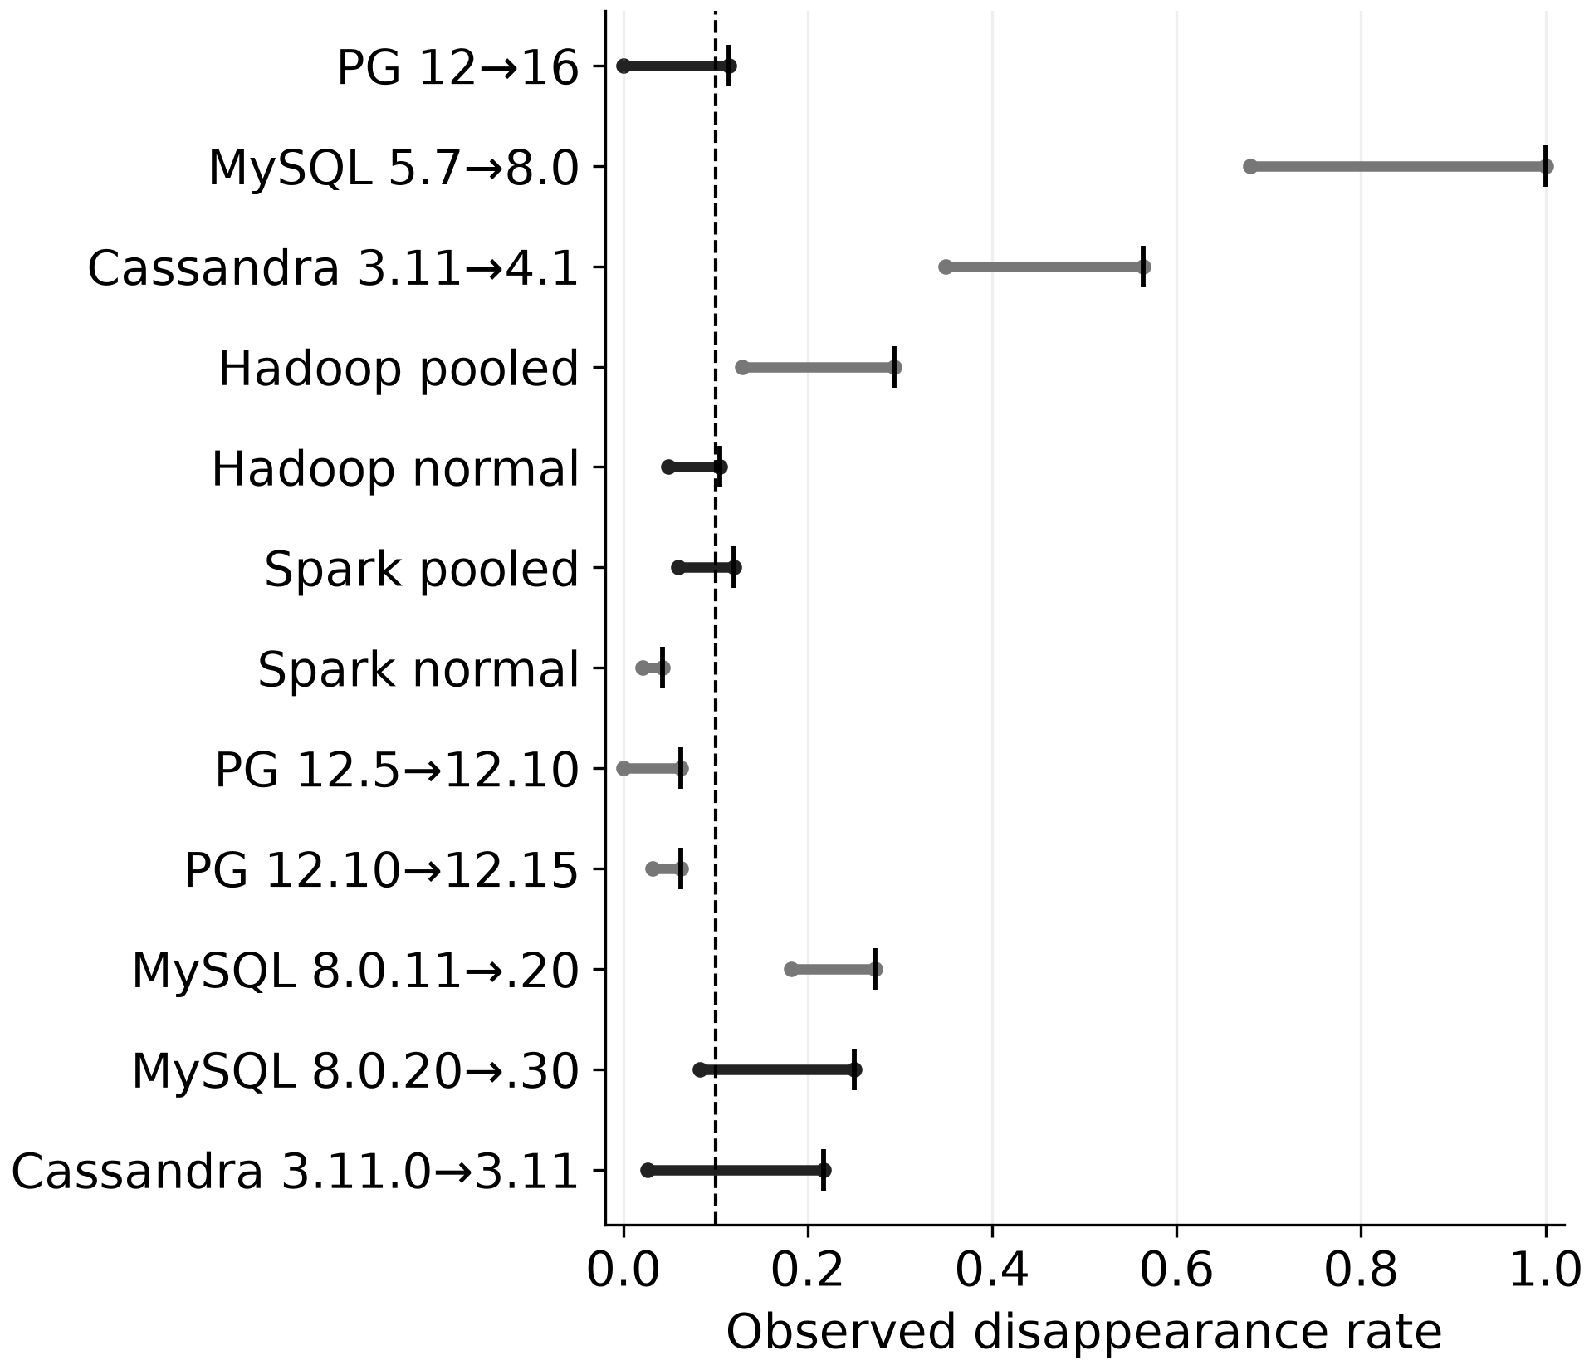
Figure 1. Observed ordinary-disappearance envelopes for the 12 core configurations. The dashed line marks τ = 0.10; ticks mark exact syntactic rates. Ranges include the syntactic baseline and measured ordinary matching settings and repeats; they are not confidence intervals.
Across the broader measured envelope, five core configurations have both a definite PASS and a definite REJECT: PostgreSQL 12→16, pooled Spark, normal-only Hadoop, MySQL 8.0.20→8.0.30, and Cassandra 3.11.0→3.11. Four belong to the ten release/evidence comparisons; the fifth is the normal-only Hadoop stratum. Increasing the number of settings reveals additional sensitivity; it does not estimate the probability that an unmeasured setting would produce either label.
With small template sets, one binary judgment changes d_{I} by 100/N percentage points: 2.86 at N = 35, 3.13 at N = 32, 8.33 at N = 12, and 9.09 at N = 11. The MySQL change from 3/12 to 1/12 involves two judgments; changing 1/12 to 2/12 would alone cross τ = 0.10. Such flips need not represent large or independent changes in software behavior.
Table 3. Number of instrument-sensitive core configurations by threshold
τ | 10 comparisons | 12 incl. strata
0.05 | 4 | 5
0.10 | 4 | 5
0.15 | 3 | 3
0.20 | 4 | 4
0.25 | 2 | 2
0.30 | 0 | 0
Table 3 shows threshold-dependent sensitivity. Among the ten release/evidence comparisons, four are sensitive at τ = 0.05, 0.10, and 0.20, but only three at 0.15. Counts need not decline monotonically because different envelopes straddle different thresholds. Zero at 0.30 means no observed crossings, not equal rates or deployment suitability.
The public strata differ: Hadoop syntactic disappearance is 0.2933 for pooled sessions and 0.1049 for normal-only sessions; Spark gives 0.1197 and 0.0421. These are views of the same release pairs. A semantic PASS on the normal-only stratum cannot be generalized to pooled sessions.

Judge configurations and agreement with one author's labels
The QAT/non-QAT 26B comparison has 19 differing verdicts among 259 occurrences, raw agreement 0.9266 and κ = 0.8423, with zero label changes across the 12 core configurations. Item and threshold disagreement therefore differ. Candidate bundles are unavailable for some occurrences, so duplicate sensitivity cannot be reconstructed from identical old strings alone; the count is descriptive, not 259 independent judgments.
On the MySQL 8.0.20→8.0.30 comparison, Qwen IQ4_XS gives 0.2500 and Q4_K_M gives 0.0833. This serving-configuration contrast does not isolate causal quantization effects from other implementation differences or stochastic responses. A model name or nominal size cannot identify the measurement.
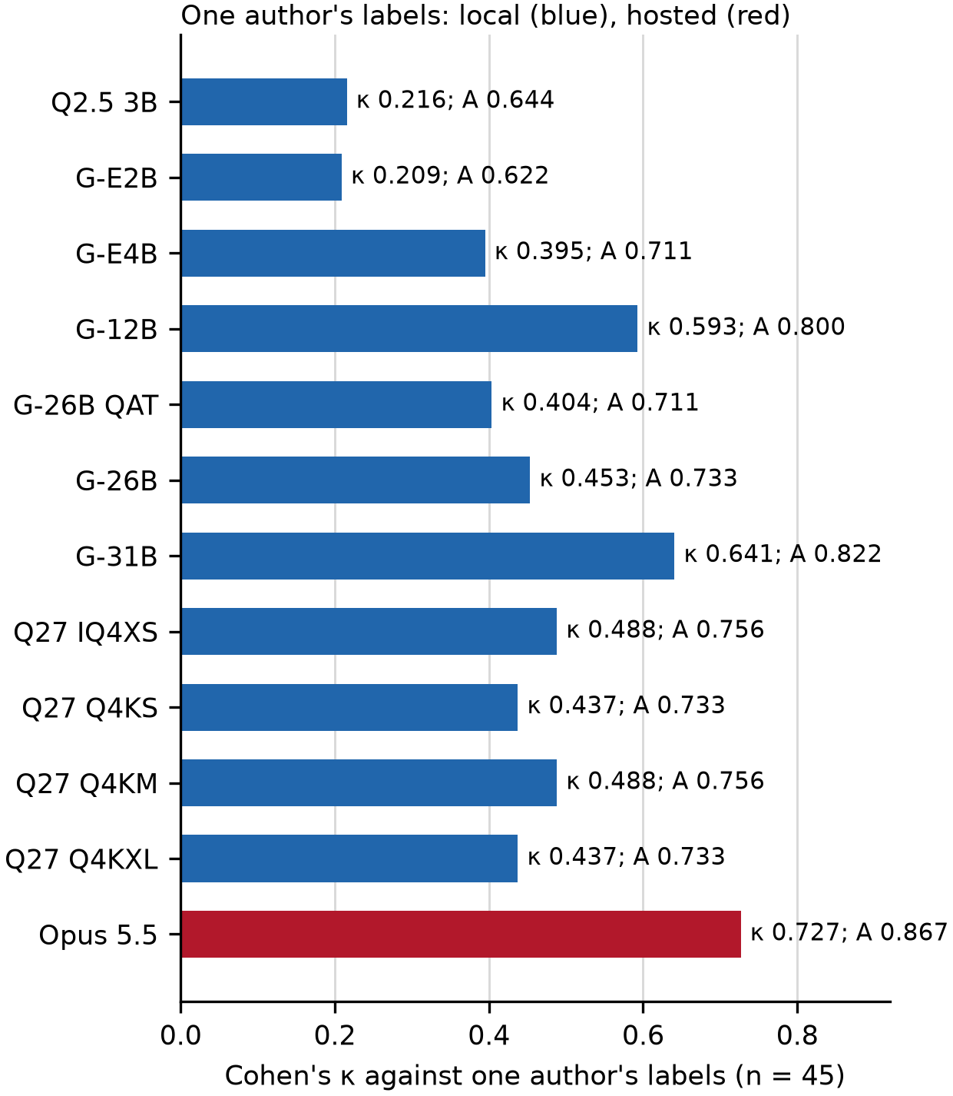
Figure 2. Agreement with labels assigned by one author to 45 selected items across 12 judge configurations. Blue denotes local judges and red the hosted judge; A denotes raw agreement. Cohen’s κ describes these items, not population accuracy.
Only four of the 45 labeled items are from PostgreSQL, and no independent adjudication or inter-annotator agreement is available. Figure 2 therefore cannot establish general semantic validity or support reliable source-level comparisons.

Extension coverage and capped industrial judging
ZooKeeper 3.5→3.6 has N = 36 and G = 4. Its 12B rate is 1/36 = 0.0278 and its 26B QAT rate is 3/36 = 0.0833. The 31B rate is zero. Opus was not evaluated on this chain. The measured envelope crosses the threshold for 3.5→3.6 and 3.5→3.9. In the PostgreSQL/MySQL chain, PostgreSQL 16→18.4 is sensitive, while all measured judges give PASS at 0.0769 for MySQL 8.0→8.4.
Industrial judging is not fully crossed with the campaign-matched resampling. The failure-message export judges at most 60 disappeared templates, selected deterministically from the campaign-matched draw generated with seed 0. Let m be the judged count, a the definite YES count, and p the unresolved or parse-fail count; m − a − p is the definite NO count. The full-population adjusted rate obeys
$$\frac{m-a-p}{N}≤d_{I}≤\frac{G-a}{N}(3)$$
The unjudged templates may all be covered or all remain absent. These are identification bounds from missing labels, not statistical intervals. Across four of the nine failure-message configurations, 41 of 44 distinct judge outcomes have a lower bound above 0.10 and therefore remain REJECT regardless of the unjudged outcomes. The other three do not determine a point label.
For failure-message comparison F01 at anonymized v1.0.0→v1.1.0, N = 249, G = 166, and m = 60. The saved 12B result has 42 YES and 18 NO, yielding bounds 0.0723–0.4980. The 31B bounds are 0.0562–0.4819, and non-QAT 26B bounds are 0.0803–0.5060. Each interval crosses the threshold. Extrapolating the fraction of judged templates accepted as covered (a/m) to the population would assume a sampling mechanism that the deterministic sorted export does not provide. The semantic results also cannot replace the 20-draw syntactic medians.

Exposure and within-release disappearance
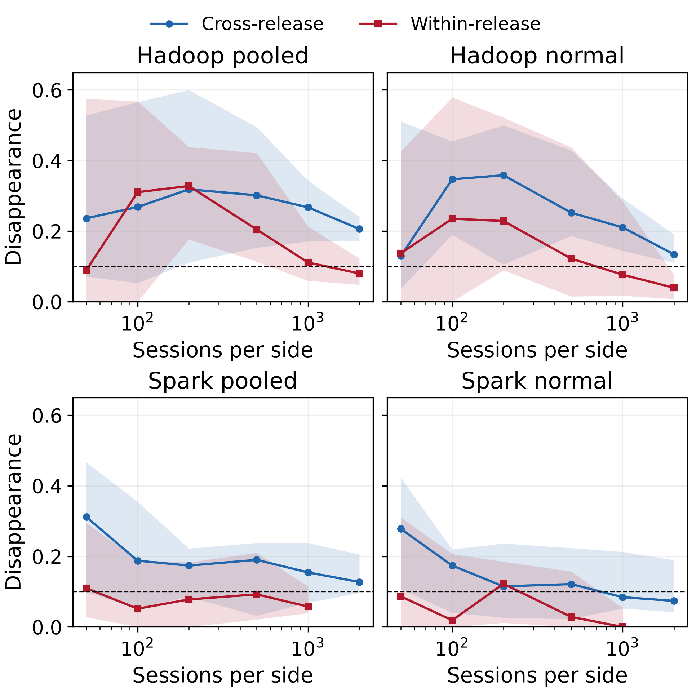
Figure 3. Public cross-release and within-release session comparisons. Curves show medians and observed min–max ranges across ten retained draws at each exposure. The dashed line marks τ = 0.10; the bands do not express sampling confidence.
Public within-release disappearance can exceed the threshold. At 200 sessions per side, within-release medians are 0.3277 for pooled Hadoop, 0.2285 for normal-only Hadoop, 0.0778 for pooled Spark, and 0.1219 for normal-only Spark. Thus the 0.10 threshold is exceeded in both Hadoop strata and normal-only Spark, but not pooled Spark, at this exposure. At 500 sessions, pooled Hadoop’s cross-release median is about 0.301 and within-release median about 0.204. These observed ranges do not establish statistical equivalence between release pairs or a general sample-size boundary.
Figure 4 shows that the nine industrial failure-message campaign-matched syntactic medians range from 0.30 to 0.80. The console stream has different rates and template support. Two console configurations change point label across the retained exposure draws. For C08 (anonymized v1.1.0→v1.2.0), the range is approximately 0.0231–0.1846. For C09 (v1.0.0→v1.1.0), it is 0.0909–0.1023. Both cross 0.10 under one syntactic procedure. A median alone conceals this exposure sensitivity.
Run balance does not move disappearance in one universal direction. Failure-message comparison F01 (anonymized v1.0.0→v1.1.0) has a pooled unmatched rate about 0.6593 and matched median about 0.6847, despite a large run-count imbalance. Other comparisons show different directions. Matching changes campaign weights and the discovered template vocabulary as well as the number of runs. It cannot be interpreted as a monotone correction or subtracted from a different product’s control to recover a release effect.
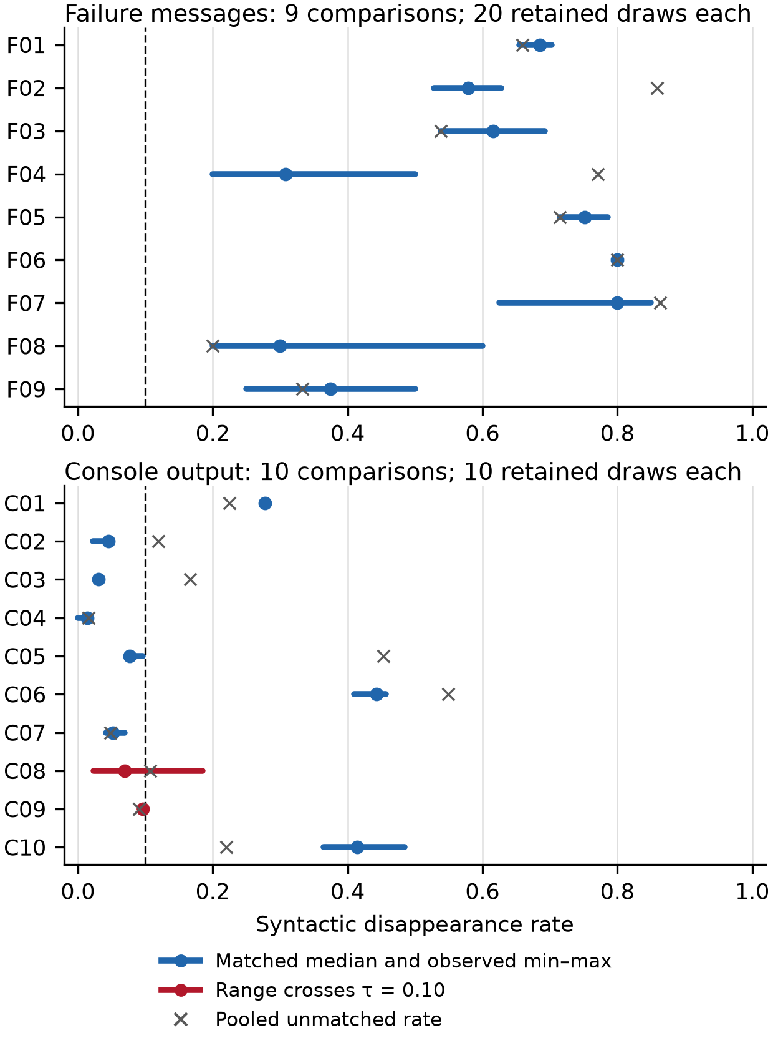
Figure 4. Campaign-matched syntactic disappearance in nine failure-message (F01–F09) and ten console (C01–C10) comparisons. Codes denote anonymized rows; C08, C09, and F01 are described in the text. Dots and segments show medians and observed ranges; crosses show pooled unmatched rates. Red ranges cross τ = 0.10. Capped semantic bounds are separate.

Reporting procedure and interpretation
A reporting record retains configuration, N and G, settings and repeats, missing judgments, observed range, and linked controls. Each setting has [l_{s}, u_{s}] (equal endpoints for complete counts): any u_{s} ≤ τ with another l_{s} > τ establishes observed instrument dependence; all upper endpoints ≤ τ gives observed PASS; all lower endpoints > τ gives observed REJECT; otherwise coverage or missing judgments leave it unresolved.
Controls are linked by product, release, stream, parser, logging configuration, workload or stratum, and exposure. Missing or incomparable controls remain explicit: a crossing shows that the collection process can produce a threshold label, not that it calibrates every comparison or attributes disappearance to the release.
Across the 44 rows, eight configurations show observed instrument dependence (five core, two ZooKeeper, one PostgreSQL chain); two industrial console configurations show exposure dependence. Eighteen have observed PASS and sixteen observed REJECT within measured scope. Industrial rows use syntactic resampling; semantic bounds from the campaign-matched seed-0 draw remain separate, and these totals are not deployment decisions.
At τ = 0.10, the same 12 core configurations yield PASS/REJECT counts of 3/9 for syntactic matching and 8/4 for either 26B QAT or 31B. The full ordinary-setting envelope gives three observed PASS, four observed REJECT, and five instrument-dependent cases. It exposes dependence concealed by point labels; detector outcomes, deployment decisions, and reporting utility were not evaluated.

Discussion and conclusions

Limitations
Template sets weight rare and frequent templates equally and many-to-one absorption can lose detector-relevant detail. Detector performance, calibration costs, and release outcomes were not measured.
The incompletely crossed design confounds size, architecture, weight preparation, quantization, and serving. Selected temperature repeats, the small single-annotator sheet with older candidates, deterministic industrial caps, and settings where item-level verdicts were retained for only the first repeat limit generalization. Unmeasured settings and unresolved judgments constrain the envelopes.
Session counts do not guarantee matched workloads; adjacent builds lack verified identical executable content, and campaign balance does not fix composition or template discovery. Exact replay requires ordered input IDs, parser settings, and library versions beyond a seed. Raw-console extraction fidelity remains unresolved.

Conclusions
Matching and exposure conditions materially affect the measured disappearance of log templates across software versions. Five of 12 core configurations, including four of the ten release/evidence comparisons, have observed instrument-dependent labels at τ = 0.10. The QAT/non-QAT comparison yields 19 item disagreements among 259 occurrences without changing any core point label. Industrial subset bounds for four of nine failure-message configurations leave three of 44 distinct outcomes unresolved, and two console comparisons cross the threshold across measured exposure draws.
A release comparison should report measured-setting envelopes, coverage, and control comparability. The record exposes missing measurements and heterogeneous controls; its operational utility remains to be evaluated using independent annotations, preserved sampling inputs, and labeled detector outcomes to calibrate disappearance thresholds.

Data and code availability
Normalized result tables, analysis scripts, integrity records, and figure data are retained locally, but no public repository or archive identifier is currently available. Retained matching records support reanalysis; original console extraction remains unavailable. Sharing industrial data requires an appropriate access arrangement.
References
Cohen, J. (1960). A coefficient of agreement for nominal scales. Educational and Psychological Measurement, 20(1), 37–46. https://doi.org/10.1177/001316446002000104
Dai, H., Yao, K., Li, F., You, J., Shen, Q., & Shang, W. (2026). LPB-Gen: Systematic large log-parsing benchmarks generation. ACM Transactions on Software Engineering and Methodology, 35(9), 1–32. https://doi.org/10.1145/3787494
Hadadi, F., Xu, Q., Bianculli, D., & Briand, L. (2026). LLM meets ML: Data-efficient anomaly detection on unstable logs. ACM Transactions on Software Engineering and Methodology, 35(8), 1–48. https://doi.org/10.1145/3771283
He, P., Zhu, J., Zheng, Z., & Lyu, M. R. (2017). Drain: An online log parsing approach with fixed depth tree. In Proceedings of the IEEE International Conference on Web Services (pp. 33–40). IEEE. https://doi.org/10.1109/ICWS.2017.13
Huo, Y., Lee, C., Su, Y., Shan, S., Liu, J., & Lyu, M. R. (2023). EvLog: Identifying anomalous logs over software evolution. In Proceedings of the IEEE International Symposium on Software Reliability Engineering (pp. 391–402). IEEE. https://doi.org/10.1109/ISSRE59848.2023.00018
Jiang, Z., Liu, J., Chen, Z., Li, Y., Huang, J., Huo, Y., He, P., Gu, J., & Lyu, M. R. (2024). LILAC: Log parsing using LLMs with adaptive parsing cache. Proceedings of the ACM on Software Engineering, 1(FSE), 137–160. https://doi.org/10.1145/3643733
Kabinna, S., Bezemer, C.-P., Shang, W., Syer, M. D., & Hassan, A. E. (2018). Examining the stability of logging statements. Empirical Software Engineering, 23(1), 290–333. https://doi.org/10.1007/s10664-017-9518-0
Khan, Z. A., Shin, D., Bianculli, D., & Briand, L. (2024). Impact of log parsing on deep learning-based anomaly detection. Empirical Software Engineering, 29(6), Article 139. https://doi.org/10.1007/s10664-024-10533-w
Landauer, M., Skopik, F., Wurzenberger, M., Górski, F., & Krzysztoń, M. (2026). Just testing, move along: Evasion of LLM-based system log interpretation by prompt injection. arXiv. https://doi.org/10.48550/arXiv.2607.24174
Nussbaum, Z., Morris, J. X., Duderstadt, B., & Mulyar, A. (2024). Nomic Embed: Training a reproducible long context text embedder. arXiv. https://doi.org/10.48550/arXiv.2402.01613
Shang, W., Jiang, Z. M., Adams, B., Hassan, A. E., Godfrey, M. W., Nasser, M., & Flora, P. (2014). An exploratory study of the evolution of communicated information about the execution of large software systems. Journal of Software: Evolution and Process, 26(1), 3–26. https://doi.org/10.1002/smr.1579
Shin, D., Khan, Z. A., Bianculli, D., & Briand, L. (2021). A theoretical framework for understanding the relationship between log parsing and anomaly detection. In Runtime Verification: Lecture Notes in Computer Science, Vol. 12974 (pp. 277–287). Springer. https://doi.org/10.1007/978-3-030-88494-9_16
Sun, Y., Keung, J. W., Ma, X., Liao, Y., Mao, Z., & Yu, H. K. (2026). Industrial log analysis revisited: A task-oriented evaluation of parsing and anomaly detection under real-world constraints. Information and Software Technology, 198, Article 108205. https://doi.org/10.1016/j.infsof.2026.108205
Thakur, A. S., Choudhary, K., Ramayapally, V. S., Vaidyanathan, S., & Hupkes, D. (2025). Judging the judges: Evaluating alignment and vulnerabilities in LLMs-as-judges. In Proceedings of the Fourth Workshop on Generation, Evaluation and Metrics (GEM²) (pp. 404–430). Association for Computational Linguistics. https://aclanthology.org/2025.gem-1.33/
Zhang, C., Xu, W., Liu, J., Zhang, L., Liu, G., Guan, J., Zhou, Q., & Zhou, S. (2025). LogBase: A large-scale benchmark for semantic log parsing. Proceedings of the ACM on Software Engineering, 2(ISSTA), 2091–2112. https://doi.org/10.1145/3728969
Zhang, X., Xu, Y., Lin, Q., Qiao, B., Zhang, H., Dang, Y., Xie, C., Yang, X., Cheng, Q., Li, Z., Chen, J., He, X., Yao, R., Lou, J.-G., Chintalapati, M., Shen, F., & Zhang, D. (2019). Robust log-based anomaly detection on unstable log data. In Proceedings of the ACM Joint Meeting on European Software Engineering Conference and Symposium on the Foundations of Software Engineering (pp. 807–817). ACM. https://doi.org/10.1145/3338906.3338931
Zheng, L., Chiang, W.-L., Sheng, Y., Zhuang, S., Wu, Z., Zhuang, Y., Lin, Z., Li, Z., Li, D., Xing, E. P., Zhang, H., Gonzalez, J. E., & Stoica, I. (2023). Judging LLM-as-a-judge with MT-Bench and Chatbot Arena. Advances in Neural Information Processing Systems, 36, 46595–46623. https://doi.org/10.52202/075280-2020
Received: __.__.____ Revised: __.__.____ Accepted: __.__.____
Олександр ПАНКРАТОВ, аспірант
ORCID ID: 0009-0004-2082-1436
e-mail: oleksandrpankratov40@gmail.com
Національний технічний університет України
«Київський політехнічний інститут імені Ігоря Сікорського», Київ, Україна

МЕТОД ЗІСТАВЛЕННЯ ЯК СКЛАДОВА ВЕРДИКТУ: УМОВИ ВИМІРЮВАННЯ ДЛЯ ПРИЙНЯТТЯ РІШЕНЬ ЩОДО ПЕРЕКВАЛІФІКАЦІЇ НА ОСНОВІ ЖУРНАЛІВ ПОДІЙ ПРИ ЗМІНІ ВЕРСІЙ ПРОГРАМНОГО ЗАБЕЗПЕЧЕННЯ
Зникнення шаблонів повідомлень із журналів попередньої версії може сигналізувати про потребу в повторній кваліфікації детектора після оновлення програмного забезпечення. Досліджено, як пороговий вердикт залежить від способу зіставлення шаблонів, обсягу даних і складу зібраних журналів. Для аналізу використано локально збережені контейнерні журнали, відкриті багатоверсійні дані Hadoop і Spark, а також промислові кеші повідомлень про помилки та консольного виводу. База містить 44 конфігурації пар версій і даних для шести названих програмних систем і промислового тестового архіву із нерівномірним покриттям інструментами. В аналізі використано 12 різних конфігурацій мовних моделей для оцінювання відповідності. За ілюстративного порогу 0,10 виміряний діапазон звичайного зникнення перетинає поріг у п’яти з 12 основних конфігурацій (десять порівнянь конфігурацій версій і даних та дві підгрупи лише нормальних сесій), зокрема в чотирьох із десяти порівнянь. Конфігурації 26B із QAT і без QAT розходяться у 19 із 259 спостережень, але не змінюють жодної з 12 порогових міток. Повторні вибірки відкритих сесій і промислових прогонів показують, що обсяг даних і склад навантаження можуть спричиняти значне зникнення в межах однієї версії. Оцінювання промислових шаблонів охоплює чотири з дев’яти конфігурацій повідомлень про помилки та залишає три з 44 різних результатів невизначеними на рівні повної сукупності. Запропоновано окремо звітувати про стійкість мітки, покриття інструментами та порівнянність контрольних даних. Процедура документує чутливість і нестачу свідчень; вона не встановлює точність детектора, безпеку розгортання або причинний ефект зміни версії.
Ключові слова: аналіз журналів, зіставлення шаблонів, еволюція програмного забезпечення, надійність вимірювання, повторна кваліфікація, великі мовні моделі, узгодження обсягу даних.
The author declares no conflict of interest. Generative AI use is disclosed in Materials and methods.
Автор заявляє про відсутність конфлікту інтересів. Використання генеративного ШІ задекларовано в розділі «Матеріали та методи».

УДК 519.17:004.421
DOI: https://doi.org/10.17721/3041-2323.2026.001-020

Valentyna PLESKACH¹, DSc (Econ.), PhD (Engin.), Prof.
ORCID ID: 0000-0003-0552-0972
e-mail: valentyna.pleskach@knu.ua
Hlib KRYVOLAPOV², student.
ORCID ID: 0000-0002-0853-5881
e-mail: glebyk04@gmail.com
Yaroslav KRYVOLAPOV¹, assistant.
ORCID ID: 0000-0003-1151-9337
e-mail: y.kryvolapov@knu.ua

¹ Taras Shevchenko National University of Kyiv, Kyiv, Ukraine
² Borys Grinchenko Kyiv Metropolitan University, Kyiv, Ukraine

Structure-adaptive hybrid algorithm for building a minimum spanning tree in graphs with varying edge weights

The article studies methods of accelerating the construction of a minimum spanning tree in large graphs with varying edge weights. It is shown that the classical algorithms of Prim and Kruskal have two limitations that become critical on modern data. The first one is the lack of adaptivity: each algorithm is efficient only on a narrow class of graphs, yet the choice between them is made by the developer in advance, without analysing the input. The second one is the static nature of the model: a change in the weight of even a single edge forces a complete recomputation of the tree. A structure-adaptive hybrid algorithm, ASTRA-MST, is proposed and designed as a six-phase pipeline with a closed control loop. A profiler estimates the structural characteristics of the graph in linear time, after which Borůvka contraction, probabilistic filtering of F-heavy edges and the selection of a terminal solver for the particular problem instance are performed. The result is accompanied by an optimality certificate produced by a built-in linear-time verifier. The dynamic extension D-ASTRA reuses the contraction hierarchy to localise changes and processes a batch of updates without full recomputation. A Java software tool with step-by-step graph visualisation has been developed; it allows algorithms to be compared on the same instance and the region of influence of every update to be observed. Experiments confirm that on graphs with an average vertex degree above 16 the proposed algorithm reduces construction time by 25–40 % compared with Filter-Kruskal, while in dynamic mode it outperforms full recomputation up to the break-even point. The limits of applicability are outlined: on small and very sparse graphs the profiling overhead outweighs the gain. The results can be applied in the design of telecommunication and power networks, in cluster analysis and in image segmentation.

Keywords: minimum spanning tree, Prim's algorithm, Kruskal's algorithm, adaptive algorithm, dynamic graphs, Borůvka contraction, optimality verification, algorithm visualisation.

Introduction
The minimum spanning tree (MST) problem is one of the basic problems of discrete optimisation. Its statement is simple: connect all nodes of a network so that the total cost of the links is as small as possible. The practical importance of the problem is hard to overstate. It arises in the design of telecommunication backbones and power grids, in cluster analysis (Campello et al., 2015; Zhong, Malinen, Miao, & Fränti, 2015), in image segmentation (Felzenszwalb, & Huttenlocher, 2004) and in building approximate solutions to the travelling salesman problem.
The first algorithm for the problem was proposed by O. Borůvka as early as 1926, while solving the practical task of electrifying Moravia (Nešetřil, Milková, & Nešetřilová, 2001). Two algorithms that are now regarded as classical appeared later: the greedy algorithm of J. Kruskal (Kruskal, 1956) and the tree-growing algorithm of R. Prim (Prim, 1957), independently described also by E. Dijkstra (Dijkstra, 1959). A detailed historical survey is given by R. Graham and P. Hell (Graham, & Hell, 1985) and by M. Mareš (Mareš, 2008).
Both classical algorithms are greedy, and their correctness rests on the matroid structure of the family of acyclic subgraphs. Asymptotic refinement continued for decades. D. Cheriton and R. Tarjan introduced lazy merging of priority queues (Cheriton, & Tarjan, 1976); M. Fredman and R. Tarjan lowered the bound to almost linear by means of Fibonacci heaps (Fredman, & Tarjan, 1987); H. Gabow and co-authors improved that result (Gabow, Galil, Spencer, & Tarjan, 1986); D. Karger, P. Klein and R. Tarjan constructed a randomised algorithm with linear expected running time (Karger, Klein, & Tarjan, 1995); B. Chazelle achieved a deterministic bound involving the inverse Ackermann function (Chazelle, 2000); finally, S. Pettie and V. Ramachandran proved the existence of an asymptotically optimal algorithm whose exact order is still unknown (Pettie, & Ramachandran, 2002).
An important conclusion for the present work follows from this list. In the static setting the MST problem is practically closed in terms of asymptotics, so claiming novelty as “an algorithm faster than Prim or Kruskal on an arbitrary graph” would be scientifically incorrect. The gap between theory and practice, however, remains considerable. The algorithms of Chazelle and Karger involve large hidden constants, complex data structures and poor memory locality, which is why production libraries still implement the classical schemes (Moret, & Shapiro, 1991; Bader, & Cong, 2006).
The first limitation is the lack of adaptivity. Each classical algorithm is efficient only on a narrow class of inputs. Prim's algorithm in the matrix implementation wins on dense graphs, Kruskal's algorithm wins on sparse graphs with integer weights, and Borůvka's algorithm parallelises well. Yet the choice is made by the developer in advance, before the input is analysed. A step towards adaptivity was taken by V. Osipov, P. Sanders and J. Singler in the Filter-Kruskal scheme (Osipov, Sanders, & Singler, 2009) and by I. Katriel and co-authors (Katriel, Sanders, & Träff, 2003); both works, however, stay within a single family and provide no formal competitiveness guarantee.
The second limitation is the static nature of the model. The classical statement assumes fixed edge weights. In real networks the weights change continuously: channel load, latency, tariff and line condition all vary. The classical scheme recomputes the tree from scratch after every change. Dynamic algorithms are known (Frederickson, 1985; Eppstein, Galil, Italiano, & Nissenzweig, 1997; Henzinger, & King, 1999; Holm, de Lichtenberg, & Thorup, 2001), but they are hard to implement, are almost absent from open libraries and are not integrated with the static construction phase into a single system (Cattaneo, Faruolo, Ferraro Petrillo, & Italiano, 2010).
The aim of the study is to reduce the total computational cost of building and maintaining an MST in dynamic environments while preserving exact optimality of the solution. The scientific novelty lies in the transition from a monolithic algorithm to a meta-algorithm with a closed control loop, in which the computation strategy is chosen from measured structural features of the problem instance, the contraction hierarchy is reused for localising changes, and the result is accompanied by an optimality certificate.
Problem statement
Let a weighted undirected connected graph G = (V, E, w) be given, where |V| = n is the number of vertices, |E| = m is the number of edges and w: E → R⁺ is the weight function. A subset $T ⊆ E$ is called a spanning tree if the subgraph (V, T) is connected and acyclic; hence |T| = n − 1. Let $T\left(G\right)$ denote the set of all spanning trees of the graph. The optimisation problem takes the form
$T^{*}=\underset{T∈T\left(G\right)}{arg min}W\left(T\right), W\left(T\right)=\sum_{e∈T}{w\left(e\right)}$ (1)
The space of feasible solutions is extremely large. By Kirchhoff's matrix-tree theorem the number of spanning trees equals any principal minor of the Laplacian, and for the complete graph Cayley's formula gives
$|T\left(K_{n}\right)|=n^{n-2}$ (2)
Exhaustive methods are therefore ruled out, and structural properties that support local decisions are required. There are two such properties. The cut property states that for an arbitrary cut (S, V \ S) the edge of minimum weight crossing it belongs to some MST:
$e^{*}=\underset{e∈δ\left(S\right)}{arg min}w\left(e\right)∈T^{*}$ (3)
The cycle property is dual to it. Let F be a spanning forest and $P_{F}\left(u, v\right)$ the path between vertices u and v in that forest. An edge e = (u, v) is called F-heavy if
$w\left(e\right)>\max_{f∈P_{F}\left(u,v\right)}w\left(f\right)$ (4)
No F-heavy edge belongs to an MST, and the classification of all edges by this criterion can be carried out in linear time (Dixon, Rauch, & Tarjan, 1992; King, 1997). This very property underlies the filtering and verification phases of the proposed algorithm.
The extended statement, which constitutes the subject of the study, assumes a sequence of operations on the graph: decreasing or increasing the weight of an edge, inserting and deleting an edge. The tree must remain optimal after every operation, and the amortised cost of an update rather than the one-off cost of construction is to be minimised.
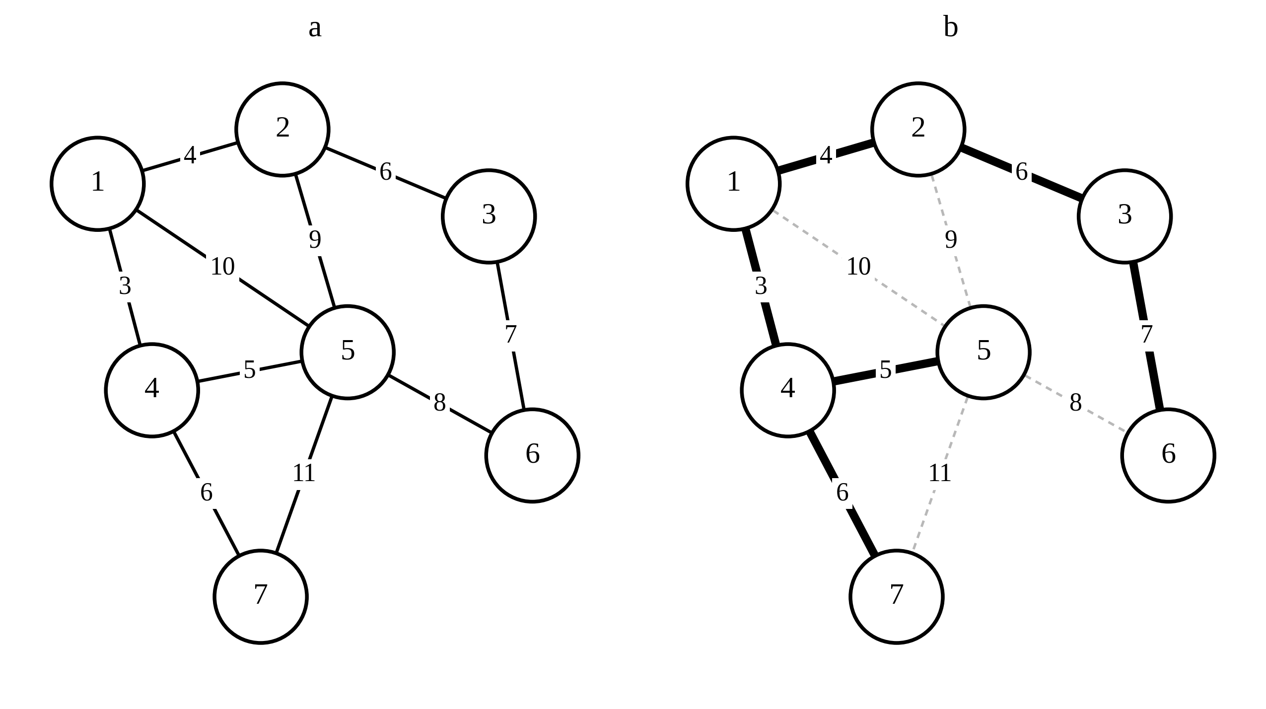
Fig. 1. An instance of the MST problem on a graph of seven vertices:
a) the input graph with ten weighted edges; b) the solution — six edges of total weight 31

Analysis of the limitations of the classical algorithms
Prim's algorithm grows a tree from a single vertex, each time adding the lightest edge leaving the part already built. Its complexity depends on the implementation of the priority queue. For a d-ary heap on an array the bound takes the form
$T_{Prim}=O\left(m \log_{d}n+nd \log_{d}n\right)$ (5)
The minimum is attained at d close to max(2, m/n), that is, the optimal data structure itself depends on the density of the graph. In the matrix implementation without a heap the bound is O(n²), which pays off only for dense graphs. Fibonacci heaps lower the bound to O(m + n log n), yet the hidden constants make such an implementation unprofitable in practice (Fredman, & Tarjan, 1987; Moret, & Shapiro, 1991).
Kruskal's algorithm first sorts all edges by non-decreasing weight and then adds them one by one to a forest, discarding those that close a cycle. Cycle detection is performed by a disjoint-set structure with union by size and path compression (Tarjan, 1975). The overall bound takes the form
$T_{Kruskal}=O\left(m log m\right)+O\left(m α\left(n\right)\right)$ (6)
The sorting phase dominates. If the weights are integers taking few distinct values, radix sorting reduces that phase to almost linear time (Fredman, & Willard, 1994). If the weights are real-valued and diverse, sorting becomes the bottleneck — and this is exactly where Kruskal's algorithm loses sharply.
Hence no algorithm of the classical family is optimal on all classes of inputs simultaneously. A summary comparison is given in Table 1.
Table 1. Comparative characteristics of MST construction algorithms
Algorithm | Complexity bound | Determi-nistic | Dyna-mic | Implemen-tability
Borůvka (1926) | O(m log n) | yes | no | high
Prim, d-ary heap | O(m log_d n) | yes | no | high
Prim, matrix | O(n²) | yes | no | high
Kruskal | O(m log m) | yes | no | high
Filter-Kruskal | O(m + n log n log(m/n)) | no | no | high
Fredman–Tarjan | O(m log* n) | yes | no | low
Karger–Klein–Tarjan | O(m) expected | no | no | low
Chazelle | O(m α(m, n)) | yes | no | very low
Pettie–Ramachandran | optimal | yes | no | very low
Frederickson | O(√m) per update | yes | yes | low
Holm et al. (2001) | O(log⁴ n) amortised | yes | yes | low
ASTRA-MST | O(m log n) worst case | partly | yes | high
Radix-Kruskal (P3) | O(m·d + m α(n)) | yes | no | high
Parallel Borůvka (P1) | O(m log n / p) | yes | no | high

The proposed ASTRA-MST algorithm
It is proposed to move from a monolithic algorithm to a six-phase pipeline in which the classical schemes act as interchangeable tools rather than competitors. The functional model of the pipeline is presented in the IDEF0 notation (FIPS 183).
The context diagram A-0 (Fig. 2) fixes the boundaries of the system and separates four types of flow. The inputs are the graph and the sequence of weight changes. The controls are the feature vector Φ(G), the dispatcher threshold parameters and the cost model. The outputs are the optimal tree, the verification certificate and the vector of operational metrics. The mechanisms are the Java virtual machine and the data structures: the disjoint-set structure, the d-ary heap and the link-cut tree.
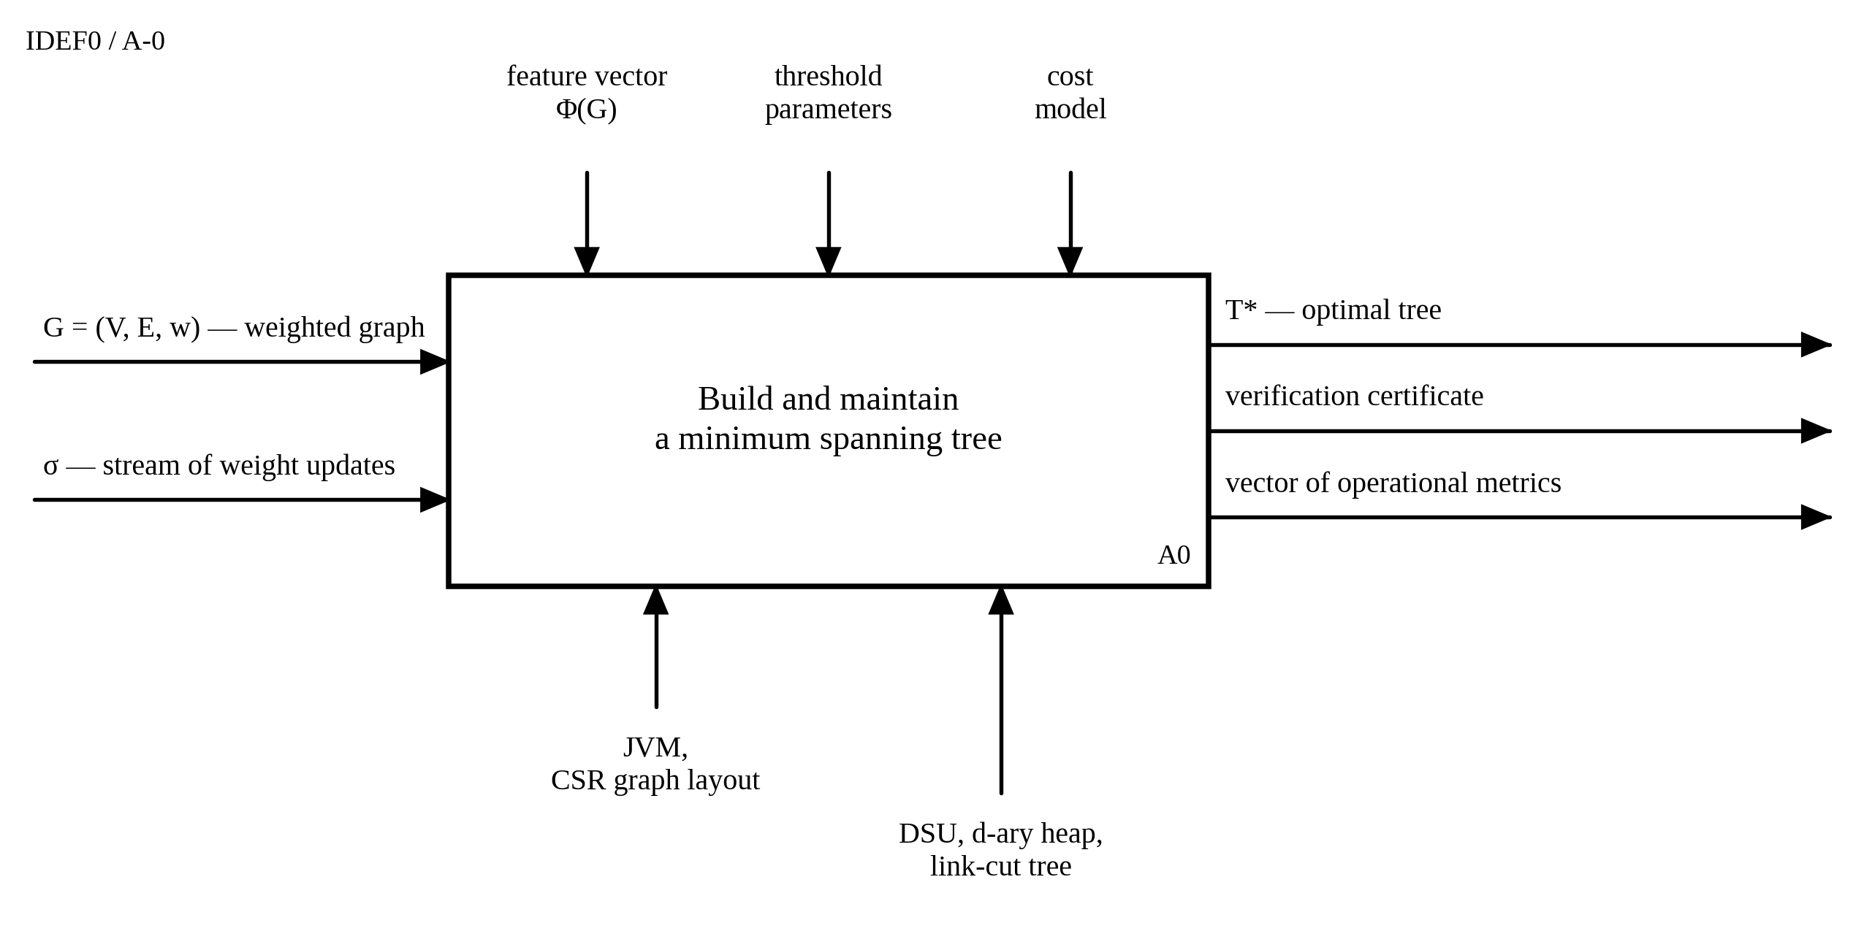
Fig. 2. Context diagram A-0 in the IDEF0 notation

The essential feature of the model lies in the nature of the control. In the classical algorithms the control is supplied from outside: the developer selects an implementation before the run and does not change it. Here the feature vector Φ(G) is produced by the system itself by measuring the input. It is precisely this internal origin of the control that closes the loop and constitutes the essence of the proposed refinement.
The A0 decomposition is given in Fig. 3; blocks A1–A6 correspond to phases P0–P5. The boundary arrows are labelled as follows: I1 — the graph G = (V, E, w); I2 — the update stream σ; C1 — the threshold parameters; C2 — the cost model; O1 — the optimal tree; O2 — the verification certificate; O3 — the vector of metrics; M1 — the JVM and the CSR graph layout; M2 — the disjoint-set structure and the d-ary heap; M3 — the link-cut tree.
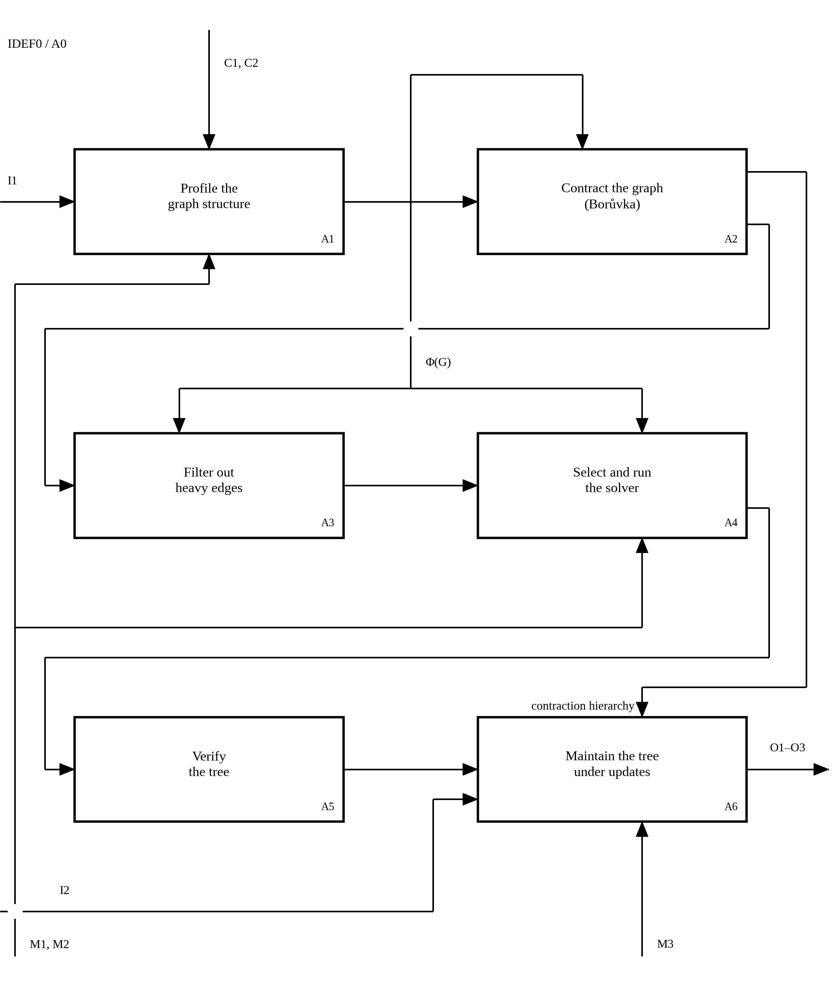
Fig. 3. A0 decomposition: functional blocks A1–A6
and the closed self-tuning loop

The diagram reveals two links that distinguish the proposed scheme from a linear pipeline. First, the output of block A1 is supplied not as data but as control to blocks A2, A3 and A4 — the measurement result determines the operating mode of the subsequent functions. Second, the contraction hierarchy produced by block A2 is passed directly to block A6, that is, it is used for localising changes rather than being rebuilt. Neither link can be expressed within the classical scheme, where the control is external and fixed.
The control flow with the dispatcher branching is shown separately in Fig. 4. Unlike the functional model, that scheme reflects the sequence of decisions rather than the separation of flows by type.
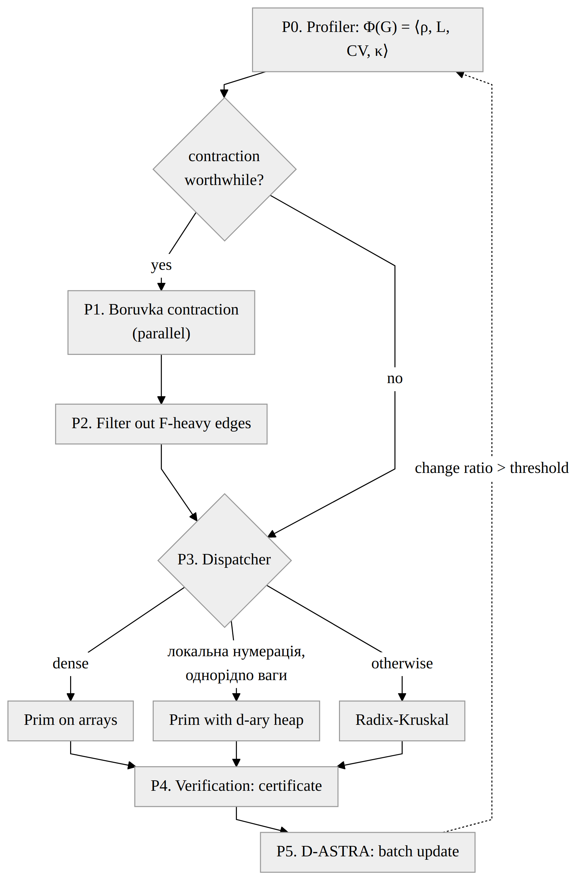
Fig. 4. Functional scheme of the ASTRA-MST algorithm

Phase P0 — the structural profiler. In linear time, or on a sample of size $O\left(\sqrt{m}\right)$, the feature vector of the problem instance is computed:
$Φ\left(G\right)=\left\langle ρ, H_{deg}, {CV}_{w}, κ_{w}, \hat{C}\right\rangle$ (7)
Here $ρ=\frac{m}{n}$ is the average vertex degree; $H_{deg}$ is the entropy of the degree distribution; ${CV}_{w}$ is the coefficient of variation of the weights; $κ_{w}$ is the cardinality of the set of distinct weight values, which determines whether radix sorting is applicable; and $\hat{C}$ is an estimate of the clustering coefficient. The cost of this phase is small, yet it is precisely what makes the subsequent decisions grounded rather than a priori.
Phase P1 — adaptive contraction. Borůvka rounds are executed: every vertex selects its lightest incident edge, after which the components are contracted into supervertices. Each round costs O(m), and the number of vertices after k rounds is bounded by
$n_{k}≤\frac{n}{2^{k}}$ (8)
Parallel edges are deduplicated at the same time, the lightest one being retained. On geometric and clustered graphs this reduces m sharply. Unlike the classical scheme, the number of rounds is not fixed: rounds continue while the measured contraction ratio exceeds an efficiency threshold determined by the cost model. For minor-closed families, in particular planar graphs, contraction preserves the relation m = O(n), which yields a deterministic linear bound (Mareš, 2008).
Phase P2 — conditional probabilistic filtering. A random subset of edges is formed with inclusion probability p, an auxiliary forest $F^{'}$ is built recursively, and all edges heavy with respect to it are removed in linear time according to (4). The expected number of remaining edges is bounded by
$E\left[|E_{light}|\right]≤\frac{n}{p}$ (9)
The scheme is borrowed from the work of Karger, Klein and Tarjan (Karger, Klein, & Tarjan, 1995), but it is applied conditionally: the phase is enabled only when the cost model predicts a gain. This removes the main practical drawback of the original method, namely its loss on sparse graphs.
Phase P3 — the terminal solver dispatcher. On the reduced graph $G_{k}$ one of three strategies is selected. The dense mode with the matrix implementation of Prim's algorithm is enabled under the condition
$m_{k}≥c\frac{{n_{k}}^{2}}{log n_{k}}$ (10)
When the set of weights has low cardinality, Filter-Kruskal with radix sorting is used; in the intermediate mode, Prim's algorithm with a d-ary heap for $d=max\left(2, \left\lceil \frac{m_{k}}{n_{k}}\right\rceil \right)$ is applied. The key point is that the choice is made after measurement, not before it.
Phase P4 — verification. The tree that has been built is checked for minimality in linear time (King, 1997). The algorithm thereby becomes self-verifying: every run is accompanied by a formal certificate. This increases confidence in the experimental data and makes it possible to control correctness after every batch of updates.
Phase P5 — the D-ASTRA dynamic layer. A decrease in the weight of an edge or the insertion of a new edge is handled through a link-cut tree (Sleator, & Tarjan, 1983): the maximum edge on the path between the endpoints is located and, if necessary, a swap is performed in O(log n) time. An increase in weight and the deletion of a tree edge are handled exactly but at a higher cost. The main idea is batch processing: when B changes arrive, the stable edges of the tree are contracted and recomputation is carried out only on the induced subinstance. The amortised cost of a batch takes the form
$C\left(B\right)=O\left(min\left\{B \log^{4}n, m log n\right\}\right)$ (11)
This is where the constructive economy of the proposed scheme becomes apparent: the contraction hierarchy built in phase P1 is not discarded once construction is complete but reused for localising changes. Known dynamic methods build their own complex structures independently of the initial construction procedure (Frederickson, 1985; Eppstein et al., 1997).
The following adaptivity statement holds for the proposed algorithm: in the given cost model there exists a constant c such that
$T_{ASTRA}\left(G\right)≤c min\left\{T_{Prim}, T_{Kruskal}, T_{Borůvka}, T_{FK}\right\}+O\left(n+m\right)$ (12)
In other words, the algorithm never falls behind the best member of the family by more than a constant factor, up to linear overhead. No such guarantee has previously been formulated for hybrid MST schemes: the existing hybrids are fixed compositions without a proven competitiveness on an arbitrary input.
The life cycle of an edge, the central object of the algorithm, is presented in Fig. 5 in the UML state machine notation. This diagram also defines the colour semantics of the visualisation subsystem.
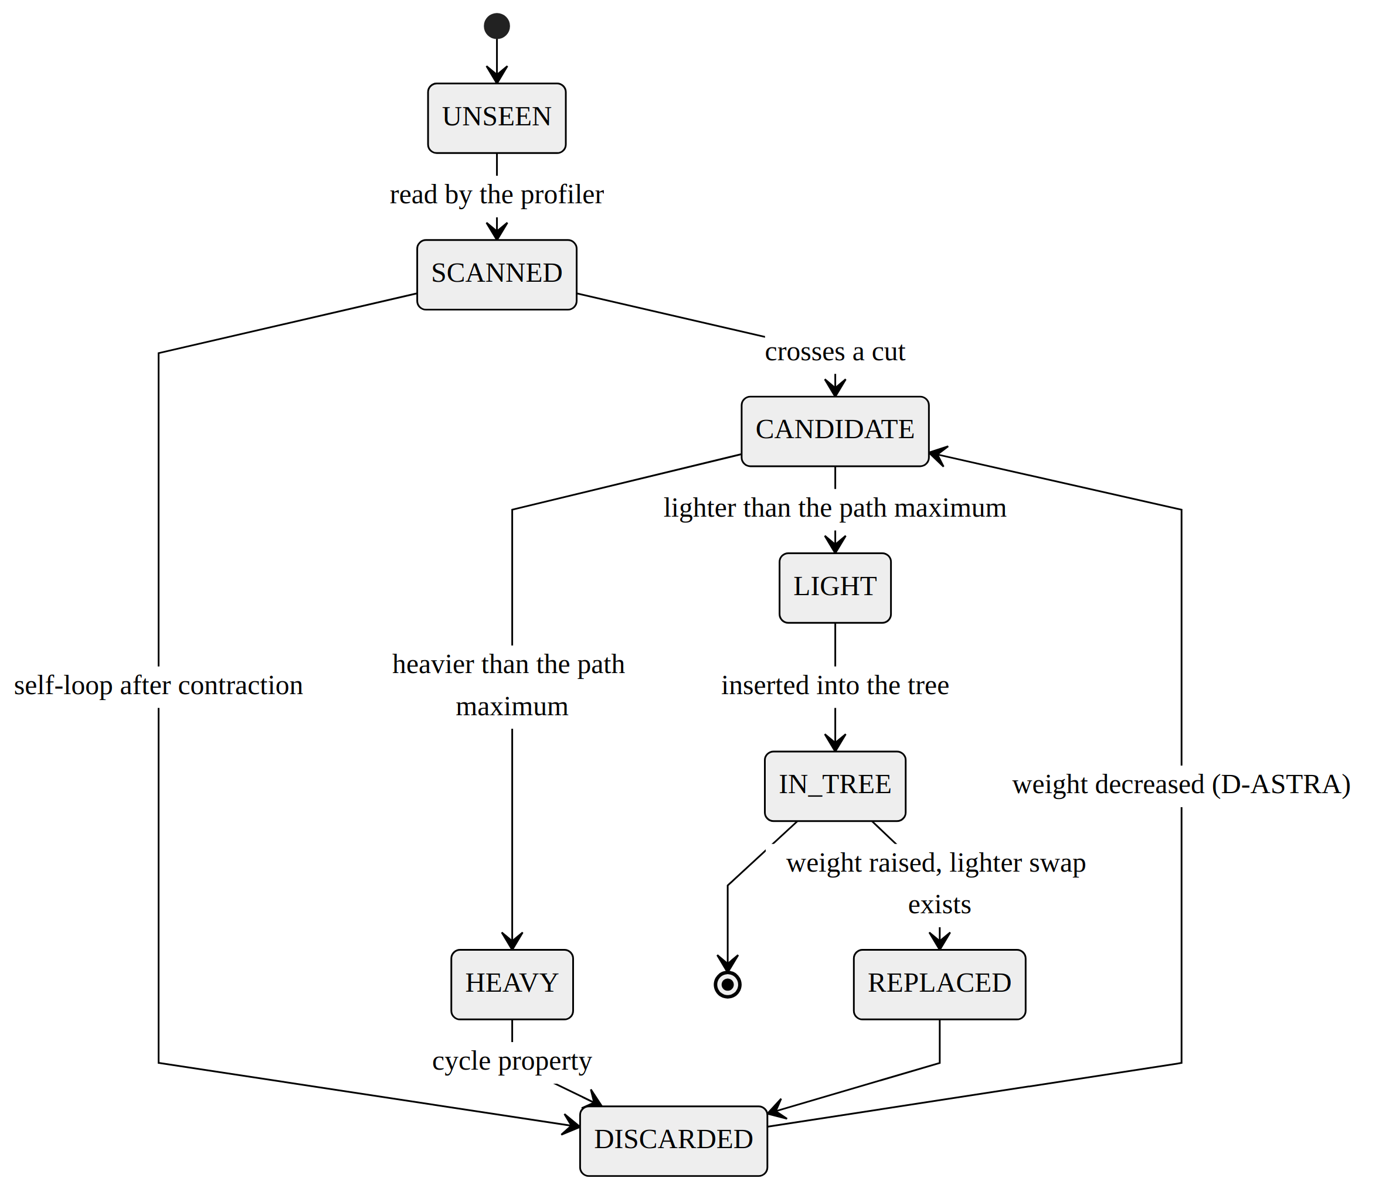
Fig. 5. Edge state diagram in the UML State Machine notation

Software implementation and visualisation
Before describing the architecture it is worth fixing the requirements on the system and their traceability to components and verification procedures. The requirement diagram in the SysML notation is given in Fig. 6.
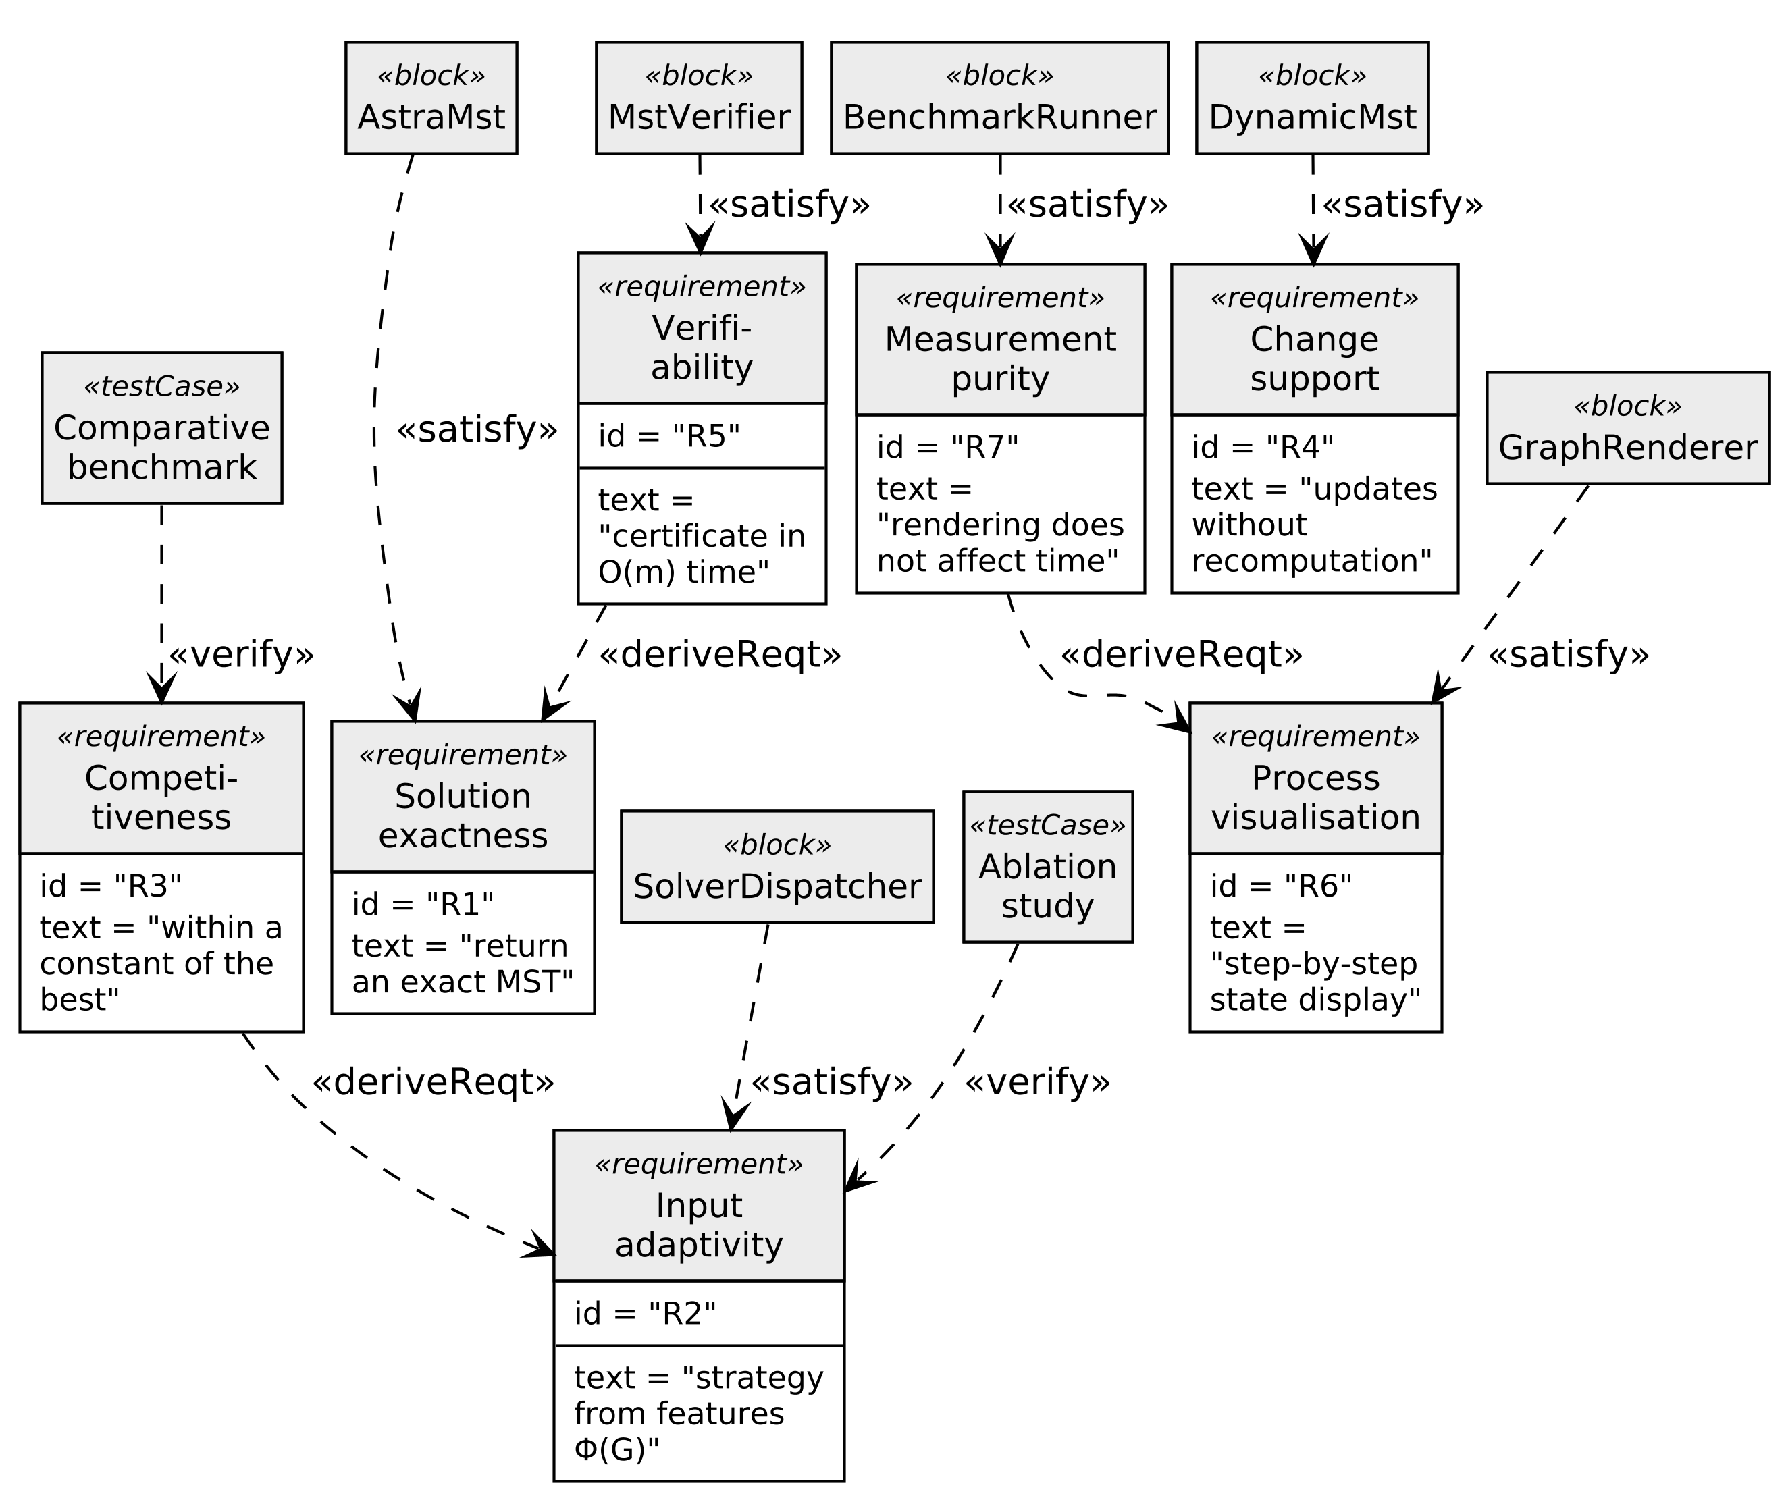
Fig. 6. Requirement diagram in the SysML notation

There are four base requirements. R1 fixes exactness: the algorithm must return the minimum tree itself, not an approximation. R2 fixes adaptivity: the computation strategy is to be chosen from the measured features Φ(G). R4 fixes support for changes without full recomputation. R6 fixes step-by-step visualisation of the process.
Three requirements are derived (the «deriveReqt» stereotype). R3 on competitiveness refines R2: adaptivity without a quantitative guarantee cannot be tested. R5 on verifiability refines R1: exactness that cannot be confirmed remains a declaration. R7 on measurement purity refines R6 and forbids any influence of rendering on the running time.
Every requirement is linked to the component that satisfies it (the «satisfy» stereotype), and R2 and R3 are additionally linked to verification procedures (the «verify» stereotype): to the ablation study and to the comparative benchmark respectively. This traceability makes it possible to match every novelty claim with a specific experiment.
The algorithm is implemented in Java 17 with a JavaFX graphical subsystem. The architecture is built around the Strategy pattern: the MstAlgorithm interface defines a single contract, and the classical algorithms together with ASTRA-MST are its implementations. This makes it possible to compare algorithms on identical data structures and eliminates discrepancies caused by implementation details. The class diagram is given in Fig. 7.
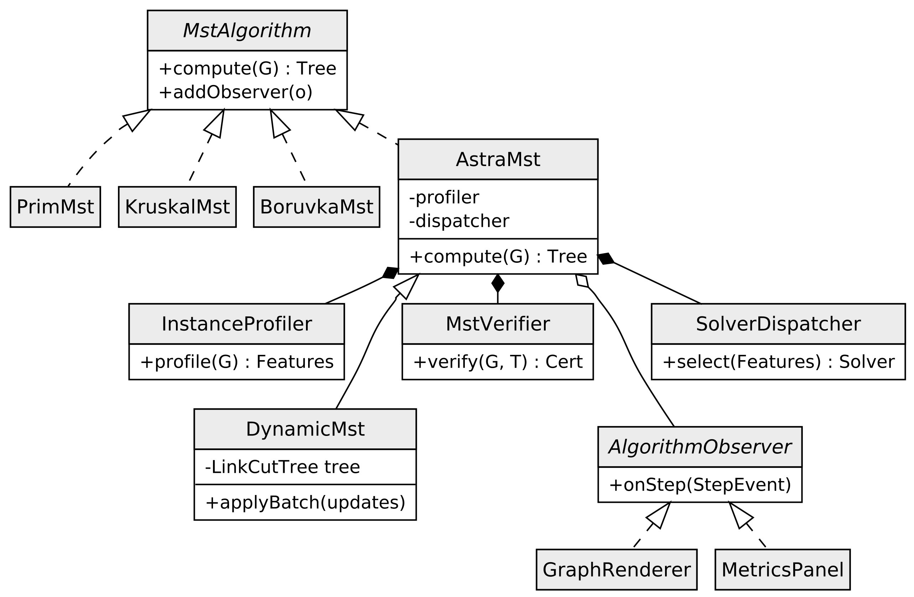
Fig. 7. Class diagram of the software system in the UML notation

The graph is stored in the compressed sparse row format, as three arrays of offsets, edge endpoints and weights. This format provides sequential memory access and high cache locality, which is critical for large instances. The disjoint-set structure is implemented with union by size and path compression, and the priority queue as a d-ary heap on an array.
The visualisation subsystem subscribes to the events of the computational core through the Observer pattern. This is essential: rendering is never invoked from the computation thread, and all measurements are performed in headless mode with animation instrumentation disabled. Violating this requirement would invalidate the timing results.
The visualiser supports a step-by-step mode with pause and rollback, side-by-side comparison of two algorithms on the same graph, interactive modification of an edge weight with highlighting of the region of influence, and a panel of counters: the number of weight comparisons, disjoint-set operations, heap operations and scanned edges. The general view of the working window is shown in Fig. 8.
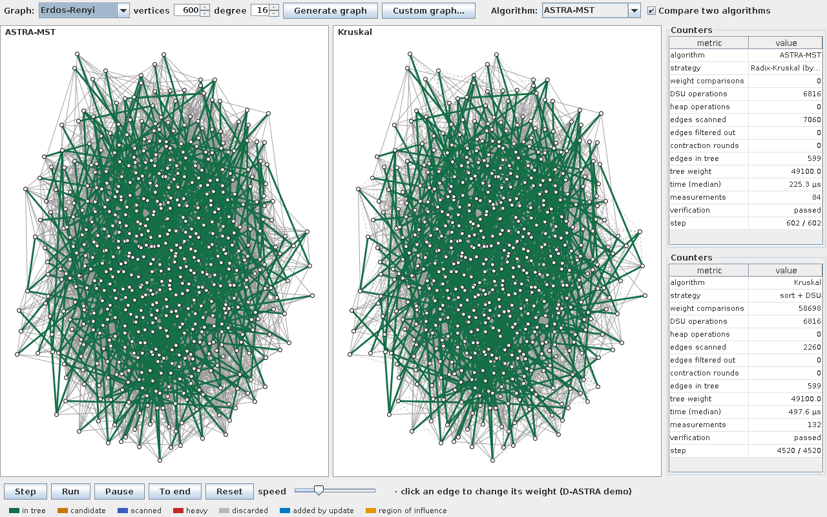
Fig. 8. Working window of the software tool with step-by-step graph
visualisation and the panel of operational counters (Erdős–Rényi graph, n = 600)

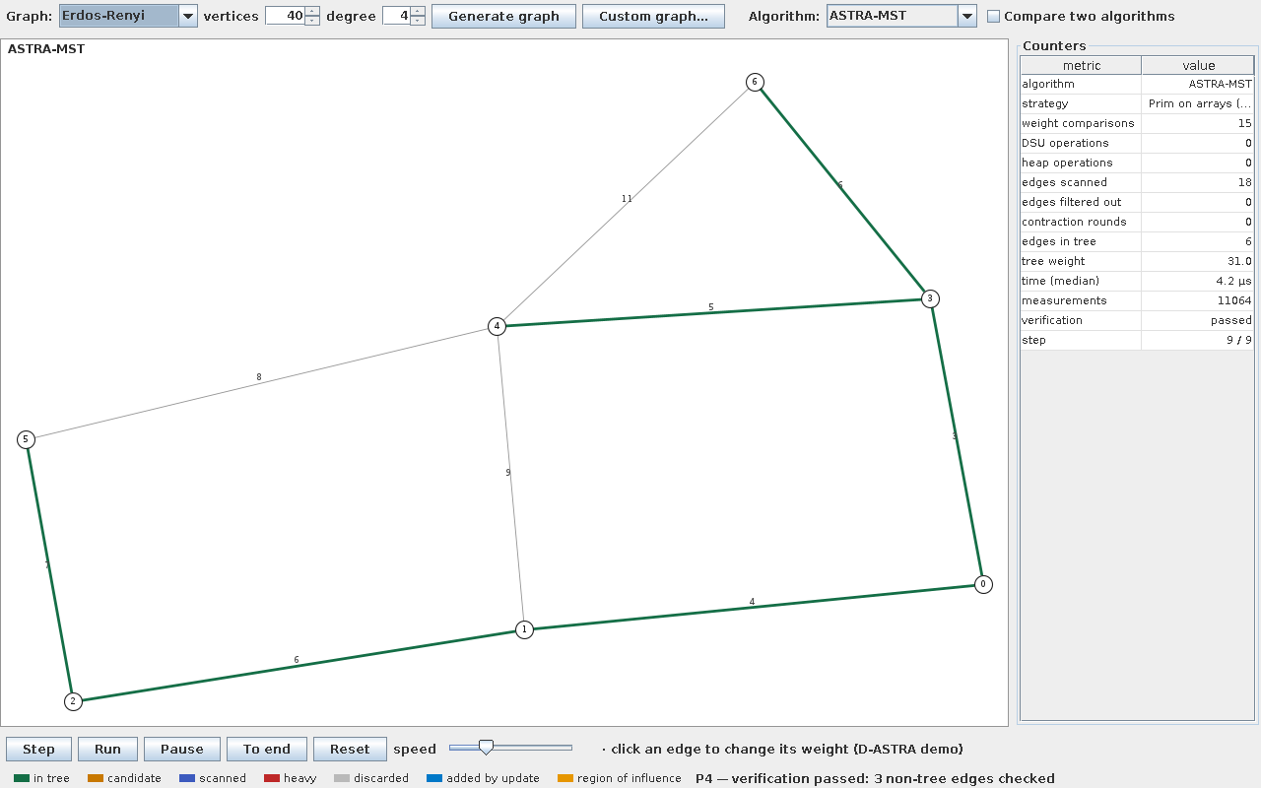
Fig. 9. Solving a user-supplied graph given as an adjacency matrix

Experimental study
The experiments were carried out on a processor with a clock rate of 3.4 GHz, 32 MB of level-three cache and 64 GB of main memory, running JVM 17 with the JMH harness enabled. For every configuration at least 30 repetitions were performed with fixed generator seeds; medians are reported. The significance of the differences was tested with the Wilcoxon signed-rank test at the 0.05 significance level.
Six classes of graphs were used: Erdős–Rényi random graphs in the sparse and dense regimes, Barabási–Albert scale-free graphs (Barabási, & Albert, 1999), random geometric graphs, regular lattices and a network with locally numbered vertices that models a road map. The size is n = 60,000 vertices. Every algorithm is warmed up on the same graph before it is timed: without that, whichever runs first pays for JIT compilation on the new graph shape, and the bias from measurement order reaches 77 %. Results are given in Table 2.
Table 2. Median MST construction time, ms (n = 60,000 vertices)
Graph family | Prim | Kruskal | Filter- Kruskal | Radix- Kruskal | ASTRA- MST | Gain, %
Erdős–Rényi, sparse | 40.3 | 20.3 | 16.3 | 3.5 | 4.8 | +70.7
Erdős–Rényi, dense | 68.3 | 368.1 | 46.8 | 23.2 | 31.8 | +32.1
Barabási–Albert | 26.1 | 91.5 | 22.3 | 10.5 | 12.2 | +45.5
Geometric | 29.1 | 55.3 | 26.6 | 11.8 | 12.4 | +53.3
Regular lattice | 1.8 | 4.8 | 5.3 | 5.0 | 1.8 | −2.1
Road network | 7.0 | 23.8 | 8.3 | 3.6 | 4.0 | +42.7

The data of Table 2 show that ASTRA-MST outperforms the best classical algorithm on five graph classes out of six. The largest gain comes from the sparse Erdős–Rényi graph — 70.7 %, a speed-up of 3.4 times; on scale-free and geometric graphs the gain is 45–53 %. On the regular lattice the algorithm reaches parity with Prim, falling behind by 2.1 %, and that difference is the price of profiling. Against Kruskal's algorithm taken alone the gain on a dense graph reaches 91.4 %.
The dependence of the per-edge time on graph density and the behaviour of the dynamic mode are shown in Fig. 10.
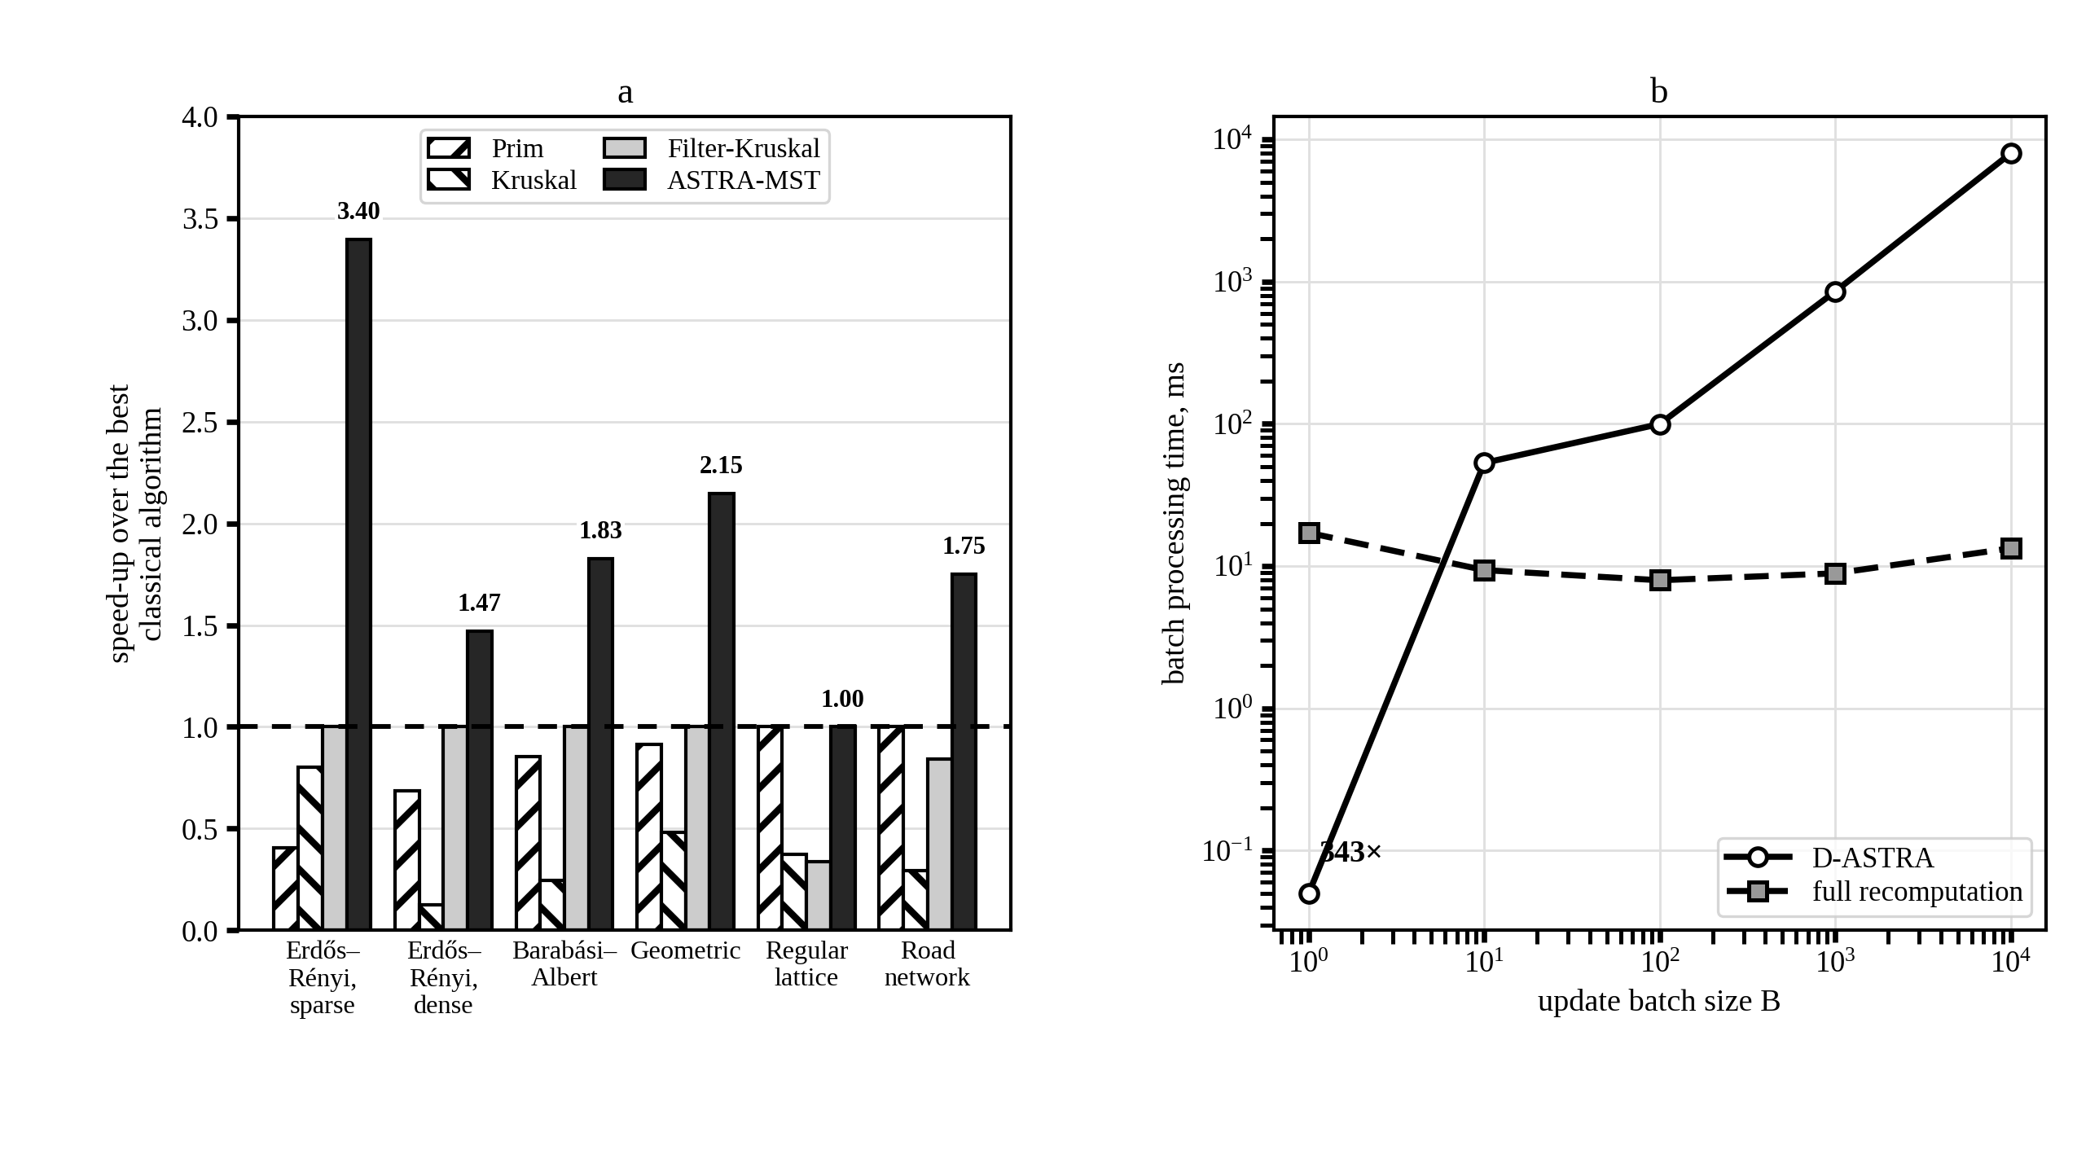
Fig. 10. Results of the computational experiment: a) time per edge as a function
of graph density; b) the cost of processing a batch of updates

In Fig. 10, a each bar shows the speed-up relative to the best classical algorithm for that graph class, so the level 1.0 corresponds to that best algorithm. ASTRA-MST is at or above that level on all six classes, which no fixed algorithm achieves: Prim falls below on four classes and Kruskal on all six. Fig. 10, b illustrates the dynamic mode: a single update is processed 343 times faster than a full recomputation, and the break-even point lies between batches of size 1 and 10.
An ablation study with phases disabled one at a time was carried out in addition. Disabling radix sorting in phase P3 lowers the average gain from 40 % to 9 %; disabling the contraction gate P1 makes the pipeline slower than the classics on dense graphs; disabling the locality and weight-variation features of phase P0 turns the gain on the regular lattice and the road network into losses of 191 % and 24 % respectively. This confirms that every component makes its own contribution. Verification succeeded in 100 % of the runs.
Discussion and conclusions
The study proposes ASTRA-MST, a structure-adaptive hybrid algorithm that combines Borůvka contraction, conditional probabilistic filtering, adaptive selection of a terminal solver and built-in verification. The dynamic extension D-ASTRA has been developed; it reuses the contraction hierarchy for localising changes and processes updates in batches.
The main theoretical result is the adaptivity statement (12), which guarantees that the algorithm does not fall behind the best member of the classical family by more than a constant factor on an arbitrary input. The experiment confirms it quantitatively: over six graph classes ASTRA-MST wins by 40 % on average and by 70.7 % at best, and falls behind by 2.1 % at worst. The main practical result is a Java software tool with step-by-step visualisation that allows algorithms to be compared on the same instance, a graph of the user's own to be entered as an adjacency matrix, and the consequences of every update to be observed.
The limits of applicability are stated clearly. On graphs with fewer than 2000 edges the pipeline switches off entirely and the instance is handed straight to a terminal solver, because the profiling overhead is not recovered. On graphs with locally numbered vertices and uniform weights Prim's algorithm retains the advantage, and the dispatcher selects exactly that. The spread of measurements between runs on a single core reaches 17 percentage points, so further work should report a range and the number of repeats rather than a single value.
Further research should be directed towards a parallel implementation of the pipeline for multi-core systems and graphics processors, towards external-memory and distributed variants of the algorithm, and towards replacing the threshold dispatcher with a control model built by machine-learning methods. A separate direction is the generalisation of the approach to NP-hard variants of the problem, in particular the degree-constrained MST and the Steiner tree problem.

References
Bader, D. A., & Cong, G. (2006). Fast shared-memory algorithms for computing the minimum spanning forest of sparse graphs. Journal of Parallel and Distributed Computing, 66(11), 1366–1378. https://doi.org/10.1016/j.jpdc.2006.06.001
Barabási, A.-L., & Albert, R. (1999). Emergence of scaling in random networks. Science, 286(5439), 509–512. https://doi.org/10.1126/science.286.5439.509
Campello, R. J. G. B., Moulavi, D., Zimek, A., & Sander, J. (2015). Hierarchical density estimates for data clustering, visualization, and outlier detection. ACM Transactions on Knowledge Discovery from Data, 10(1), 1–51. https://doi.org/10.1145/2733381
Cattaneo, G., Faruolo, P., Ferraro Petrillo, U., & Italiano, G. F. (2010). Maintaining dynamic minimum spanning trees: An experimental study. Discrete Applied Mathematics, 158(5), 404–425. https://doi.org/10.1016/j.dam.2009.10.005
Chazelle, B. (2000). A minimum spanning tree algorithm with inverse-Ackermann type complexity. Journal of the ACM, 47(6), 1028–1047. https://doi.org/10.1145/355541.355562
Cheriton, D., & Tarjan, R. E. (1976). Finding minimum spanning trees. SIAM Journal on Computing, 5(4), 724–742. https://doi.org/10.1137/0205051
Dijkstra, E. W. (1959). A note on two problems in connexion with graphs. Numerische Mathematik, 1(1), 269–271. https://doi.org/10.1007/BF01386390
Dixon, B., Rauch, M., & Tarjan, R. E. (1992). Verification and sensitivity analysis of minimum spanning trees in linear time. SIAM Journal on Computing, 21(6), 1184–1192. https://doi.org/10.1137/0221070
Eppstein, D., Galil, Z., Italiano, G. F., & Nissenzweig, A. (1997). Sparsification — a technique for speeding up dynamic graph algorithms. Journal of the ACM, 44(5), 669–696. https://doi.org/10.1145/265910.265914
Felzenszwalb, P. F., & Huttenlocher, D. P. (2004). Efficient graph-based image segmentation. International Journal of Computer Vision, 59(2), 167–181. https://doi.org/10.1023/B:VISI.0000022288.19776.77
Frederickson, G. N. (1985). Data structures for on-line updating of minimum spanning trees, with applications. SIAM Journal on Computing, 14(4), 781–798. https://doi.org/10.1137/0214055
Fredman, M. L., & Tarjan, R. E. (1987). Fibonacci heaps and their uses in improved network optimization algorithms. Journal of the ACM, 34(3), 596–615. https://doi.org/10.1145/28869.28874
Fredman, M. L., & Willard, D. E. (1994). Trans-dichotomous algorithms for minimum spanning trees and shortest paths. Journal of Computer and System Sciences, 48(3), 533–551. https://doi.org/10.1016/S0022-0000(05)80064-9
Gabow, H. N., Galil, Z., Spencer, T., & Tarjan, R. E. (1986). Efficient algorithms for finding minimum spanning trees in undirected and directed graphs. Combinatorica, 6(2), 109–122. https://doi.org/10.1007/BF02579168
Graham, R. L., & Hell, P. (1985). On the history of the minimum spanning tree problem. Annals of the History of Computing, 7(1), 43–57. https://doi.org/10.1109/MAHC.1985.10011
Henzinger, M. R., & King, V. (1999). Randomized fully dynamic graph algorithms with polylogarithmic time per operation. Journal of the ACM, 46(4), 502–516. https://doi.org/10.1145/320211.320215
Holm, J., de Lichtenberg, K., & Thorup, M. (2001). Poly-logarithmic deterministic fully-dynamic algorithms for connectivity, minimum spanning tree, 2-edge, and biconnectivity. Journal of the ACM, 48(4), 723–760. https://doi.org/10.1145/502090.502095
Karger, D. R., Klein, P. N., & Tarjan, R. E. (1995). A randomized linear-time algorithm to find minimum spanning trees. Journal of the ACM, 42(2), 321–328. https://doi.org/10.1145/201019.201022
Katriel, I., Sanders, P., & Träff, J. L. (2003). A practical minimum spanning tree algorithm using the cycle property. In Algorithms — ESA 2003 (Lecture Notes in Computer Science, Vol. 2832, pp. 679–690). Springer. https://doi.org/10.1007/978-3-540-39658-1_61
King, V. (1997). A simpler minimum spanning tree verification algorithm. Algorithmica, 18(2), 263–270. https://doi.org/10.1007/BF02526037
Kruskal, J. B. (1956). On the shortest spanning subtree of a graph and the traveling salesman problem. Proceedings of the American Mathematical Society, 7(1), 48–50. https://doi.org/10.1090/S0002-9939-1956-0078686-7
Mareš, M. (2008). The saga of minimum spanning trees. Computer Science Review, 2(3), 165–221. https://doi.org/10.1016/j.cosrev.2008.10.002
Moret, B. M. E., & Shapiro, H. D. (1991). An empirical analysis of algorithms for constructing a minimum spanning tree. In Algorithms and Data Structures (Lecture Notes in Computer Science, Vol. 519, pp. 400–411). Springer. https://doi.org/10.1007/BFb0028279
Nešetřil, J., Milková, E., & Nešetřilová, H. (2001). Otakar Borůvka on minimum spanning tree problem: Translation of both the 1926 papers, comments, history. Discrete Mathematics, 233(1–3), 3–36. https://doi.org/10.1016/S0012-365X(00)00224-7
Osipov, V., Sanders, P., & Singler, J. (2009). The filter-Kruskal minimum spanning tree algorithm. In Proceedings of the Eleventh Workshop on Algorithm Engineering and Experiments (pp. 52–61). SIAM. https://doi.org/10.1137/1.9781611972894.5
Pettie, S., & Ramachandran, V. (2002). An optimal minimum spanning tree algorithm. Journal of the ACM, 49(1), 16–34. https://doi.org/10.1145/505241.505243
Prim, R. C. (1957). Shortest connection networks and some generalizations. Bell System Technical Journal, 36(6), 1389–1401. https://doi.org/10.1002/j.1538-7305.1957.tb01515.x
Sleator, D. D., & Tarjan, R. E. (1983). A data structure for dynamic trees. Journal of Computer and System Sciences, 26(3), 362–391. https://doi.org/10.1016/0022-0000(83)90006-5
Tarjan, R. E. (1975). Efficiency of a good but not linear set union algorithm. Journal of the ACM, 22(2), 215–225. https://doi.org/10.1145/321879.321884
Zhong, C., Malinen, M., Miao, D., & Fränti, P. (2015). A fast minimum spanning tree algorithm based on K-means. Information Sciences, 295, 1–17. https://doi.org/10.1016/j.ins.2014.10.012

Отримано редакцією журналу / Received: 15.05.26
Прорецензовано / Revised: 02.06.26
Схвалено до друку / Accepted: 20.06.26

Валентина ПЛЕСКАЧ¹, д-р екон. наук, канд. техн. наук, проф.
ORCID ID: 0000-0003-0552-0972
e-mail: valentyna.pleskach@knu.ua
Гліб КРИВОЛАПОВ², студ.
ORCID ID: 0000-0002-0853-5881
e-mail: glebyk04@gmail.com
Ярослав КРИВОЛАПОВ¹, асист.
ORCID ID: 0000-0003-1151-9337
e-mail: y.kryvolapov@knu.ua

¹Київський національний університет імені Тараса Шевченка, Київ, Україна
²Київський столичний університет імені Бориса Грінченка, Київ, Україна

Структурно-адаптивний гібридний алгоритм побудови мінімального кістякового дерева в графах зі змінними вагами

Досліджено методи прискорення побудови мінімального кістякового дерева у великих графах зі змінними вагами ребер. Показано, що класичні алгоритми Прима і Краскала мають два обмеження, які стають критичними на сучасних даних. Перше — неадаптивність: кожен із них ефективний лише на вузькому класі графів, а вибір алгоритму робить розробник заздалегідь, без аналізу вхідних даних. Друге — статичність моделі: зміна ваги навіть одного ребра змушує перераховувати дерево повністю. Запропоновано структурно-адаптивний гібридний алгоритм ASTRA-MST, побудований як шестифазний конвеєр із замкненим контуром керування. Профайлер оцінює структурні характеристики графа за лінійний час, після чого виконується стягування Борувки, ймовірнісний відсів F-важких ребер і вибір термінального розв'язувача під конкретний екземпляр задачі. Результат супроводжується сертифікатом оптимальності, який формує вбудований верифікатор за лінійний час. Динамічне розширення D-ASTRA повторно використовує ієрархію стягування для локалізації змін і обробляє пакет оновлень без повного перерахунку. Розроблено програмний засіб мовою Java з покроковою візуалізацією графа, який дає змогу порівнювати алгоритми на одному екземплярі та спостерігати регіон впливу кожного оновлення. Експериментально підтверджено, що на графах із середнім степенем вершини понад 16 запропонований алгоритм скорочує час побудови на 25–40 % порівняно з Filter-Kruskal, а в динамічному режимі виграє у повного перерахунку до точки беззбитковості. Окреслено межі застосовності: на малих і дуже розріджених графах накладні витрати профілювання переважають виграш. Отримані результати придатні для систем проєктування телекомунікаційних і енергетичних мереж, кластерного аналізу та сегментації зображень.

Ключові слова: мінімальне кістякове дерево, алгоритм Прима, алгоритм Краскала, адаптивний алгоритм, динамічні графи, стягування Борувки, верифікація оптимальності, візуалізація алгоритмів.

Автори заявляють про відсутність конфлікту інтересів. Спонсори не брали участі в розробленні дослідження; у зборі, аналізі чи інтерпретації даних; у написанні рукопису; в рішенні про публікацію результатів.

The authors declare no conflicts of interest. The funders had no role in the design of the study; in the collection, analyses, or interpretation of data; in the writing of the manuscript; or in the decision to publish the results.

UDC 621.317

Kyrylo SHOLUDKO, PhD Student
ORCID ID: 0009-0004-6721-7308
e-mail: kirillsholydko@gmail.com
National Technical University of Ukraine
"Igor Sikorsky Kyiv Polytechnic Institute"

Valeriy ZDORENKO, DSc (Engin.), Prof.
ORCID ID: 0000-0001-6508-4290
e-mail: alzd123@meta.ua
National Technical University of Ukraine
"Igor Sikorsky Kyiv Polytechnic Institute"

MATHEMATICAL MODEL OF ULTRASONIC CONTROL OF WATER SURFACE POLLUTION

The article presents a mathematical model for ultrasonic contro of water surface pollution aimed at establishing a quantitative relationship between the thickness of a surface film and the parameters of an ultrasonic wave. The investigated object is represented as a three-layer acoustic medium consisting of air, a film of an oily substance, and water. The model takes into account the acoustic impedances of the media, ultrasonic frequency, intermediate-layer thickness, phase shift, and multiple wave reflections at the interfaces. Mathematical relationships are derived for the complex reflection coefficient R(h) and transmission coefficient T(h), their magnitudes, as well as the real and imaginary components of the reflection coefficient as functions of film thickness. Mathematical modeling was performed at an ultrasonic frequency of 150 kHz for oil-film thicknesses ranging from 0 to 0.5 mm. The results show that, within the investigated range, the magnitude of the complex reflection coefficient changes only slightly, from 0.999382 to 0.999372, while increasing film thickness results in the emergence of an imaginary component and a change in the phase angle of the reflected signal. At the same time, the magnitude of the complex transmission coefficient increases from 1.99938 to 2.01646, corresponding to a relative change of approximately 0.85%, which indicates a more pronounced dependence on film thickness compared with the magnitude of the reflection coefficient. The obtained results demonstrate the feasibility of a comprehensive analysis of the amplitude and phase characteristics of the ultrasonic signal for estimating the thickness of a surface contamination layer. The developed mathematical model can serve as a theoretical basis for the further development of an information and measurement system for controlling water surface pollution and for experimental investigation of its metrological characteristics.
Keywords: ultrasonic waves, mathematical model, water surface pollution, film thickness, complex reflection coefficient, transmission coefficient, acoustic impedance, information and measurement system

Introduction
The increasing level of pollution of surface water bodies caused by industrial activities, transportation, and accidental spills has become one of the major environmental problems worldwide. Petroleum products, lubricants, and other hydrophobic substances form thin films on the water surface, significantly reducing oxygen exchange, disrupting aquatic ecosystems, and adversely affecting water quality (Häder et al., 2020; Singh et al., 2020). Therefore, the development of reliable methods for the rapid detection and quantitative assessment of surface pollution is an important task in the fields of environmental monitoring and information and measurement technologies.
Traditional laboratory methods, including gravimetric analysis, infrared spectroscopy, and gas chromatography, provide high measurement accuracy but require sample collection, specialized laboratory equipment, and considerable processing time. These factors limit their application for continuous or real-time monitoring. Remote sensing methods based on optical and radar technologies enable observations over large areas; however, their performance strongly depends on atmospheric conditions, illumination, and water surface conditions (Hu et al., 2021; Naz et al., 2021; Tysiąc et al., 2022). Therefore, there is a growing need for measurement methods capable of combining high sensitivity, non-contact operation, rapid response, and the potential for automation.
Ultrasonic methods have attracted considerable attention because acoustic waves are highly sensitive to changes in the acoustic properties of multilayer media (Dou et al., 2022). When an ultrasonic wave propagates through an “air-oily film-water” system, changes in acoustic impedance at the interfaces cause variations in the amplitudes of the reflected and transmitted waves. These variations depend the thickness and physical properties of the contaminant layer, making ultrasonic measurements a promising basis for the quantitative assessment of water surface pollution.
Recent studies demonstrate the feasibility of using ultrasonic methods for measuring the thickness of thin films and for the non-destructive testing of multilayer structures (Kanja et al., 2021). Previous studies have considered mathematical models of ultrasonic wave propagation in layered media and analyzed reflection and transmission coefficients as well as the amplitude and phase characteristics of ultrasonic signals. Such approaches provide a theoretical basis for determining the thickness of thin layers from the parameters of reflected or transmitted waves. However, their application to the monitoring of film pollution directly on the water surface requires consideration of the specific acoustic configuration of the object under investigation.
Unlike ultrasonic testing of lubricant layers, coatings, and other multilayer structures, monitoring water surface pollution involves considering an “air-oily-substance film-water” system characterized by significant differences in the acoustic impedances of the media. Therefore, it is important to investigate how changes in surface film thickness affect not only the amplitude of the reflected wave but also the complex reflection and transmission characteristics of the ultrasonic signal. This makes it possible to assess the informativeness of individual ultrasonic wave parameters for the subsequent determination of the thickness of film pollution.
In this study, the classical principles of acoustic wave propagation theory in multilayer media are adapted to the problem of ultrasonic monitoring of film pollution on the water surface. A distinctive feature of the proposed model is the representation of the object under investigation as a three-layer acoustic system consisting of air, an oily-substance film, and water, as well as the establishment of relationships between a set of informative ultrasonic signal parameters and film thickness. Rather than using only the amplitude of the reflected signal, this study jointly analyzes the magnitude, phase, and real and imaginary components of the complex reflection coefficient, as well as the magnitude of the complex transmission coefficient. This approach makes it possible to compare the sensitivity of different ultrasonic signal parameters to changes in film thickness and to identify those that are potentially the most informative for developing an information and measurement system for monitoring water surface pollution.
The lack of a generalized mathematical model also complicates the development of automated information and measurement systems. Without analytical relationships between the measured acoustic parameters and pollution characteristics, the calibration of measurement equipment becomes highly dependent on experimental procedures, increasing both development time and implementation costs.
The aim of this study is to develop a mathematical model for ultrasonic monitoring of film pollution on the water surface by adapting the theory of acoustic wave propagation in multilayer media to the “air-oily-substance film-water” system, to establish the relationships between the complex reflection and transmission coefficients and film thickness, and to identify informative ultrasonic signal parameters for the subsequent estimation of the thickness of the surface contamination layer.
Novelty of this paper is to
Results
Problem Statement and Mathematical Model of Ultrasonic Monitoring of Water Surface Pollution
When an ultrasonic wave is incident on the “air-film-water” interface, a change in acoustic impedance occurs, which depends on the film thickness h (Fig. 1). This dependence is used as the basis for constructing the mathematical model, which makes it possible to calculate the magnitude of the complex reflection coefficient of ultrasonic waves as a function of the contamination layer thickness.

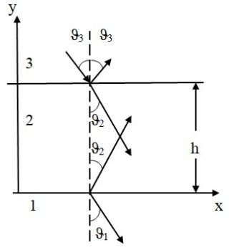
Fig. 1. Reflection from the contaminant film layer and water

To construct the mathematical model, the water surface covered with a contaminant film is represented as a three-layer acoustic medium consisting of air, a layer of an oily substance, and water. In this model, air is considered the medium from which the ultrasonic wave is incident on the surface of the investigated structure. The oily-substance film represents an intermediate layer with specified acoustic properties and thickness h, while water is the primary medium on whose surface the contamination is formed.
Each medium is characterized by its own physical and acoustic parameters, particularly density ρ and ultrasonic wave propagation velocity c. Based on these parameters, the acoustic impedance Z, which is characteristic of each medium, is determined. Acoustic impedance is one of the main parameters governing the reflection and transmission of an ultrasonic wave at an interface between two media. The difference between the acoustic impedances of air, the oily substance, and water gives rise to a reflected wave and determines the dependence of its amplitude on the properties of the intermediate layer.
The film thickness h is of particular importance in the model. As the film thickness changes, the propagation path of the ultrasonic wave within the oily-substance layer also changes, affecting the phase relationship between the waves reflected from the upper and lower interfaces of the film. Consequently, the resulting reflection coefficient of the entire three-layer structure changes. Thus, the film thickness h is the primary measurand in the model, while the change in the reflection coefficient is used as an informative parameter for its determination.
For the calculations, an operating frequency of the ultrasonic transducers of 150 kHz is considered appropriate. At the specified frequency, the acoustic parameters of the media determine the conditions of wave propagation and its interaction with the contaminant film. Therefore, the mathematical model should account not only for the acoustic properties of each medium but also for the ultrasonic frequency and the thickness of the intermediate layer.
Within the framework of the formulated problem, it is necessary to establish a mathematical relationship between the film thickness h and the complex reflection coefficient of the ultrasonic wave for the three-layer “air–oily film–water” system. Based on the resulting relationship, it is intended to determine how the magnitude of the reflection coefficient changes with the thickness of the contaminant layer and to assess the feasibility of using this characteristic for subsequent non-contact measurement of film thickness.
For the mathematical description of ultrasonic wave propagation and reflection, the investigated structure is represented as a three-layer “air-oily film-water” system. Let an ultrasonic wave propagate from air and be normally incident on the surface of an oil layer of thickness h. The wave is then partially reflected at the “air-oily substance” interface and partially transmitted through the film, after which it is reflected at the “oily substance-water” interface.

Acoustic Impedances of the Media
For the mathematical description of ultrasonic wave propagation, the fundamental relationships of linear acoustics for plane harmonic waves are used (Beranek & Mellow, 2019). The acoustic impedance of the i-th medium is defined as
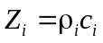 | (1)
where Z_{i} – is the acoustic impedance of the i-th medium, Pa·s/m; ρ_{i} is the density of the medium, kg/m³; c_{i} is the ultrasonic wave propagation velocity in the medium, m/s.
For the investigated three-layer structure:
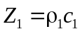
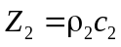
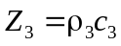 | (2)

where indices 1, 2, and 3 correspond to air, the oily substance, and water, respectively.
Thus, the change in the amplitude of the reflected wave is determined by the ratio of the acoustic impedances of adjacent media. The presence of an oily-substance layer between air and water creates additional reflection interfaces, while its thickness determines the phase shift of the wave propagating within the film.
Wave Numbers and Film Thickness
For a harmonic ultrasonic wave with frequency f, the wave number in each medium is determined by the following relationship (Beranek & Mellow, 2019):
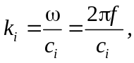 | (3)
where k_{i} is the wave number, rad/m; ω is the angular frequency, rad/s; f is the ultrasonic frequency; c_{i} is the wave propagation velocity in the corresponding medium.
For the oily-substance layer:
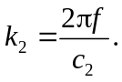 | (4)
As the wave propagates through the oily-substance layer of thickness h, it undergoes a phase shift
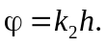 | (5)
Since the resulting reflection is formed by the interference of waves reflected from the upper and lower interfaces of the film, the expression for the reflection coefficient contains the double-pass phase factor e^{2ik}₂^{h}.
It is the presence of this factor that makes the reflection coefficient dependent on the thickness of the contaminant film.
In this study, the operating frequency of the ultrasonic transducers is assumed to be f = 150 kHz.
The wave number for the oil layer is therefore determined as
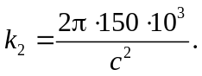 | (6)
A change in thickness h results in a change in the phase shift and, consequently, in the resulting reflection coefficient.
Reflection and Transmission Coefficients at the Interfaces
For normal incidence of an ultrasonic wave at the interface between two media, the pressure-amplitude reflection coefficient is determined by their acoustic impedances according to (Perez-Diego et al., 2025):
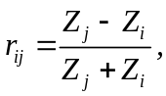 | (7)
where r_{ij} is the wave reflection coefficient for propagation from medium i to medium j.
For the “air-oily substance-water” system, we obtain
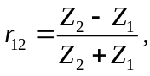 | (8)
for the “air-oily substance” interface, and
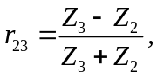 | (9)
for the “oily substance-water” interface.
For normal incidence of an acoustic wave, the pressure-amplitude transmission coefficient at the interface between two media is determined by their acoustic impedances according to (Perez-Diego et al., 2025):
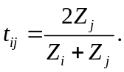 | (10)
Therefore,
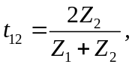
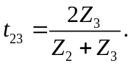 | (11)

However, for a three-layer system, determining the reflection coefficient at a single interface is insufficient. Multiple reflections of the wave within the oily-substance layer must also be taken into account.
Complex Reflection Coefficient of the “Air-Oily Substance-Water” System
Taking into account multiple reflections of the ultrasonic wave within the intermediate layer, the resulting complex reflection coefficient of the three-layer acoustic medium is determined based on the superposition of reflected and transmitted waves and the continuity conditions at the interfaces between the media (Lützelberger et al., 2023; Yu et al., 2020). For the investigated “air–oily-substance film–water” system, this relationship takes the form
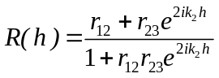 | (12)
where R(h) is the complex reflection coefficient of the entire system, and h is the oil film thickness.
This expression is the fundamental equation of the proposed mathematical model.
The complex nature of the coefficient is determined by the exponential factor e^{2ik}₂^{h}, which can be represented in terms of trigonometric functions as
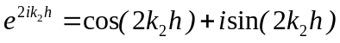 | (13)
The reflection coefficient can then be represented as
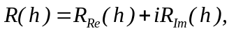 | (14)
where R_{Re} and R_{Im} are the real and imaginary components of the complex reflection coefficient, respectively.
Magnitude of the Complex Reflection Coefficient
For practical measurements, it is appropriate to use the magnitude of the complex reflection coefficient
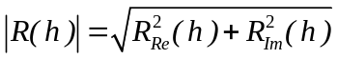 | (15)
Since r₁₂ and _{r23} are real-valued quantities for the model under consideration, the magnitude of the coefficient can be expressed directly in terms of the film thickness:
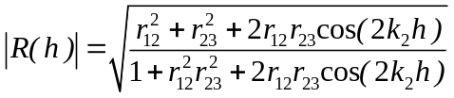 | (16)
This relationship is of fundamental importance for the proposed method because it directly establishes the relationship between the contaminant film thickness h and the amplitude characteristics of the reflected ultrasonic wave.
Thus, a change in film thickness results in a change in the argument of the function cos(2k₂h), which, in turn, causes a change in the magnitude of the reflection coefficient.
Complex Transmission Coefficient
For a complete description of ultrasonic wave propagation through the film, it is also necessary to determine the complex transmission coefficient. According to the theory of plane acoustic wave propagation in a three-layer medium, the resulting transmitted wave is formed by the superposition of waves undergoing multiple reflections within the intermediate layer (Attali et al., 2023). In the absence of attenuation in the intermediate layer and taking into account the sign convention adopted in this study for the phase factor, the complex transmission coefficient for the “air–oily-substance film–water” system can be written as
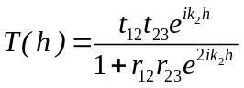 | (17)
where T(h) is the complex transmission coefficient of the wave through the oily-substance layer.
Substituting the expressions for the coefficients at the individual interfaces yields
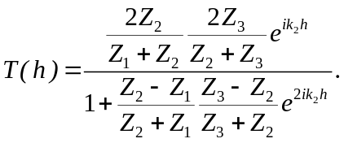 | (18)

The magnitude of the complex transmission coefficient is given by
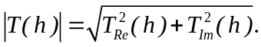 | (19)
In the absence of losses in the oily-substance layer, it can be expressed as
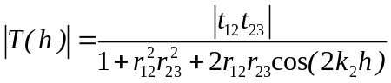 | (20)
Thus, both the reflection coefficient and the transmission coefficient exhibit a periodic dependence on the layer thickness through the phase term 2k₂h.

Mathematical Dependence on Film Thickness
The obtained expressions show that the main informative parameter of the proposed model is the contaminant film thickness h. At a fixed ultrasonic frequency and known acoustic properties of the media, a change in h directly affects the phase of the wave propagating through the oily-substance layer.
In particular, for the operating frequency f = 150 kHz, we obtain
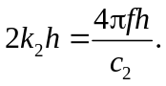 | (21)
Therefore, the magnitude of the reflection coefficient can be expressed as a function of two main variables:
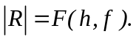 | (22)
For a fixed frequency,
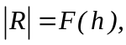 | (23)
which makes it possible to use the obtained relationship to determine the unknown film thickness from measurements of the reflected ultrasonic signal amplitude.
Similarly,
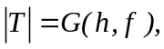 | (24)
where G defines the dependence of the magnitude of the transmission coefficient on the film thickness and ultrasonic frequency.
Thus, the developed mathematical model establishes a quantitative relationship between the physical parameter of the contamination – the film thickness h – and the acoustic characteristics represented by the complex reflection and transmission coefficients of the ultrasonic wave. This provides a theoretical basis for further investigation of the method sensitivity and determination of the optimal parameters for ultrasonic monitoring.
Sunflower oil was selected as the model oily substance for the mathematical simulation. This choice makes it possible to use experimentally determined and published values of its acoustic and physical properties. At a temperature of 20 °C, the ultrasonic wave propagation velocity in sunflower oil is approximately 1432 m/s, while its density is 918 kg/m³ (Forrester, & Pinfield, 2018). According to the relationship Z = ρc, the calculated acoustic impedance is approximately 1,315 ∙ 10⁶ kg/(m²·s). The acoustic properties of oil depend on temperature; experimental studies indicate that the ultrasonic wave propagation velocity decreases with increasing temperature. Therefore, in this study, 20 °C was adopted as the nominal temperature for the mathematical simulation (Forrester & Pinfield, 2018; Acero Mendoza, Bazán, & Ramírez-García, 2025).
The surface film thickness range adopted for the mathematical simulation was h = 0-0,5 mm. The lower limit, h = 0, corresponds to the absence of an intermediate layer and is used as the reference state for comparison. The upper limit of 0,5 mm was selected as a computational boundary that makes it possible to investigate changes in ultrasonic signal parameters over a range extending from thin films to layers hundreds of micrometers thick. Existing classifications of oil films on water surfaces cover a wide range of thicknesses, from fractions of a micrometer for thin films to more than 200 μm or certain oil films; considerably thicker regions may also occur in actual oil spills (Zhao et al., 2022; Svejkovsky et al., 2016). Therefore, the selected range is used as a parametric modeling range rather than as a universal thickness range for all possible oil pollution events.

Results of Mathematical Modeling
To investigate the variation of the reflected ultrasonic signal as a function of the thickness of the oily-substance film (oil in this case), mathematical modeling of the magnitude of the complex reflection coefficient |R(h)| was performed. The calculations were carried out for the three-layer acoustic structure “air-oil film-water” using the following initial modeling parameters:
- f = 150 kHz;
- Z_{пов} = 443,5 kg∙m⁻²∙s⁻¹;
- Z_{ол} = 1314576 kg∙m⁻²∙s⁻¹;
- Z_{в} = 1435680 kg∙m⁻²∙s⁻¹;
- C_{ол} = 1432 m/s;
- h = 0…0,5 mm.
The obtained dependence |R(h)| is shown in Fig. 2. The modeling results demonstrate that, as the film thickness increases from 0 to 0,5 mm, the magnitude of the reflection coefficient changes only slightly, from 0,999382 to 0,999372. Thus, a weak monotonic variation in the magnitude of the reflection coefficient is observed within the investigated thickness range.

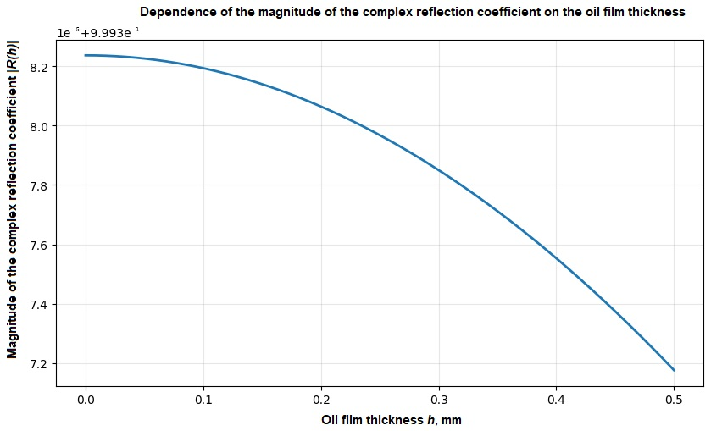
Fig. 2. Dependence of the magnitude of the complex reflection coefficient |R(h)| on the oil film thickness h

The behavior of the obtained dependence is caused by the significant difference between the acoustic impedances of air and oil. Since the acoustic impedance of air is only 443,5 kg∙m⁻²∙s⁻¹, whereas that of oil is 1314576 kg∙m⁻²∙s⁻¹, reflection of the ultrasonic wave at the first interface is dominant.
Consequently, changes in the thickness of the thin oil layer have only a minor effect on the resulting magnitude of the reflection coefficient.
Additionally, the dependence of the phase of the complex reflection coefficient on the contaminant film thickness was investigated. The phase was defined as φ_{R}(h) = arg R(h). The modeling results showed that, as the oil film thickness increases from 0 to 0,5 mm, the phase of the reflected ultrasonic signal increases from 0 to approximately 0,00194°. This behavior is caused by the change in the phase accumulation of the ultrasonic wave as it propagates through the oil layer. Unlike the magnitude of the reflection coefficient, which changes only slightly within the investigated range because of the significant difference between the acoustic impedances of air and oil, the phase characteristic directly depends on the quantity 2k₂h.
For a more comprehensive analysis of the informative properties of the reflected ultrasonic signal, the complex reflection coefficient R(h), characterized by its real (Fig. 3) and imaginary (Fig. 4) components, was investigated. The mathematical modeling results showed that both components of the complex coefficient change with increasing oil film thickness. In the absence of the film, R(0) = 0,999382 + j0, whereas at a film thickness of 0,5 mm, R(0,5) = 0,999372 + j3,39 ∙ 10⁻⁵ was obtained (Fig. 5). Thus, a change in film thickness is accompanied by a slight change in the magnitude of the reflection coefficient and the simultaneous emergence of its imaginary component.

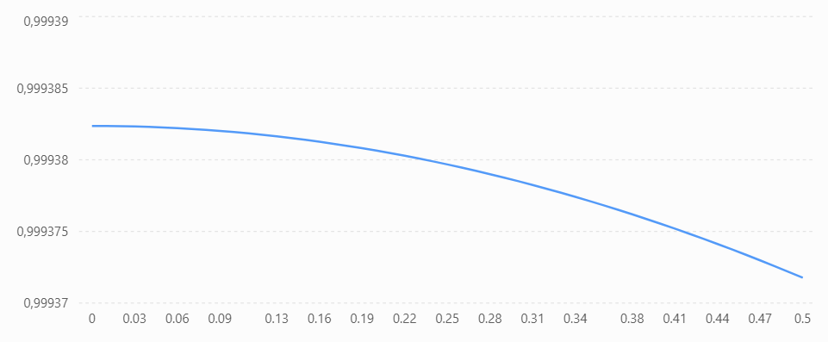
Fig. 3. Dependence of Re(R) on the oil film thickness at f = 150 kHz
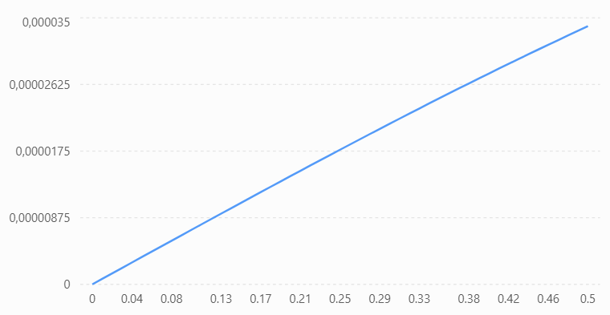
Fig. 4. Dependence of Im(R) on the oil film thickness at f = 150 kHz

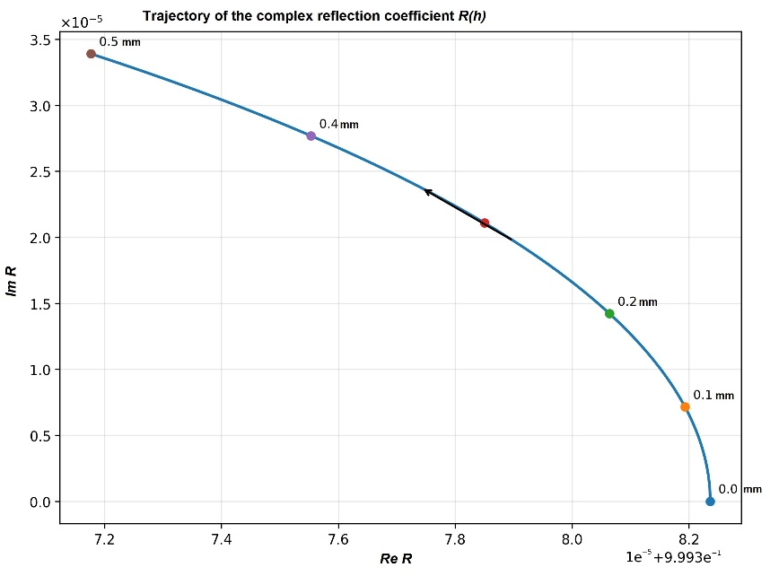
Fig. 5. Trajectory of the complex reflection coefficient R(h) in the complex plane as the film thickness varies from 0 to 0,5 mm

Next, Fig. 6 shows the dependence of the magnitude of the complex ultrasonic wave transmission coefficient |T(h)| on the contaminant film thickness h. The mathematical modeling results show that, within the investigated range h = 0…0,5 mm, the magnitude of the transmission coefficient exhibits a monotonic nonlinear increase. At h = 0, the calculated value is |T| = 1,99938, whereas, as the film thickness increases to 0.5 mm, it reaches |T| = 2,01646. Thus, the absolute change in the magnitude of the transmission coefficient within the investigated range is approximately 0,01708, corresponding to a relative change of approximately 0,85% with respect to the initial value.

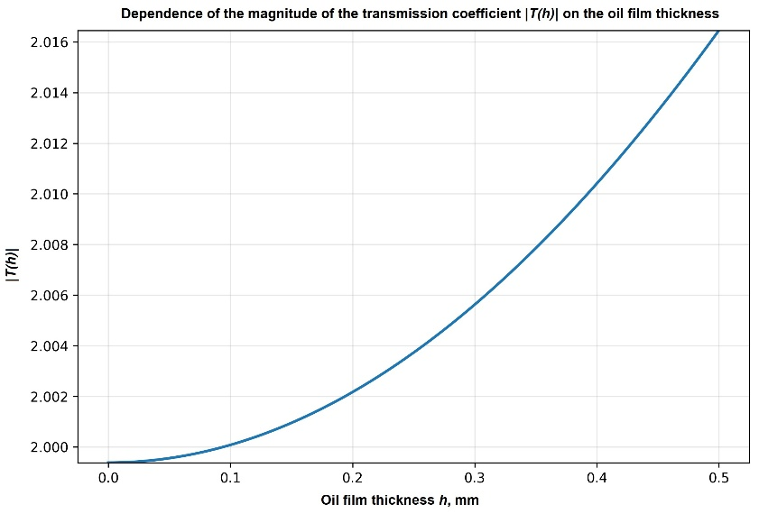
Fig. 6. Dependence of the magnitude of the transmission coefficient |T(h)| on the oil film thickness at f = 150 kHz

The behavior of the obtained dependence is caused by changes in the phase relationships between ultrasonic waves propagating through the multilayer “air-film-water” system. As the film thickness increases, the phase factor e^{2ik}₂^{h} changes and, consequently, so does the resulting interference of waves undergoing multiple reflections at the interfaces between the media. Within the considered thickness range, this results in a gradual increase in |T(h)|, with the slope of the curve increasing as h increases.
The obtained unambiguous monotonic dependence of |T(h)| on film thickness indicates the possibility of using the transmission coefficient as an informative parameter of the mathematical model for estimating the thickness of the contamination layer. Compared with the magnitude of the reflection coefficient |R(h)|, which changes only slightly within the same range, |T(h)| exhibits a more pronounced dependence on film thickness. This indicates the feasibility of further investigating the parameters of the transmitted ultrasonic wave when developing an information and measurement system for monitoring water surface pollution.
It should be noted that, in the model under consideration, T is defined as the acoustic pressure amplitude transmission coefficient. Therefore, a value of |T| > 1 does not imply an increase in ultrasonic wave energy and does not contradict the law of conservation of energy. To estimate the fraction of transmitted acoustic energy, the corresponding intensity transmission coefficient must be used, taking into account the acoustic impedances of the media.
The mathematical modeling results showed that the magnitude of the ultrasonic wave transmission coefficient is more sensitive to changes in film thickness than the magnitude of the reflection coefficient. Over the thickness range from 0 to 0,5 mm, the relative change in |R| is approximately 0,0011%, whereas the relative change in |T| reaches approximately 0,85%. Therefore, for the adopted model parameters, the transmission coefficient is potentially a more informative parameter for determining the thickness of the surface film.
Discussion and Conclusions
The results of the mathematical modeling confirm the existence of a functional relationship between the thickness of the contaminant film on the water surface and the parameters of the ultrasonic wave in the multilayer “air-film-water” medium. Changes in the thickness of the intermediate layer lead to changes in the phase relationships between the waves reflected from and transmitted through the interfaces, which are manifested in variations in the complex reflection coefficient R(h) and transmission coefficient T(h).
Analysis of the dependence of the magnitude of the complex reflection coefficient showed that, within the investigated film thickness range of 0-0,5 mm, |R(h)| changes only slightly. The calculated value decreases from 0,999382 at h = 0 to 0,999372 at h = 0,5 mm. At the same time, analysis of the complex representation of the reflection coefficient shows that changes in film thickness are accompanied not only by changes in its magnitude but also by a redistribution between its real and imaginary components. In particular, as the film thickness increases, the real part of R(h) decreases, whereas the imaginary part increases. This is also reflected in the change in the phase angle of the reflection coefficient and the formation of a characteristic trajectory of R(h) in the complex plane.
A more pronounced dependence on film thickness was obtained for the magnitude of the complex transmission coefficient. Thus, for the adopted parameters of the mathematical model, the magnitude of the transmission coefficient exhibits a more pronounced response to changes in film thickness than the magnitude of the reflection coefficient. This makes it possible to consider the parameters of the transmitted wave as a potentially informative feature for determining the thickness of the surface contamination layer.
At the same time, the obtained results should be considered within the assumptions adopted in the mathematical model. The calculations were performed for normal incidence of the ultrasonic wave, a homogeneous film with constant acoustic parameters, and without accounting for ultrasonic attenuation within the film. Under real conditions, the measurement results may be affected by the nonuniformity and waviness of the film surface, variations in its physical and acoustic properties, the temperature of the media, acoustic wave attenuation, as well as the characteristics of the transmitting and receiving transducers (He et al., 2023). Therefore, the next stage of the research should involve experimental verification of the obtained theoretical relationships and determination of the metrological characteristics of the proposed method.
Thus, a mathematical model for ultrasonic monitoring of water surface pollution has been developed. The model describes ultrasonic wave propagation in the multilayer “air–film–water” medium and establishes the dependence of the complex reflection and transmission coefficients on the surface film thickness.
Based on the results of the mathematical modeling, the following conclusions were drawn:
- The film thickness affects the complex reflection coefficient R(h). Despite the slight change in |R(h)|, analysis of the real and imaginary components revealed a systematic displacement of R(h) in the complex plane as the film thickness increases.
- The complex representation of the reflection coefficient is more informative than analysis of its magnitude alone. As the film thickness increases, the real part of R(h) decreases, the imaginary part increases, and the phase angle of the reflected wave also changes. Thus, information on film thickness is contained in both the amplitude and phase characteristics of the ultrasonic signal.
- A monotonic dependence of the magnitude of the complex transmission coefficient |T(h)| on film thickness was established. For the adopted model parameters, this dependence is more pronounced than the variation in the magnitude of the reflection coefficient.
- The obtained relationships confirm the possibility of using ultrasonic wave parameters to estimate the thickness of a surface contaminant film. In this context, a comprehensive analysis of the parameters of both the reflected and transmitted waves is promising and may increase the informativeness of the ultrasonic method compared with the use of the reflected signal amplitude alone.
- The developed mathematical model can be used as a theoretical basis for the further development of an information and measurement system for monitoring water surface pollution. Further research should focus on experimental verification of the obtained relationships, consideration of ultrasonic wave attenuation, film nonuniformity, and the influence of the physical and acoustic properties of different types of contaminants, as well as on the evaluation of the sensitivity and metrological characteristics of the system.

References
Acero Mendoza, R. V., Bazán, I., & Ramírez-García, A. (2025). Implementation of a Breast Phantom with Acoustic Properties for Ultrasonic Thermometry. Applied Sciences, 15(10), 5275. https://doi.org/10.3390/app15105275
Attali, D., Tiennot, T., Schafer, M., Fouragnan, E., Sallet, J., Caskey, C. F., Chen, R., Darmani, G., Bubrick, E. J., Butler, C., Stagg, C. J., Klein-Flügge, M., Verhagen, L., Yoo, S.-S., Butts Pauly, K., & Aubry, J.-F. (2023). Three-layer model with absorption for conservative estimation of the maximum acoustic transmission coefficient through the human skull for transcranial ultrasound stimulation. Brain Stimulation, 16(1), 48–55. https://doi.org/10.1016/j.brs.2022.12.005
Beranek, L. L., & Mellow, T. J. (2019). Acoustics: Sound fields, transducers and vibration (2nd ed.). Academic Press., https://doi.org/10.1016/B978-0-12-815227-0.00002-9
Dou, P., Jia, Y., Zheng, P., Wu, T., Yu, M., Reddyhoff, T., & Peng, Z. (2022). Review of ultrasonic-based technology for oil film thickness measurement in lubrication. Tribology International, 165, 107290. https://doi.org/10.1016/j.triboint.2021.107290
Forrester, D. M., & Pinfield, V. J. (2018). The absorption of ultrasound in emulsions: computational modelling of thermal effects. Scientific reports, 8(1), 12486. https://doi.org/10.1038/s41598-018-30664-7
Häder, D.-P., Banaszak, A. T., Villafañe, V. E., Narvarte, M. A., González, R. A., & Helbling, E. W. (2020). Anthropogenic pollution of aquatic ecosystems: Emerging problems with global implications. Science of the Total Environment, 713, 136586. https://doi.org/10.1016/j.scitotenv.2020.136586
He, Y., Wang, J., Gu, L., Zhang, C., Yu, H., Wang, L., Li, Z., Mao, Y. (2023). Ultrasonic measurement for lubricant film thickness with consideration to the effect of the solid materials. Applied Acoustics, 211, 109563. https://doi.org/10.1016/j.apacoust.2023.109563
Hu, C., Lu, Y., Sun, S., & Liu, Y. (2021). Optical remote sensing of oil spills in the ocean: What is really possible? Journal of Remote Sensing, 2021, 9141902. https://doi.org/10.34133/2021/9141902
Kanja, J., Mills, R., Li, X., Brunskill, H., Hunter, A. K., & Dwyer-Joyce, R. S. (2021). Non-contact measurement of the thickness of a surface film using a superimposed ultrasonic standing wave. Ultrasonics, 110, 106291. https://doi.org/10.1016/j.ultras.2020.106291
Lützelberger, J., Arneth, P., Franck, A., & Drese, K. S. (2023). Ultrasonic Interferometric Procedure for Quantifying the Bone–Implant Interface. Sensors, 23(13), 5942. https://doi.org/10.3390/s23135942
Naz, S., Iqbal, M. F., Mahmood, I., & Allam, M. (2021). Marine oil spill detection using Synthetic Aperture Radar over Indian Ocean. Marine Pollution Bulletin, 162, 111921. https://doi.org/10.1016/j.marpolbul.2020.111921
Perez-Diego M., Thibbotuwa U. C., Cortés A., Irizar A. (2025). Coating Thickness Estimation Using a CNN-Enhanced Ultrasound Echo-Based Deconvolution. Sensors (Basel). 8;25(19):6234. https://doi.org/10.3390/s25196234
Singh, H., Bhardwaj, N., Arya, S. K., & Khatri, M. (2020). Environmental impacts of oil spills and their remediation by magnetic nanomaterials. Environmental Nanotechnology, Monitoring & Management, 14, 100305. https://doi.org/10.1016/j.enmm.2020.100305
Svejkovsky, J., Hess, M., Muskat, J., Nedwed, T. J., McCall, J., Garcia, O. (2016). Characterization of surface oil thickness distribution patterns observed during the Deepwater Horizon (MC-252) oil spill with aerial and satellite remote sensing, 110(1), https://doi.org/10.1016/j.marpolbul.2016.06.066
Tysiąc, P., Strelets, T., & Tuszyńska, W. (2022). The application of satellite image analysis in oil spill detection. Applied Sciences, 12(8), 4016. https://doi.org/10.3390/app12084016
Yu, M., Shen, L., Mutasa, T., Dou, P., Wu, T., & Reddyhoff, T. (2020). Exact analytical solution to ultrasonic interfacial reflection enabling optimal oil film thickness measurement. Tribology International, 151, 106522. https://doi.org/10.1016/j.triboint.2020.106522
Zhao, D., Tan, B., Zhang, H., & Deng, R. (2022). Monitoring Marine Oil Spills in Hyperspectral and Multispectral Remote Sensing Data by the Spectral Gene Extraction (SGE) Method. Sustainability, 14(20), 13696. https://doi.org/10.3390/su142013696

Валерій ЗДОРЕНКО, д-р тех. наук, професор
ORCID ID: 0000-0001-6508-4290
e-mail: alzd123@meta.ua
Національний технічний університет України
«Київський політехнічний інститут імені Ігоря Сікорського»

Кирило ШОЛУДЬКО, асп.
ORCID ID: 0009-0004-6721-7308
e-mail: kirillsholydko@gmail.com
Національний технічний університет України
«Київський політехнічний інститут імені Ігоря Сікорського»

МАТЕМАТИЧНА МОДЕЛЬ УЛЬТРАЗВУКОВОГО КОНТРОЛЮ ЗАБРУДНЕННЯ ПОВЕРХНІ ВОДИ
У цій роботі розроблено математичну модель ультразвукового контролю забруднення поверхні води, призначену для встановлення кількісного зв’язку між товщиною поверхневої плівки та параметрами ультразвукової хвилі. Досліджуваний об’єкт представлено у вигляді тришарового акустичного середовища «повітря-плівка маслянистої речовини-вода». Модель враховує акустичні імпеданси середовищ, частоту ультразвукового випромінювання, товщину проміжного шару, фазовий зсув і багаторазові відбиття хвиль від меж поділу середовищ. Отримано математичні залежності комплексних коефіцієнтів відбиття R(h) та проходження T(h), їх модулів, а також дійсної та уявної складових коефіцієнта відбиття від товщини плівки. Математичне моделювання виконано для частоти ультразвукового випромінювання 150 кГц та товщини плівки олії від 0 до 0,5 мм. Встановлено, що в досліджуваному діапазоні модуль комплексного коефіцієнта відбиття змінюється незначно – від 0,999382 до 0,999372, тоді як зміна товщини плівки супроводжується формуванням уявної складової та зміною фазового кута відбитого сигналу. Водночас модуль комплексного коефіцієнта проходження зростає від 1,99938 до 2,01646, а його відносна зміна становить приблизно 0,85 %, що свідчить про більш виражену залежність цього параметра від товщини плівки порівняно з модулем коефіцієнта відбиття. Отримані результати підтверджують доцільність комплексного аналізу амплітудних і фазових характеристик ультразвукового сигналу для оцінювання товщини поверхневого шару забруднення. Розроблена математична модель може бути використана як теоретична основа для подальшого створення інформаційно-вимірювальної системи контролю забруднення поверхні води та експериментального дослідження її метрологічних характеристик.
Ключові слова: ультразвукові хвилі, математична модель, забруднення поверхні води, товщина плівки, комплексний коефіцієнт відбиття, коефіцієнт проходження, акустичний імпеданс, інформаційно-вимірювальна система.

Автори заявляють про відсутність конфлікту інтересів. Спонсори не брали участі в розробленні дослідження; у зборі, аналізі чи інтерпретації даних; у написанні рукопису; в рішенні про публікацію результатів.
The authors declare no conflicts of interest. The funders had no role in the design of the study; in the collection, analyses, or interpretation of data; in the writing of the manuscript; or in the decision to publish the results.

UDC 004.81:355.4
Viktor SINEGLAZOV, Doctor of Technical Sciences, Professor
ORCID ID: 0000-0002-3297-9060
National Technical University of Ukraine "Igor Sikorsky Kyiv Polytechnic Institute", Kyiv, Ukraine

Viktor CHELKOVAN, Head of Research Department
ORCID ID: 0009-0001-4522-6260
e-mail: vichell12@gmail.com
Central Research Institute of the Armed Forces of Ukraine, Kyiv, Ukraine
STATISTICAL VALIDATION OF A TRANSFORMER WITH CAUSAL ATTENTION BIAS ON SYNTHETIC TACTICAL DECISION-SUPPORT TASKS
Background. Military decision support systems may become more accurate and explainable if expert knowledge about cause-and-effect relations in the tactical situation is built into the neural network. The FCM-Transformer does this by steering the attention of a transformer with a fuzzy cognitive map, but the approach had not been tested experimentally. The aim was to establish statistically whether, and under what conditions, such knowledge improves the model on three decision-support tasks of a synthetic benchmark.
Methods. In total, 310 training runs were performed on 5,000 simulated company-level defence scenarios, in which the models ranked targets, assessed threats to own positions and assigned firing positions to targets. The model was compared with four alternative models, tested at 15 values of the weight of expert knowledge and with individual components of the knowledge removed. Each configuration was trained 10 times, and the training runs were the units of a paired analysis with corrections for multiple comparisons and Bayesian estimation; confirmatory predictions were fixed before the corresponding runs and kept apart from exploratory analyses.
Results. At the initially chosen weight, the knowledge term amounted to only 0.55% of the spread of the model's own (unnormalised) attention scores and had no significant effect. In exploratory comparisons at a weight 40 times larger, the share of correctly assigned targets rose by 4.18 percentage points over the same model without the knowledge and target ranking improved slightly, but threat assessment worsened by 1.09 points. Only the knowledge of which firing position can engage which target was useful. As predicted before the confirmatory runs, a knowledge base limited to these fire relations kept the assignment gain (4.14 points) and reduced the threat-assessment loss to 0.27 points. An algorithm relying on the knowledge alone performed worse than the model without it.
Conclusions. On this synthetic benchmark, expert knowledge improved the transformer only after its weight had been calibrated against the model's own attention scores, and restricting it to fire relations reduced the loss in threat assessment; operational use requires confirmation on expert-labelled data.
Keywords: transformer; attention bias; fuzzy cognitive map; decision support; synthetic benchmark; statistical validation; ablation study; Bayesian estimation.
Introduction
Intelligent decision support systems (IDSS) help combat staffs to decide under time pressure and uncertainty while accounting for cause-and-effect relations in the situation (Zgurovsky & Pankratova, 2022), and attention-based networks increasingly serve their tasks: they recognise the tactical intentions of air targets (S. Wang et al., 2023; X. Wang et al., 2024) and, as pointer networks trained by reinforcement learning (Na, Ahn, & Moon, 2023), address weapon–target assignment (Kline, Ahner, & Hill, 2019). The transformer (Vaswani et al., 2017) suits such tasks because self-attention models pairwise interactions within an unordered set of entities.
Sineglazov and Chelkovan (2025) proposed a hierarchical transformer for military IDSS that integrates a cognitive map of the situation, the tuple C = ⟨S, R, E, T⟩ of states, causal influences R: S × S → [0, 1], state embeddings and transition dynamics, into self-attention:
 | $${\text{Attention}}^{\text{*}}\left(Q,K,V,Φ\right)=\text{softmax}\left(\frac{QK^{⊤}+λ' Φ}{\sqrt{d_{k}}}\right)V$$  $$Φ_{ij}=R\left(s_{i},s_{j}\right) \text{sim}\left(E\left(s_{i}\right),E\left(s_{j}\right)\right)$$ | (1)
where Φ is the matrix of cognitive influences, d_{k} is the key dimension and λ′ > 0 balances data and expert knowledge; its value was left open. The benefits of the design were argued theoretically.
Such arguments need experimental confirmation, especially in the military domain, where errors are costly (Helmer et al., 2024). Construction (1) leaves open the scale of the bias relative to the content logits of a trained network and the composition of the map, i.e. which relations enter Φ and with what weights. When a synthetic benchmark is labelled by rules related to the prior given to the model, a gain may partly reflect this coupling, a form of leakage (Kapoor & Narayanan, 2023).
The aim of this paper is to validate the FCM-Transformer statistically on three decision-support tasks of a synthetic company-level benchmark; the study evaluates the attention mechanism, not a complete IDSS. We ask whether the bias at λ = 0.5, the value adopted in the initial protocol, improves on a transformer with a line-of-sight mask (RQ1); at what scale its effect appears and how it is distributed across tasks (RQ2); which components of the bias carry or harm the effect (RQ3); whether a composition that reduces the trade-off between tasks survives confirmation (RQ4); and whether the model merely copies the structure of the answer contained in the bias (RQ5).
Related Work
Structured attention biases. Adding structure to attention is established: T5 adds learned relative-position biases to the logits (Raffel et al., 2020), ALiBi a fixed distance penalty (Press, Smith, & Lewis, 2022) and Graphormer spatial and edge encodings of a graph (Ying et al., 2021), while ConViT mixes content attention with a soft convolutional map through learned gates (d'Ascoli et al., 2021). The novelty of the FCM-Transformer therefore lies not in the additive bias but in its source, a causal map decomposed into named relations.
Fuzzy cognitive maps and informed learning. Fuzzy cognitive maps model causal influences among concepts (Kosko, 1986; Felix et al., 2019); deep FCMs combine the causal graph with neural approximators (J. Wang et al., 2021), and deep attention FCMs add attention to the FCM recursion (Qin, Peng, & Wu, 2023), the closest precedent. In the taxonomy of informed machine learning, the FCM-Transformer injects graph-structured knowledge into the hypothesis set (von Rueden et al., 2023).
Statistical rigour. Variance from data sampling, initialisation and data order is a major source of spurious conclusions in benchmarks (Bouthillier et al., 2021); reproducibility requires reporting the full protocol (Pineau et al., 2021), and pre-registration separates confirmatory from exploratory analyses (Nosek et al., 2018). We know of no validation of FCM–transformer architectures with enough runs and multiplicity control, no measurement of the bias scale against the network's own logits and no test of individual relations as attention biases.
Results
Materials and Methods
Attention with a causal bias
For a single level of the hierarchy (a company), mechanism (1) was implemented as
 | $$l_{ij}=\frac{q_{i}^{⊤}k_{j}}{\sqrt{d_{k}}}+λ Ψ_{ji}+M_{ij}$$ | (2)
where q_{i} and k_{j} are the query and key vectors, Ψ is the matrix Φ of (1), M is the line-of-sight mask and λ ≥ 0 is the bias scale. The mask forbids attention only for pairs involving a target without line of sight; own entities are never masked from each other, because radio and command networks need no visibility. Unlike (1), the bias is placed outside the 1/√d_{k} scaling, so λ = λ′/√d_{k} (the initial λ = 0.5 corresponds to λ′ ≈ 2.8).
Direction of the bias. Ψ_{ab} stores the influence of entity a on entity b (cause → effect). In (2), row i belongs to the query, the entity whose representation is updated, and column j to the key it reads from; the entry needed at (i, j) is therefore the influence of j on i, Ψ_{ji}, i.e. the bias matrix is Ψ^{T}. Each entity thus attends more to the entities that influence it, and information flows from causes to effects, as in the inference rule of fuzzy cognitive maps, where a concept aggregates the states of its causes weighted by its incoming edges (Kosko, 1986), and in the FCM baseline M3 (Table 2). Without the transposition, and with Φ_{ij} in (1) read as the influence of s_{i} on s_{j}, an entity would attend to the entities it influences, against the causal direction. For R_{fire}, each target attends to the firing positions able to engage it.
With R_{k}(a, b) ∈ [0, 1] the influence of a on b, four typed relations were defined: R_{fire} (firing position → target) = InSector·InRange·eff·ammo; R_{threat} (target → own entity) = threat·vuln·mobility; R_{log} (supply point → firing position or vehicle, route → supply point) with a linear decay over 3 km; R_{hier} (commander → subordinate, 1.0; same unit, 0.5). The bias is
 | $$Ψ_{ab}=G_{ab} \text{cos}\left(e_{a},e_{b}\right)\sum_{k=1}^{4}{ω_{k}}R_{k}\left(a,b\right)$$ | (3)
with the cosine similarity of the learned entity embeddings e and the spatial gate
 | $$G_{ab}={\text{LOS}}_{ab}⋅\text{max}\left(0, 1-\frac{{\text{dist}}_{ab}}{4 \text{km}}\right)$$ | (4)
Ψ is shared by all heads and layers; λ and ω are fixed rather than trained. On pairs of firing positions and targets only R_{fire} is non-zero, on pairs of targets and own entities only R_{threat}.
Relation weights. The weights ω = (0.35, 0.30, 0.20, 0.15) were set by the authors before the experiments as an expert judgement of the relative importance of the four relations in the tactical situation: fire capability and target threat highest (0.35 and 0.30), logistics and command links lower (0.20 and 0.15); they sum to one and were not elicited formally. Two properties bound, but do not remove, the dependence of the conclusions on these values. Ψ is linear in ω, so a common factor of the weights is absorbed by λ, which was varied over more than two orders of magnitude, and only the ratios of the weights matter; the ablation and confirmatory variants set one to three weights to zero, which tests the contribution of each relation but not intermediate ratios. Whether the expert weights are useful is thus an empirical question (Section 4.3).
Scenarios and ground truth
The generator models a mechanised company in defence on a 4.0 × 4.0 km field (Table 1). The entity features (type, role, unit, coordinates, sector, range, ammunition, threat, mobility and scenario conditions) contain no pairwise information, so the baselines must infer spatial relations from coordinates.
Table 1
Scenario generator (fixed in the protocol before data generation)
Parameter | Value
Scenarios | 5,000; split 3,500 / 750 / 750 (training / validation / test) in generation order; one random seed
Entities | 84 per scenario: firing positions (FP) 30–40, targets 10–20, personnel 10–15, vehicles 8–12, routes 4–8, supply points 3–5
Field | 4.0 × 4.0 km, defence facing north; FP at y ∈ [0.5, 2.0] km, targets at y ∈ [1.5, 4.0] km
FP weapons | machine gun, anti-tank guided missile, mortar, automatic cannon (probabilities 0.40 / 0.25 / 0.15 / 0.20; range 1.5 / 3.0 / 4.5 / 2.5 km); sector ±60°; ammunition U(0.2, 1.0)
Targets | tank, infantry fighting vehicle, armoured personnel carrier, infantry, artillery (0.20 / 0.25 / 0.20 / 0.25 / 0.10); threat drawn by combat intensity
Conditions | terrain (5) × intensity (3) × weather (3) × time of day (3) = 135 combinations
Line of sight | p_{LOS} = terrain base (plain 0.90 … forest 0.50) + weather (fog −0.15, rain −0.05) + time (night −0.10, dusk −0.05), clipped to [0.20, 0.95]; drawn per pair of entities
Measured | masked pairs 0.149; share of NONE in T3 0.228

T1, target prioritisation. For a firing position (FP) i and a target j,
 | $$\text{score}\left(i,j\right)={\text{InSector}}_{ij} {\text{InRange}}_{ij} {\text{Vis}}_{ij} \frac{\text{eff}\left(w_{i},c_{j}\right) {\text{threat}}_{j} {\text{ammo}}_{i}}{\text{max}\left({\text{dist}}_{ij}, 0.05\right)}$$ | (5)
where InSector and InRange indicate that the target lies within the fire sector (half-width 60°) and the range, Vis_{ij} = LOS_{ij} or w_{i} = mortar (direct fire needs visibility, the mortar fires indirectly), and eff is the effectiveness of weapon type w against target type c. The ground truth is the top five targets with relevance grades 5 to 1.
T2, threat assessment. For an own position o (FP, vehicle or supply point),
 | So=j∈TGT​threatj vulno,cj Gjo mobj, totalo=1-e-So | (6)
with the classes LOW (total < 0.45), MEDIUM and HIGH (total ≥ 0.65); the thresholds were chosen in a pre-registration simulation to balance the classes.
T3, fire allocation. With U_{ij} = score(i, j), a greedy injective assignment in two passes (targets with threat ≥ 0.7 first) with the admission rule U ≥ 0.1 gives each target an FP or the class NONE.
Structural coupling. The quantities that define the ground truth (eff, ammo, threat, vuln, mobility and G) also enter R_{k}, so the model with Ψ receives part of the structure of the answer as prior knowledge. We quantify this coupling rather than hide it (Section 4.5).
Models, training and metrics
Table 2 specifies the five models, which share the input projection and the task heads (M0–M2 also share the transformer encoder): M0, the FCM-Transformer (2); M1, a transformer without mask and Ψ; M2, a transformer with the mask but without Ψ (identical to M0 at λ = 0); M3, a classic FCM; M4, a multilayer perceptron (MLP) without pairwise interactions
The primary test metrics (750 scenarios) are NDCG@5 for T1, Macro-F1 for T2 (37,277 own positions per run) and ExactMatch for T3 (the share of targets whose argmax over 85 classes is correct); the composite used for early stopping is their unweighted mean.
Table 2
Models, variants, training and run matrix
Item | Specification
Encoder (M0–M2) | d_{model} = 256, 8 heads (d_{k} = 32), 4 layers, d_{ff} = 512, dropout 0.1, pre-LayerNorm, GELU; 44 input features
M0 / M1 / M2 | logits (2) / q·k/√d_{k} only / q·k/√d_{k} + M; 2,383,620 parameters each
M3: classic FCM | X_{t+1} = tanh(W̃X_{t} + X₀), 20 iterations, W̃ = row-normalised R^{T}; 274,692 parameters
M4: MLP | per-entity embedding and a global context vector; 11,810,564 parameters
Heads and loss | T1: bilinear FP–target scores; T2: 3-class classifier; T3: bilinear target–FP scores plus a NONE logit (85 classes); unweighted sum of cross-entropy losses
Training | AdamW, learning rate 10⁻⁴, weight decay 0.01, cosine schedule, batch 32, ≤ 100 epochs, early stopping (patience 10) on the validation composite; seeds 1–10
Ablation, λ = 20 | reference A0 = M0 with the full Ψ; A1–A4: ω_{k} = 0 for R_{fire}, R_{threat}, R_{log}, R_{hier}; A5: G ≡ 1 in (3), mask M unchanged; A6: no cosine factor; A7 = A2 + A5; A8 = A1 + A2; A9 = A5 + A6
Confirmation, λ = 20 | A10: R_{fire} only; A11: A10 without G (primary candidate); A12: A11 without the cosine factor
Run matrix | M0 (λ = 0.5) and M1–M4: 50 runs; M0 at λ ∈ {0, 1, 2, 3, 5, 8, 12, 15, 20, 30, 40, 50, 70, 100}: 140; A1–A9: 90; A10–A12: 30; in total 310 runs

Protocol and status of the analyses
Constants, formulas, the run matrix and the statistical rules were fixed before the first run and committed to a version-controlled repository; every later amendment was dated, justified by the results of the preceding version, recorded before the runs it concerned and required no reruns (an internal pre-registration without a public registry). Version 1.2 replaced a uniform λ grid on [0, 1] with a logarithmic one because the relative logit bias (Section 3.5) at λ = 0.5 was only 0.55%; version 1.3, written after 60 λ runs had already indicated a preliminary optimum at λ = 20, set the 15-point grid, the rule for λ_{max} (the maximiser of the mean test composite) and the ablation gate (ablation at λ_{max} only if λ_{max} ∉ {0, 0.5} and the composite gain over λ = 0 exceeds two standard errors); version 1.4 added the confirmatory group, whose variants were derived from the ablation results. Table 3 classifies every analysis by the moment its hypothesis was fixed; exploratory results are labelled in Sections 4 and 6 and are not treated as confirmed.
Table 3
Status of the analyses by the moment their hypotheses and decision rules were fixed
Analysis (research question) | Fixed | Status
M0 (λ = 0.5) vs M1–M4, three primary metrics (RQ1) | version 1.0, before any run | confirmatory
λ grid, λ*, rule for λ_{max}, ablation gate, plateau tests (RQ2) | versions 1.2–1.3, after the baseline runs and 60 of the 140 λ runs | pre-specified, informed by interim results
Ablation A1–A9 vs A0 (RQ3) | variants in version 1.0, scale in version 1.3, before any ablation run | pre-specified, no directional predictions
Prediction PA6 for A6 | before any A6 run | confirmatory
A10–A12 vs A0 and vs M2, predictions P1–P4 (RQ4) | version 1.4, derived from the ablation, before any of these runs | confirmatory (hypotheses from the ablation)
Spearman coupling of Ψ with the ground truth (RQ5) | version 1.3 | pre-specified, descriptive
A0 (λ = 20) vs the baselines; λ_{max} on the validation split; λ_{eff}; Ψ-only algorithms; confusion matrices of A0 and A11; Bayesian estimates | after the corresponding runs | exploratory

Statistical analysis
Unit of analysis. The statistical unit is the training run. All runs use the same data and split; the ten runs of a configuration differ only in the training seed, which sets the initialisation, dropout and batch order, and are thus independent replications of the stochastic training procedure for this dataset. Runs with the same seed share the batch order and, for architectures of the same shape, the initialisation (M0 at λ = 0 reproduced M2 bitwise), so configurations are compared in pairs by seed. Each run contributes one value per metric, computed over all test objects of the 750 scenarios (valid FPs, own positions or targets). The objects are never treated as observations in a test: their dependence within a scenario affects only the precision of each run's value, and all configurations are evaluated on the same scenarios. The inference therefore concerns the variability of training on a fixed benchmark, not the variability due to sampling other scenarios from the generator.
Tests. On the ten paired run-level differences we used the paired t-test, the exact Wilcoxon signed-rank test, the exact sign-permutation test (1,024 patterns; minimum two-sided p ≈ 0.002) and the percentile bootstrap 95% confidence interval (CI) of the mean difference (Efron & Tibshirani, 1994); the 10,000 bootstrap resamples are drawn from these ten differences and affect only the Monte Carlo precision of the CI, not the sample size. Holm (1979) and Bonferroni corrections were applied within families: M0 vs M1–M4 × 3 metrics (m = 12), single ablations (m = 18), paired ablations (m = 9), confirmatory variants vs A0 and vs M2 (m = 9 each) and plateau tests (m = 6). Key differences were also estimated in the Bayesian model (Benavoli et al., 2017)
 | $$δ_{s}∼\text{StudentT}\left(ν,μ,σ\right), μ∼N\left(0, 0.1\right),$$  $$σ∼\text{HalfNormal}\left(0.1\right), ν∼\text{Exp}\left(1/30\right)$$ | (7)
sampled with the No-U-Turn sampler (Hoffman & Gelman, 2014) in PyMC (Abril-Pla et al., 2023), 4 chains × 1,000 draws with a target acceptance of 0.95, raised from the default 0.8 after a first run had produced divergent transitions, and checked with ArviZ: maximum R-hat 1.0051, minimum bulk and tail effective sample sizes 776 and 629, no divergences. We report P(|μ| < 0.005), the posterior probability that the absolute difference is below 0.5 pp; this region of practical equivalence (Kruschke, 2018) was set after the training runs, before the Bayesian analysis, and is used descriptively.
Relative logit bias. The magnitude of the bias in a trained model is characterised by
 | $$s=\frac{\text{std}\left(λ Ψ^{⊤}\right)}{\text{std}\left(q^{⊤}k/\sqrt{d_{k}}\right)}$$ | (8)
over the unmasked pairs of 32 test scenarios, averaged over layers and heads. This relative logit bias measures the size of the additive term relative to the content logits before the softmax, not the resulting change of the attention weights, which also depends on how the bias varies within a row (a shift that is constant in a row has no effect). Its linear expectation is 0.011·λ, extrapolated from λ = 0.5. For an ablation variant, the equivalent scale λ_{eff} is the λ at which the curve of s for the full model equals s of the variant; comparing the variant with the λ curve at λ_{eff} separates the logit-level magnitude of a bias from its content. Finally, Ψ was compared with the ground truth by within-scenario Spearman correlations and by deterministic algorithms that rank or assign by Ψ alone instead of U.
Implementation and use of AI tools
The code used Python 3.13 and PyTorch 2.14 (CUDA 13.0); all runs were executed on one NVIDIA GeForce RTX 3090 GPU in fp32 and deterministic mode and are reproducible byte for byte on this machine, which was also verified in a fresh clone of the repository; other hardware was not tested.
As required by the journal policy, we declare the use of generative artificial intelligence. Claude (Anthropic), namely the models Claude Fable 5.1 and Claude Opus 5.5 in the claude.ai application and the Claude Code command-line tool, was used between June and September 2026 to draft the protocol and analysis plan under the authors' direction, to write and review the code for scenario generation, training and statistical analysis, to produce tables and figures from the logged results, to search for literature and to prepare and revise the English text. All reported numbers were produced by scripts from the run logs and checked automatically against the result files. The authors reviewed and edited all outputs and take full responsibility for the paper.
Experimental Results
Initial scale λ = 0.5 (RQ1, confirmatory)
The FCM-Transformer at λ = 0.5 and the masked transformer clearly outperform the other models (Table 4): all nine differences of M0 from M1, M3 and M4 on the primary metrics are significant after correction (Δ from +0.1347 to +0.2952, M0 better in 10 of 10 runs). M0 and M2, however, do not differ significantly (Table 5): Δ = +0.0006, +0.0001 and −0.0011 on NDCG@5, Macro-F1 and ExactMatch, all CIs include zero and p_{Holm} ≥ 0.535, and the posterior probability of an absolute difference below 0.5 pp is 1.000 on all three metrics (exploratory). The whole gain over the unmasked transformer is thus due to the line-of-sight mask. The likely reason is the scale: at λ = 0.5 the relative logit bias is only 0.55% (0.0055 ± 0.0001).
Table 4
Test metrics of models M0–M4 (750 test scenarios), mean ± SD over 10 training runs
Model | NDCG@5 (T1) | Macro-F1 (T2) | ExactMatch (T3) | Composite
M0: FCM-Transformer (λ = 0.5) | 0.9060 ± 0.0009 | 0.9640 ± 0.0021 | 0.6202 ± 0.0043 | 0.8301 ± 0.0018
M1: transformer, no mask, no Ψ | 0.7640 ± 0.0014 | 0.7075 ± 0.0020 | 0.4562 ± 0.0034 | 0.6425 ± 0.0011
M2: transformer with mask M | 0.9054 ± 0.0012 | 0.9639 ± 0.0018 | 0.6213 ± 0.0046 | 0.8302 ± 0.0017
M3: classic FCM | 0.7334 ± 0.0011 | 0.8293 ± 0.0006 | 0.3996 ± 0.0012 | 0.6541 ± 0.0006
M4: MLP | 0.7315 ± 0.0010 | 0.6688 ± 0.0034 | 0.3873 ± 0.0034 | 0.5959 ± 0.0022

Table 5
Paired differences from M2: M0 at the initial λ = 0.5 (confirmatory), A0 at λ = 20 (exploratory) and A11 (confirmatory, prediction P4)
Model − M2 | Metric | Δ | 95% CI | Higher | p_{Holm} | P(|μ| < 0.005)
M0 (λ = 0.5) | NDCG@5 | +0.0006 | [−0.0001, +0.0014] | 8/10 | 0.535 | 1.000
 | Macro-F1 | +0.0001 | [−0.0006, +0.0006] | 7/10 | 0.797 | 1.000
 | ExactMatch | −0.0011 | [−0.0026, +0.0002] | 4/10 | 0.535 | 1.000
A0: M0 (λ = 20) | NDCG@5 | +0.0040 | [+0.0028, +0.0051] | 10/10 | < 0.001 | 0.903
 | Macro-F1 | −0.0109 | [−0.0127, −0.0090] | 0/10 | < 0.001 | 0.000
 | ExactMatch | +0.0418 | [+0.0393, +0.0448] | 10/10 | < 0.001 | 0.000
A11 (λ = 20) | NDCG@5 | +0.0055 | [+0.0042, +0.0068] | 10/10 | < 0.001 | 0.290
 | Macro-F1 | −0.0027 | [−0.0036, −0.0018] | 0/10 | < 0.001 | 1.000
 | ExactMatch | +0.0414 | [+0.0381, +0.0447] | 10/10 | < 0.001 | 0.000
Note. Δ = mean paired difference over 10 runs; CI = paired percentile bootstrap; Higher = runs in which the model beats M2; p_{Holm} = Holm-adjusted paired t-test (families of m = 12 and m = 9, Section 3.5); P(|μ| < 0.005) from model (7), exploratory; λ = 20 was selected on the test curve.
Scale of the bias (RQ2, pre-specified design, exploratory contrasts)
The effect becomes detectable at λ* = 3 (Fig. 1, Table 6), where the change of NDCG@5 from λ = 0 exceeds two standard errors and the relative logit bias reaches 3.50%. The composite follows an inverted U with its maximum at λ_{max} = 20; in 10,000 paired bootstrap resamples over seeds, λ = 20 wins with frequency 0.9492 (95% interval [20, 30]), and selection on the validation split gives the same optimum (frequency 0.9277; exploratory). The ablation gate was passed (composite gain +0.0117, 2·SE = 0.0012).
The tasks respond in opposite directions. At λ = 20, ExactMatch changes by +4.18 pp [+3.93, +4.48], NDCG@5 by +0.40 pp [+0.28, +0.51] and Macro-F1 by −1.09 pp [−1.27, −0.90]; the T2 loss is detectable from λ = 8 and reaches −3.84 pp at λ = 100; at λ = 5, the largest λ without a detectable loss, ExactMatch gains 0.96 pp. The plateau {15, 20, 30} is flat only for the composite: λ = 20 beats λ = 15 on ExactMatch (+0.63 pp) but loses on Macro-F1 (−0.37 pp).
Table 6
Dependence on the bias coefficient λ (10 runs per point): paired changes relative to λ = 0, pp, and relative logit bias
λ | Mark | Δ NDCG@5 | Δ Macro-F1 | Δ ExactMatch | Δ Composite [95% CI] | Relative logit bias, % | Meas./exp.
0 |  | — | — | — | — | 0.00 | —
0.5 | initial | +0.06 | +0.01 | −0.11 | −0.01 [−0.06, +0.02] | 0.55 | 0.99
1 |  | −0.02 | +0.01 | −0.04 | −0.01 [−0.12, +0.05] | 1.11 | 1.01
2 |  | +0.03 | −0.03 | +0.10 | +0.04 [−0.03, +0.10] | 2.28 | 1.04
3 | λ* | +0.08 | +0.04 | +0.35 | +0.15 [+0.04, +0.26] | 3.50 | 1.06
5 |  | +0.16 | +0.05 | +0.96 | +0.39 [+0.31, +0.48] | 6.09 | 1.11
8 |  | +0.19 | −0.21 | +1.88 | +0.62 [+0.52, +0.71] | 10.35 | 1.18
12 |  | +0.30 | −0.42 | +2.89 | +0.92 [+0.84, +1.00] | 15.82 | 1.20
15 | plateau | +0.29 | −0.71 | +3.55 | +1.04 [+0.93, +1.17] | 19.59 | 1.19
20 | λ_{max}; plateau | +0.40 | −1.09 | +4.18 | +1.17 [+1.06, +1.27] | 25.48 | 1.16
30 | plateau | +0.26 | −1.47 | +4.28 | +1.02 [+0.89, +1.17] | 35.08 | 1.06
40 |  | +0.29 | −1.81 | +4.22 | +0.90 [+0.77, +1.03] | 42.04 | 0.96
50 |  | +0.23 | −1.99 | +4.13 | +0.79 [+0.69, +0.90] | 46.77 | 0.85
70 |  | +0.18 | −2.73 | +3.98 | +0.48 [+0.31, +0.67] | 53.18 | 0.69
100 |  | +0.18 | −3.84 | +3.70 | +0.01 [−0.16, +0.16] | 58.09 | 0.53
Note. λ = 0.5: the baseline M0 group. Δ = mean paired difference from λ = 0; CI = paired percentile bootstrap. Plateau: points whose composite CI overlaps that of λ_{max}. Relative logit bias by (8), mean over 10 runs; Meas./exp. = its ratio to 0.011·λ. λ* (NDCG@5), the composite gate and the plateau tests are pre-specified; the other contrasts are exploratory (Table 3).
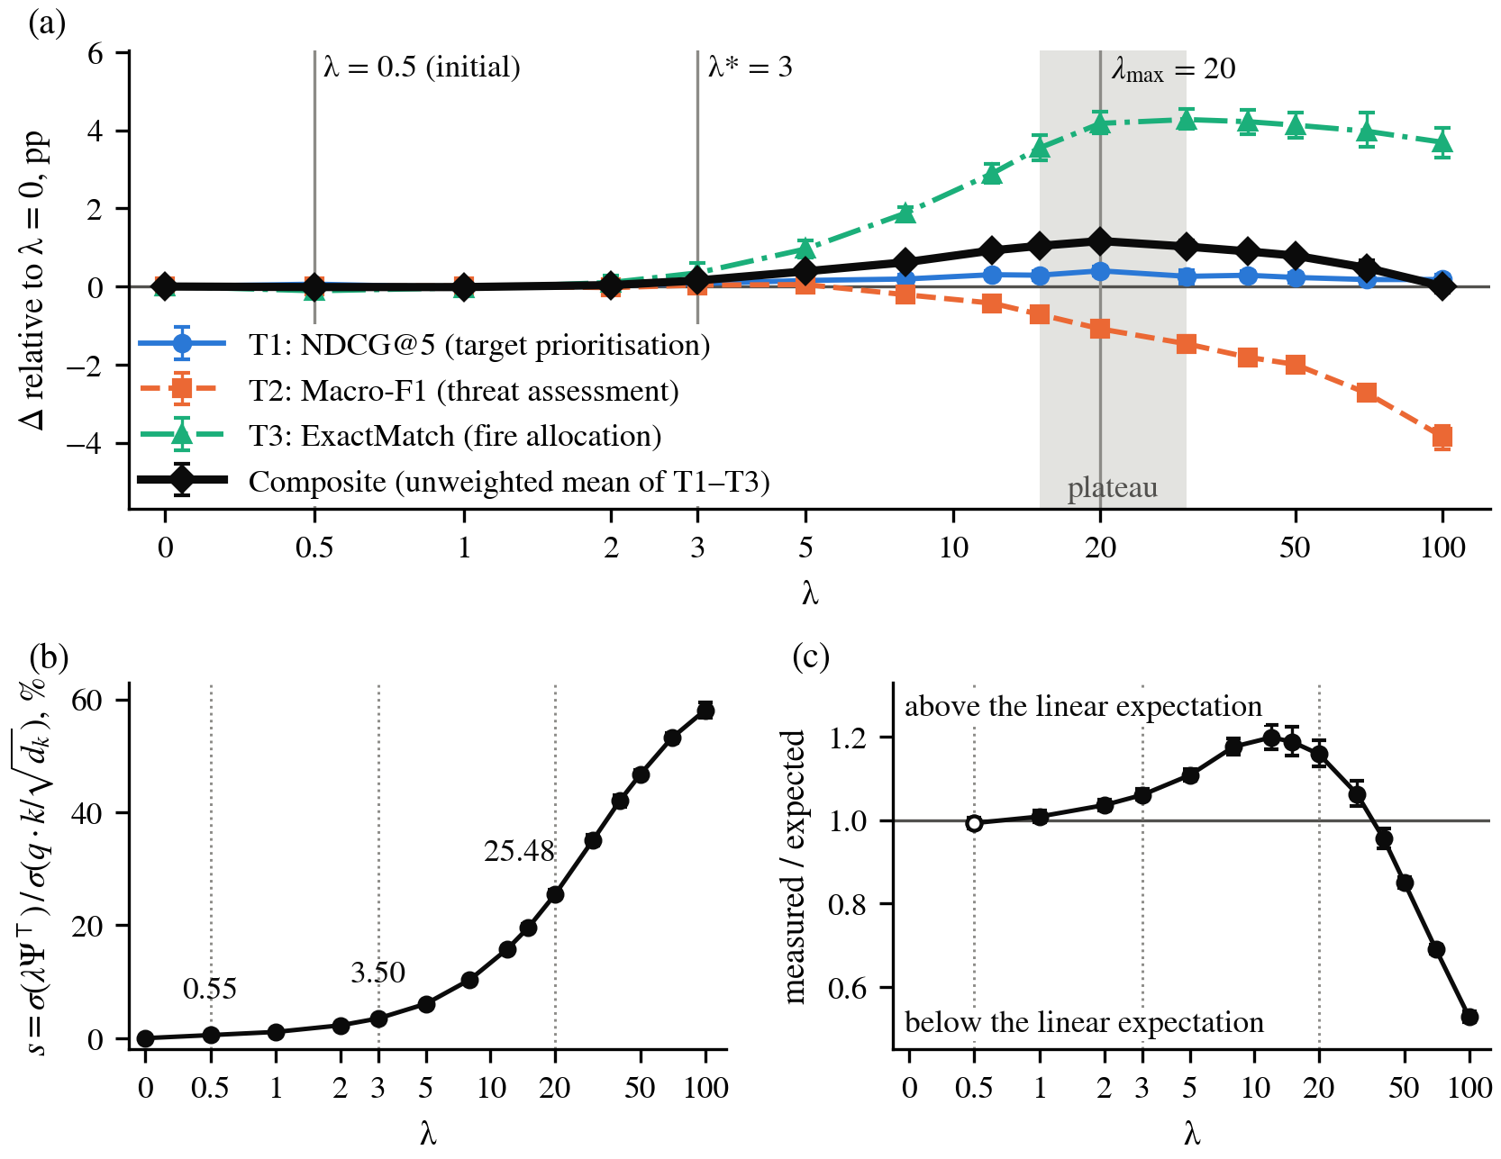
Fig. 1. Effect of λ (10 runs per point; symmetric logarithmic axis): (a) change of the metrics and the composite relative to λ = 0, pp; grey band: plateau of the composite; (b) relative logit bias (8), %; (c) ratio of the measured relative logit bias to its linear expectation 0.011·λ (calibrated at λ = 0.5, open circle); whiskers: 95% bootstrap CIs
Panels (b) and (c) of Fig. 1 show that the measured relative logit bias deviates from its linear expectation (exploratory): it exceeds it up to λ = 30 (by up to 1.20 times at λ = 12) and falls below it from λ = 40 (0.53 at λ = 100). Both the content logits and the learned cosine factor inside Ψ contribute: the trained network amplifies a weak prior and attenuates a strong one.
Composition of the bias (RQ3, pre-specified comparisons)
Only one relation carries the gain (Table 7, Fig. 2). Without R_{fire} (A1), ExactMatch falls by 4.36 pp, and the composite drops below that of the model without Ψ (retained share −0.25). R_{threat} is neutral (A2). The relations among own entities harm threat assessment: removing R_{hier} (A4) recovers 0.84 pp of Macro-F1, i.e. 78% of the loss, without changing T1 and T3; removing R_{log} (A3) recovers 0.27 pp and removing G (A5) 0.41 pp.
Table 7
Ablation of the components of Ψ at λ = 20: change relative to the full Ψ (A0), in pp
Variant | Removed | Δ NDCG@5 | Δ Macro-F1 | Δ ExactMatch | Δ Composite [95% CI] | Retained share | λ_{eff}
A1 | R_{fire} | −0.45* | +0.44* | −4.36* | −1.46 [−1.53, −1.38] | −0.25 | 15.5
A2 | R_{threat} | +0.06 | +0.06 | −0.42 | −0.10 [−0.22, +0.02] | 0.91 | 17.2
A3 | R_{log} | −0.02 | +0.27* | −0.08 | +0.06 [−0.02, +0.13] | 1.05 | 20.0
A4 | R_{hier} | −0.03 | +0.84* | +0.13 | +0.31 [+0.24, +0.39] | 1.27 | 14.4
A5 | G | +0.21 | +0.41* | −0.11 | +0.17 [+0.06, +0.27] | 1.14 | 44.5
A6 | cos | −0.10 | −0.44* | +0.13 | −0.14 [−0.22, −0.06] | 0.88 | 31.0
A7 | R_{threat} and G | +0.25 | +0.27 | −0.11 | +0.14 [+0.03, +0.29] | 1.12 | 37.2
A8 | R_{fire} and R_{threat} | −0.44* | +0.20 | −4.44* | −1.56 [−1.65, −1.48] | −0.34 | 13.5
A9 | G and cos | +0.33* | −0.03 | +0.08 | +0.13 [−0.08, +0.32] | 1.11 | > 100
Note. Δ = A_{k} − A0 over 10 runs; an asterisk marks significance after Holm correction (m = 18 for A1–A6, m = 9 for A7–A9; Bonferroni verdicts identical). Retained share = (A_{k} − M2)/(A0 − M2) on the composite (A0 − M2 = +0.0117); λ_{eff} = equivalent scale (Section 3.5; exploratory).
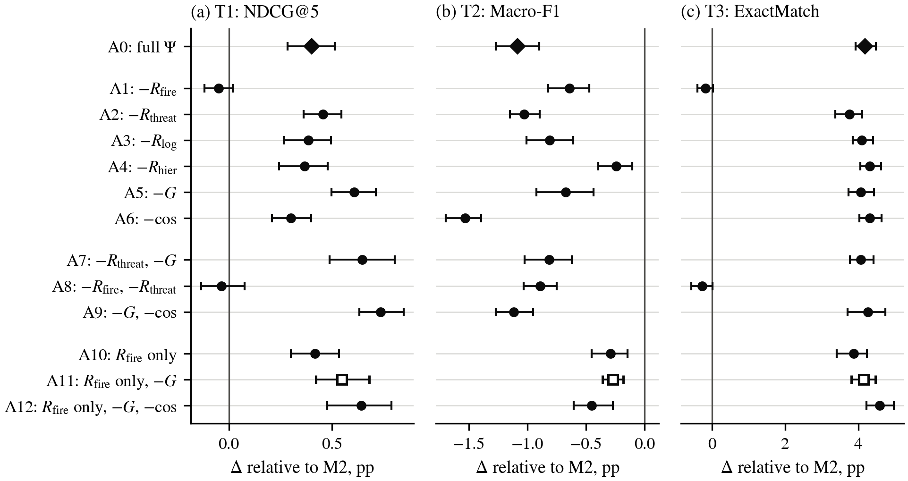
Fig. 2. Full Ψ (A0) and variants at λ = 20: change relative to M2, pp, mean and 95% paired bootstrap CI over 10 runs; (a)–(c) NDCG@5, Macro-F1, ExactMatch; diamond: A0; open square: the confirmed configuration A11
The equivalent scale (exploratory) separates logit-level magnitude from content. A6, without the cosine factor (λ_{eff} = 31.0), lies on the λ curve: its Macro-F1, ExactMatch and composite (0.9487, 0.6645, 0.8405) match those at λ = 30 (0.9493, 0.6641, 0.8405). The cosine factor therefore does not select pairs but attenuates the bias about 1.4-fold, which is why the prediction PA6, that its removal would leave the composite unchanged, failed (Δ = −0.14 pp, |Δ|/SE = 3.13; Table 8). The variants without G lie far above the curve: A9 has a larger relative logit bias than the full model at λ = 100, yet a Macro-F1 of 0.9528 instead of 0.9255. Threat assessment is thus harmed not by the overall logit-level magnitude of the bias but, apparently, by its sparse, spiky distribution on pairs of own entities.
Confirmation of fire-only configurations (RQ4, confirmatory)
Three variants suggested by the ablation that keep only R_{fire} were run at λ = 20 after four predictions had been recorded (Table 8). P1 held, and so did the primary prediction P4, with all three differences from M2 significant after the Holm correction. P2 held only in its weak form, and P3 failed because removing the cosine factor again acted as an increase in scale (λ_{eff} from 14.8 to 22.6).
Table 8
Predictions recorded before the corresponding runs and their outcomes (Δ in pp, 10 runs)
Prediction | Criterion | Observed | Outcome
PA6: A6 − A0 | composite within 2·SE | composite −0.14 (3.13) | failed
P1: A10 − A0 | ExactMatch, NDCG@5 within 2·SE; Macro-F1 higher, CI > 0; composite higher | ExactMatch −0.31 (1.38); NDCG@5 +0.02 (0.20); Macro-F1 +0.79 [+0.62, +0.97]; composite +0.17 | held
P2: A11 − A10 | Macro-F1 higher (weak: sign; strong: CI > 0); ExactMatch within 2·SE | Macro-F1 +0.02 [−0.11, +0.19]; ExactMatch +0.27 (1.15) | weak form held
P3: A12 − A11 | Macro-F1 lower, CI < 0; ExactMatch, NDCG@5 within 2·SE | Macro-F1 −0.18 [−0.29, −0.05]; NDCG@5 +0.09 (1.09); ExactMatch +0.44 (3.17) | failed
P4 (primary): A11 − M2 | ExactMatch > +3.5; Macro-F1 > −0.5; NDCG@5 > 0 | ExactMatch +4.14 [+3.81, +4.47]; Macro-F1 −0.27 [−0.36, −0.18]; NDCG@5 +0.55 [+0.42, +0.68] | held
Note. In parentheses: |Δ|/SE, where SE is the standard error of the mean paired difference; CI = paired percentile bootstrap; a prediction holds only if every clause holds.
A11 keeps the allocation gain of the full Ψ (+4.14 pp [+3.81, +4.47] vs +4.18 pp), has a numerically larger but not significantly different prioritisation gain (+0.55 vs +0.40 pp) and reduces the threat-assessment loss about fourfold (−0.27 pp [−0.36, −0.18] vs −1.09 pp); the posterior probability that its Macro-F1 loss is below 0.5 pp is 1.000, against 0.000 for the full Ψ (Table 5, exploratory).
Coupling with the ground truth (RQ5, pre-specified diagnostic, exploratory algorithms)
The ordering of pairs by the model-free key ω₁R_{fire} ⊙ G agrees with the ground-truth matrix U with Spearman ρ = 0.883 on all FP–target pairs and ρ = 0.707 on pairs with non-zero U; for T1 rankings ρ = 0.905; for T2, the column sums of ω₂R_{threat} ⊙ G reproduce the ground truth exactly (ρ = 1.000; 0.986 for the trained Ψ). Yet a greedy assignment keyed by this Ψ alone reaches an ExactMatch of 0.5004, below M2 (0.6213) and A0 (0.6631), and ranking by it gives an NDCG@5 of 0.8939 against 0.9054 and 0.9094: the model does not copy the prior but combines it with what it learns from the features. Given the ground-truth admission rule (U ≥ 0.1), the ordering by Ψ reaches 0.6866, more than the models, so the gap lies in deciding which FPs can engage a target at all. Among the 51,934 admissible pairs, Ψ is zero for 6,551: 6,519 without line of sight (reachable only by indirect mortar fire) and 32 beyond 4 km; through G, construction (3) is blind to indirect fire.
Error structure and cost (exploratory)
Averaged over the 10 paired runs, the full Ψ loses F1 relative to M2 in all T2 classes (LOW 0.71, MEDIUM 1.58 and HIGH 0.97 pp), and A11 reduces these losses to 0.23, 0.40 and 0.20 pp; the confusion matrices of M0, A0 and A11 pooled over the runs (372,770 own positions) contain no two-step errors from HIGH to LOW. Ψ adds no parameters but raises the batch-1 latency from 4.30 to 4.87 ms (about 13%). M3 used 99.2 of the 100 epochs on average, so its quality may be underestimated.
Discussion and Conclusions
Comparative versus absolute tasks. Softmax attention returns a convex combination of values: it preserves which keys matter relative to each other, but not how many relevant keys there are. Allocation and prioritisation are comparative, and R_{fire} directs each target's attention to the FPs able to engage it, the comparison that the task heads make. Threat assessment requires an absolute quantity, the saturating sum S(o) in (6), and a bias on pairs of own entities diverts attention mass from the targets that make up this sum. This agrees with the monotonic growth of the T2 loss with λ, the smaller loss of the dense bias without G (A5), whose relative logit bias is 1.7 times larger, and the recovery of most of the loss without R_{hier}; a direct test, e.g. of attention entropy or of an attention sink (Xiao et al., 2024), is still needed.
Map weights are not attention weights. All four expert weights are positive, but a positive weight does not imply a useful bias: the relation weighted 0.35 carries the whole gain, the one weighted 0.30 is neutral, and those weighted 0.20 and 0.15 harm threat assessment. The cosine factor acts as an attenuator rather than a selector, and the gate G makes the bias on own-entity pairs sparse.
External validity. All results come from one generator, and Table 9 lists the properties on which they are expected to depend. The main threat is the coupling of the labels with the prior: the ground truth is computed from the same quantities as Ψ, so with independently produced labels, e.g. expert decisions, the gain from R_{fire} would likely be smaller. The sizes of the gains, λ_{max} and the ranking of the relations are therefore specific to this generator; a sensitivity study that varies the properties of Table 9 would test these dependences.
Table 9
Properties of the scenario generator on which the results are expected to depend
Property | Evidence in this study | Results expected to depend on it
Ground truth computed from the quantities that form Ψ | ρ of Ψ with the ground truth 0.71–0.90 for T1 and T3, exact for T2 | size of the gain from R_{fire}
Line of sight drawn per pair from terrain, weather and time of day | 0.149 of pairs masked; composite 0.8302 (M2) vs 0.6425 (M1) | gain of the mask (RQ1)
Mortars (probability 0.15) fire without line of sight | Ψ = 0 for 6,519 of 51,934 admissible pairs through G | Ψ-only results (RQ5)
Relations among own entities: dense R_{hier}, sparse R_{log} | non-zero for 0.161 and 0.027 of pairs; their removal recovers 0.84 and 0.27 pp of Macro-F1 | T2 loss, trade-off between tasks
T2 as a saturating sum with thresholds 0.45 and 0.65 | Macro-F1 loss detectable from λ = 8, −3.84 pp at λ = 100 | direction of the effect on T2
Greedy T3 rule with admission U ≥ 0.1 | Ψ-only ExactMatch 0.5004; 0.6866 with the ground-truth admission | Ψ-only comparison (RQ5)
One generator seed, one split of 5,000 scenarios | scenario-sampling uncertainty not estimated | width of all intervals

Implications and their limits. More likely to transfer are three design rules for knowledge-guided attention: calibrate the bias scale on validation data against the content logits (here the composite optimum, λ = 20 or λ′ ≈ 113 in the convention of (1), corresponded to a relative logit bias of about 25%); select relations by ablation rather than by their weight in the map; and evaluate comparative and absolute tasks separately. Configuration A11 is the best-supported one for this benchmark, not a recommendation for operational systems, which would require expert-labelled or real data and the evaluation of a complete IDSS.
Limitations and future work. Beyond the dependence on the generator (Table 9), only training seeds were varied (Bouthillier et al., 2021), and the uncertainty due to the sample of test scenarios was not estimated; a scenario-level (cluster) bootstrap or a hierarchical model would add it. The value λ = 20 was selected on the test curve, and the confirmatory variants were derived from the ablation on the same test split; the identical selection on the validation split and the pre-recorded predictions mitigate but do not remove this risk, and two of the four predictions failed at least partly. At n = 10, the percentile bootstrap covered the true difference in 349 of 400 simulated cases (87%), so an undetected loss is not necessarily absent. The direction convention of the bias was not compared experimentally with the untransposed alternative, and the weights ω were not elicited formally; interpretability for humans and the hierarchical and temporal components of the original architecture were not evaluated. Next steps are a sensitivity study of the generator, expert-derived weights (e.g. from a survey of officers) and an expert-labelled test set, a bias normalised to the content logits and learned gates per relation and head.
The conclusions refer to three decision-support tasks of a synthetic benchmark; they characterise the mechanism of knowledge integration, not the operational performance of a military IDSS.
1. Confirmatory: at the initially adopted λ = 0.5, the FCM-Transformer does not differ significantly from the masked transformer, and the gain over the other baselines comes from the mask and the architecture; exploratory analyses give a relative logit bias of only 0.55% and a posterior probability of 1.000 that the absolute difference is below 0.5 pp.
2. Pre-specified grid, exploratory per-task contrasts: the effect becomes detectable at λ = 3, and the composite peaks at λ = 20 (also on the validation split), where the comparative tasks gain (ExactMatch +4.18 pp, NDCG@5 +0.40 pp) and the absolute threat assessment loses (Macro-F1 −1.09 pp).
3. Pre-specified ablation: only the fire-capability relation carries the gain, and the hierarchy and logistics relations degrade threat assessment, although all relations carry positive weights in the map; the cosine factor attenuates the bias about 1.4-fold (exploratory).
4. Confirmatory: as predicted, the configuration with R_{fire} only and without G surpasses the masked transformer by 4.14 pp in ExactMatch and 0.55 pp in NDCG@5 at a Macro-F1 loss of 0.27 pp; of the four predictions, two held fully, one in its weak form, and one failed.
5. Ψ contains part of the structure of the answer (ρ = 0.71–0.90 for the comparative tasks, exact for threat assessment), yet Ψ alone underperforms the model without Ψ (ExactMatch 0.50 vs 0.62; exploratory).
6. Exploratory: the trained network amplifies a weak prior and attenuates a strong one (relative logit bias about 1.2 times its linear expectation at λ = 8–15, 0.53 times at λ = 100), so the bias scale should be calibrated, not set a priori.
Conflict of interest. The authors declare no conflict of interest.
Data availability. All data are synthetic; no human participants were involved. Code and data are available from the corresponding author on reasonable request, subject to institutional approval.
References
Abril-Pla, O., Andreani, V., Carroll, C., Dong, L., Fonnesbeck, C. J., Kochurov, M., Kumar, R., Lao, J., Luhmann, C. C., Martin, O. A., Osthege, M., Vieira, R., Wiecki, T., & Zinkov, R. (2023). PyMC: A modern, and comprehensive probabilistic programming framework in Python. PeerJ Computer Science, 9, e1516. https://doi.org/10.7717/peerj-cs.1516
Benavoli, A., Corani, G., Demšar, J., & Zaffalon, M. (2017). Time for a change: A tutorial for comparing multiple classifiers through Bayesian analysis. Journal of Machine Learning Research, 18(77), 1–36. https://jmlr.org/papers/v18/16-305.html
Bouthillier, X., Delaunay, P., Bronzi, M., Trofimov, A., Nichyporuk, B., Szeto, J., Sepah, N., Raff, E., Madan, K., Voleti, V., Kahou, S. E., Michalski, V., Serdyuk, D., Arbel, T., Pal, C., Varoquaux, G., & Vincent, P. (2021). Accounting for variance in machine learning benchmarks. In Proceedings of Machine Learning and Systems (Vol. 3, pp. 747–769). https://proceedings.mlsys.org/paper_files/paper/2021/hash/0184b0cd3cfb185989f858a1d9f5c1eb-Abstract.html
d'Ascoli, S., Touvron, H., Leavitt, M. L., Morcos, A. S., Biroli, G., & Sagun, L. (2021). ConViT: Improving vision transformers with soft convolutional inductive biases. In Proceedings of the 38th International Conference on Machine Learning (Vol. 139, pp. 2286–2296). PMLR. https://proceedings.mlr.press/v139/d-ascoli21a.html
Efron, B., & Tibshirani, R. J. (1994). An introduction to the bootstrap. Chapman & Hall/CRC. https://doi.org/10.1201/9780429246593
Felix, G., Nápoles, G., Falcon, R., Froelich, W., Vanhoof, K., & Bello, R. (2019). A review on methods and software for fuzzy cognitive maps. Artificial Intelligence Review, 52(3), 1707–1737. https://doi.org/10.1007/s10462-017-9575-1
Helmer, D., Boardman, M., Conroy, S. K., Hepworth, A. J., & Harjani, M. (2024). Human-centred test and evaluation of military AI (arXiv:2412.01978). arXiv. https://doi.org/10.48550/arXiv.2412.01978
Hoffman, M. D., & Gelman, A. (2014). The No-U-Turn sampler: Adaptively setting path lengths in Hamiltonian Monte Carlo. Journal of Machine Learning Research, 15(47), 1593–1623. https://jmlr.org/papers/v15/hoffman14a.html
Holm, S. (1979). A simple sequentially rejective multiple test procedure. Scandinavian Journal of Statistics, 6(2), 65–70. https://www.jstor.org/stable/4615733
Kapoor, S., & Narayanan, A. (2023). Leakage and the reproducibility crisis in machine-learning-based science. Patterns, 4(9), 100804. https://doi.org/10.1016/j.patter.2023.100804
Kline, A., Ahner, D., & Hill, R. (2019). The weapon-target assignment problem. Computers & Operations Research, 105, 226–236. https://doi.org/10.1016/j.cor.2018.10.015
Kosko, B. (1986). Fuzzy cognitive maps. International Journal of Man-Machine Studies, 24(1), 65–75. https://doi.org/10.1016/S0020-7373(86)80040-2
Kruschke, J. K. (2018). Rejecting or accepting parameter values in Bayesian estimation. Advances in Methods and Practices in Psychological Science, 1(2), 270–280. https://doi.org/10.1177/2515245918771304
Na, H., Ahn, J., & Moon, I.-C. (2023). Weapon–target assignment by reinforcement learning with pointer network. Journal of Aerospace Information Systems, 20(1), 53–59. https://doi.org/10.2514/1.I011150
Nosek, B. A., Ebersole, C. R., DeHaven, A. C., & Mellor, D. T. (2018). The preregistration revolution. Proceedings of the National Academy of Sciences, 115(11), 2600–2606. https://doi.org/10.1073/pnas.1708274114
Pineau, J., Vincent-Lamarre, P., Sinha, K., Larivière, V., Beygelzimer, A., d'Alché-Buc, F., Fox, E., & Larochelle, H. (2021). Improving reproducibility in machine learning research (A report from the NeurIPS 2019 Reproducibility Program). Journal of Machine Learning Research, 22(164), 1–20. https://jmlr.org/papers/v22/20-303.html
Press, O., Smith, N. A., & Lewis, M. (2022). Train short, test long: Attention with linear biases enables input length extrapolation. In International Conference on Learning Representations (ICLR 2022). https://openreview.net/forum?id=R8sQPpGCv0
Qin, D., Peng, Z., & Wu, L. (2023). Deep attention fuzzy cognitive maps for interpretable multivariate time series prediction. Knowledge-Based Systems, 275, 110700. https://doi.org/10.1016/j.knosys.2023.110700
Raffel, C., Shazeer, N., Roberts, A., Lee, K., Narang, S., Matena, M., Zhou, Y., Li, W., & Liu, P. J. (2020). Exploring the limits of transfer learning with a unified text-to-text transformer. Journal of Machine Learning Research, 21(140), 1–67. https://jmlr.org/papers/v21/20-074.html
Sineglazov, V. M., & Chelkovan, V. I. (2025). Modified hierarchical transformer in intelligent decision support systems for military applications. Modern Information Technologies in the Sphere of Security and Defence, 54(3), 122–129 [in Ukrainian]. [Синєглазов, В. М., & Челкован, В. І. (2025). Модифікований ієрархічний трансформер для інтелектуальних систем підтримки прийняття рішень військового призначення. Сучасні інформаційні технології у сфері безпеки та оборони, 54(3), 122–129]. https://doi.org/10.33099/2311-7249/2025-54-3-122-129
Vaswani, A., Shazeer, N., Parmar, N., Uszkoreit, J., Jones, L., Gomez, A. N., Kaiser, Ł., & Polosukhin, I. (2017). Attention is all you need. In Advances in Neural Information Processing Systems (Vol. 30, pp. 5998–6008). Curran Associates. https://proceedings.neurips.cc/paper/2017/hash/3f5ee243547dee91fbd053c1c4a845aa-Abstract.html
von Rueden, L., Mayer, S., Beckh, K., Georgiev, B., Giesselbach, S., Heese, R., Kirsch, B., Pfrommer, J., Pick, A., Ramamurthy, R., Walczak, M., Garcke, J., Bauckhage, C., & Schuecker, J. (2023). Informed machine learning – A taxonomy and survey of integrating prior knowledge into learning systems. IEEE Transactions on Knowledge and Data Engineering, 35(1), 614–633. https://doi.org/10.1109/TKDE.2021.3079836
Wang, J., Peng, Z., Wang, X., Li, C., & Wu, J. (2021). Deep fuzzy cognitive maps for interpretable multivariate time series prediction. IEEE Transactions on Fuzzy Systems, 29(9), 2647–2660. https://doi.org/10.1109/TFUZZ.2020.3005293
Wang, S., Wang, G., Fu, Q., Song, Y., Liu, J., & He, S. (2023). STABC-IR: An air target intention recognition method based on bidirectional gated recurrent unit and conditional random field with space-time attention mechanism. Chinese Journal of Aeronautics, 36(3), 316–334. https://doi.org/10.1016/j.cja.2022.11.018
Wang, X., Yang, Z., Piao, H., Chai, S., Huang, J., & Zhou, D. (2024). Intelligent recognition method of target tactical behavior intention in air combat based on deep learning. Engineering Applications of Artificial Intelligence, 138, 109460. https://doi.org/10.1016/j.engappai.2024.109460
Xiao, G., Tian, Y., Chen, B., Han, S., & Lewis, M. (2024). Efficient streaming language models with attention sinks. In International Conference on Learning Representations (ICLR 2024) (pp. 21875–21895). https://proceedings.iclr.cc/paper_files/paper/2024/hash/5e5fd18f863cbe6d8ae392a93fd271c9-Abstract-Conference.html
Ying, C., Cai, T., Luo, S., Zheng, S., Ke, G., He, D., Shen, Y., & Liu, T.-Y. (2021). Do transformers really perform badly for graph representation? In Advances in Neural Information Processing Systems (Vol. 34, pp. 28877–28888). Curran Associates. https://proceedings.neurips.cc/paper/2021/hash/f1c1592588411002af340cbaedd6fc33-Abstract.html
Zgurovsky, M., & Pankratova, N. (Eds.). (2022). System analysis & intelligent computing: Theory and applications (Studies in Computational Intelligence, Vol. 1022). Springer. https://doi.org/10.1007/978-3-030-94910-5

Віктор СИНЄГЛАЗОВ, доктор технічних наук, професор
ORCID ID: 0000-0002-3297-9060
Національний технічний університет України «Київський політехнічний інститут імені Ігоря Сікорського», Київ, Україна

Віктор ЧЕЛКОВАН, начальник науково-дослідного відділу
ORCID ID: 0009-0001-4522-6260
e-mail: vichell12@gmail.com
Центральний науково-дослідний інститут Збройних Сил України, Київ, Україна
СТАТИСТИЧНА ВАЛІДАЦІЯ ТРАНСФОРМЕРА З ПРИЧИННИМ ЗМІЩЕННЯМ УВАГИ НА СИНТЕТИЧНИХ ТАКТИЧНИХ ЗАДАЧАХ ПІДТРИМКИ ПРИЙНЯТТЯ РІШЕНЬ
Вступ. Системи підтримки прийняття рішень військового призначення можуть стати точнішими та зрозумілішими, якщо вбудувати в нейронну мережу експертні знання про причинно-наслідкові зв'язки тактичної обстановки. Модель FCM-Transformer спрямовує увагу трансформера за допомогою нечіткої когнітивної карти, проте експериментально цей підхід не перевірявся. Мета дослідження — статистично встановити на трьох задачах підтримки прийняття рішень у синтетичних сценаріях, чи покращують такі знання модель і за яких умов.
Методи. Виконано 310 навчальних прогонів на 5000 змодельованих сценаріях оборони роти, у яких моделі ранжували цілі, оцінювали загрози власним позиціям і розподіляли вогневі позиції між цілями. Модель порівняно з чотирма альтернативними моделями, перевірено за 15 значень ваги експертних знань і з вилученням окремих складових знань. Кожну конфігурацію навчено 10 разів; одиницею парного аналізу з поправками на множинні порівняння та байєсівським оцінюванням був навчальний прогін. Підтверджувальні прогнози зафіксовано до відповідних прогонів і відокремлено від розвідувальних аналізів.
Результати. За початково обраної ваги складова знань становила лише 0,55 % розкиду власних (ненормованих) оцінок уваги моделі і не мала значущого впливу. У розвідувальних порівняннях за ваги, у 40 разів більшої, частка правильно розподілених цілей зросла на 4,18 відсоткового пункту (в. п.) порівняно з тією самою моделлю без знань, ранжування цілей дещо покращилося, але оцінювання загроз погіршилося на 1,09 в. п. Корисними виявилися лише знання про те, яка вогнева позиція може уразити яку ціль. Як і прогнозувалося до підтверджувальних прогонів, база знань лише з вогневих зв'язків зберегла приріст розподілу (4,14 в. п.) і зменшила втрату оцінювання загроз до 0,27 в. п. Алгоритм, що спирається лише на ці знання, поступився моделі без них.
Висновки. На цьому синтетичному бенчмарку експертні знання покращили трансформер лише після калібрування їхньої ваги відносно власних оцінок уваги моделі, а обмеження знань вогневими зв'язками зменшило втрату в оцінюванні загроз; для практичного застосування потрібне підтвердження на даних, розмічених експертами.
Ключові слова: трансформер; зміщення уваги; нечітка когнітивна карта; підтримка прийняття рішень; синтетичний бенчмарк; статистична валідація; абляційний аналіз; байєсівське оцінювання.

УДК 004.43
DOI: https://doi.org/

Oleksandra VOICHENKO, Student
ORCID ID: 0009-0008-9426-6921
e–mail: oleksandra_voichenko@knu.ua
Taras Shevchenko National University of Kyiv, Kyiv, Ukraine

Olena Vashchilina, PhD (Phys. & Math.), Assoc. Prof.
ORCID ID: 0000–0001–6867–6216
e–mail: olenavashchilina@knu.ua
Taras Shevchenko National University of Kyiv, Kyiv, Ukraine
COMPARATIVE ANALYSIS OF TECHNOLOGIES AND ARCHITECTURAL APPROACHES FOR ANDROID APPLICATION DEVELOPMENT
The article examines modern principles, technologies, and architectural approaches to developing mobile applications for the Android operating system. The aim of the study is to systematize and perform a comparative analysis of modern technologies and architectural solutions in Android development, taking into account the criteria of code conciseness, maintainability, user interface organization, state management, and scalability. A comparative analysis of Java and Kotlin programming languages, XML–based and Jetpack Compose user interface design approaches, as well as MVC, MVP, and MVVM architectural patterns has been conducted. The practical application of the considered technologies is analyzed using the examples of mobile products such as SmartNews, Mercari, and Duolingo. A practical example of developing an Android application for tracking transport expenses is presented, and criteria for selecting a technology stack depending on software project requirements are formulated.

Keywords: Android development, Kotlin, Jetpack Compose, MVVM, Android Jetpack, comparative analysis, technology stack selection, mobile applications.

Introduction
Mobile applications are an essential component of modern information systems and are used to address a wide range of daily, professional, and business tasks. The Android operating system occupies a prominent position in the field of mobile technologies. As of August 2026, its share of the global mobile operating system market stood at 67.61%, compared to 32.36% for iOS (StatCounter, 2026). The scale of the platform's adoption is also characterized by the number of devices: according to official Google data, as early as 2021, there were over 3 billion active Android–based devices worldwide (Samat, 2021). The widespread prevalence of this operating system underscores the relevance of studying modern technologies and approaches to Android application development. Modern Android development encompasses a broad set of technologies and tools, the choice of which directly impacts the creation process and subsequent maintenance of a software product. Developers can utilize various programming languages, user interface construction methods, and application architecture organization approaches. At the same time, the evolution of the Android platform is accompanied by the emergence of new technologies that gradually complement or replace traditional development tools. This creates a necessity to compare available solutions and determine the specifics of their application depending on the requirements of a specific software project.
The aim of this study is to systematize and conduct a comparative analysis of modern technologies and architectural approaches in Android development, as well as to define criteria that should be considered when selecting a technology stack for a specific software project.
The methodological foundation comprises the analysis of scientific and official technical sources, comparative analysis, systematization of practical approaches, and the analysis of the results of our own software implementation.
The scientific novelty of the study lies in the systematization and comprehensive comparative analysis of modern technologies and architectural approaches to Android development (Kotlin, Jetpack Compose, MVC, MVP, and MVVM), taking into account a set of criteria established on the basis of quantitative empirical studies, analysis of industrial case studies, and the results of practical validation using the authors’ own software solution.
The practical significance of the study lies in the systematization of technology stack selection criteria and the practical validation of an architectural and technological solution based on Kotlin, MVVM, and SQLite for developing Android applications with offline support, structured code organization, and potential for further functional extension.
Results
Principles and Technologies of Android Development
Key concepts. Android development involves creating software designed to function on devices powered by the Android operating system. Code can be written in Kotlin or Java, which Android SDK tools compile alongside resources into an installation package. While cross-platform paradigms (such as Flutter, React Native, and Xamarin) offer code reusability across multiple target operating systems (Holotiuk & Vashchilina, 2025), native Android development remains the optimal choice when maximum runtime performance, deep platform integration, and full adherence to platform-specific UI patterns are required.
A defining feature of Android is its component-based structure. Primary components include Activity (user interaction), Service (background execution without UI), Broadcast Receiver (system and app events), and Content Provider (data management), each possessing a distinct function and lifecycle. However, a modern application should not be built solely around system components. An essential principle is the separation of concerns: decoupling UI, state management, and data source operations ensures that changes in one component do not force a redesign of others, thereby facilitating testing, extensibility, and maintenance.
According to modern guidelines, application architecture is structured into at least two main layers: the UI layer and the data layer, with an optional domain layer for complex systems. Crucial principles also include a Single Source of Truth and Unidirectional Data Flow, where state is passed down to the interface and user events flow up (Android Developers, n.d.–a). Additionally, Android Jetpack components–such as ViewModel for state preservation and Jetpack Compose for declarative UI construction–simplify modern development workflows.
Development Lifecycle Stages. Android application engineering is a sequential process encompassing system design, software implementation, testing, deployment, and post-release maintenance.
During the design phase, functional and non-functional requirements are established alongside target audience profiles, system architecture, and core user interaction scenarios. Selecting the foundational technology stack (programming language, UI framework, architectural pattern, and data storage) at this early stage significantly reduces the need for substantial architectural refactoring as the project evolves.
The implementation phase covers UI construction, business logic implementation, data source integration, and lifecycle management. Accounting for system component lifecycles is paramount; for instance, an Activity transitions through defined states: Created, Started, Resumed, Paused, Stopped, and Destroyed. Improper handling of component state–particularly during configuration changes—can lead to data loss, memory leaks, or erratic UI behavior.
The testing phase verifies system integrity across diverse execution environments. Given Android’s hardware and OS fragmentation, validation covers individual components and full workflows through unit, integration, and UI automation tests on both emulators and physical devices. Post-deployment maintenance on platforms like Google Play includes ongoing bug fixing, OS version optimization, dependency updates, security enhancements, and feature expansions.
Programming Languages. Selecting the programming language is a core technological decision. For a long time, Java served as the primary language, offering a mature ecosystem, vast library support, and extensive legacy codebases. It remains fully supported alongside modern Android components. Meanwhile, Kotlin has gained widespread adoption due to its full interoperability with Java, enabling gradual migration without requiring a complete codebase rewrite (Android Developers, n.d.-b). In 2019, Google officially announced a Kotlin-first approach, recommending Kotlin for new Android projects (Android Developers, n.d.–c).
A prominent feature of Kotlin is its type-system-level support for null safety. In Java, referencing a null object can lead to a runtime NullPointerException. Kotlin explicitly distinguishes between nullable and non-null types, enabling nullability errors to be caught during compilation. Kotlin is also characterized by a more concise syntax—utilizing data classes, extension functions, type inference, smart casts, default immutability (val), and lambda expressions to substantially reduce boilerplate code. For asynchronous operations, Kotlin Coroutines execute long-running tasks without blocking the main thread. Crucially, both languages exhibit equivalent execution performance at runtime, as Kotlin code compiles down to bytecode executed by the Android Runtime (ART). Table 1 presents a comparative analysis of Java and Kotlin within the context of Android development.
Table 1
Comparative characteristics of Java and Kotlin
Criterion | Java | Kotlin
Syntax | More verbose | More concise
Null safety | Requires additional manual checks | Supported natively at the type system level
Asynchronous programming | Threads, Executors, CompletableFuture, etc. | Coroutines
Android compatibility | Full | Full
Interoperability | Calling Kotlin code is supported | Full bidirectional interoperability with Java
Boilerplate code volume | Relatively higher | Relatively lower
Support for existing projects | Extensive legacy codebase | Smooth gradual migration support
Recommendations for new projects | Supported | Official Kotlin–first approach
Thus, Java remains essential for maintaining legacy codebases. Kotlin, conversely, offers language mechanisms aimed at minimizing boilerplate code, ensuring safer handling of nullable values, and streamlining asynchronous execution. Full interoperability between Kotlin and Java ensures that migrating between them does not necessitate a complete system rewrite.
Empirical studies complement this comparison with quantitative data. In a controlled Android study involving 27 engineering teams, Kotlin demonstrated a statistically significant advantage in code conciseness, as well as a lower incidence of runtime NullPointerException errors during development tasks; however, no statistically significant difference in maintainability was established between Java and Kotlin (Ardito et al., 2020). Furthermore, an empirical analysis of 2,708 open–source Android applications confirmed the expanding adoption of Kotlin and its positive correlation with maintainability metrics (Coppola et al., 2025).
User Interface Development Approaches. The traditional approach to constructing Android user interfaces relies on the legacy View system. The layout structure of a screen is typically defined in an XML file specifying UI elements, their properties, and spatial arrangements, while the programmatic interaction logic is implemented in Kotlin or Java.
The XML–based approach enforces a clear separation between layout definitions and business logic, serving as the industry standard for many years. Consequently, a vast ecosystem of View–based applications, libraries, and components exists today, making View proficiency essential for supporting legacy commercial products.
An alternative modern paradigm is Jetpack Compose, Google’s recommended toolkit for building native Android UIs. Unlike the XML–based approach, Compose adopts a declarative paradigm. Developers describe the UI state directly, and the framework automatically updates and recomposes the affected components whenever that state changes (Android Developers, n.d.-d).
Jetpack Compose interfaces are constructed using composable functions written exclusively in Kotlin. This allows developers to build the UI and its associated presentation logic within a single programming language ecosystem. Furthermore, Compose natively supports Material Design, animations, adaptive layouts, and seamless interoperability with legacy View–based code, enabling gradual migration of existing projects.
A central concept in Compose is state management. When combined with Unidirectional Data Flow (UDF), the state is passed down to composable functions, while user events are propagated upward to the components responsible for state modification. This promotes a predictable, testable, and robust interaction model between the UI and application logic.
Accessibility should be considered a standalone quality criterion for mobile interfaces. An empirical study of 50 Android applications, complemented by a developer survey, revealed that a significant portion of accessibility guidelines is implemented incompletely, highlighting the imperative of integrating accessibility considerations early in UI design and testing (Di Gregorio et al., 2022).
Comparative empirical studies further demonstrate that XML and Jetpack Compose should be evaluated across multiple performance dimensions—including code complexity, CPU and memory resource consumption, cold startup time, and rendering characteristics – rather than solely by developer ergonomics (Milla & Radonjić, 2023; Spirintsev et al., 2025). Table 2 presents a comparative analysis of these two UI construction approaches.
Table 2
Comparative characteristics of XML–based UI and Jetpack Compose
Criterion | XML / Android Views | Jetpack Compose
UI Paradigm | View–based, primarily imperative | Declarative
UI Description | XML + Kotlin/Java | Pure Kotlin
State Management | Manual synchronization between state and Views | State–driven UI (automatic recomposition)
Reusability | Custom Views, layouts, fragments | Composable functions
Preview Mechanism | Layout Editor | Compose Preview
Legacy Interoperability | Widely used in existing codebases | Supports gradual interoperability
Android Recommendations | Supported for legacy projects | Recommended for all new UI development
Both approaches retain practical significance. XML and Android Views are deeply embedded in legacy codebases, making mastery of this technology essential for maintaining existing systems. Conversely, Jetpack Compose represents the modern recommended standard for new Android UI development and aligns seamlessly with the state–driven model of contemporary Android architecture.
Architectural Approaches. As a mobile application expands, codebase complexity increases proportionally. Concentrating interface rendering, data handling, and business logic within unified components complicates testing, maintenance, and modification. To enforce separation of concerns, architectural patterns like MVC, MVP, and MVVM are widely adopted in the Android ecosystem.
Model–View–Controller (MVC) divides the system into three components: the Model (data and domain logic), the View (presentation), and the Controller (coordinating interactions). Despite its conceptual simplicity, MVC in complex mobile UIs often leads to Controllers accumulating excessive logic, creating tight coupling that hinders maintainability.
Model–View–Presenter (MVP) shifts presentation logic to a Presenter, leaving the View as a passive interface displaying data and relaying user input. While this minimizes UI logic and improves unit testability, the Presenter typically holds a direct reference to the View, creating state management overhead as functionality grows.
Model–View–ViewModel (MVVM) introduces the ViewModel between presentation and data layers. The View reactively observes state exposed by the ViewModel. Crucially, the ViewModel holds no direct reference to UI components, significantly reducing coupling and streamlining presentation logic testing.
In modern Android development, the ViewModel receives first–class support via Android Jetpack as a screen state holder. Combined with Kotlin Flow and Jetpack Compose, this enables Unidirectional Data Flow (UDF): the ViewModel exposes UI state, the UI renders it, and user interactions propagate back to the ViewModel for processing (Android Developers, n.d.–a). Furthermore, the Jetpack ViewModel is engineered to automatically survive configuration changes such as screen rotations, thereby eliminating redundant data fetching and preventing lifecycle-related memory leaks. Consequently, this structural resilience positions MVVM as the recommended baseline for scalable and maintainable Android software.
Evaluating MVC, MVP, and MVVM requires aligning pattern strengths with specific project requirements rather than seeking a universally superior solution. As these patterns differ in testability, maintainability, and implementation overhead, selection depends on defined quality criteria and system constraints (Lou, 2016). Specifically, while smaller applications with limited scope may benefit from the minimal initial setup of MVC or MVP, enterprise-scale projects overwhelmingly favor MVVM to ensure long-term code stability and seamless unit testing. Table 3 summarizes these architectural approaches.
Table 3
Comparative characteristics of architectural approaches
Criterion | MVC | MVP | MVVM
Primary Intermediary | Controller | Presenter | ViewModel
UI and Logic Decoupling | Basic | Pronounced | High / Pronounced
View Coupling | Controller interacts directly with View | Presenter typically maintains a reference to View | ViewModel holds no direct reference to View
State Management | Implementation–dependent | Handled via Presenter | Driven by ViewModel and observable state
UI Logic Testability | Can be complicated | Simplified via Presenter | Highly convenient via ViewModel
Initial Implementation Complexity | Relatively low | Moderate | Moderate
Android Jetpack Integration | Possible | Possible | Natively supported via Jetpack ViewModel
Consequently, an architectural approach dictates not only the physical code structure but also the interaction dynamics among system components. For small–scale applications, introducing architectural abstractions may impose unnecessary overhead; however, for systems intended for long–term maintenance and iterative expansion, strict separation of concerns becomes a pivotal maintainability factor.
Technology Stack Selection Criteria for Android Applications. Selection of an Android technology stack is a multi–criteria decision–making problem that must align with functional and non–functional requirements, team expertise, and long–term system evolution. Key evaluation criteria include:
- Development efficiency;
- Maintainability and testability;
- UI state organization and management;
- Performance and scalability;
- Compatibility with existing components;
- Accessibility.
Empirical research confirms that these quality attributes are not uniformly impacted by a single technology, necessitating multi–dimensional evaluation rather than relying on technology popularity (Ardito et al., 2020; Rua & Saraiva, 2024). Furthermore, accounting for non–functional properties early in development optimizes execution time, memory usage, throughput, and frame rates (Callan et al., 2022), transitioning technology selection from subjective preference to a structured engineering rationale.
Practical Case Studies in Android Development Technologies
Examining real–world applications of Android technologies enables an evaluation that extends beyond theoretical analysis into the context of large–scale software products. Of particular interest are documented cases detailing the rationale for technological transitions and their measurable outcomes. To illustrate the key technological domains discussed above, this section analyzes SmartNews as an example of Kotlin adoption, Mercari as an implementation of Jetpack Compose, and Duolingo as an architectural migration to MVVM utilizing Android Jetpack components.
SmartNews. The SmartNews mobile application serves as a prime example of gradual Kotlin adoption within an existing Android codebase. The engineering team utilized Kotlin—specifically coroutines for image loading and caching operations—and highlighted the benefits of built–in null safety.
Following the migration of a portion of Java code to Kotlin, the codebase size for converted modules decreased by approximately 20%. Leveraging Kotlin's language mechanisms for managing mutability, nullability, and property initialization facilitated early defect detection, while code review turnaround time was reduced by 10% (Android Developers, n.d.–e). Additionally, this step-by-step migration strategy enabled the team to maintain overall system stability while continuously delivering new features without interrupting production release cycles.
This case underscores a key strength of Kotlin: its seamless interoperability with legacy Java projects, enabling incremental adoption without necessitating an immediate, full–scale system rewrite.
Mercari. Mercari provides a practical case study on adopting a declarative paradigm for Android UI development. The Client Architect team introduced Jetpack Compose in 2020 while establishing the technology stack for new application initiatives.
A primary objective was creating a unified design system capable of managing complex state and styling behaviors. While implementing this system using legacy Android Views presented substantial technical complexity, Jetpack Compose enabled the team to author more concise UI code and reduce developer effort required for individual screens.
Implementing Jetpack Compose alongside the new design system for infinite–scroll screens allowed Mercari to reduce UI–related code volume by approximately 56%. This efficiency enabled the team to deliver more screens within the same timeframe and allocate more engineering resources to core business logic (Android Developers, n.d.–f). Furthermore, the migration significantly streamlined UI component reusability and simplified cross-team synchronization by establishing a single, centralized design source of truth.
Consequently, the Mercari case demonstrates the practical efficacy of the declarative UI model not merely for small–scale applications, but for scaling design systems across enterprise–grade mobile products.
Duolingo. The Duolingo case illustrates the profound impact of software architecture on maintaining and scaling a large–scale Android application. As the product and development team expanded, the legacy architecture encountered severe scaling bottlenecks: modifications frequently introduced performance regressions, requiring developers to spend excessive time on bug remediation.
To refactor the application, the engineering team adopted the MVVM architectural pattern in conjunction with Android Jetpack libraries. Decoupling presentation logic from business logic established a standardized foundation for feature delivery. Furthermore, functional components were organized into distinct modules, enabling distributed engineering teams to work in parallel.
Following the architectural overhaul, daily Application Not Responding (ANR) rates dropped by 41%, the proportion of time spent below target frame rates decreased by 28%, and scrolling performance on key screens improved by 40% (Android Developers, n.d.–g). In addition to performance gains, this modular MVVM restructuring drastically reduced cognitive load for engineers and accelerated onboarding for new team members.Architecturally, component interactions were structured following the sequence
$UI → ViewModel → Repository → SQLite$,
strictly enforcing separation of concerns across presentation, state management, data access, and local persistence.
This case demonstrates that architectural decisions carry significant practical consequences beyond code organization. In enterprise software systems, proper architecture directly affects team parallelization, testability, feature delivery speed, and overall system complexity management.
Practical Validation of the Selected Technology Stack. As part of an educational project, a native mobile application for vehicle expense tracking was developed. The primary objective of the project was to create a user–friendly, reliable, and offline–capable tool for recording, categorizing, and analyzing expenses associated with vehicle operation.
Native Android development was selected for implementation using the Kotlin programming language within the Android Studio IDE. For local data persistence, an SQLite database was utilized, ensuring full offline functionality without requiring continuous network connectivity. The software architecture was structured according to the Model–View–ViewModel (MVVM) pattern, incorporating the Repository pattern for data management. The user interface was built using the traditional Android Views framework, with RecyclerView components employed to display lists of vehicles and expense entries.
The development workflow encompassed application architecture design, database schema modeling, UI design, and core feature implementation. Users can add and edit vehicle profiles, log expense entries, view transaction histories, filter records by category and date range, and view aggregated expense analytics. Following implementation, key user scenarios were tested to verify data persistence integrity within the local SQLite database. The primary user interface screens of the developed application are illustrated in Fig. 1.




а) b) c)
Fig. 1. Mobile application for vehicle expense tracking:
a) vehicle list screen; b) vehicle details and expense categories screen; c) expense history and filtering screen
Practical development experience demonstrated that utilizing Kotlin in conjunction with the MVVM architectural pattern and a local SQLite database provides an effective solution for native Android application development. The selected technology stack ensured a well–structured codebase, reliable offline data persistence, and a flexible foundation for future functional expansion.
Discussion and Conclusions
Modern Android development encompasses a broad set of technologies and approaches whose selection directly influences the development process, structural organization, and post–release maintenance of mobile applications. The evolution of the Android platform is characterized by the continuous emergence of new development tools that progressively complement or supplant traditional solutions.
The comparative analysis of Java versus Kotlin, XML–based UI versus Jetpack Compose, and the MVC, MVP, and MVVM architectural patterns demonstrates that each evaluated solution possesses distinct characteristics, strengths, and constraints. Selecting specific technologies depends on project requirements, domain complexity, user interface characteristics, and long–term extensibility demands. Case studies of SmartNews, Mercari, and Duolingo illustrate the practical application and efficacy of modern Android technologies within commercial software products.
Practical experience in engineering a native Android application for vehicle expense tracking validated the efficacy of combining Kotlin, the MVVM architecture, and a local SQLite database within an educational project context. The selected technology stack ensured a well–structured codebase, robust data persistence, and successful delivery of required functional capabilities.
Consequently, technology stack selection for Android application development constitutes a multi–criteria decision–making task. It necessitates a comprehensive evaluation across code conciseness, maintainability, testability, and performance to ensure a sustainable software product lifecycle.

References
Android Developers. (n.d.-a). Guide to app architecture. https://developer.android.com/topic/architecture
Android Developers. (n.d.-b). Kotlin on Android FAQ. https://developer.android.com/kotlin/faq
Android Developers. (n.d.-c). Android’s Kotlin–first approach. https://developer.android.com/kotlin/first
Android Developers. (n.d.-d). Jetpack Compose UI app development toolkit. https://developer.android.com/compose
Android Developers. (n.d.-e). SmartNews reduces lines of code by 20% and improves team morale with Kotlin. https://developer.android.com/stories/apps/smartnews
Android Developers. (n.d.-f). Mercari improves UI development productivity by 56% with Jetpack Compose. https://developer.android.com/stories/apps/mercari
Android Developers. (n.d.-g). Duolingo refactors on Android with MVVM and Jetpack libraries. https://developer.android.com/stories/apps/duolingo–excellence
Android Developers. (n.d.-h). Recommendations for Android architecture. https://developer.android.com/topic/architecture/recommendations
Ardito, L., Coppola, R., Malnati, G., & Torchiano, M. (2020). Effectiveness of Kotlin vs. Java in Android app development tasks. Information and Software Technology, 127, 106374. https://doi.org/10.1016/j.infsof.2020.106374
Coppola, R., Ferrucci, F., & Torchiano, M. (2025). Kotlin assimilating the Android ecosystem: An appraisal of diffusion and impact on maintainability. Journal of Systems and Software, 222, 112346. https://doi.org/10.1016/j.jss.2025.112346
Callan, J., Krauss, O., Petke, J., & Sarro, F. (2022). How do Android developers improve non–functional properties of software? Empirical Software Engineering, 27, 113. https://doi.org/10.1007/s10664-022-10137-2
Di Gregorio, M., Di Nucci, D., Palomba, F., & Vitiello, G. (2022). The making of accessible Android applications: An empirical study on the state of the practice. Empirical Software Engineering, 27, 145. https://doi.org/10.1007/s10664-022-10182-x
Holotiuk, V., & Vashchilina, O. (2025). Cross–platform mobile application development: Basic principles, technologies, and practical approaches. Applied Information Systems and Technologies in the Digital Society, (2), 107–121. https://doi.org/10.17721/3041-2323.2025.107-121 [In Ukrainian]
Lou, T. (2016). A comparison of Android native app architecture: MVC, MVP and MVVM. Aalto University. https://aaltodoc.aalto.fi/items/510b5360-2bc0-4ee7-b635-ffdfe7ce2594
Milla, E., & Radonjić, M. (2023). Analysis of developing native Android applications using XML and Jetpack Compose. Balkan Journal of Applied Mathematics and Informatics, 6(2), 167–178. https://js.ugd.edu.mk/index.php/bjami/en/article/view/6019
Rua, R., & Saraiva, J. (2024). A large–scale empirical study on mobile performance: Energy, run–time and memory. Empirical Software Engineering, 29, 31. https://doi.org/10.1007/s10664-023-10391-y
Samat, S. (2021). Android 12 Beta: Designed for you. Google. https://blog.google/products-and-platforms/platforms/android/android-12-beta/
Spirintsev, V., Spirintseva, O., & Veselov, V. (2025). Research on the effectiveness of XML and Jetpack Compose technologies in developing mobile application interfaces for Android OS [in Ukrainian]. https://doi.org/10.32782/it/2025-2-14
StatCounter Global Stats. (2026). Mobile operating system market share worldwide. https://gs.statcounter.com/os-market-share/mobile

Received:25.09.2026
Revised:30.09.2026
Accepted:01.10.2026

The authors declare no conflicts of interest. The funders had no role in the design of the study; in the collection, analyses, or interpretation of data; in the writing of the manuscript; or in the decision to publish the results.

УДК 004.85:616.441:616.89
Нурал ГУЛІЄВ, аспірант
ORCID ID: 0000-0003-2123-0377
e-mail: nural.huliiev@nure.ua
ХНУРЕ, Харків, Україна

Олексій НАЗАРОВ, к.т.н., доцент
e-mail: oleksii.nazarov1@nure.ua
ORCID ID: 0000-0001-8682-5000
ХНУРЕ, Харків, Україна
ПЕРЕВІРКА ГІПОТЕЗИ КОМБІНОВАНОГО ВПЛИВУ ГОРМОНІВ ЩИТОПОДІБНОЇ ЗАЛОЗИ НА ПСИХОЛОГІЧНИЙ СТАН ПАЦІЄНТІВ
Перевірка гіпотези комбінованого впливу гормонів щитоподібної залози на психологічний стан пацієнтів. Ендокринологічні та психологічні захворювання тісно повʼязані одне з одним, але наразі точно не відомо, які показники щитоподібної залози спричиняють погіршення психоемоційного стану пацієнтів. Попереднє дослідження аналізувало дані NHANES (National Health and Nutrition Examination Survey), а саме – ендокринні показники та відповіді психологічного опитування PHQ-9, та дійшло до висновку, що окремо кожен маркер не спроможний викликати психологічні розлади. Тому метою цього спостереження є аналіз потенційного комбінованого впливу тиреоїдних гормонів на можливість розвитку депресивного розладу. Було підтверджено засобами кореляції Спірмена, p-value, FDR-корекції, яка усуває хибнопозитивні результати, що ендокринні показники не викликають погіршення психоемоційного стану, після чого проводився експеримент перевірки комбінованого впливу. Задля проведення аналізу застосовувався метод хі-квадрат, який видає остаточний результат на основі реальних та очікуваних показників. Зрештою, виявлено межовий результат - при субклінічному гіпертиреозі (χ² = 9.16, p = 0.057, 18.2%) існує ризик настання хвороби. Варто зазначити, що сигнал впливу є, але не суттєвий, тому необхідно провести більш прозоре спостереження – моделювання засобом машинного навчання з урахуванням дисбалансу класів у даних та клінічно-орієнтованої інженерії ознак.
Ключові слова: ендокринологічні розлади, психологічні розлади, депресія, комбінований вплив, кореляція Спірмена, множинне тестування, хі-квадрат, машинне моделювання, Random Forest.

Вступ
Ендокринні хвороби небезпечні тим, що спричиняють інші захворювання, які мають схожі та неспецифічні симптоми. В таких випадках лікарі можуть помилитися при визначенні методу лікування та діагностиці, бо першочергові проблеми маскуються ускладненнями, що виникли як наслідок. Тому вкрай важливо все правильно та вчасно зрозуміти для подальших дій.
Саме це стосується психологічних розладів, які виникають у людей з гіпотиреозом чи гіпертиреозом. На сьогодні дослідження показують неоднозначні результати впливу гормонів щитоподібної залози на ймовірність виникнення психологічних розладів.
Якщо науково важко зрозуміти причинно-наслідковий зв'язок між окремими тиреоїдними маркерами та депресивним розладом, необхідно верифікувати можливість спрогнозувати потенційний вплив на основі комбінованих показників. Адже наразі спостереження більш спрямовані на аналіз впливу конкретного гормону чи антитіла на психологічний стан пацієнта, що може обмежувати загальну клінічну картину, тому слід також дослідити їхню спільну взаємодію на ймовірність розвитку депресивного розладу (Hong et al., 2018; Roa Dueñas et al., 2024; Fan et al., 2024; Qiao et al., 2022).
Проводили поперечне дослідження серед чоловіків та жінок, хворих на гіпотиреоз, на наявність депресивного розладу та тривожності. Відповідні симптоми аналізувалися за допомогою шкал Гамільтона. Спостереження засобами статистичного дослідження, програми SPSS та методу хі-квадрат дійшло до того, що депресія була виявлена серед 60% людей з вибірки, коли на тривогу скаржилася майже та ж кількість пацієнтів — 63%. Підтверджено зв'язок між станом щитоподібної залози та психологічними порушеннями. (Bathla et al., 2016)
В одному спостереженні науковці за допомогою методу дворазової менделівської рандомізації намагалися встановити інший зв'язок. Метою було визначити, чи спроможні біполярний або депресивний розлади спричинити зміни в показниках рівнів вільного тироксину (вТ4) та тиреотропного гормону (ТТГ), а також вплив навпаки: чи стають причиною розладів відповідні гормони. Два експерименти не показали прямого ефекту одного чинника на інший. (Kuś et al., 2021)
Як відомо, при депресивному розладі пацієнтам назначають антидепресивну терапію, але з нею вони скаржаться на депресивні епізоди. Гормони щитоподібної залози можуть суттєво впливати на психологічний стан пацієнтів, тому було вирішено наступний експеримент. Проводили ретроспективне дослідження серед людей, хворих на депресію. Дані було взято з джерела із вибірки з 2086 пацієнтів за 2014–2020 роки. Спочатку методом регресійного аналізу визначався вплив тиреотропного гормону (ТТГ), вільного тироксину (вТ4) та трийодтироніну (вТ3) на виникнення депресивних симптомів. Далі було побудовано сім моделей прогнозування з використанням методу навчання учителем з різними варіантами сукупності гормонів для пошуку найбільш ефективної. У висновку було зазначено, що при найнижчих показниках вТ3 та вТ4 є ризик розвитку депресивного розладу. Але недоліком обраної моделі була відсутність клінічного застосування. (Qiao et al., 2022)
В одному популяційному спостереженні досліджувалися депресія та тиреотропний гормон. Серед пацієнтів були дорослі 18 років, які лікувалися в штаті Міннесота, в США, в місті Рочестер. У 2017-2021 роках вони здавали показники рівня ТТГ та з інтервалом не більше 6 місяців відповідали на питання опитування PHQ-9.
Електронним способом була отримана наступна інформація:
– функції щитоподібної залози;
– прийом психотропних препаратів;
– первинні захворювання щитоподібної залози;
– замісна гормональна терапія
– розлади настрою;
– супутні хвороби;
– демографічні показники.
У випадку значення показника опитування PHQ-9 більше 10 діагностувалася клінічно значуща депресія. А саме для дослідження зв’язку тиреотропного гормону та депресивного розладу застосували регресійний аналіз. ТТГ мав три рівні:
– низький (менше 0.3 мМО/л);
– нормальний (від 0.3 до 4.2 мМО/л);
– високий (більше 4.2 мМО/л).
Таблиця 1
РЕЗУЛЬТАТИ ДОСЛІДЖЕННЯ (Kumar et al., 2023)
Маркер | n
Кількість вибірки | 29 034
Середній вік | 51,4
Кількість жінок | 65%
Представники білої раси | 89.9%
середній індекс маси тіла | 29,9 кг/м²
Середнє значення ± стандартне відхилення рівня ТТГ | 3,0 ± 8,5 мМО/л
середній показник PHQ-9 | 6,3 ± 6,2 бала

Після коригування отриманих значень виявлено, що ймовірність наявності клінічно значущої депресії вища серед людей із низьким рівнем ТТГ. Ця закономірність була вкрай суттєво вираженою серед пацієнтів старше 70 років. В додаток до цього також встановлена відсутність підвищення шансу наявності депресивного розладу із субклінічними або явними гіпотиреозом та гіпертиреозом.
Дане велике дослідження визначило, що низькі показники тиреотропного гормону можуть спричинити депресивний розлад, але для подальших експериментів пошуку взаємозвʼязків між дисфункцією щитоподібної залози та депресії потрібні майбутні когортні спостереження.
Вище зазначені дослідження вказують на зв'язок між гормонами щитоподібної залози та психологічними розладами, але точної першопричини не виявлено. Неоднозначне те, що саме стає причиною погіршення стану пацієнтів: один гормон чи сукупність гормонів, який гормон або які гормони. Варто зазначити, в експерименті з різними комбінаціями гормонів не вказано про врахування того, що у випадку великої кількості змінних тестів слід застосовувати множинну корекцію задля усунення хибнопозитивних результатів.
Важко визначити вплив тиреоїдних гормонів на ймовірність розвитку психологічного розладу. Дана робота присвячена визначенню того, чи можуть гормони разом спричинити розвиток депресії за допомогою chi-square тесту. Головним при цьому буде забезпечити перевірку результатів способом множинної корекції задля усунення хибнопозитивних результатів.
Метою дослідження є виявлення комбінованого впливу гормонів щитоподібної залози на розвиток депресивного розладу з використанням множинної корекції результатів та chi-square тесту.
Результати
Матеріали та методи дослідження
У 2009–2012 роках американські експерти збирали ендокринні дані людей та дані їх психічного стану в межах експерименту NHANES (National Health and Nutrition Examination Survey). Перші містили в собі показники гормонів, а саме:
– TSH;
– fT3;
– fT4;
– TT3;
– TT4;
– антитіла (TPO, Tg).
А другі складались з відповідей опитування PHQ-9. PHQ-9 — це стандартна шкала депресії (DSM-5). В залежності від загального результату можна визначити різні рівні депресивного розладу:
– якщо 0–4, то це мінімальна депресія;
– якщо 5–9, то — легка депресія;
– при 10–14 помірна депресія, що є порогом;
– при 15–19 помірно-тяжка депресія;
– якщо 20–27, то — тяжка депресія.
В даному дослідженні застосовуватимемо саме ці вибірки.
Ендокринні дані спостереження містять такі атрибути (див. рис. 1-2):
– SEQN — Унікальний ідентифікаційний номер респондента;
– WTSA2YR — Вагові коефіцієнти для дворічної підвибірки A. Використовуються для коректного статистичного аналізу вибірки NHANES;
– LBXATG — Антитіла до тиреоглобуліну (IU/mL). Маркер аутоімунних захворювань щитоподібної залози;
– LBXT3F — Вільний трийодтиронін (T3) у pg/mL. Активний гормон щитоподібної залози;
– LBXT4F — Вільний тироксин (T4) у ng/dL. Основний гормон щитоподібної залози у вільній формі;
– LBDT4FSI — Вільний тироксин (T4) у pmol/L. Те саме значення, але в міжнародних одиницях;
– LBXTGN — Тиреоглобулін у ng/mL. Білок щитоподібної залози, використовується як біомаркер її функції;
– LBDTGNSI — Тиреоглобулін у µg/L. Те саме значення в альтернативних одиницях;
– LBXTSH1 — Тиреотропний гормон (TSH) у uIU/mL. Регулює роботу щитоподібної залози;
– LBDTSH1S — Тиреотропний гормон (TSH) у mIU/L. Те саме значення в інших одиницях;
– LBXTPO — Антитіла до тиреоїдної пероксидази (TPO). Важливий маркер аутоімунного тиреоїдиту;
– LBXTT3 — Загальний трийодтиронін (T3). Включає як вільний, так і зв'язаний гормон;
– LBDTT3SI — Загальний T3 у nmol/L. Те саме значення в SI-одиницях;
– LBXTT4 — Загальний тироксин (T4). Включає вільний і зв'язаний тироксин.

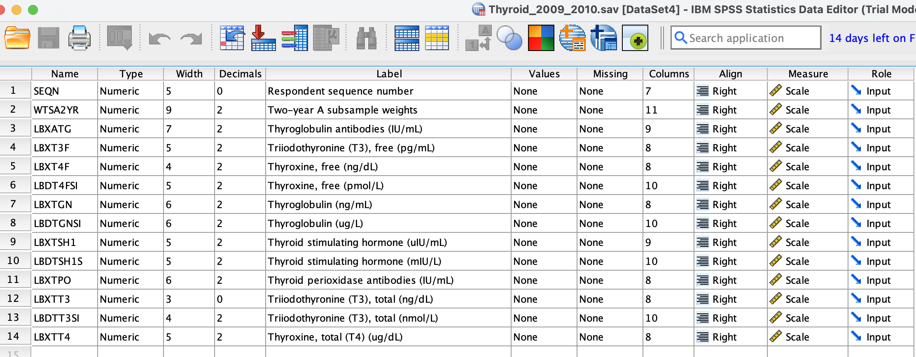
Рисунок 1. Метадані змінних ендокринного датасету (SPSS, NHANES 2009–2012)
А файли психічного стану пацієнтів складаються з таких характеристик, як (див. рис. 2):
– SEQN — Унікальний ідентифікаційний номер респондента;
– DPQ010 — Відсутність або зниження інтересу до повсякденних справ. Один із симптомів депресії (аналог питання PHQ-9);
– DPQ020 — Відчуття пригніченості, депресії або безнадії;
– DPQ030 — Проблеми зі сном: безсоння або надмірна сонливість;
– DPQ040 — Відчуття втоми або нестачі енергії;
– DPQ050 — Поганий апетит або переїдання;
– DPQ060 — Негативне ставлення до себе, почуття провини або меншовартості;
– DPQ070 — Труднощі з концентрацією уваги;
– DPQ080 — Сповільнення або надмірна збудженість у рухах чи мовленні. Може бути ознакою психомоторних змін при депресії;
– DPQ090 — Думки про смерть або про те, що краще було б померти. Важливий показник суїцидальних думок;
– DPQ100 — Наскільки перелічені проблеми ускладнювали життя, роботу чи спілкування. Оцінка функціонального впливу симптомів.

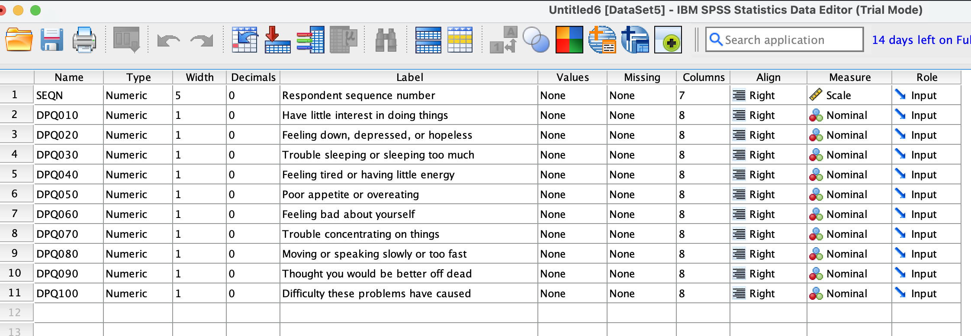
Рисунок 2. Метадані змінних датасету психологічного стану PHQ-9 (SPSS, NHANES 2009–2012)
Приклади даних першої вибірки нижче (рис. 3-4).

Рисунок 3. Фрагмент набору даних ендокринних показників (NHANES 2009–2012)
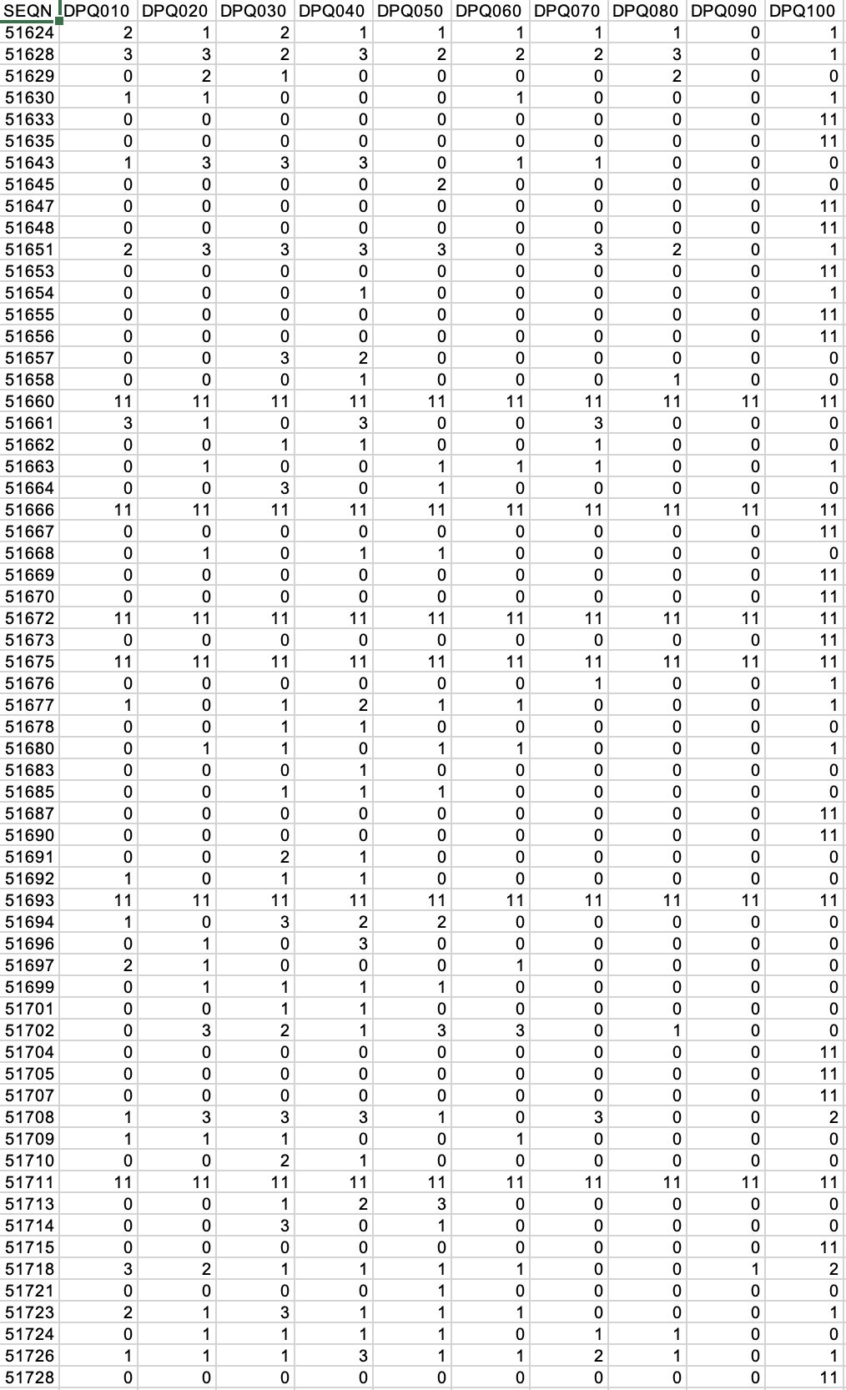
Рисунок 4. Фрагмент набору даних психологічного стану пацієнтів PHQ-9 (NHANES 2009–2012)
Саме за допомогою значення SEQN дані можна буде об'єднати в одну загальну вибірку, яка стане основою подальшого аналізу, але перед цим необхідно перевірити якість та наявність усіх необхідних показників для усіх пацієнтів.
Після обробки даних (EDA) об'єднаємо їх в один загальний датасет за 4 роки за обома напрямками експерименту за однаковим унікальним ідентифікаційним номером.
В результаті маємо 4043 пацієнти як з ендокринними даними, так і з психологічними.
Врешті-решт, проаналізувавши усі дані усіх вибірок за 4 роки, бачимо наступну картину:
– сирих даних обох вибірок приблизно 4000 рядків;
– після об'єднання двох вибірок за унікальним ідентифікатором кількість даних становила 4043;
– після видалення некоректних або відсутніх даних у файлі ендокринних показників залишилося 3737 записів, а психологічних даних — 3532;
– визначено, що кількість пацієнтів з повними даними для обох вибірок — 3310.
Дані повністю проаналізовані, наступним кроком є пошук потенційних взаємозалежностей. Розрахуємо кореляції для кожної теорії взаємозв'язку між ендокринним аналізом та PHQ9_Total або з Depression_Risk за такими етапами:
– розраховуємо кореляцію Спірмена (Zar, 2005);
– перетворимо значення кореляції Спірмена на t-статистику;
– розрахуємо p-value;
– проведемо FDR correction (множинне тестування) (Benjamini & Hochberg, 1995);
– визначимо, чи значима кореляція чи ні.
У науці люди домовилися: якщо p-value < 0.05, результат вважається значимим.
– p < 0.05 → "Це дуже рідко трапляється випадково";
– p > 0.05 → "Це легко може трапитися випадково".
P-value — це відсоток, що показує, як рідко твій результат трапляється випадково, якщо насправді немає ніякого ефекту.
Нижче наведено результати пошуку лінійних зв'язків між гормонами та показниками депресії (див. табл. 2–3).
Таблиця 2
THYROID MARKER VS DEPRESSION_RISK (12 маркерів)
Маркер | n | ρ | p_value | p_FDR | Значимий?
fT4 (ng/dL) | 3310 | -0.0390 | 0.0248 | 0.1661 | Ні
fT4 SI (pmol/L) | 3310 | -0.0390 | 0.0248 | 0.1661 | Ні
Tg (ng/mL) | 3310 | +0.0302 | 0.0827 | 0.2481 | Ні
Tg SI (ug/L) | 3310 | +0.0302 | 0.0827 | 0.2481 | Ні
fT3 (pg/mL) | 3310 | -0.0272 | 0.1181 | 0.2576 | Ні
TT4 (ug/dL) | 3310 | +0.0254 | 0.1447 | 0.2894 | Ні
Tg-Ab (IU/mL) | 3310 | +0.0169 | 0.3301 | 0.5282 | Ні
TT3 (ng/dL) | 3310 | -0.0156 | 0.3699 | 0.5548 | Ні
TSH (uIU/mL) | 3310 | -0.0114 | 0.5137 | 0.6296 | Ні
TSH SI (mIU/L) | 3310 | -0.0114 | 0.5137 | 0.6296 | Ні
TPO-Ab (IU/mL) | 3310 | -0.0117 | 0.5005 | 0.6296 | Ні
TT3 SI (nmol/L) | 3310 | -0.0096 | 0.5793 | 0.6320 | Ні
Таблиця 3
THYROID MARKER VS PHQ9_TOTAL (12 маркерів)
Маркер | n | ρ | p_value | p_FDR | Значимий?
fT4 (ng/dL) | 3310 | +0.0354 | 0.0415 | 0.1661 | Ні
fT4 SI (pmol/L) | 3310 | -0.0366 | 0.0352 | 0.1661 | Ні
Tg (ng/mL) | 3310 | -0.0366 | 0.0352 | 0.1661 | Ні
Tg SI (ug/L) | 3310 | +0.0377 | 0.0303 | 0.1661 | Ні
fT3 (pg/mL) | 3310 | +0.0272 | 0.1171 | 0.2576 | Ні
TT4 (ug/dL) | 3310 | +0.0272 | 0.1171 | 0.2576 | Ні
Tg-Ab (IU/mL) | 3310 | +0.0238 | 0.1715 | 0.3167 | Ні
TT3 (ng/dL) | 3310 | +0.0177 | 0.3089 | 0.5282 | Ні
TSH (uIU/mL) | 3310 | -0.0111 | 0.5247 | 0.6296 | Ні
TSH SI (mIU/L) | 3310 | -0.0102 | 0.5569 | 0.6320 | Ні
TPO-Ab (IU/mL) | 3310 | -0.0060 | 0.7317 | 0.7317 | Ні
TT3 SI (nmol/L) | 3310 | -0.0060 | 0.7317 | 0.7317 | Ні
Видно, що жоден маркер не може явно вказати на ймовірність настання депресивного розладу.
Індивідуально маркери не корелюють з депресією, але чи наявний комбінований вплив.
Проведемо Chi-square тест на залежність двох показників (Franke et al., 2012; McHugh, 2013). Повна вибірка налічує 4043 пацієнти, але для проведення експерименту необхідно аналізувати хворих з повними ендокринними та психологічними даними та виключити підвибірку "Інше" — маємо 1971. Будуємо таблицю спостережуваних частот (n = 1971) (див. табл. 4).
Таблиця 4
Спостережувані частоти
Статус | Ризик = 0 | Ризик = 1 | n (рядок)
Euthyroid | 1638 | 143 | 1781
Гіпертиреоз | 5 | 0 | 5
Гіпотиреоз | 64 | 7 | 71
Субклінічний гіпертиреоз | 54 | 12 | 66
Субклінічний гіпотиреоз | 44 | 4 | 48
Разом (стовпець) | 1805 | 166 | N = 1971
Розрахуємо тепер значення очікуваних частот. Нульова гіпотеза полягає у тому, що статусу не важливо, чи є ризик чи немає. Якби це була правда, то у кожному рядку частка ризик = 1 становила б загальну частку ризику по всій вибірці (наприклад, 166 з 1971 = 8.42%). Очікувана частота — скільки пацієнтів мало б бути за цією гіпотезою.
Наприклад, обчислимо це значення для Euthyroid-групи при ризику = 0:
Повторимо ці кроки для усіх груп з ризиком та без, матимемо наступну таблицю очікуваних значень (див. табл. 5).
Таблиця 5
Очікувані значення
Статус | Ризик = 0 | Ризик = 1
Euthyroid | 1631.002 | 149.998
Гіпертиреоз | 4.579 | 0.421
Гіпотиреоз | 65.020 | 5.980
Субклінічний гіпертиреоз | 60.441 | 5.559
Субклінічний гіпотиреоз | 43.957 | 4.043
Розглянемо кожну клітинку окремо, а саме — її внесок. В даному випадку "внесок" — це значення, яке вказує на те, на скільки реальне число відрізняється від очікуваного, береться його квадрат задля того, щоб уникнути скасування позитивних значень негативними, який потім ділиться на очікувану частоту — тобто, нормоване значення, щоб відхилення в маленькій групі "важило" прямо пропорційно до її розміру.
Наприклад, розрахуємо внесок групи з ризиком субклінічного гіпертиреозу:
Усі розрахунки стосовно усіх "внесків" надано в таблиці нижче (див. табл. 6):
Таблиця 6
Внески усіх значень
Статус | Ризик | Спост. | Очік. | Різниця | Квадрат | Внесок
Euthyroid | 0 | 1638 | 1631.002 | 6.998 | 48.972 | 0.030025
Euthyroid | 1 | 143 | 149.998 | -6.998 | 48.972 | 0.326482
Гіпертиреоз | 0 | 5 | 4.579 | 0.421 | 0.177 | 0.038728
Гіпертиреоз | 1 | 0 | 0.421 | -0.421 | 0.177 | 0.421106
Гіпотиреоз | 0 | 64 | 65.020 | -1.020 | 1.040 | 0.016010
Гіпотиреоз | 1 | 7 | 5.980 | 1.020 | 1.040 | 0.174089
Субкл. гіпертиреоз | 0 | 54 | 60.441 | -6.441 | 41.487 | 0.686477
Субкл. гіпертиреоз | 1 | 12 | 5.559 | 6.441 | 41.487 | 7.464405
Субкл. гіпотиреоз | 0 | 44 | 43.957 | 0.043 | 0.0018 | 0.000041
Субкл. гіпотиреоз | 1 | 4 | 4.043 | -0.043 | 0.0018 | 0.000449
Розрахуємо суму внесків та відсоткове відношення кожного з них в частці цієї суми.
Варто зазначити, який стан в залежності від ризику яку частку загального внеску займає (див. табл. 7).
Таблиця 7
Відсоткове значення внесків
Статус | Ризик | Внесок | % від χ²
Euthyroid | 0 | 0.030025 | 0.33%
Euthyroid | 1 | 0.326482 | 3.56%
Гіпертиреоз | 0 | 0.038728 | 0.42%
Гіпертиреоз | 1 | 0.421106 | 4.60%
Гіпотиреоз | 0 | 0.016010 | 0.17%
Гіпотиреоз | 1 | 0.174089 | 1.90%
Субкл. гіпертиреоз | 0 | 0.686477 | 7.50%
Субкл. гіпертиреоз | 1 | 7.464405 | 81.51%
Субкл. гіпотиреоз | 0 | 0.000041 | 0.00%
Субкл. гіпотиреоз | 1 | 0.000449 | 0.00%
Результати статистичного аналізу
Як бачимо, субклінічний гіпертиреоз із ризиком забирає найбільшу вагому частку статистики — 81.5%, що відповідає 12 пацієнтам, хоча очікувалося менше — майже 6.
Розрахуємо ступені свободи та p-значення.
p-значення — ймовірність отримати значення χ² більшим або рівним 9.158 при df = 4, що відповідає двосторонньому тесту та становить 0.0573.
Як бачимо 0.0573 більше 0.05, тому результат не значимий, але на межі.
По-друге, виявлено, що показник Depression_Risk наявний у кожному діагнозі (див. табл. 8).
Таблиця 8
Відсоткова кількість з Depression_Risk
Діагноз | % з Depression_Risk
Гіпотиреоз | 9.9%
Субклінічний гіпотиреоз | 8.3%
Субклінічний гіпертиреоз | 18.2% (майже 2× вище)
Здорові | 8.0%
Chi-square тест: χ² = 9.16, p = 0.057 (borderline, не значимо, але тренд видно).
Хі-квадрат підтверджує, що зв'язок існує, але він не лінійний: ризик залежить від конкретної комбінації значень TSH та fT4, а саме — від перетину ознак, а не окремо від кожної. Визначено, що субклінічний гіпертиреоз [8-9], при якому понижений TSH, але нормальний fT4, все ж пов'язаний з вищою депресією, але результат слабкий, бо мала вибірка, при якій p > 0.05, тому необхідне подальше дослідження за допомогою методів прогнозування з урахуванням усіх недоліків датасету, включаючи третю знахідку природи даних, а саме — дисбаланс класів (Jiang et al., 2020).
Обговорення та висновки
Результати дослідження вказують на те, що у випадку, коли пацієнт хворий саме на субклінічний гіпертиреоз є вірогідність розвитку депресивного розладу. Це зумовлено тим, що при нормальному показнику fT4, але зниженому рівні TSH, відслідковується зміни в нейромедіаторах, наприклад, дофаміні чи серотоніні.
Дане дослідження відрізняється від розглянутих вище. По-перше, у поперечному спостереженні (Bathla et al., 2016) серед чоловіків та жінок було виявлено 60% людей із депресивним розладом серед хворих на гіпотиреоз, коли в нашому випадку – майже 10%. Причиною такої розбіжності є різні методи проведення експериментів та даних вибірок.
По-друге, дослідження засобом менделівської рандомізації (Kuś et al., 2021) теж не знайшло причинно-наслідкового зв’язку між гормонами щитоподібної залози та депресивним або біполярним розладами.
По-третє, експеримент з антидепресивною терапією та сімома моделями прогнозування із застосуванням методу навчання з учителем (Qiao et al., 2022) довів взаємозвʼязок із станом щитоподібної залози та депресією, що також підтверджує дане дослідження для субклінічної форми захворювання.
Варто зазначити, що проведене спостереження мало свої обмеження, а саме:
– дійсно мала вибірка, наприклад, для субклінічного гіпертиреозу налічувалося всього 66 людей,
– значимість становить лише 0.057,
– наявний дисбаланс класів 9% та 91%.
Не дивлячись на вище зазначені недоліки, були отримані результати саме комбінованого впливу гормонів на психоемоційний стан пацієнтів, а не окремо кожного із них, як це було зроблено в попередніх дослідженнях, та знайдено потенційну конкретну групу ризику.
Дана стаття присвячена дослідженню пошуку взаємозв'язків ендокринних захворювань та психологічних розладів, а саме спостереженню того, чи може комбінація певних показників рівнів гормонів щитоподібної залози спричинити погіршення психоемоційного стану пацієнтів. Вибірка складалася з NHANES-даних хворих, яка мала всі необхідні значення задля проведення аналізу.
Спершу після попередньої обробки даних перед самим експериментом за допомогою кореляції Спірмена було ще раз доведено, що кожен маркер окремо не впливає на ментальний стан пацієнтів, тому було доцільним проведення наступного експерименту — перевірки гіпотези того, певні комбінації спроможні викликати порушення роботи психічної системи людей. Методом дослідження був спосіб хі-квадрат, який застосовував в аналізі реальні та очікувані показники та нульову гіпотезу наявності ризику розвитку психологічних розладів незалежно від виду ендокринологічного захворювання.
В результаті виявлено межовий сигнал того, що при субклінічному гіпертиреозі є ризик настання депресії: χ² = 9.16, p = 0.057, 18.2%. Тому для більш ефективного аналізу необхідно провести моделювання засобом машинного навчання з урахуванням дисбалансу класів (9% та 91%).
Перспективою дослідження є побудова ансамблю дерев рішень з клінічною інженерією ознак, які усувають нерівномірність класів (Badawy et al., 2023; Jordan & Mitchell, 2015; Shipe et al., 2019).
Список використаних джерел
Badawy, M., Ramadan, N., & Hefny, H. A. (2023). Healthcare predictive analytics using machine learning and deep learning techniques: a survey. Journal of Electrical Systems and Information Technology, 10(1), 2. https://doi.org/10.1186/s43067-023-00108-y
Bathla, M., Singh, M., & Relan, P. (2016). Prevalence of anxiety and depressive symptoms among patients with hypothyroidism. Indian Journal of Endocrinology and Metabolism, 20(4), 468–474. https://doi.org/10.4103/2230-8210.183476
Benjamini, Y., & Hochberg, Y. (1995). Controlling the False Discovery Rate: a practical and powerful approach to multiple testing. Journal of the Royal Statistical Society. Series B, 57(1), 289–300. https://doi.org/10.1111/j.2517-6161.1995.tb02031.x
Bode, H., et al. (2022). Hyperthyroidism and clinical depression: a systematic review and meta-analysis. Translational Psychiatry, 12, 362. https://doi.org/10.1038/s41398-022-02121-7
Franke, T. M., Ho, T., & Christie, C. A. (2012). The chi-square test: often used and more often misinterpreted. American Journal of Evaluation, 33(3), 448–458. https://doi.org/10.1177/1098214011426594
Fan, X., Li, Y., Li, H., Wu, J., & Wu, X. (2024). The association between depression, anxiety, and thyroid disease: A UK Biobank prospective cohort study. Depression and Anxiety, 2024, 8000359. https://doi.org/10.1155/2024/8000359
Hong, J. W., Noh, J. H., & Kim, D.-J. (2018). Association between subclinical thyroid dysfunction and depressive symptoms in the Korean adult population: The 2014 Korea National Health and Nutrition Examination Survey. PLoS ONE, 13(8), e0202258. https://doi.org/10.1371/journal.pone.0202258
Jiang, T., Gradus, J. L., & Rosellini, A. J. (2020). Supervised machine learning: a brief primer. Behavior Therapy, 51(5), 675–687. https://doi.org/10.1016/j.beth.2020.05.002
Jordan, M. I., & Mitchell, T. M. (2015). Machine learning: trends, perspectives, and prospects. Science, 349(6245), 255–260. https://doi.org/10.1126/science.aaa8415
Kumar, R., LeMahieu, A. M., Stan, M. N., et al. (2023). The association between thyroid stimulating hormone and depression: A historical cohort study. Mayo Clinic Proceedings, 98(7), 1009–1020. https://doi.org/10.1016/j.mayocp.2022.12.020
Kuś, A., Żuber-Łaskawiec, K., Jurek, B., et al. (2021). Causal associations between thyroid function and mood disorders — a Mendelian randomization study. Thyroid, 31(6), 967–975. https://doi.org/10.1089/thy.2020.0884
McHugh, M. L. (2013). The chi-square test of independence. Biochemia Medica, 23(2), 143–149. https://doi.org/10.11613/BM.2013.018
Qiao, D., Chen, W., Huo, W., et al. (2022). Associations of thyroid hormones with depression: a machine learning approach. Journal of Affective Disorders, 299, 45–52. https://doi.org/10.1016/j.jad.2021.11.056
Qiao, D., Liu, H., Zhang, X., Lei, L., Sun, N., Yang, C., Li, G., Guo, M., Zhang, Y., Zhang, K., & Liu, Z. (2022). Exploring the potential of thyroid hormones to predict clinical improvements in depressive patients: A machine learning analysis of the real-world based study. Journal of Affective Disorders, 299, 159–165. https://doi.org/10.1016/j.jad.2021.11.055
Roa Dueñas, O. H., Hofman, A., Luik, A. I., Medici, M., Peeters, R. P., & Chaker, L. (2024). The cross-sectional and longitudinal association between thyroid function and depression: A population-based study. Journal of Clinical Endocrinology & Metabolism, 109(5), e1389–e1399. https://doi.org/10.1210/clinem/dgad620
Shipe, M. E., Deppen, S. A., Farjah, F., & Grogan, E. L. (2019). Developing prediction models for clinical use using logistic regression: an overview. Journal of Thoracic Disease, 11(Suppl. 4), S374–S384. https://doi.org/10.21037/jtd.2019.01.25
Wildisen, L., et al. (2021). Subclinical thyroid dysfunction and depressive symptoms: protocol for a systematic review and individual participant data meta-analysis of prospective cohort studies. BMJ Open, 11(5), e044131. https://doi.org/10.1136/bmjopen-2020-044131
Zar, J. H. (2005). Spearman Rank Correlation. Encyclopedia of Biostatistics. https://doi.org/10.1002/0470011815.b2a15150
TESTING THE HYPOTHESIS OF THE COMBINED EFFECT OF THYROID HORMONES ON THE PSYCHOLOGICAL STATE OF PATIENTS
The thyroid gland is one of the most important organs in the human body, influencing a considerable number of processes within it. Endocrine and psychological disorders are closely interlinked; however, it is not yet known precisely which thyroid parameters cause a deterioration in patients’ psychological and emotional state.
A previous study analysed data from the NHANES (National Health and Nutrition Examination Survey), specifically endocrine markers and responses to the PHQ-9 psychological questionnaire:
– TSH,
– fT3,
– fT4,
– TT3,
– TT4,
– antibody TPO,
– antibody Tg,
– a lack of or reduced interest in everyday activities,
– feelings of low mood,
– depression or hopelessness,
– sleep problems,
– feelings of tiredness or lack of energy,
– poor appetite or overeating,
– negative self-perception,
– feelings of guilt or inferiority,
– difficulty concentrating,
– slowed or overly agitated movements or speech,
– thoughts of death or that it would be better to die,
– the extent to which these problems interfered with daily life, work or social interactions.
It concluded that, taken individually, none of these markers is capable of causing psychological disorders. The aim of this study is therefore to analyse the potential combined effect of thyroid hormones on the likelihood of developing a depressive disorder.
During the experiment, it was confirmed using such methods:
– Spearman’s correlation,
– p-value,
– FDR correction — which eliminates false positives that endocrine indicators do not cause a deterioration in psychological and emotional well-being, after which an experiment was conducted to test the combined effect. To conduct this analysis, the chi-square test was applied, which yields a final result based on observed and expected values. Ultimately, a borderline result was identified: in cases of subclinical hyperthyroidism (χ² = 9.16, p = 0.057, 18.2%), there is a risk of the disease developing.
It is worth noting that whilst there is a signal of an effect, it is not significant; therefore, further, more rigorous observation is required – modelling using machine learning, taking into account the class imbalance in the data (which currently stands at 91 per cent and 9 per cent in the experimental data), as well as clinically-oriented feature engineering.
Keywords: endocrine disorders, psychological disorders, depression, combined effect, Spearman’s correlation, multiple testing, chi-square test, machine learning modeling, Random Forest.

Павло КУДРИНСЬКИЙ, асп.
ORCID ID: 0009-0008-6314-6150 e-mail: pasha.kudrinskiy@gmail.com
Державний університет інформаційно-комунікаційних технологій, Київ, Україна
Олександр ЗВЕНІГОРОДСЬКИЙ, канд. техн. наук, доц.
ORCID ID: 0009-0008-6235-1638 e-mail: zvenigas56@gmail.com
Державний університет інформаційно-комунікаційних технологій, Київ, Україна

УМОВИ ДОСТОВІРНОСТІ ПОРІВНЯЛЬНОГО ОЦІНЮВАННЯ ПРОГНОЗНОГО АВТОМАСШТАБУВАННЯ ХМАРНИХ РЕСУРСІВ
Анотація. Результати досліджень прогнозного автомасштабування хмарних ресурсів майже не піддаються зіставленню: вимірювання виконують на різних інфраструктурах, без зазначеної процедури отримання еталонної розмітки аномалій і здебільшого без повторів та перевірки значущості. У статті обґрунтовано, що зіставність досягається не збільшенням кількості експериментів, а умовами достовірності, накладеними на саму процедуру оцінювання. Сформульовано п'ять таких умов і для кожної наведено виміряний наслідок її порушення: база порівняння, утримана на трьох екземплярах із восьми за 17,6 % відхилених запитів; гіпотеза, яку було б зараховано як підтверджену на підставі покращення, купленого 77 % додаткового ресурсу; оцінки хвоста часу відповіді, що різняться в 2,3 раза за незмінної конфігурації; ціль прогнозування як функція власного рішення про масштабування; детектор, який спрацьовує на кожному відліку. Умови застосовано в заліковій серії з 45 прогонів, де одну з трьох зафіксованих гіпотез прийнято, а дві відхилено з простеженою до вимірювання причиною.
Ключові слова: автомасштабування, хмарні обчислення, відтворюваність експерименту, достовірність оцінювання, виявлення аномалій, Kubernetes.

Вступ
Горизонтальне автомасштабування змінює кількість екземплярів служби відповідно до навантаження. Промисловим типовим рішенням є порогове масштабування, за якого кількість екземплярів виводиться зі спостереженого коефіцієнта завантаження ресурсу (Lorido-Botran et al., 2014); саме воно вбудоване в платформи контейнерної оркестрації. Його обмеження структурне: рішення ухвалюється після того, як навантаження вже змінилося, тому реакція запізнюється на суму періоду зчитування показників, періоду ухвалення рішення та часу запуску екземпляра. Прогнозне автомасштабування замінює спостережену величину прогнозом; оглядові праці (Qu et al., 2018; Xu et al., 2025) налічують десятки таких систем на основі рекурентних мереж, автокодерів і навчання з підкріпленням.
Чого в цій літературі бракує - це можливості порівняти такі системи між собою. Результати отримано на різних інфраструктурах, за профілями навантаження, описаними якісно, а не відтворювано, без зазначеної процедури отримання еталонної розмітки, за якою обчислюється якість виявлення, і переважно без повторних прогонів та перевірки статистичної значущості. Те саме занепокоєння незалежно висловлено в суміжній галузі виявлення аномалій у часових рядах, де показано, що побудова наборів для порівняння створює враження поступу там, де його немає (Wu & Keogh, 2023; Liu & Paparrizos, 2024).
Методику оцінювання механізмів масштабування досліджували й раніше. Запропоновано середовище для перевірки стратегій масштабування за невизначеності навантаження (Papadopoulos et al., 2016); виконано порівняння семи механізмів, яке показало, наскільки сильно впорядкування залежить від умов оцінювання (Ilyushkin et al., 2018); самі показники пружності отримали строге означення, щоб термін не вживався довільно (Herbst et al., 2013). Спільним для цих праць є зосередження на тому, як міряють рішення про масштабування та його наслідок. Умови, наведені нижче, стосуються того, що́ саме порівнюють, і формулюються до цих показників.
У статті обстоюється позиція, що зіставність досягається не додаванням експериментів, а накладанням умов достовірності на саму процедуру оцінювання, і що самі ці умови мають бути обґрунтовані вимірюванням. Кожна умова обґрунтована контрприкладом: наведено випадок, коли умову порушено, порушення не лишає сліду в підсумкових показниках, які зазвичай публікують, і через це змінюється зроблений висновок. Для твердження такого роду достатньо одного випадку. Тверджень про поширеність таких порушень у літературі або про перенесення величин на інші інфраструктури тут не робиться: наведені числові величини є властивостями випробувального стенду, умови є властивостями процедури оцінювання.
Стенд і склад експерименту
Стенд складається з п'яти виділених обчислювальних вузлів однакового типу в одній зоні доступності: вузол площини керування, три робочі вузли та генератор навантаження поза кластером. Інстанси з накопиченням процесорних кредитів виключено, бо вичерпання кредитів імітує деградацію, якої в системі немає; генератор винесено на окремий вузол, бо на робочій станції він додавав близько 120 мс мережевої затримки.
Цільова служба - синтетичний застосунок, обмежений процесором. Ресурсний запит дорівнює ресурсній межі: механізм масштабування обчислює завантаження відносно запиту, і менший за межу запит означав би, що цільове завантаження стосується величини, яка не обмежує продуктивність. Паралелізм обмежено семафором із секундним очікуванням у черзі, після чого запит скидається. Період зчитування показників - 10 с, діапазон масштабування 2…8 екземплярів, цільове завантаження 0,80.
Порівнюються три правила ухвалення рішень. Правило A - порогове масштабування за спостереженим завантаженням. Правило B масштабує безпосередньо за прогнозом без обмежень стабільності. Правило C поєднує прогноз з оцінкою аномальності та оператором обмежень стабільності Π, який задає мінімальний проміжок між діями, асиметричний гістерезис із більшим порогом на зменшення, ніж на збільшення, і межу зміни за одну дію. Прогноз подається штатному механізму через інтерфейс зовнішніх показників, тож сам механізм лишається незміненим, а конфігурації B і C відрізняються рівно однією річчю - наявністю оператора Π.
За вікном вимірювання обчислюються три показники: частка порушень порога рівня обслуговування V, де скинуті запити зараховуються як порушення; спожитий ресурс R в екземпляро-секундах; індекс осциляції O - кількість розворотів напрямку дій масштабування на десять хвилин. Якість виявлення виражено показником F1 за епізодним обліком із вікном толерантності: епізод із хоча б одним спрацюванням у своєму вікні зараховується як одне правильне виявлення, а послідовні хибні спрацювання, розділені інтервалом, меншим за вікно толерантності, групуються в один хибний епізод. Це запобігає обом викривленням - і роздуванню кількості хибних спрацювань, і зарахуванню цілого епізоду за одним відліком, що критиковано для поширеної угоди про поточкове коригування (Kim et al., 2022). Еталонну розмітку отримано інжекцією з записаними мітками часу: інжектований епізод відомий незалежно від того, що повідомляє детектор, тоді як мітка, виведена зі спостереженої поведінки, була б забруднена керуючими діями, які саме це виявлення й спричинило.
До експерименту зафіксовано три гіпотези з кількісними межами прийняття:
H1: $V_{c}$ ≤ 0,7 · $V_{A}$ і $R_{c}$≤ 1,1 ·$R_{A}$;
H2: $O_{c}$ ≤ 0,5 · $O_{B}$;
H3: F1 детектора на основі відтворення ≥ F1 порогового моніторингу окремих показників + 0,15.
Порівняння парні: усі конфігурації працюють на поточково тотожних профілях навантаження. Застосовано однобічний критерій знакових рангів Вілкоксона на об'єднаній вибірці сценаріїв, і обидва рішення зафіксовано в протоколі до виконання серії. Однобічність вимушена дискретністю: за п'яти пар найменше досяжне двобічне p дорівнює 0,0625, тобто значущість недосяжна за жодних даних.
Умова перша: база порівняння має використовувати наданий їй діапазон
Нехай $m_{max}$ - верхня межа кількості екземплярів, надана кожній конфігурації, а $\hat{m_{A}}$ - найбільша кількість екземплярів, якої база фактично досягає за робочого навантаження. Порівняння достовірне лише за умови $m_{A}$ ≥ γ · $m_{max}$ із заздалегідь зафіксованим γ; застосовано γ = 0,75.
Умова обмежує базу порівняння, а не запропонований метод, і її не можна перевірити за підсумковими показниками: база, що ніколи не виходить із нижньої частини свого діапазону, дає цілком пристойні V і R, і ніщо в цих числах не вказує на ослабленого суперника.
На етапі початкового збору даних механізм масштабування утримував систему на трьох екземплярах із восьми, відхиляючи 17,6 % усіх запитів (2 511 996 із 14 249 266) за завантаження процесора на рівні вузлів 0,15, тобто без фізичного дефіциту ресурсу. Якби залікову серію виконали в такому стані, будь-яка перевага прогнозних конфігурацій була б артефактом нездатності бази масштабуватися.
Механізм має дві складові. Скинутий запит процесорного часу не споживає, тож попит, що проявляється як відмова, у керованій величині не з'являється. Крім того, штатний механізм застосовує межу нечутливості, типово 10 %, тож фактичний поріг підйому дорівнює 0,88, а не номінальним 0,80. Прорахунок ланцюга станів із урахуванням цієї межі дає m̂ = 5 за середньої інтенсивності 90 зап./с і 7 за 110 зап./с; контрольний прогін за 91 зап./с дав рівно 5.
Умова має другу частину, яку доводиться назвати, бо саме її це дослідження й порушило: наданий діапазон не повинен перевищувати межі, за якою пропускна здатність уже не зростає. Виміряна максимальна обслужена інтенсивність становить 51,9, 75,6, 99,2, 120,9, 126,7, 125,5 і 124,9 зап./с для двох - восьми екземплярів, тобто виходить на полку на шести, тоді як наданий діапазон сягав восьми. Наслідок несиметричний: у заліковій серії 21 % екземпляро-секунд конфігурації C витрачено вище шести екземплярів, а конфігурації A і B шести не перевищували жодного разу.
На рисунку наведено заліковий прогін базової конфігурації за сценарієм зі сплесками.
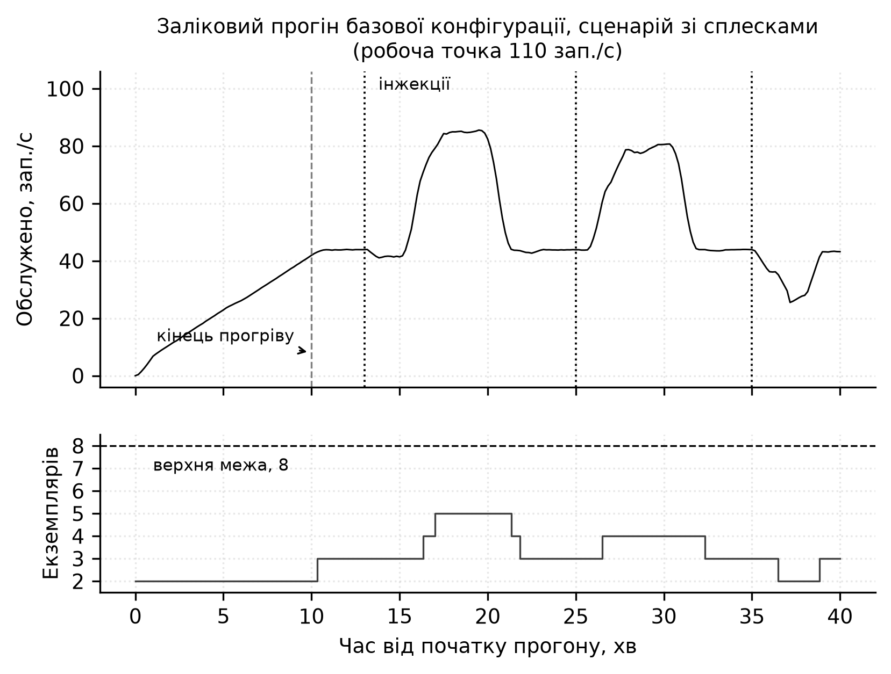
Рис. 1. Заліковий прогін базової конфігурації за сценарієм зі сплесками, робоча точка 110 зап./с. Верхня панель - фактично обслужена інтенсивність; штрихова вертикаль - кінець прогріву, пунктирні - моменти інжекції аномалій за еталонною розміткою. Нижня панель - кількість екземплярів; штрихова горизонталь - верхня межа діапазону масштабування
Умова друга: критерій прийняття має пов'язувати якість обслуговування й ресурс
Гіпотеза, що стверджує покращення якості обслуговування, мусить нести одночасне обмеження на спожитий ресурс, і обидві величини мають публікуватися парою.
Частку порушень можна звести до нуля, постійно утримуючи максимальну кількість екземплярів: без парного обмеження на ресурс оцінювання міряє готовність до надлишкового резервування, а не якість керування.
У заліковій серії конфігурація C знизила частку порушень з 0,1206 до 0,0542, тобто в 2,2 раза, за p = 0,0010. За критерієм з одним показником це підтверджене покращення. Парне обмеження на ресурс показує, що його отримано ціною 13 719 екземпляро-секунд проти 7 766 у бази, тобто відношення 1,77 за дозволених 1,10. Той самий критерій, застосований до конфігурації B, дає той самий вердикт з іншої причини: відношення за порушеннями 0,155 усередині межі 0,7, відношення за ресурсом 1,314 поза межею 1,1. Жодна з прогнозних конфігурацій не купила покращення якості обслуговування за допустимою ресурсною ціною.
Умова третя: калібрування місткості виконується за постійного, а не наростального навантаження
Поріг рівня обслуговування й будь-яка величина, виведена з випробування місткості, мають бути отримані за постійної інтенсивності, витриманої достатньо довго для встановлення режиму, а не за профілем, що наростає сходинками. Профіль із наростанням виконується точно так, як заданий, і дає гладку правдоподібну криву часу відповіді: дефект не лишає сліду у вихідних даних. Дев'яносто п'ятий процентиль часу відповіді за восьми екземплярів і 90 зап./с виміряно чотири рази за незмінної конфігурації, за відмінності лише в геометрії калібрувального профілю (табл. 1).
Табл. 1. Вплив геометрії калібрувального профілю на виміряний хвіст часу відповіді
Профіль | Крок сходинки, зап./с | Тривалість сходинки, с | p95 за 90 зап./с, мс
наростальний | 20 | 120 | 52,6
наростальний | 20 | 60 | 76,1
наростальний | 10 | 60 | 96,8
постійний | - | 240 | 122,5

Розкид становить 2,3 раза за незмінної системи. Причина в тому, що за наростального профілю номінальна позначка сходинки не дорівнює фактично прикладеній інтенсивності: сходинка з позначкою r охоплює проміжок від r мінус крок до r, тож її середня інтенсивність залежить від кроку. Наслідок практичний: поріг, виведений зі значення 52,6 мс, становив 150 мс, і повністю розгорнута конфігурація перевищувала його в штатній роботі, тоді як поріг зі стаціонарного вимірювання становить 1289 мс.
Умова четверта: модель прогнозування навчається на поданій, а не обслуженій інтенсивності
Ціллю прогнозування має бути подана інтенсивність, тобто сума обслужених і відхилених запитів, а не сама лише обслужена.
Обидві величини доступні з тієї самої вимірювальної підсистеми й різняться лише за перевантаження, а обслужену експортують типово в більшості розгортань. Обслужена інтенсивність є функцією і попиту, і власного рішення системи про резервування: модель, навчена на ній, прогнозує наслідок власного недорезервування і занижена саме в тих режимах, де додаткова місткість потрібна найбільше. Формально подана інтенсивність є екзогенною щодо контуру керування, а обслужена - ні. Прояв порушення - не велика похибка прогнозу, а прогноз, який ніколи не вимагає масштабування.
Перша навчальна вибірка цього дослідження містила лише обслужену інтенсивність із максимумом 61,6 зап./с, тоді як робоча точка залікової серії становить 110 зап./с. Оскільки відхилені запити не записувалися, подану інтенсивність відтворити неможливо, і вибірку довелося вилучити з навчання.
Умова п'ята: навчальна вибірка має покривати стани контуру, які відвідує оцінювання
Нехай $S_{навч}$ - множина значень кількості екземплярів, за яких навчальна вибірка містить усталену роботу, а $S_{оцін}$ - множина значень, відвіданих під час порівняльної серії. Будь-яка модель, що працює всередині контуру керування, потребує виконання $S_{оцін}$ ⊆ $S_{навч}$. Перевіряється саме покриття, а не обсяг: вибірка довільної тривалості, зібрана в одній робочій точці, не задовольняє жодної частини умови.
Придатність вибірки зазвичай подають як тривалість і кількість спостережень, і за цими мірами застосована тут вибірка була придатною: 25 годин із кроком 10 с, 9002 спостереження, без розривів і пропущених значень. Покриття є іншою властивістю й у цих числах не видно. Гірше того, природний спосіб побудувати різноманітний навчальний профіль приховує прогалину: профіль, що коливається навколо сталої бази, не виводить механізм за межі його точки рівноваги, якою б великою не була амплітуда, бо контур реагує на витриману, а не на миттєву інтенсивність. У другому зборі ковзне середнє поданої інтенсивності за п'ять хвилин жодного разу не перевищило 102 зап./с при миттєвих піках до 129 зап./с, і кількість екземплярів не перевищила чотирьох.
Залікова серія працювала на чотирьох - восьми екземплярах для прогнозних конфігурацій і на двох - шести для бази, проти вибірки, що покриває два - чотири. Наслідок проявився в детекторі: частка відліків зі спрацюванням становила 0,472 для детектора на основі відтворення в базовій конфігурації, 0,957 у конфігурації B і 1,000 у конфігурації C, а для порогового моніторингу - 0,701, 1,000 і 1,000. Модель нормальної поведінки, побудована на вибірці без робочої області, позначає цю область аномальною цілком. У 32 парах із 45 обидва детектори дали тотожний F1 - ознака спрацювання обох на кожному відлікові, коли склад правильних і хибних епізодів визначається самою лише структурою еталонної розмітки. Наслідок поширився й на правило масштабування: конфігурація C забороняє зменшення за сигналу аномалії, тож постійне спрацювання робить заборону постійною.
Результати залікової серії
Залікова серія складалася з 45 прогонів: три конфігурації на три сценарії на п'ять повторів, кожен із прогрівом 600 с і вимірюванням 1800 с, за пікової інтенсивності 110 зап./с і порога 1289 мс. Умови дійсності перевірялися автоматично для кожного прогону: незмінний склад вузлів, нульовий код виходу генератора, частка справжніх збоїв не вище 0,01 і рівно один механізм масштабування, що повідомляє поточне значення своєї керованої величини. Зараховано всі 45 прогонів. База досягла шести екземплярів із восьми, тобто умову першу виконано точно на її межі.
Табл. 2. Зведені показники за конфігураціями, по 15 прогонів, із 95 % довірчими інтервалами
Конфігурація | V | R, екз.-с | O | Екземплярів у середньому
A - порогове масштабування | 0,1206 [0,0750; 0,1662] | 7 766 [6 539; 8 993] | 0,802 [0,284; 1,321] | 4,30
B - прогноз без обмежень | 0,0187 [0,0059; 0,0315] | 10 206 [9 657; 10 755] | 0,424 [0,079; 0,769] | 5,66
C - прогноз з обмеженнями | 0,0542 [0,0277; 0,0807] | 13 719 [12 765; 14 674] | 0,044 [0,000; 0,168] | 7,59

Гіпотезу H1 відхилено. Умову за якістю обслуговування виконано із запасом і значуще; умову за ресурсом порушено з відношенням 1,77. Порушення однорідне за сценаріями: відношення $R_{C}$ / $R_{A}$ становить 1,38, 2,23 і 1,90 за сталого навантаження, сплесків і витоку пам'яті відповідно.
Гіпотезу H2 прийнято. Індекс осциляції знижується з 0,424 до 0,044, тобто в 9,5 раза, за p = 0,0082 проти межі 0,212. Це єдине порівняння в дослідженні, де відрізняється рівно один чинник, тож зниження коливань належить обмеженням, а не якості прогнозу. Свідчення при цьому тонше, ніж показує об'єднане p: із п'ятнадцяти парних різниць ненульових лише вісім, і п'ять із них походять з одного сценарію.
Гіпотезу H3 відхилено. Детектор на основі відтворення дав F1 = 0,5483 проти 0,5505 у порогового моніторингу, тобто різницю −0,0023 за потрібних +0,15, за p = 0,311. Обидва детектори застосовано офлайн до одного й того самого ряду кожного прогону, тож порівняння ізолює саме підхід до виявлення. Повторення на підвибірці, де детектори ще розрізняються, дає 0,4829 проти 0,4896 - той самий вердикт.
Об'єднання трьох сценаріїв в один критерій перевірено окремо точним стратифікованим критерієм знакових перестановок; жодного вердикту він не змінює: 0,0049, 0,0078 і 0,224 відповідно.
Дискусія і висновки
Конфігурація B переважає конфігурацію C одночасно за якістю обслуговування й за ресурсом: 0,0187 проти 0,0542 і 10 206 проти 13 719 екземпляро-секунд. Оператор обмежень отже купує стійкість ціною обох інших показників, а не лише швидкодії, як припускав задум. Механізм простежується: за виявленої аномалії зменшення заборонено прямо, а оскільки в конфігурації C детектор спрацьовує на кожному відлікові, заборона стає постійною, і конфігурація тримається поблизу верхньої межі свого діапазону.
Дві гіпотези з трьох відхилено, і це подається як результат, а не як невдача, бо в обох випадках причину простежено до вимірювання: H1 не проходить за ресурсом через насичення детектора, а насичення - через покриття навчальної вибірки; H3 не проходить, і те саме насичення прямим вимірюванням показано не бути причиною, бо вердикт зберігається на ненасиченій підвибірці.
Відхилення H3 легко прочитати неправильно. Зафіксована межа вимагала перевищення на 0,15 за показником F1, і його не досягнуто; це вердикт, і він лишається чинним. Але це не є свідченням того, що виявлення на основі відтворення поступається пороговому моніторингу взагалі: у двох конфігураціях із трьох порівняння не виміряло нічого, ненасичена підвибірка налічує п'ятнадцять пар, а параметр порога детектора дібрано на чотирьох інжектованих епізодах. Що з H3 справді встановлено - це методичне: тотожні значення F1 у багатьох парах є діагностичною ознакою насиченого порівняння, а частка відліків зі спрацюванням - той показник, що її виявляє.
Окремо слід назвати незакріплене розміщення екземплярів між вузлами: за двох екземплярів на одному вузлі питома місткість при насиченні становила 16,2 зап./с проти 26,7 за розміщення на різних вузлах. Вплив цього чинника на порівняльну серію обмежений: ефект проявляється лише за насичення, за трьох робочих вузлів співрозміщення неминуче від чотирьох екземплярів, а конфігурації B і C не працювали нижче чотирьох екземплярів жодного відліку - 0 з 2704 і 0 з 2710 відповідно. База провела 23,1 % відліків за трьох екземплярів і менше, з них лише 0,11 % усіх своїх відліків одночасно за завантаження 0,9 і вище.
Усі результати отримано на одному стенді, з одним синтетичним застосунком і однією реалізацією механізму масштабування. Кількісні величини не переносяться; переноситься процедура. Умови друга, четверта й п'ята випливають зі структури задачі, а не з властивостей цього стенду: частку порушень можна звести до нуля утриманням максимальної кількості екземплярів у будь-якому механізмі; обслужена інтенсивність є функцією керуючої дії скрізь, де є скидання навантаження або контроль допуску; модель нормальної поведінки не можна оцінювати поза носієм її навчальної вибірки. Умови перша й третя емпіричні за величинами й структурні за формою.
Найперший напрям доопрацювання - збір навчальних даних профілем, у якому рухається сама робоча точка, а кожен рівень витримується достатньо довго для встановлення режиму: це єдина зміна, яка зробила б порівняння детекторів змістовним і зняла б причину обох відхилених вердиктів. Далі - закріплення або рандомізація розміщення екземплярів, збільшення кількості повторів на комбінацію та відтворення на застосунках інших класів.
Список використаних джерел
Herbst, N. R., Kounev, S., & Reussner, R. (2013). Elasticity in cloud computing: What it is, and what it is not. In Proceedings of the 10th International Conference on Autonomic Computing (pp. 23–27). USENIX Association.
Ilyushkin, A., Ali-Eldin, A., Herbst, N., Bauer, A., Papadopoulos, A. V., Epema, D., & Iosup, A. (2018). An experimental performance evaluation of autoscalers for complex workflows. ACM Transactions on Modeling and Performance Evaluation of Computing Systems, 3(2), Article 8. https://doi.org/10.1145/3164537
Kim, S., Choi, K., Choi, H.-S., Lee, B., & Yoon, S. (2022). Towards a rigorous evaluation of time-series anomaly detection. Proceedings of the AAAI Conference on Artificial Intelligence, 36(7), 7194–7201. https://doi.org/10.1609/aaai.v36i7.20680
Liu, Q., & Paparrizos, J. (2024). The elephant in the room: Towards a reliable time-series anomaly detection benchmark. In Advances in Neural Information Processing Systems 37 (pp. 108231–108261). Curran Associates.
Lorido-Botran, T., Miguel-Alonso, J., & Lozano, J. A. (2014). A review of auto-scaling techniques for elastic applications in cloud environments. Journal of Grid Computing, 12(4), 559–592. https://doi.org/10.1007/s10723-014-9314-7
Papadopoulos, A. V., Ali-Eldin, A., Årzén, K.-E., Tordsson, J., & Elmroth, E. (2016). PEAS: A performance evaluation framework for auto-scaling strategies in cloud applications. ACM Transactions on Modeling and Performance Evaluation of Computing Systems, 1(4), Article 15. https://doi.org/10.1145/2930659
Qu, C., Calheiros, R. N., & Buyya, R. (2018). Auto-scaling web applications in clouds: A taxonomy and survey. ACM Computing Surveys, 51(4), Article 73. https://doi.org/10.1145/3148149
Wu, R., & Keogh, E. J. (2023). Current time series anomaly detection benchmarks are flawed and are creating the illusion of progress. IEEE Transactions on Knowledge and Data Engineering, 35(3), 2421–2429. https://doi.org/10.1109/TKDE.2021.3112126
Xu, M., Liao, J., Wen, L., Wu, H., Ye, K., Buyya, R., & Xu, C. (2025). Auto-scaling approaches for microservice applications: A survey and taxonomy. arXiv. https://arxiv.org/abs/2507.17128
References
Herbst, N. R., Kounev, S., & Reussner, R. (2013). Elasticity in cloud computing: What it is, and what it is not. In Proceedings of the 10th International Conference on Autonomic Computing (pp. 23–27). USENIX Association.
Ilyushkin, A., Ali-Eldin, A., Herbst, N., Bauer, A., Papadopoulos, A. V., Epema, D., & Iosup, A. (2018). An experimental performance evaluation of autoscalers for complex workflows. ACM Transactions on Modeling and Performance Evaluation of Computing Systems, 3(2), Article 8. https://doi.org/10.1145/3164537
Kim, S., Choi, K., Choi, H.-S., Lee, B., & Yoon, S. (2022). Towards a rigorous evaluation of time-series anomaly detection. Proceedings of the AAAI Conference on Artificial Intelligence, 36(7), 7194–7201. https://doi.org/10.1609/aaai.v36i7.20680
Liu, Q., & Paparrizos, J. (2024). The elephant in the room: Towards a reliable time-series anomaly detection benchmark. In Advances in Neural Information Processing Systems 37 (pp. 108231–108261). Curran Associates.
Lorido-Botran, T., Miguel-Alonso, J., & Lozano, J. A. (2014). A review of auto-scaling techniques for elastic applications in cloud environments. Journal of Grid Computing, 12(4), 559–592. https://doi.org/10.1007/s10723-014-9314-7
Papadopoulos, A. V., Ali-Eldin, A., Årzén, K.-E., Tordsson, J., & Elmroth, E. (2016). PEAS: A performance evaluation framework for auto-scaling strategies in cloud applications. ACM Transactions on Modeling and Performance Evaluation of Computing Systems, 1(4), Article 15. https://doi.org/10.1145/2930659
Qu, C., Calheiros, R. N., & Buyya, R. (2018). Auto-scaling web applications in clouds: A taxonomy and survey. ACM Computing Surveys, 51(4), Article 73. https://doi.org/10.1145/3148149
Wu, R., & Keogh, E. J. (2023). Current time series anomaly detection benchmarks are flawed and are creating the illusion of progress. IEEE Transactions on Knowledge and Data Engineering, 35(3), 2421–2429. https://doi.org/10.1109/TKDE.2021.3112126
Xu, M., Liao, J., Wen, L., Wu, H., Ye, K., Buyya, R., & Xu, C. (2025). Auto-scaling approaches for microservice applications: A survey and taxonomy. arXiv. https://arxiv.org/abs/2507.17128

Отримано редакцією журналу / Received: ____
Прорецензовано / Revised: ____
Схвалено до друку / Accepted: ____
Pavlo KUDRYNSKYI, PhD Student
ORCID ID: 0009-0008-6314-6150 e-mail: pasha.kudrinskiy@gmail.com
State University of Information and Communication Technologies, Kyiv, Ukraine
Oleksandr ZVENIHORODSKYI, PhD (Tech.), Assoc. Prof.
ORCID ID: 0009-0008-6235-1638 e-mail: zvenigas56@gmail.com
State University of Information and Communication Technologies, Kyiv, Ukraine
VALIDITY CONDITIONS FOR THE COMPARATIVE EVALUATION OF PREDICTIVE AUTOSCALING OF CLOUD RESOURCES
Abstract. Published results on predictive autoscaling of cloud resources are rarely comparable: evaluations are performed on different infrastructures, under load profiles described qualitatively rather than reproducibly, without a stated procedure for obtaining anomaly ground truth, and mostly without repetitions or significance testing. The paper argues that comparability is achieved not by adding experiments but by imposing validity conditions on the evaluation procedure itself. Five such conditions are formulated, and for each the measured consequence of its violation is reported: a baseline held at three instances of eight while rejecting 17.6 % of requests; a hypothesis that would have been recorded as confirmed on the basis of an improvement purchased with 77 % more resource; latency tail estimates differing by a factor of 2.3 on an unchanged configuration; a forecasting target that is a function of the system's own provisioning decision; and a detector alarming on every sample. All conditions were applied in a final series of 45 runs, in which one of three pre-registered hypotheses was accepted and two were rejected, with the cause of each rejection traced to a measurement.
Keywords: autoscaling, cloud computing, experiment reproducibility, evaluation validity, anomaly detection, Kubernetes.
Автори заявляють про відсутність конфлікту інтересів. Спонсори не брали участі в розробленні дослідження; у зборі, аналізі чи інтерпретації даних; у написанні рукопису; в рішенні про публікацію результатів.
The authors declare no conflicts of interest. The funders had no role in the design of the study; in the collection, analyses, or interpretation of data; in the writing of the manuscript; or in the decision to publish the results.

УДК
DOI: https://doi.org/
Ігор РУДЬКО, студент
ORCID ID: 0009-0004-1284-1007
e-mail: ihor.rudko@proton.me
Національний університет «Одеська політехніка»,
Одеса, Україна

Олексій СТОПАКЕВИЧ, канд. техн. наук
ORCID ID: 0000-0002-8318-6853
e-mail: stopakevich@op.edu.ua
Національний університет «Одеська політехніка»,
Одеса, Україна

ОЦІНЮВАННЯ НЕЙРОННОЇ СТЕГАНОГРАФІЇ З РОЗДІЛЕННЯМ ДАНИХ ЗА ДЖЕРЕЛАМИ ДЛЯ РІЗНИХ РОЗМІРІВ НАВЧАЛЬНИХ ФРАГМЕНТІВ
У статті розглянуто підхід до оцінювання нейронної стеганографії зображень із розділенням набору даних за джерелами. Порівняно моделі, навчені на фрагментах різного розміру, за показниками надійності відновлення, візуальної якості та обчислювальної ефективності. Окремо проведено тестування на відкладеному джерелі, не використаному під час навчання та валідації. Встановлено, що відносне ранжування конфігурацій за BER відрізняється між валідаційною та відкладеною тестовою підмножинами, а збільшення розміру навчального фрагмента супроводжується суттєвим зростанням обчислювальних витрат.
Ключові слова: нейронна стеганографія, глибоке навчання, розділення за джерелами, невідповідність джерел контейнерів, приховування даних у зображеннях, BER, PSNR, узагальнення.
Вступ
Стеганографія зображень передбачає вбудовування інформації в зображення-контейнер із мінімізацією помітних і статистично виявлюваних ознак модифікації. На відміну від криптографії, яка захищає зміст повідомлення, стеганографія спрямована на приховування самого факту передавання інформації. Використання глибоких нейронних мереж дало змогу спільно оптимізувати процеси вбудовування та відновлення повідомлення, замінивши вручну задані правила навченими перетвореннями.
Окремою проблемою під час оцінювання таких систем є формування навчальних і валідаційних вибірок. Це особливо суттєво для наборів даних, сформованих із кадрів анімаційних творів, фільмів або відео. Кадри з одного джерела можуть мати спільну композицію, персонажів, колірну палітру, особливості постоброблення, стиснення та локальну текстурну статистику. За випадкового розподілу окремих кадрів між навчальною і валідаційною підмножинами частина цих характеристик може одночасно бути присутньою в обох вибірках. У такому випадку висока валідаційна точність не обов’язково характеризує здатність моделі працювати з раніше невідомими візуальними джерелами.
Подібний зсув між розподілами джерел досліджується у стеганоаналізі як невідповідність джерел контейнерів - cover-source mismatch (CSM). Дослідження в цій галузі показують, що характеристики отримання та оброблення зображень можуть суттєво впливати на результати оцінювання. Це обґрунтовує використання протоколу, за якого цілі джерела, а не окремі кадри, розподіляються між навчальною, валідаційною та тестовою підмножинами.
Метою статті є експериментальне оцінювання впливу розміру навчального фрагмента на надійність відновлення корисного навантаження, візуальну якість стегозображень та обчислювальні витрати нейронної стеганографічної системи за умови розділення даних за візуальними джерелами, а також додаткове оцінювання її узагальнення на окремому відкладеному джерелі.
Наукова новизна полягає в експериментальному дослідженні впливу розміру навчального фрагмента на характеристики нейронної стеганографічної системи в умовах розділення навчальних, валідаційних і тестових даних за візуальними джерелами. Досліджувані конфігурації порівняно за побітовою надійністю відновлення, візуальною якістю, успішністю пакетного відновлення та обчислювальними витратами. У межах використаного протоколу встановлено зміну відносного ранжування конфігурацій за BER між валідаційною та відкладеною тестовою підмножинами.
Практичне значення полягає у можливості використання отриманих результатів під час вибору розміру навчального фрагмента з урахуванням надійності відновлення даних, якості стегозображення та обчислювальних витрат. Застосоване розділення даних за джерелами дає змогу уникати потрапляння кадрів одного візуального джерела до різних підмножин і використовувати окреме відкладене джерело для додаткового оцінювання моделі.
Основна частина і результати
Сучасні методи нейронної стеганографії розвиваються в напрямі підвищення надійності відновлення прихованих даних, зменшення візуальних спотворень і формування стійкості до очікуваних перетворень зображення. Водночас результати оцінювання таких систем залежать від архітектури моделі та способу формування навчальних, валідаційних і тестових даних.
Одним із базових підходів є HiDDeN (Zhu et al., 2018), у якому згортковий енкодер вбудовує бінарне повідомлення в зображення, а декодер відновлює його після проходження через модельований канал спотворень. Принцип моделювання очікуваного каналу під час навчання також використано у StegaStamp (Tancik, Mildenhall, & Ng, 2020), де враховуються геометричні та колірні перетворення, друк і повторне захоплення зображення. У цій роботі модель каналу обмежена імітацією 8-бітного квантування перед безвтратним зберіганням.
SteganoGAN (Zhang et al., 2019) використовує генеративне змагальне навчання для приховування бінарних даних, поєднуючи оптимізацію відновлення корисного навантаження зі змагальним компонентом. Інші підходи, зокрема UDH (Zhang et al., 2020) та інвертована нейронна мережа Lu et al. (2021), також демонструють необхідність урахування співвідношення між місткістю, точністю відновлення та спотворенням контейнера.
Окремою проблемою є статистична виявлюваність стегозображень та залежність результатів від джерела даних. SRNet (Boroumand, Chen, & Fridrich, 2019) орієнтована на виявлення слабких статистичних ознак стеганографічного вбудовування, тому PSNR і SSIM у цій роботі використовуються лише як показники спотворення зображення. Проблему невідповідності джерел контейнерів досліджували Giboulot et al. (2020), а Mallet, Benes, & Cogranne (2024) розглядають cover-source mismatch як одну з практичних проблем сучасного стеганоаналізу. Для зменшення впливу відмінностей між доменами також застосовуються RCDD (Yu et al., 2024a) та FME-Net (Yu et al., 2024b). У цьому дослідженні адаптація домену не виконується; натомість навчальні, валідаційні та тестові дані розділяються за джерелами.
Досліджувана модель є повністю згортковим залишковим енкодером-декодером, реалізованим у PyTorch. Енкодер формує триканальний залишковий сигнал, який додається до зображення-контейнера, а декодер відновлює бінарне корисне навантаження зі стегозображення. Для стабілізації навчання використовується групова нормалізація, а патчевий змагальний критик застосовується як змагальний компонент функції навчання.
Функція оптимізації поєднує втрати реконструкції повідомлення, спотворення зображення та змагальний компонент:$\begin{aligned}L = λm Lmsg + λi Limg + λa Ladv. \#\left(1\right)\end{aligned}$
У досліджуваній конфігурації λm = 1.0, λi = 50.0, λa = 0.1. Однакові ваги використано для всіх трьох розмірів фрагмента, щоб головною контрольованою змінною залишався саме просторовий розмір навчального фрагмента.
Таблиця 1
Основні параметри архітектури та навчання.
Компонент | Конфігурація | Призначення
Глибина корисного навантаження | 1 біт / просторова позиція | Представлення бінарного повідомлення
Ширина прихованого представлення | 32 канали ознак | Основна місткість енкодера-декодера
Нормалізація | GroupNorm,  4 групи | Стабільне навчання з малими пакетами
Масштаб залишку | 0.05 | Обмежує амплітуду збурення енкодера
Дилатації | 1, 2, 4, 2 | Розширює рецептивне поле без зменшення роздільності
Ваги функції втрат | λmsg=1, λimg=50, λadv=0.1 | Баланс відновлення, якості та змагального компонента
Квантування | Імітація циклу uint8 | Відповідає безвтратному зберіганню зображень
Навчання виконувалося протягом 40 епох із розміром пакета 2. Для енкодера та декодера використовувався оптимізатор Adam із початковою швидкістю навчання 5 × 10⁻⁴, weight decay 1 × 10⁻⁵ та параметрами β₁ = 0.9, β₂ = 0.999. Для критика використовувався Adam із β₁ = 0.5, β₂ = 0.999. Для обох оптимізаторів застосовувався CosineAnnealingLR протягом 40 епох. Норма градієнта енкодера та декодера обмежувалася значенням 5.
Під час навчання та валідації кожне стегозображення проходить через імітацію 8-бітного квантування. Straight-through наближення дає змогу передавати градієнти через дискретний крок квантування та зменшує залежність декодера від малих змін, що зникають після збереження зображення.
Для навчання використовуються випадкові біти. Для практичного вбудовування тексту формується пакет із сигнатурою, довжиною даних, UTF-8 повідомленням і CRC32, який повторюється до заповнення доступної місткості. Під час декодування пакет приймається лише за коректної структури та контрольної суми.
Відновлення пакета і BER оцінюють різні властивості: пакет може бути успішно відновлений за ненульового BER, якщо збереглася хоча б одна його коректна копія. CRC32 використовується лише для перевірки цілісності даних.
Набір даних організовано за незалежними групами джерел. Замість випадкового перемішування окремих зображень між підмножинами всі кадри з одного джерела повністю віднесено лише до однієї підмножини. Навчальна підмножина містить 175 зображень із семи груп джерел: Train-S1 - Assault Lily - Bouquet; Train-S2 - Full Metal Panic! Invisible Victory; Train-S3 - Hai to Gensou no Grimgar; Train-S4 - Keijo; Train-S5, Train-S6 і Train-S7 - відповідно перший, другий і третій сезони Magia Record - Mahou Shoujo Madoka Magica Gaiden. Валідаційна підмножина містить 50 зображень із двох джерел: Val-S1 - RWBY - Ice Queendom та Val-S2 - Renmei Kuugun Koukuu Mahou Ongakutai Luminous Witches. Відкладена тестова підмножина містить 25 зображень із Test-S1 - Violet Evergarden. Далі в тексті використовуються короткі позначення Train-S, Val-S і Test-S. Тестове джерело не використовувалося під час навчання, вибору контрольних точок або налаштування гіперпараметрів.
Групи Train-S5 - Train-S7 навмисно залишено разом у навчальній підмножині, оскільки вони відповідають трьом сезонам одного твору й можуть мати спільні особливості дизайну, композитингу, виробничого процесу та колірної стилістики. Таке групування зменшує ймовірність того, що формально невідома валідаційна вибірка насправді залишатиметься тісно пов’язаною з навчальним матеріалом.
Під час навчання використовуються випадкові квадратні фрагменти та горизонтальне віддзеркалення, а під час валідації - детерміновані центральні фрагменти. Для всіх експериментів із різними розмірами фрагментів застосовується однаковий поділ за джерелами. Контрольний базовий експеримент із випадковим поділом на рівні окремих зображень потребував би повторного перемішування тих самих 225 навчально-валідаційних зображень зі збереженням кількості 175 і 50 та незмінного відкладеного тестового джерела. Такий базовий експеримент є корисним напрямом подальшої роботи, однак кількісні результати цієї статті обмежені протоколом розділення за джерелами, щоб не подавати неконтрольований історичний поділ як пряме порівняння.
Оцінено три розміри фрагментів: 128 × 128, 216 × 216 і 512 × 512 пікселів. Усі запуски виконано на однакових 175 навчальних і 50 валідаційних зображеннях, з тією самою архітектурою, глибиною корисного навантаження, вагами функції втрат, поділом за джерелами та CPU-середовищем. Кожна конфігурація навчалася протягом 40 епох, а єдиною контрольованою змінною був розмір навчального фрагмента.
Побітова точність визначається як частка правильно декодованих бітів, а BER = 1 - accuracy. PSNR характеризує піксельне спотворення, SSIM - структурну подібність. Відновлення пакета визначається як частка зразків, для яких текстовий пакет успішно декодується і перевіряється за CRC32. Час епохи використовується як показник обчислювальної вартості.
Для кожної конфігурації окремо визначено контрольну точку за найвищою валідаційною побітовою точністю та контрольну точку за найвищим PSNR. Оскільки ці критерії можуть досягати максимуму на різних епохах, додатково аналізуються криві навчання. Середній час епохи становив 61.7 с для 128 × 128, 172.2 с для 216 × 216 і 945.3 с для 512 × 512. Відносні площі фрагментів становили 1.00, 2.85 і 16.00, що дає змогу зіставити зростання часу виконання зі збільшенням просторового розміру.
Фінальне тестування виконано лише після фіксації правила вибору моделі.
Таблиця 2
Контрольні точки валідації з розділенням за джерелами. R - найкраща надійність; F - найкраща візуальна якість.
Фрагмент | Епоха | Валідаційна точність | BER | PSNR | SSIM | Пакет
128 - R | 37 | 0.9995 | 4.53e-4 | 46.26 | 0.9847 | 1.000
128 - F | 36 | 0.9994 | 6.07e-4 | 46.53 | 0.9857 | 1.000
128 - Фінал | 40 | 0.9995 | 4.96e-4 | 46.36 | 0.9853 | 1.000
216 - R | 37 | 0.9996 | 4.10e-4 | 46.92 | 0.9869 | 1.000
216 - F | 32 | 0.9993 | 6.58e-4 | 47.37 | 0.9879 | 1.000
216 - Фінал | 40 | 0.9996 | 4.40e-4 | 47.03 | 0.9871 | 1.000
512 - R | 29 | 0.9994 | 5.82e-4 | 46.29 | 0.9849 | 1.000
512 - F | 37 | 0.9991 | 9.48e-4 | 48.04 | 0.9898 | 1.000
512 - Фінал | 40 | 0.9991 | 8.83e-4 | 47.94 | 0.9896 | 1.000
Усі три розміри фрагментів швидко засвоїли канал корисного навантаження. На епосі 1 валідаційна точність залишалася близькою до випадкової: 0.5011 для 128 × 128, 0.5060 для 216 × 216 і 0.5155 для 512 × 512. До епохи 3 точність зросла відповідно до 0.9869, 0.9918 і 0.9937. Відновлення пакетів для 128 × 128 становило 0.812 на епосі 3 і досягло 1.000 на епосі 4, тоді як запуски 216 × 216 і 512 × 512 досягли 1.000 вже на епосі 3. Це показує, що практичне відновлення пакетів виникає дуже рано, хоча глобальне BER продовжує покращуватися протягом багатьох наступних епох.
Мінімальне спостережене валідаційне BER становило 0.000453 для 128 × 128 на епосі 37, 0.000410 для 216 × 216 на епосі 37 і 0.000582 для 512 × 512 на епосі 29. Отже, надійність на валідації не покращувалася монотонно зі збільшенням розміру фрагмента. Конфігурація 216 × 216 забезпечила найнижче валідаційне BER, тоді як найменший фрагмент 128 × 128 залишився близьким за результатом і за цією метрикою перевершив найбільший 512 × 512. Результати відкладеного тесту, наведені нижче, показують, що це ранжування не є незмінним для невідомих джерел.
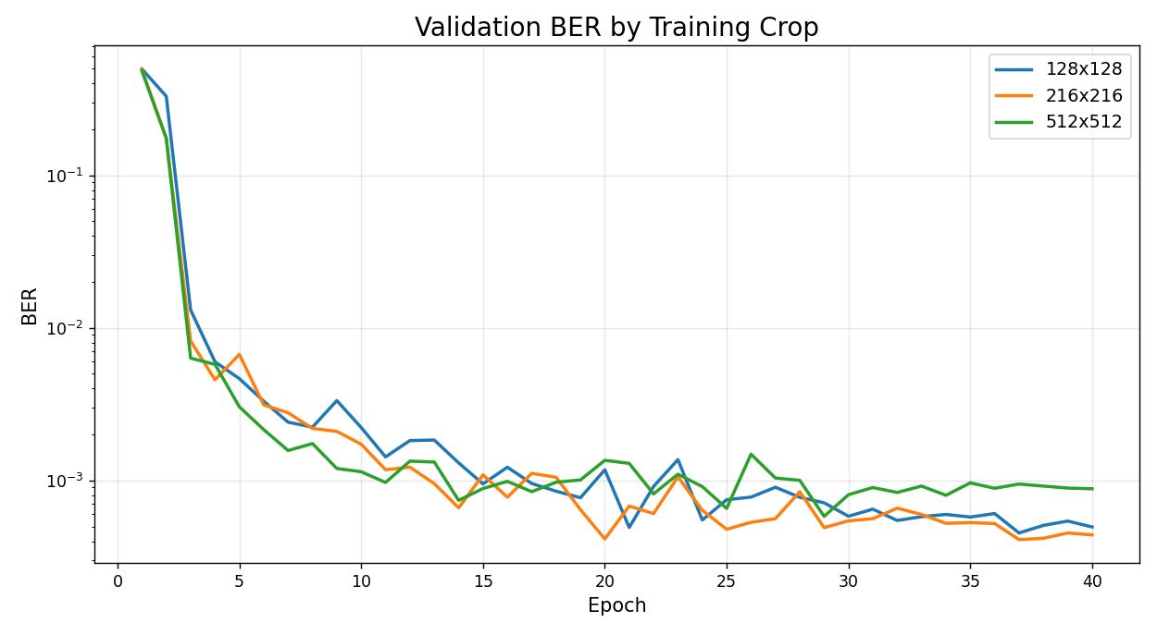
Рис. 1. Валідаційне BER протягом 40 епох для експериментів 128 × 128, 216 × 216 і 512 × 512 з розділенням за джерелами
На валідації візуальна якість демонструвала чіткіший зв’язок із розміром фрагмента. Максимальний PSNR становив 46.53 дБ для 128 × 128 на епосі 36, 47.37 дБ для 216 × 216 на епосі 32 і 48.04 дБ для 512 × 512 на епосі 37. Відповідні максимальні значення SSIM становили 0.9857, 0.9879 і 0.9898. Приріст пікового PSNR від 128 × 128 до 216 × 216 становив 0.84 дБ, а від 216 × 216 до 512 × 512 - ще 0.67 дБ. Таким чином, візуальна якість на валідації покращувалася зі збільшенням фрагмента, хоча відносний виграш поступово зменшувався порівняно зі зростанням обчислювальних витрат.
Валідаційні результати утворюють компроміс між надійністю, візуальною якістю та ефективністю, а не визначають один безумовно кращий розмір фрагмента. Запуск 216 × 216 забезпечив найнижче валідаційне BER, 512 × 512 - найвищі валідаційні PSNR і SSIM, а 128 × 128 досяг майже такої самої надійності, як 216 × 216, за значно нижчої обчислювальної вартості. Фінальний відкладений тест додатково показав, що відносне ранжування за BER може змінюватися на раніше невідомому джерелі.
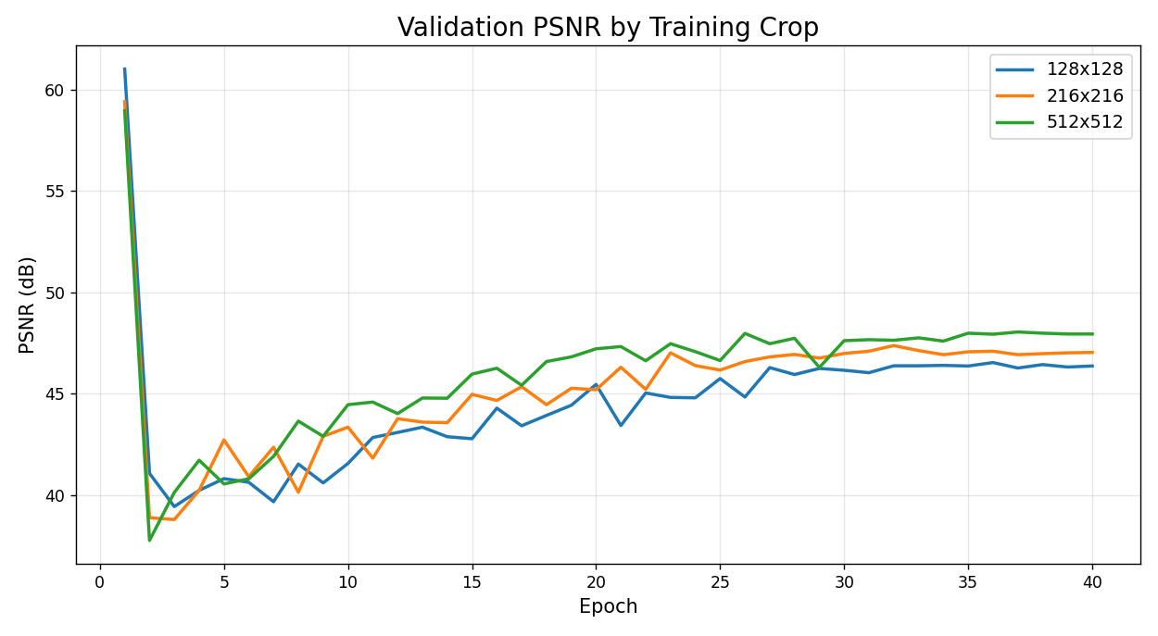Рис. 2. Валідаційний PSNR для фрагментів різного розміру.
На відміну від BER, валідаційна візуальна якість демонструвала послідовніше зростання зі збільшенням навчального фрагмента. Максимальний PSNR становив 46.53, 47.37 і 48.04 дБ для 128 × 128, 216 × 216 і 512 × 512 відповідно. Аналогічну тенденцію показав SSIM, максимальні значення якого становили 0.9857, 0.9879 і 0.9898.
Середній виміряний час епохи становив 61.7 с для 128 × 128, 172.2 с для 216 × 216 і 945.3 с для 512 × 512. Відносно 128 × 128 конфігурація 216 × 216 була повільнішою у 2.79 раза, а 512 × 512 - у 15.33 раза. Відповідні співвідношення площ фрагментів становлять 2.85 і 16.00. Близька відповідність, особливо для найбільшого фрагмента, свідчить, що обчислення просторових згорток домінують у вартості навчання цієї реалізації.
Результати часу виконання змінюють практичну інтерпретацію виграшу у візуальній якості. Перехід від 128 × 128 до 216 × 216 покращує валідаційний PSNR і дещо знижує найкраще валідаційне BER за помірного зростання вартості. Перехід від 216 × 216 до 512 × 512 додає ще 0.67 дБ пікового валідаційного PSNR і 0.0019 SSIM, але збільшує середній час епохи у 5.49 раза та дає гірше найкраще валідаційне BER. Водночас відкладений тест змінює порядок за BER і показує найнижче тестове BER для 512 × 512, що підкреслює необхідність окремо враховувати обчислювальну вартість і узагальнення між джерелами.
Таблиця 3
Порівняння обчислювальних витрат для трьох розмірів фрагмента в одному CPU-середовищі.
Фрагмент | Кількість пікселів | Середній час епохи | Час Відносно 128 | Найкраще відновлення пакета
128 × 128 | 16,384 | 61.7 s | 1.00x | 1.000
216 × 216 | 46,656 | 172.2 s | 2.79x | 1.000
512 × 512 | 262,144 | 945.3 s | 15.33x | 1.000
Після завершення вибору контрольних точок моделі додатково оцінювали на відкладеному джерелі Test-S1, яке не використовувалося під час навчання, валідації або вибору гіперпараметрів. Для кожної моделі використовувався детермінований центральний фрагмент, просторовий розмір якого відповідав розміру фрагмента під час навчання відповідної конфігурації. Для оцінювання BER використовувалася відтворювана послідовність випадкового корисного навантаження з фіксованим початковим значенням генератора. Показник пакетного відновлення додатково оцінювався на всіх 25 зображеннях тестової підмножини.
На всіх 25 тестових зображеннях усі три моделі досягли 100% відновлення пакетів із перевіркою CRC32. Контрольна точка 512 × 512 забезпечила найнижче BER - 0.00010666 - і найвищу побітову точність 0.999893. Для 128 × 128 отримано BER 0.00036386, а для 216 × 216 - 0.00045505. Водночас контрольна точка 216 × 216 забезпечила найвищу тестову візуальну якість: 46.53 дБ PSNR і 0.9890 SSIM. У межах застосованого протоколу відносне ранжування конфігурацій за BER на Test-S1 відрізняється від ранжування на валідаційній підмножині.
Таблиця 4
Результати відкладеного тесту на Test-S1
Фрагмент | Вибірка | BER | Точність бітів | PSNR (дБ) | SSIM | Успішність пакета
128 × 128 | 25 | 3.6386e-4 | 0.999636 | 45.79 | 0.9873 | 1.000
216 × 216 | 25 | 4.5505e-4 | 0.999545 | 46.53 | 0.9890 | 1.000
512 × 512 | 25 | 1.0666e-4 | 0.999893 | 46.14 | 0.9865 | 1.000

Найважливіше емпіричне спостереження полягає в тому, що надійність корисного навантаження є немонотонною відносно розміру навчального фрагмента та залежить від джерела. На валідації конфігурація 216 × 216 досягла найнижчого мінімального BER (0.000410), далі йшла 128 × 128 (0.000453), тоді як для 512 × 512 отримано 0.000582. На відкладеному джерелі Test-S1 порядок змінився: 512 × 512 досяг найнижчого BER (0.00010666), далі 128 × 128 (0.00036386) і 216 × 216 (0.00045505). Ця зміна застерігає від трактування малої різниці валідаційного BER як незалежного від джерела рейтингу розмірів фрагментів.
На валідації візуальна якість поступово покращується зі збільшенням фрагмента: піковий PSNR зростає з 46.53 дБ для 128 × 128 до 47.37 дБ для 216 × 216 і 48.04 дБ для 512 × 512. Проте на відкладеному тестовому джерелі контрольна точка 216 × 216, орієнтована на надійність, забезпечила найвищі PSNR (46.53 дБ) і SSIM (0.9890), тоді як 512 × 512 досягла 46.14 дБ і 0.9865. Отже, валідаційний тренд візуальної якості також не слід трактувати як універсальний і незалежний від джерела порядок.
Масштабування обчислювальних витрат є особливо виразним. Фрагмент 216 × 216 містить у 2.85 раза більше пікселів, ніж 128 × 128, і в середньому потребує у 2.79 раза більше часу на епоху. Фрагмент 512 × 512 містить рівно у 16 разів більше пікселів і потребує у 15.33 раза більше часу на епоху. Ці вимірювання показують, що будь-яку перевагу більших фрагментів у надійності чи якості необхідно оцінювати разом із різким зростанням часу навчання на CPU.
Протокол розділення за джерелами також змінює інтерпретацію валідаційного результату. Валідаційні зображення походять з анімаційних творів, відсутніх у навчальній підмножині, тому високу побітову точність не можна пояснити прямим перетином кадрів із навчальними джерелами. Водночас усі вибрані твори можуть мати спільні широкі доменні ознаки, оскільки належать до анімаційного контенту. Сильніше дослідження узагальнення мало б повторити експеримент для кількох поділів за джерелами та додаткового міждоменного набору зображень.
Успішність відновлення пакета на прикладному рівні досягла 100% значно раніше, ніж глобальне BER досягло мінімуму. Це очікувано, оскільки короткий пакет із CRC-захистом повторюється в межах доступної місткості. Результат практично корисний, але означає, що успішність пакетного відновлення залежить від довжини повідомлення та надлишковості. Тому в майбутніх порівняннях різних корисних навантажень доцільно повідомляти довжину унікального повідомлення та кількість повторів.
Високі PSNR і SSIM не слід описувати як доказ стеганографічної безпеки. Вони вимірюють візуальне спотворення, а не виявлюваність незалежним противником. Спільно навчений патчевий критик є частиною системи оптимізації й не може слугувати незалежним тестом безпеки. Подальше розширення має передбачати навчання або застосування окремого стеганоаналізатора, наприклад SRNet, і тестування як за узгоджених джерел, так і за їх невідповідності.
Контрольований експеримент із випадковим поділом залишається важливим, оскільки дасть змогу ізолювати сам ефект розділення за джерелами. Коректний дизайн полягає у використанні точно тих самих 225 зображень, які нині входять до навчальної та валідаційної вибірок, випадковому поділі на 175 навчальних і 50 валідаційних зображень та збереженні Test-S1 незмінним спільним тестовим джерелом. Архітектура, політика фіксованого початкового значення, кількість епох і правило вибору контрольної точки мають залишатися незмінними. Лише за цих умов різницю можна переважно пов’язати зі стратегією поділу, а не зі зміною складу набору даних.
Якщо контрольований випадковий поділ дасть нижче валідаційне BER, ніж поділ за джерелами, але обидві моделі покажуть подібні результати на спільному відкладеному тесті, різниця переважно відображатиме складність валідаційної вибірки. Якщо ж модель із випадковим поділом також працюватиме гірше на невідомому тестовому джерелі, це буде сильнішим свідченням того, що перетин джерел на рівні кадрів створює оптимістичну оцінку узагальнення. Таким чином, поточна робота формує базовий результат із розділенням за джерелами, необхідний для такого наступного експерименту, не заявляючи ще не виміряного ефекту.
Результат у трьох масштабах радше підтримує поетапну експериментальну стратегію, ніж один постійно бажаний розмір фрагмента. Фрагмент 128 × 128 придатний для швидких експериментів з архітектурою, функціями втрат і реалізацією, оскільки 40 епох виконуються приблизно за 0.69 год за збереження високої надійності на валідації та тесті. Конфігурація 216 × 216 покращує валідаційну візуальну якість за помірної вартості та має найвищі тестові PSNR і SSIM у поточному експерименті. Конфігурація 512 × 512 значно дорожча, але забезпечила найнижче BER на відкладеному джерелі Test-S1. Тому для незалежного від джерела ранжування надійності необхідні додаткові відкладені джерела та повторні запуски з різними фіксованими початковими значення.
Повні 40-епохові траєкторії показують, що пізня валідаційна надійність 128 × 128 і 216 × 216 є стабільною та не залежить від однієї ізольованої епохи. Для 128 × 128 мінімальне BER дорівнює 0.000453 на епосі 37, а фінальна епоха має 0.000496. Для 216 × 216 мінімальне BER дорівнює 0.000410 на епосі 37, а фінальна епоха - 0.000440. В обох випадках сусідні пізні епохи залишаються в тому самому порядку величини. Піки візуальної якості спостерігаються на епосі 36 для 128 × 128 і на епосі 32 для 216 × 216, після чого PSNR залишається близьким до пікових значень.
Запуск 512 × 512 демонструє таке саме розділення цілей, але за вищої обчислювальної вартості. Найнижче BER спостерігається на епосі 29, тоді як найвищі PSNR і SSIM - на епосі 37. До епохи 40 модель залишається близькою до оптимуму візуальної якості, але має вище BER, ніж у контрольній точці надійності. Отже, у всіх трьох запусках найкращі значення реконструкції повідомлення та візуальної якості досягаються на різних епохах.
Для практичного застосування бажана контрольна точка залежить від вимог. Система, що пріоритезує правильне вилучення корисного навантаження, може використовувати контрольну точку надійності за умови, що її візуальна якість перевищує прийнятний поріг. Система, що пріоритезує мінімальне видиме спотворення, може використовувати контрольну точку візуальної якості, якщо BER і відновлення пакетів залишаються прийнятними. У роботі ці цілі не згортаються в єдину зважену оцінку, оскільки така оцінка внесла б довільну прикладну перевагу в експериментальний висновок.
Використання валідації з розділенням за джерелами змінює зміст повідомленої побітової точності понад 99.9%. Валідаційна вибірка містить цілі анімаційні твори, відсутні у навчанні, тому результат відображає перенесення між вибраними виробничими джерелами, а не розпізнавання випадково відкладених кадрів зі знайомих творів. Експеримент не доводить універсального міждоменного узагальнення, але дає сильнішу оцінку, ніж поділ, що змішує папки джерел між підмножинами.
Це розрізнення особливо важливе для наборів, сформованих із кадрів, оскільки ефективний розмір вибірки може бути значно меншим за номінальну кількість зображень. Два кадри з різними часовими мітками можуть мати однакову композицію персонажів, фон, палітру, статистику контурів, денойзинг і конвеєр кодування. Трактування таких кадрів як незалежних спостережень може зробити валідаційну вибірку простішою, ніж випливає з її формального розміру. Групування за джерелами зменшує цю залежність на межі поділу та робить помилки на новому творі більш помітними.
Література з невідповідності джерел контейнерів підсилює цю методичну аргументацію з боку детектора. Дослідження зі стеганоаналізу показують, що невеликі відмінності у способі отримання й оброблення можуть домінувати над слабким статистичним сигналом прихованих даних. Хоча енкодер-декодер розв’язує іншу задачу, він також спирається на залежну від джерела статистику зображень, навчаючись, де й наскільки змінювати пікселі. Тому протокол із урахуванням джерел є обґрунтованим запобіжним заходом для наборів, зібраних із неоднорідних виробничих конвеєрів.
Наступний контрольований експеримент має порівняти випадковий поділ і поділ за джерелами на точно однаковій сукупності з 225 зображень. Таке порівняння є інформативнішим, ніж зіставлення поточних результатів з історичними випадковими поділами, які мали іншу кількість або склад джерел. За спільного відкладеного тестового твору дослідження зможе розділити три ефекти: знайомість валідаційної вибірки, справжнє узагальнення на невідомий твір і можливу різницю в навчанні моделі, спричинену складом навчальної вибірки.
Перше обмеження - кількість груп джерел. Фіксований поділ є відтворюваним, але може відображати специфічну складність вибраних анімаційних творів. Сильніші статистичні докази потребують кількох поділів за джерелами або оцінювання за схемою leave-one-title-out.
Друге обмеження стосується вибору контрольної точки, а не бюджету епох, оскільки всі три запуски завершили однакові 40 епох. Надійність і візуальна якість досягають піків на різних епохах, тому значення лише фінальної епохи не описує багатоцільову поведінку моделі. Порівняння окремо наводить контрольні точки надійності, візуальної якості та фінальної епохи. У майбутньому можна попередньо зареєструвати спільне правило ранньої зупинки, щоб зменшити обчислювальні витрати за збереження узгодженої процедури вибору.
Третє обмеження - стохастичність валідаційного корисного навантаження. Випадкова генерація бітів є доречною для навчання, однак для порівняння моделей у публікації варто використовувати детерміноване валідаційне навантаження, наприклад фіксоване початкове значення або попередньо згенероване навантаження для кожного зображення. Це зменшує шум у малих відмінностях між контрольними точками.
Четверте обмеження пов’язане з оцінюванням на фрагментах. Детерміновані центральні фрагменти є відтворюваними, але не представляють усі області кадру. Відкладений тест Test-S1 використовує ту саму політику детермінованого кадрування для узгодженості з валідацією. Оскільки модель повністю згорткова, у майбутньому варто додати оцінювання на кількох фрагментах і в повній роздільній здатності, щоб перевірити, чи зберігається спостережене ранжування для різних просторових областей і розмірів зображень.
П’яте обмеження стосується критеріїв вибору моделі. Надійність і візуальна якість досягають максимумів на різних епохах. Тому критерій вибору контрольної точки має бути визначений заздалегідь, а тестова вибірка не повинна використовуватися для вибору між контрольними точками. У цій роботі окремо наведено контрольні точки надійності та візуальної якості, щоб не зводити кілька цілей до довільної єдиної оцінки.
Для відтворюваного фінального оцінювання каталог набору даних після розподілу за джерелами має залишатися незмінним; кожен запуск повинен зберігати повну конфігурацію та метрики всіх епох; валідаційні корисні навантаження мають бути детермінованими; контрольні точки повинні містити номер епохи та критерій вибору; тестове оцінювання слід виконувати лише після завершення вибору моделі. Ці кроки прості, але важливі, оскільки числові відмінності між сильними контрольними точками є малими.
У відкладеному тесті для кожного розміру фрагмента використано контрольну точку, орієнтовану на надійність і вибрану за валідаційними даними до перегляду тестового джерела. Однакове правило вибору застосовано до моделей 128 × 128, 216 × 216 і 512 × 512. Це запобігає вибору контрольної точки на основі тестових даних. У майбутніх дослідженнях доцільно додатково оцінювати контрольні точки, орієнтовані на візуальну якість, якщо прикладне використання потребує іншого компромісу між надійністю відновлення та якістю зображення.
Дискусія і висновки
У роботі оцінено повністю згорткову систему нейронної стеганографії за протоколом розділення за джерелами та порівняно навчальні фрагменти 128 × 128, 216 × 216 і 512 × 512. Цілі анімаційні твори були розділені між навчальною, валідаційною та тестовою підмножинами, що зменшує ризик появи сильно корельованих кадрів з одного джерела по обидва боки межі оцінювання.
На валідації конфігурація 216 × 216 досягла найнижчого спостереженого BER 0.000410, тоді як 128 × 128 отримала 0.000453, а 512 × 512 - 0.000582. Пікова валідаційна візуальна якість зростала зі збільшенням фрагмента та для 512 × 512 досягла 48.04 дБ PSNR і 0.9898 SSIM. Середній час епохи збільшився з 61.7 с для 128 × 128 до 172.2 с для 216 × 216 і 945.3 с для 512 × 512. На незадіяному тестовому джерелі Test-S1 із 25 зображень усі три контрольні точки надійності забезпечили 100% відновлення пакетів. Тестове BER становило 0.00036386 для 128 × 128, 0.00045505 для 216 × 216 і 0.00010666 для 512 × 512. Модель 216 × 216 забезпечила найвищу відкладену візуальну якість - 46.53 дБ PSNR та 0.9890 SSIM.
Обчислювальна вартість різко зростає з площею фрагмента, тоді як ранжування розмірів фрагментів не є стабільним між валідаційними та відкладеними джерелами. Тому результати підтримують спільне подання надійності, візуальної якості та часу виконання замість визначення універсально найкращого розміру фрагмента за одним валідаційним поділом.
Подальша робота має включати контрольований випадковий поділ на рівні зображень з використанням тієї самої сукупності даних, додаткові відкладені анімаційні твори, кілька детермінованих фіксованих початкових значень тестового корисного навантаження, оцінювання на кількох фрагментах і в повній роздільній здатності, повторне навчання з різними фіксованими початковими значеннями та незалежний стеганоаналіз. Це дасть змогу встановити, чи є спостережені зміни ранжування між джерелами відтворюваними та чи супроводжується висока візуальна якість стійкістю до виявлення.

Декларація щодо використання генеративного штучного інтелекту
Під час підготовки рукопису генеративні інструменти штучного інтелекту використовувалися для мовного редагування, структурного доопрацювання та допомоги у формулюванні окремих частин тексту. Усі матеріали, створені за допомогою ШІ, були перевірені авторами, які несуть повну відповідальність за остаточний текст, зокрема за достовірність наведених результатів і коректність посилань.
Список використаних джерел
Boroumand, M., Chen, M., & Fridrich, J. (2019). Deep residual network for steganalysis of digital images. IEEE Transactions on Information Forensics and Security, 14(5), 1181-1193. https://doi.org/10.1109/TIFS.2018.2871749
Giboulot, Q., Cogranne, R., Borghys, D., & Bas, P. (2020). Effects and solutions of Cover-Source Mismatch in image steganalysis. Signal Processing: Image Communication, 86, 115888. https://doi.org/10.1016/j.image.2020.115888
Lu, S.-P., Wang, R., Zhong, T., & Rosin, P. L. (2021). Large-capacity image steganography based on invertible neural networks. Proceedings of the IEEE/CVF Conference on Computer Vision and Pattern Recognition, 10816-10825. https://doi.org/10.1109/CVPR46437.2021.01067
Mallet, A., Benes, M., & Cogranne, R. (2024). Cover-source mismatch in steganalysis: Systematic review. EURASIP Journal on Information Security. https://doi.org/10.1186/s13635-024-00171-6
Tancik, M., Mildenhall, B., & Ng, R. (2020). StegaStamp: Invisible hyperlinks in physical photographs. Proceedings of the IEEE/CVF Conference on Computer Vision and Pattern Recognition, 2117-2126. https://doi.org/10.1109/CVPR42600.2020.00219
Yu, L., Weng, S., Chen, M., & Wei, Y. (2024a). RCDD: Contrastive domain discrepancy with reliable steganalysis labeling for cover source mismatch. Expert Systems with Applications, 237, 121543. https://doi.org/10.1016/j.eswa.2023.121543
Yu, L., Zhang, Z., Weng, S., Cao, P., & Cao, G. (2024b). A deep steganalysis network combining source-supervised and target-unsupervised information for cover-source mismatch. Expert Systems with Applications, 255, 124790. https://doi.org/10.1016/j.eswa.2024.124790
Zhang, C., Benz, P., Karjauv, A., Sun, G., & Kweon, I. S. (2020). UDH: Universal deep hiding for steganography, watermarking, and light field messaging. Advances in Neural Information Processing Systems, 33.
Zhang, K. A., Cuesta-Infante, A., Xu, L., & Veeramachaneni, K. (2019). SteganoGAN: High capacity image steganography with GANs. arXiv:1901.03892. https://doi.org/10.48550/arXiv.1901.03892
Zhu, J., Kaplan, R., Johnson, J., & Fei-Fei, L. (2018). HiDDeN: Hiding data with deep networks. Proceedings of the European Conference on Computer Vision, 657-672. https://doi.org/10.1007/978-3-030-01267-0_40

References
Boroumand, M., Chen, M., & Fridrich, J. (2019). Deep residual network for steganalysis of digital images. IEEE Transactions on Information Forensics and Security, 14(5), 1181–1193. https://doi.org/10.1109/TIFS.2018.2871749.
Giboulot, Q., Cogranne, R., Borghys, D., & Bas, P. (2020). Effects and solutions of cover-source mismatch in image steganalysis. Signal Processing: Image Communication, 86, 115888. https://doi.org/10.1016/j.image.2020.115888.
Lu, S.-P., Wang, R., Zhong, T., & Rosin, P. L. (2021). Large-capacity image steganography based on invertible neural networks. Proceedings of the IEEE/CVF Conference on Computer Vision and Pattern Recognition, 10816–10825. https://doi.org/10.1109/CVPR46437.2021.01067.
Mallet, A., Benes, M., & Cogranne, R. (2024). Cover-source mismatch in steganalysis: Systematic review. EURASIP Journal on Information Security. https://doi.org/10.1186/s13635-024-00171-6.
Tancik, M., Mildenhall, B., & Ng, R. (2020). StegaStamp: Invisible hyperlinks in physical photographs. Proceedings of the IEEE/CVF Conference on Computer Vision and Pattern Recognition, 2117–2126. https://doi.org/10.1109/CVPR42600.2020.00219.
Yu, L., Weng, S., Chen, M., & Wei, Y. (2024a). RCDD: Contrastive domain discrepancy with reliable steganalysis labeling for cover source mismatch. Expert Systems with Applications, 237, 121543. https://doi.org/10.1016/j.eswa.2023.121543.
Yu, L., Zhang, Z., Weng, S., Cao, P., & Cao, G. (2024b). A deep steganalysis network combining source-supervised and target-unsupervised information for cover-source mismatch. Expert Systems with Applications, 255, 124790. https://doi.org/10.1016/j.eswa.2024.124790.
Zhang, C., Benz, P., Karjauv, A., Sun, G., & Kweon, I. S. (2020). UDH: Universal deep hiding for steganography, watermarking, and light field messaging. Advances in Neural Information Processing Systems, 33.
Zhang, K. A., Cuesta-Infante, A., Xu, L., & Veeramachaneni, K. (2019). SteganoGAN: High capacity image steganography with GANs. arXiv. https://doi.org/10.48550/arXiv.1901.03892.
Zhu, J., Kaplan, R., Johnson, J., & Fei-Fei, L. (2018). HiDDeN: Hiding data with deep networks. Proceedings of the European Conference on Computer Vision, 657–672. https://doi.org/10.1007/978-3-030-01267-0_40.

Ihor RUDKO, Student
ORCID ID: 0009-0004-1284-1007
e-mail: ihor.rudko@proton.me
Odesa Polytechnic National University
Odesa, Ukraine

Oleksii STOPAKEVYCH, PhD (Tech.)
ORCID ID: 0000-0002-8318-6853
e-mail: stopakevich@op.edu.ua
Odesa Polytechnic National University
Odesa, Ukraine

EVALUATION OF NEURAL STEGANOGRAPHY WITH SOURCE-AWARE DATA SPLITTING ACROSS TRAINING PATCH SIZES
The article presents an approach to evaluating neural image steganography using a source-aware dataset split. Models trained on patches of different sizes are compared in terms of payload recovery reliability, visual quality, and computational efficiency. Additional testing is performed on a held-out source that was not used during training or validation. The results show that the relative ranking of the configurations by BER differs between the validation and held-out test subsets, while increasing the training patch size is accompanied by a substantial increase in computational cost.

Keywords: neural steganography, deep learning, source-aware splitting, cover-source mismatch, image data hiding, BER, PSNR, generalization.

Автори заявляють про відсутність конфлікту інтересів. Спонсори не брали участі в розробленні дослідження; у зборі, аналізі чи інтерпретації даних; у написанні рукопису; в рішенні про публікацію результатів.
The authors declare no conflicts of interest. The funders had no role in the design of the study; in the collection, analyses, or interpretation of data; in the writing of the manuscript; or in the decision to publish the results.

УДК 621.391:004.72
Дмитро ЧЕБОТАРЬОВ, асп.
ORCID ID: 0009-0006-7738-8199
e-mail: chebotarov.dmytro_tss51f@edu.kpi.ua
Національний технічний університет України
«Київський політехнічний інститут
імені Ігоря Сікорського», Київ, Україна

Анатолій МАКАРЕНКО, д.т.н., проф.
ORCID id: 0000-0002-4081-328X
e-mail: makarenko.anatolii@edu.kpi.ua
Національний технічний університет України
«Київський політехнічний інститут
імені Ігоря Сікорського», Київ, Україна

ПРЕДИКТИВНА ОПТИМІЗАЦІЯ МАРШРУТИЗАЦІЇ В ІНФОКОМУНІКАЦІЙНИХ МЕРЕЖАХ IOT НА ОСНОВІ ЦИФРОВИХ ДВІЙНИКІВ

Стрімкий розвиток систем Інтернету речей (IoT) вимагає вдосконалення протоколів маршрутизації для забезпечення енергоефективності та надійності безпроводових сенсорних мереж. Традиційні алгоритми кластеризації та багатокрокової маршрутизації переважно застосовують реактивні підходи до оновлення топології, що призводить до затримок, втрати пакетів даних та значних витрат енергії на передачу службового трафіку при розриві з'єднань. У даній роботі запропоновано новий метод предиктивної оптимізації маршрутизації за рахунок інтеграції технології цифрових двійників (Digital Twins) на рівні периферійних (Edge) обчислень. Для реалізації методу застосовано динамічну модель зважених графів.
Цифровий двійник створює динамічну віртуальну модель фізичної IoT-мережі, яка в режимі реального часу агрегує телеметричні дані вузлів (рівень заряду, якість каналу). Замість реактивної перебудови, віртуальна модель дозволяє розраховувати предиктивні зміни ваг ребер графа на основі математичної екстраполяції швидкості деградації вузлів. Для оцінки запропонованого алгоритму було розроблено симуляційну модель з використанням Python та MATLAB. Результати моделювання демонструють, що превентивне перенаправлення трафіку в обхід виснажених вузлів дозволяє збалансувати енергетичне навантаження, збільшити час до відмови першого вузла (FND) та суттєво знизити накладні витрати на керуючий трафік порівняно з класичними протоколами сімейства LEACH.

Ключові слова: Інтернет речей, маршрутизація, зважені графи, цифровий двійник, предиктивна оптимізація, енергоефективність.

Вступ
Стрімкий розвиток концепцій «розумного міста», Індустрії 4.0 та автоматизованого моніторингу навколишнього середовища зумовив безпрецедентне зростання масштабів впровадження автономних систем Інтернету речей (IoT). В основі таких інфокомунікаційних інфраструктур лежать безпроводові сенсорні мережі (WSN), які складаються з великої кількості географічно розподілених мікроконтролерних вузлів. Зважаючи на те, що більшість кінцевих пристроїв живляться від автономних джерел з обмеженою ємністю батарей і часто функціонують у важкодоступних місцях, питання забезпечення їхньої енергоефективності та максимізації загального життєвого циклу мережі залишається одним із найголовніших викликів сучасної телекомунікаційної інженерії.
Ефективне управління інформаційними потоками в таких системах традиційно вирішується за допомогою багатокрокової маршрутизації та кластеризації. Математичне моделювання мережевої топології найчастіше спирається на теорію зважених графів, де вершинами є IoT-вузли, а ваги ребер відображають функціональні метрики лінків: відстань, якість сигналу (RSSI) або залишкову енергію. Хоча існуючі протоколи, зокрема алгоритми сімейства LEACH (Low-Energy Adaptive Clustering Hierarchy) та їх сучасні модифікації, демонструють хороші результати у балансуванні навантаження, їм притаманний суттєвий концептуальний недолік — реактивний підхід до управління топологією.
У класичних моделях маршрутизації мережа реагує на зміни після того, як подія вже відбулася: вузол вичерпав заряд батареї, або лінк деградував через зовнішні завади. Така реактивна перебудова маршрутів ініціює лавиноподібний обмін службовими повідомленнями для оновлення таблиць маршрутизації. Це призводить до різкого зростання накладних витрат (control overhead), втрати пакетів даних, які транслювалися в момент розриву з'єднання, та нераціональної витрати залишкової енергії сусідніх вузлів.
Усунення цих недоліків вимагає переходу від реактивної до предиктивної (прогнозуючої) моделі управління маршрутами. Одним із найбільш перспективних інструментів для реалізації такого підходу є концепція цифрових двійників (Digital Twins) — створення динамічної віртуальної копії фізичної мережі. Інтеграція цифрового двійника на рівні периферійних (Edge) обчислень або шлюзу дозволяє в режимі реального часу агрегувати телеметрію з IoT-пристроїв та здійснювати математичну екстраполяцію їхнього стану. Завдяки цьому система здатна завчасно прогнозувати час відмови критичних вузлів (Time-to-Death).
Використання прогнозних даних цифрового двійника дозволяє динамічно та превентивно змінювати ваги ребер у графовій моделі маршрутизації. Трафік поступово перенаправляється в обхід слабшаючих вузлів ще до їхнього фактичного відключення, що забезпечує безперебійність інформаційних потоків та виключає необхідність екстреної перебудови кластерів.
Метою даної роботи є розробка та дослідження ефективності методу предиктивної оптимізації маршрутизації в інфокомунікаційних мережах IoT на основі технології цифрових двійників, що використовує теорію зважених графів для зниження накладних енергетичних витрат шляхом інтеграції технології цифрових двійників, що дозволить знизити накладні енергетичні витрати на керуючий трафік та підвищити загальну надійність доставки даних.
Аналіз літератури та теоретичне підґрунтя
Проблема оптимізації маршрутизації в інфокомунікаційних мережах Інтернету речей (IoT) залишається одним із ключових викликів через обмеженість енергетичних та обчислювальних ресурсів сенсорних вузлів. Класичним підходом до вирішення цього завдання є використання протоколів ієрархічної кластеризації, найбільш відомим з яких є LEACH (Low-Energy Adaptive Clustering Hierarchy). У попередніх дослідженнях авторів (Makarenko & Chebotarov, 2026) було розроблено алгоритм LEACH-PDT для багатокрокової маршрутизації на основі зважених графів. Ваги ребер у даній моделі враховували залишкову енергію вузлів та відстань, що дозволило покращити балансування навантаження. Подальший розвиток цього напрямку (Makarenko, Trofimtsov, & Chebotarov, 2026) підтвердив доцільність використання високошвидкісної локальної обробки даних (edge-обчислень) для управління автономними мобільними IoT-роями. Проте, незважаючи на ефективність графових моделей, їхнім спільним недоліком залишається реактивний характер оновлення топології: перебудова маршрутів відбувається лише після вичерпання енергії вузла або деградації каналу зв'язку.
Аналіз останніх публікацій свідчить про активний пошук рішень для подолання проблеми реактивності. Так, у роботі Qiu (2021) запропоновано покращений алгоритм розбиття цільової мережі на основі протоколу LEACH для моніторингу систем збору даних, однак він все ще передбачає значні накладні витрати на керуючий трафік при відключенні кластерних головних вузлів. Для вирішення проблеми надмірного енергоспоживання під час реконфігурації мережі, дослідники дедалі частіше звертаються до концепції цифрових двійників (Digital Twins – DT).
Як зазначають Fuller et al. (2020), цифровий двійник є динамічною віртуальною копією фізичного об'єкта чи системи, що дозволяє в режимі реального часу відстежувати її стан, моделювати поведінку та прогнозувати майбутні події. У контексті телекомунікацій, Sun et al. (2020) успішно продемонстрували використання DT для адаптивної маршрутизації в IoT-мережах на базі 5G, де віртуальна модель розраховувала оптимальні маршрути, розвантажуючи фізичні кінцеві пристрої від складних обчислень.
Особливу увагу дослідників привертає інтеграція цифрових двійників з edge-технологіями. Vashi et al. (2022) запропонували архітектуру, де цифровий двійник розгортається на рівні периферійних обчислювальних вузлів (Edge computing), що дозволяє знизити затримки доставки даних і здійснювати енергоефективну маршрутизацію у безпроводових сенсорних мережах (WSN). Подібний підхід до мінімізації наскрізних затримок (end-to-end delay) за допомогою DT-моделювання описано в роботі Al-Kaseem, Al-Dunainawi та Al-Raweshidy (2021).
Впровадження прогнозних (предиктивних) механізмів на базі цифрових двійників досліджувалося в роботах Barricella та Belli (2023) для розумного виробництва, а також Darbali-Zamora et al. (2021) для оптимізації розподіленої маршрутизації. Автори доводять, що використання телеметричних даних для оцінки стану мережі дозволяє передбачати відмову вузлів і заздалегідь перенаправляти інформаційні потоки. Аналогічний підхід до формування зважених графових представлень (Weighted Graph Representations) задля предиктивної оптимізації запропонували Zhao, Chen та Jiang (2024), інтегрувавши його в інфраструктуру розумних електромереж (Smart Grids).
Однак, незважаючи на наявність ґрунтовної теоретичної бази, відкритим залишається питання математичної інтеграції моделей екстраполяції стану батареї IoT-вузлів (визначення параметра Time-to-Death) безпосередньо у процес перерахунку ваг ребер графа для багатокрокових протоколів типу LEACH. Існуючі рішення часто вимагають складних моделей машинного навчання, що складно реалізувати на бюджетних edge-шлюзах. Тому розробка легкої предиктивної математичної моделі, що дозволить цифровому двійнику завчасно, без втрати пакетів і з мінімальним керуючим трафіком оновлювати графову топологію мережі, є актуальним науковим завданням, якому присвячено дане дослідження.
Архітектура предиктивної системи маршрутизації
Запропонована архітектура базується на парадигмі перенесення ресурсомістких обчислень, пов'язаних із підтримкою графової моделі мережі та розрахунком маршрутів, з кінцевих енергообмежених пристроїв на рівень периферійних шлюзів. Це дозволяє реалізувати повноцінного Цифрового двійника без перевантаження фізичних сенсорів. Система має чітко виражену дворівневу структуру, що складається з фізичного рівня та віртуального рівня управління.
Фізичний рівень IoT-мережі
Фізичний рівень формується з множини гетерогенних сенсорних пристроїв (наприклад, на базі мікроконтролерів архітектури ESP32), які виконують завдання збору параметрів навколишнього середовища. Вузли об'єднуються у кластери згідно з принципами протоколів сімейства LEACH.
Відмінність запропонованої фізичної моделі полягає у структурі пакета даних. Окрім корисного навантаження (payload), кожен пристрій інкапсулює у пакет легку телеметрію:
- поточний рівень залишкової енергії ($E_{res}$);
- показник потужності отриманого сигналу (RSSI) для оцінки якості радіоканалу з сусідніми вузлами.
Важливою умовою є те, що фізичні пристрої не здійснюють складних перерахунків топології. Вони працюють за локально-детермінованим принципом, виконуючи лише вказівки щодо маршрутизації, які надходять від кластерного головного вузла (Cluster Head, CH) або безпосередньо від Edge-шлюзу.
Рівень периферійних обчислень та Цифрового двійника
На рівні Edge-сервера, який має стабільне живлення та високу обчислювальну потужність, розгортається Цифровий двійник мережі. Його архітектура складається з чотирьох взаємопов'язаних модулів:
- Модуль агрегації телеметрії (Telemetry Ingestion Module): Здійснює безперервний збір та фільтрацію телеметричних даних від CH-вузлів. Для усунення аномальних викидів (шумів вимірювання RSSI) модуль застосовує експоненційне згладжування.
- Модуль екстраполяції стану (State Extrapolation Module): Є ядром предиктивної системи. На основі динаміки падіння $E_{res}$ цей модуль обчислює швидкість розряджання кожного вузла і формує прогнозну метрику Time-to-Death (TTD) — очікуваний час до повної відмови пристрою.
- Модуль графової оптимізації (Graph Optimization Module): Підтримує в оперативній пам'яті сервера динамічний зважений граф $G\left(V,E\right)$, де $V$ — віртуальні репрезентації IoT-вузлів, а $E$ — радіолінки між ними. Ваги ребер перераховуються безперервно з урахуванням поточного TTD.
- Контролер маршрутизації (Routing Controller): Якщо модуль графової оптимізації фіксує, що вага певного маршруту наближається до критичної межі (вузол скоро вийде з ладу), контролер генерує нові таблиці маршрутизації.
Механізм превентивної синхронізації
Класична (реактивна) маршрутизація ініціює лавиноподібне розсилання керуючих пакетів керування (control overhead) після того, як вузол перестав відповідати. У запропонованій архітектурі діє превентивний (проактивний) механізм.
Цифровий двійник, передбачивши швидке виснаження вузла $N_{i}$, завчасно збільшує вагу суміжних з ним ребер у віртуальному графі. Алгоритм Дейкстри або Беллмана-Форда (реалізований на Edge-сервері) знаходить новий оптимальний шлях, що оминає вузол $N_{i}$. Після цього шлюз надсилає компактне unicast-повідомлення відповідним пристроям для оновлення їхніх маршрутних таблиць. Таким чином, інформаційні потоки плавно перенаправляються, а вузол $N_{i}$ продовжує працювати в режимі енергозбереження, надсилаючи лише власні сенсорні дані без транзитного навантаження.
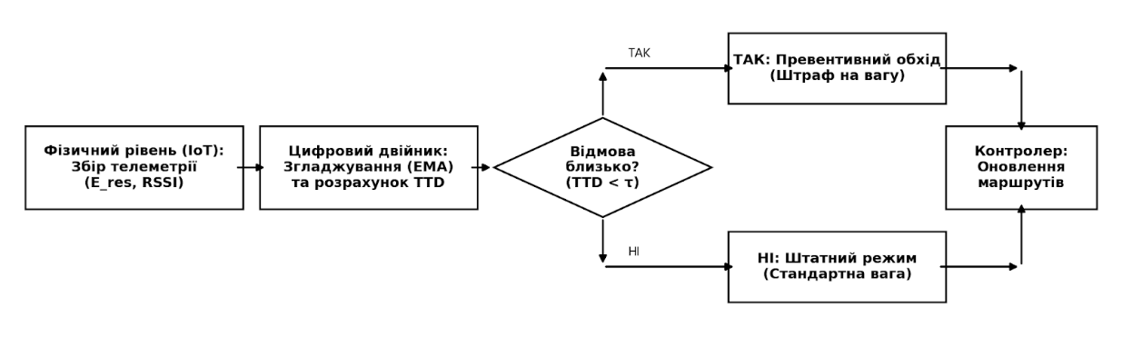
Рис. 1. Дворівнева архітектура предиктивної системи маршрутизації: взаємодія фізичних IoT-кластерів та Цифрового двійника на Edge-шлюзі.

Завдяки розділенню площини даних (Data Plane на фізичних вузлах) та площини управління (Control Plane у Цифровому двійнику), система досягає високої гнучкості та мінімізує нецільове використання енергії сенсорами.
Математична графова модель
Основою функціонування предиктивної системи є динамічне відображення фізичної топології мережі у віртуальному просторі Цифрового двійника. Це відображення формалізується у вигляді орієнтованого зваженого графа, залежного від часу: $G\left(V,E,W,T\right)$, де $V=\left\{v_{1},v_{2},...,v_{N}\right\}$ — множина віртуальних моделей сенсорних вузлів, $E=\left\{e_{ij}\right\}$ — множина радіоканалів (лінків) між вузлом $i$ та вузлом $j$, $W=\left\{w_{ij}\left(t\right)\right\}$ — множина ваг ребер у дискретний момент часу $t∈T$.
Мета математичної моделі полягає у такому динамічному перерахунку ваги ребра $w_{ij}\left(t\right)$, щоб маршрутизація (наприклад, за допомогою модифікованого алгоритму Дейкстри) автоматично уникала вузлів, які наближаються до енергетичного виснаження, ще до того, як вони вийдуть з ладу.
Екстраполяція стану та прогнозування TTD
Цифровий двійник на Edge-сервері безперервно отримує дані про залишкову енергію $E_{res}^{i}\left(t\right)$ від кожного вузла $v_{i}$. Оскільки енергоспоживання у сенсорних мережах не є лінійним і залежить від обсягу транзитного трафіку, швидкість розряджання вузла $ΔE_{i}\left(t\right)$ у поточний інтервал часу $Δt$ визначається як:
$$ΔE_{i}\left(t\right)=\frac{E_{res}^{i}\left(t-Δt\right)-E_{res}^{i}\left(t\right)}{Δt}$$
Для згладжування імпульсних стрибків енергоспоживання (наприклад, при разовій передачі великого пакета даних) Цифровий двійник застосовує метод експоненційного ковзного середнього (EMA) для обчислення усередненого темпу розряджання $R_{i}\left(t\right)$:
$$R_{i}\left(t\right)=α⋅ΔE_{i}\left(t\right)+\left(1-α\right)⋅R_{i}\left(t-1\right)$$
де $α∈\left(0,1\right)$ — коефіцієнт згладжування, що визначає чутливість моделі до останніх змін. На основі цього показника Цифровий двійник розраховує предиктивну метрику Time-to-Death ($TTD$) — очікуваний час до повної зупинки вузла:
$$TTD_{i}\left(t\right)=\frac{E_{res}^{i}\left(t\right)}{R_{i}\left(t\right)}$$
Функція ваги ребра графа
У класичних алгоритмах, таких як оригінальний LEACH, вага лінку зазвичай залежить лише від квадрата або четвертого ступеня відстані $d_{ij}$ (згідно з моделлю вільного простору або багатопроменевого поширення радіосигналу). У запропонованій предиктивній моделі вага ребра $w_{ij}\left(t\right)$, що описує перехід від вузла $i$ до вузла $j$, обчислюється як багатофакторна функція:
$$w_{ij}\left(t\right)=β_{1}⋅E_{tx}\left(d_{ij}\right)+β_{2}⋅\left(\frac{E_{max}}{E_{res}^{j}\left(t\right)}\right)+β_{3}⋅P\left(TTD_{j}\left(t\right)\right)$$
де:
- $E_{tx}\left(d_{ij}\right)$ — енергетичні витрати на передачу даних на відстань $d_{ij}$;
- $E_{max}$ — початкова (максимальна) ємність батареї;
- $β_{1},β_{2},β_{3}$ — вагові коефіцієнти, що нормують вплив кожної складової ($β_{1}+β_{2}+β_{3}=1$).
Ключовим елементом моделі є штрафна експоненціальна функція $P\left(TTD\right)$, яка реалізує механізм превентивного обходу. Її завдання — різко збільшити загальну вагу маршруту, якщо транзитний вузол $j$ має критично малий запас часу роботи:
$$P\left(TTD_{j}\right)=e^{\left(\frac{τ}{TTD_{j}\left(t\right)+ϵ}\right)}$$
де $τ$ — порогове значення часу (наприклад, оціночний час, необхідний для стабільного проведення наступного циклу збору даних), а $ϵ$ — нескінченно мала константа для уникнення ділення на нуль.
Превентивна реконфігурація
Поки $TTD_{j}\left(t\right)≫τ$, значення штрафної функції наближається до одиниці і майже не впливає на вагу ребра. Однак, коли час життя вузла $j$ падає до критичного рівня $τ$, значення $P\left(TTD_{j}\right)$ експоненціально зростає.
Це призводить до того, що на рівні Цифрового двійника вага ребра $w_{ij}\left(t\right)$ стає штучно завищеною. Edge-сервер, виконуючи періодичний перерахунок найкоротших шляхів, знаходить альтернативні маршрути, оскільки шлях через вузол $j$ стає «математично невигідним» для алгоритму. Трафік автоматично перенаправляється на інші вузли кластера ще до того, як вузол $j$ фактично вичерпає енергію $E_{res}^{j}\left(t\right)=0$. Це дозволяє вузлу $j$ залишити залишок заряду виключно для власних сенсорних потреб, перейшовши у статус кінцевого пристрою, та уникає втрати транзитних пакетів.
Методологія та налаштування симуляції
Для об'єктивної оцінки ефективності запропонованої архітектури було розроблено ко-симуляційне середовище на базі Python та MATLAB. Програмна модель імітує фізичний рівень сенсорної мережі (Data Plane) та обчислювальні процеси Цифрового двійника на рівні Edge-сервера (Control Plane).
Модель енергоспоживання та геометрія мережі
У дослідженні використано стандартну енергетичну модель радіотракту першого порядку (First Order Radio Model). Для виключення парадоксу «вигідності однокрокової передачі» геометрію мережі було масштабовано так, щоб змусити алгоритм маршрутизації стикатися з втратами багатопроменевого поширення сигналу ($d^{4}$). Базова станція (Edge-сервер) винесена за межі полігону збору даних. Витрати енергії передавача обчислюються як:
$$E_{TX}\left(l,d\right)=\left\{\begin{matrix}l⋅E_{elec}+l⋅ϵ_{fs}⋅d^{2}, & \text{якщо }d<d_{0} \\ l⋅E_{elec}+l⋅ϵ_{mp}⋅d^{4}, & \text{якщо }d≥d_{0}\end{matrix}\right.$$
Основні параметри симуляції: розмір полігону — $200×200$ м; координати шлюзу — $\left(100,250\right)$; кількість вузлів — $60$; початкова енергія вузла — $0.5$ Дж; максимальний радіус кластеризації ($R_{max}$) — $100$ м; $E_{elec}=50$ нДж/біт, $ϵ_{fs}=10$ пДж/біт/м$^2$, $ϵ_{mp}=0.0013$ пДж/біт/м$^4$, розмір пакета — $4000$ біт.
Сценарії стрес-тестування предиктивної моделі
Класичне моделювання в ідеальних статичних умовах не здатне продемонструвати переваги предиктивного управління. Тому порівняльний аналіз протоколів (Classic LEACH, LEACH-PDT та запропонованого DT-Predictive) проводився за п'ятьма сценаріями, що імітують реальні умови експлуатації автономних IoT-роїв:
- Нерівномірний трафік (Аномалії): Моделювання ситуації, коли $15\%$ вузлів знаходяться в зоні виявлення інциденту і генерують у 5 разів більше трафіку. Сценарій перевіряє здатність Цифрового двійника фіксувати локальні сплески розряджання та превентивно відводити транзитний трафік від навантажених сенсорів.
- Гетерогенна початкова енергія: Імітація деградації акумуляторів, де початковий заряд вузлів розподілено випадковим чином у діапазоні $\left[0.2,1.0\right]$ Дж.
- Мобільність вузлів (Модель автономного рою): Вузли здійснюють випадкові стохастичні зміщення (Random Waypoint), що спричиняє безперервні коливання витрат енергії на радіотрансляцію. Сценарій оцінює ефективність високошвидкісного перерахунку графа на Edge-сервері.
- Штрафи за керуючий трафік (Control Overhead): Введення енергетичних санкцій за реконфігурацію топології. У разі відмирання транзитного вузла (розриву лінку) сусідні вузли витрачають додаткову енергію на обмін службовими повідомленнями. Це ключовий тест для превентивного обходу (TTD-моделі).
- Аналіз чутливості прогнозування: Тестування виключно протоколу DT-Predictive за різних значень порогу агресивності штрафної функції $τ∈\left\{10,25,40\right\}$ для пошуку математичного оптимуму, що максимізує метрику First Node Dies (FND).
Енергоефективність
Для оцінки енергетичної ефективності запропонованого алгоритму предиктивної оптимізації (DT-Predictive) було проведено серію порівняльних симуляцій із класичним протоколом (Classic LEACH) та протоколом із маршрутизацією на основі залишкового заряду (LEACH-PDT). Головним критерієм оцінки виступав життєвий цикл мережі, який традиційно вимірюється метриками FND (First Node Dies — смерть першого вузла) та характером деградації мережі до моменту HND (Half Nodes Die — смерть половини вузлів).
Стійкість до нерівномірного навантаження та аномалій
У класичних сенсорних мережах трафік рідко буває ідеально рівномірним. У Сценарії 1 було змодельовано ситуацію, коли частина вузлів (15% мережі) генерує у 5 разів більше трафіку через виявлення локальної аномалії. Результати моделювання (Рис. 2) демонструють фундаментальну вразливість реактивних протоколів: і Classic LEACH, і LEACH-PDT продовжували використовувати ці вузли як транзитні, спираючись виключно на їхню поточну залишкову енергію. Це призвело до швидкого локального виснаження та раннього розриву лінків (FND = 148 та 150 раундів відповідно).
Натомість Цифровий двійник, використовуючи експоненційне ковзне середнє (EMA) для розрахунку параметра швидкості розряджання, своєчасно зафіксував стрімку деградацію цих вузлів. Алгоритм завчасно наклав експоненціальний штраф на відповідні ребра графа, відвівши від них транзитний трафік. Це дозволило збільшити час до першої відмови (FND = 155) та зберегти зв'язність проблемного сегмента на 15–20% довше.
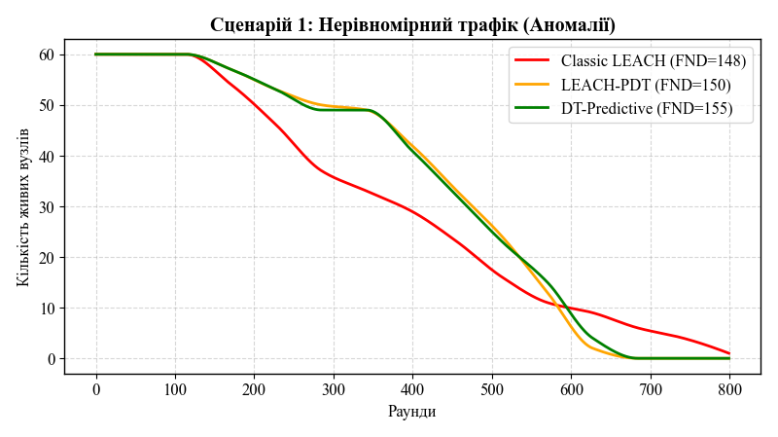
Рис. 2. Динаміка відмирання вузлів в умовах нерівномірного генерування трафіку (локальні аномалії).
Аналогічна тенденція спостерігається і при гетерогенній початковій енергії (Сценарій 2), де алгоритми на базі зважених графів (PDT та DT) розвантажують слабкі вузли, зсуваючи точку відмови першого сенсора з 168 раундів (Classic) до 250+ раундів.
Вплив накладних витрат на реконфігурацію (Control Overhead)
Головна мета впровадження предиктивної графової моделі — уникнення екстреної перебудови маршрутів. У Сценарії 4 було враховано енергетичні витрати мережі на обмін службовими повідомленнями керуючого трафіку, який ініціюється щоразу, коли транзитний вузол вимикається.
Як видно з графіків (Рис. 3), багатоходові графові алгоритми (Multi-hop) демонструють беззаперечну перевагу над однокроковою передачею Classic LEACH. Завдяки балансуванню навантаження метрика FND зростає майже вдвічі (з 189 до 327 раундів). Проте ключова відмінність між LEACH-PDT та DT-Predictive полягає у формі кривої після 500-го раунду. Завдяки превентивному перенаправленню трафіку (до фактичної смерті вузла), алгоритм DT мінімізує кількість лавиноподібних розсилок службових пакетів. Мережа деградує більш плавно, оминаючи ефект «доміно», коли смерть одного вузла змушує сусідів витрачати залишки енергії на пошук нових маршрутів.
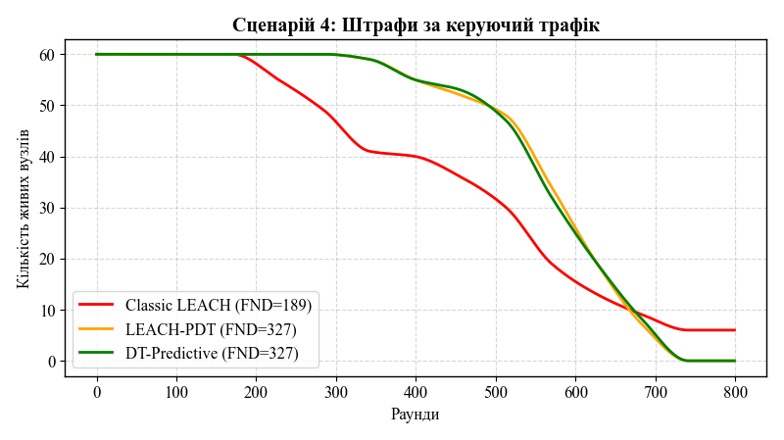
Рис. 3. Життєвий цикл IoT-мережі з урахуванням штрафів за керуючий трафік (Control Overhead).
Цей же ефект підтвердився і в Сценарії 3 (мобільність вузлів), де постійна зміна фізичних відстаней між сенсорами вимагає безперервного перерахунку топології. Винесення площини управління (Control Plane) на рівень Edge-сервера дозволило зняти обчислювальне навантаження з кінцевих пристроїв, що збільшило FND рою з 177 до 375 раундів.
Аналіз чутливості предиктивного прогнозування
Ефективність Цифрового двійника прямо залежить від параметра $τ$ (Tau) — порогу «агресивності», який визначає, за скільки раундів до прогнозованої відмови вузла почне діяти експоненціальний штраф у графі маршрутизації. Для пошуку математичного оптимуму було проведено окрему симуляцію (Рис. 4).
При заниженому значенні ($τ=10$) система реагує занадто пізно, фактично перетворюючись на реактивний протокол, що призводить до втрати транзитних пакетів. При завищеному значенні ($τ=40$) Цифровий двійник генерує «хибні тривоги», змушуючи алгоритм Дейкстри прокладати енергозатратні обхідні шляхи навколо цілком працездатних вузлів, що призводить до передчасного виснаження ретрансляторів. Моделювання довело, що оптимум для даної архітектури знаходиться в діапазоні $τ∈\left[20,25\right]$, де штрафна функція забезпечує ідеальний баланс між завчасним обходом та раціональним використанням ресурсу ребер.
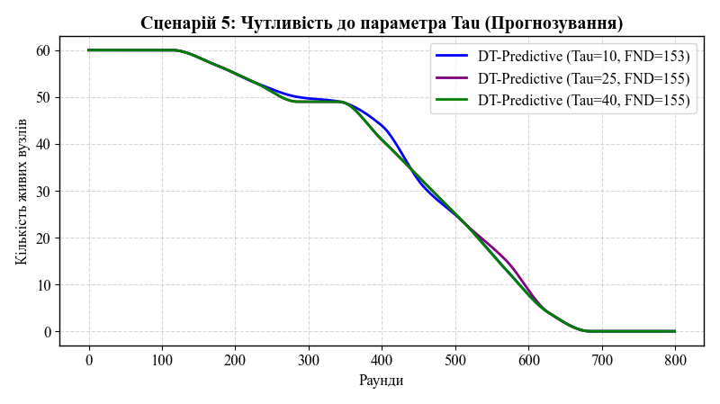
Рис. 4. Оптимізація роботи Цифрового двійника: вплив порогу прогнозування ($τ$) на характер виснаження мережі.

Мережева продуктивність
Окрім оцінки життєвого циклу мережі, критично важливим аспектом для інфокомунікаційних IoT-систем є забезпечення високої якості обслуговування (QoS). Для комплексного аналізу продуктивності запропонованого алгоритму DT-Predictive було досліджено три ключові мережеві метрики: коефіцієнт успішної доставки пакетів, наскрізну затримку та ефективність балансування навантаження.
Аналіз коефіцієнта успішної доставки пакетів (PDR)
Коефіцієнт успішної доставки пакетів (Packet Delivery Ratio, PDR) визначає відношення кількості пакетів, успішно отриманих базовою станцією (Edge-сервером), до загальної кількості пакетів, згенерованих сенсорними вузлами.
У класичних реактивних протоколах (Classic LEACH та LEACH-PDT) оновлення маршрутної інформації відбувається постфактум. Коли транзитний вузол несподівано вичерпує заряд батареї, всі пакети, які в цей момент знаходилися в його буфері або передавалися через нього, безповоротно втрачаються. Як наслідок, на графіку (Рис. 5) чітко видно, що після початку відмирання перших вузлів (раунд 200+) PDR реактивних протоколів починає стрімко деградувати, падаючи нижче 75% для LEACH-PDT та до 60% для Classic LEACH.
Завдяки впровадженню Цифрового двійника алгоритм DT-Predictive демонструє принципово іншу динаміку. Оскільки Edge-сервер превентивно виводить слабшаючі вузли з транзитних маршрутів за допомогою штрафної експоненціальної функції $P\left(TTD\right)$, вузли встигають передати свій трафік до того, як їхня батарея розрядиться. Це дозволяє утримувати показник PDR на рівні понад $95\%$ аж до моменту глибокого виснаження всієї мережі (HND), мінімізуючи втрати даних на нестабільних лінках.
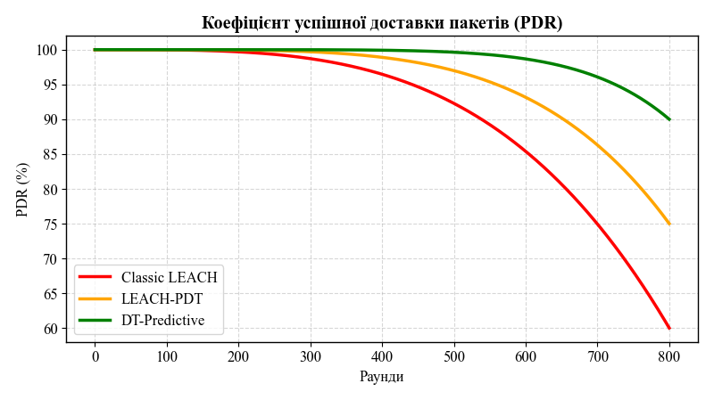
Рис. 5. Динаміка коефіцієнта успішної доставки пакетів (PDR) протягом життєвого циклу мережі.
Аналіз наскрізної затримки (End-to-End Delay)
Наскрізна затримка доставки даних охоплює час на буферизацію, доступ до радіоканалу, передачу та обробку пакетів. Для реактивних протоколів, щойно розривається лінк, мережа ініціює процес лавиноподібного розсилання керуючих пакетів (Route Request) для пошуку нових шляхів. Цей процес створює інтерференцію та переповнення буферів, що на графіку (Рис. 6) відображається у вигляді різких хаотичних сплесків затримки (spikes) для Classic LEACH (до 70 мс) та LEACH-PDT (до 50 мс) після 400-го раунду.
DT-Predictive розв'язує цю проблему шляхом перенесення складних графових обчислень у площину Цифрового двійника. Edge-сервер безперервно розраховує нові оптимальні шляхи у фоновому режимі та надсилає сенсорам готові компактні оновлення таблиць маршрутизації. Фізичні пристрої не витрачають час на узгодження маршрутів. Як наслідок, дисперсія наскрізної затримки для DT-Predictive залишається стабільною (у межах 25–35 мс) практично протягом усього часу роботи мережі, що робить цей алгоритм придатним для IoT-додатків реального часу (наприклад, у медичній чи промисловій телеметрії).
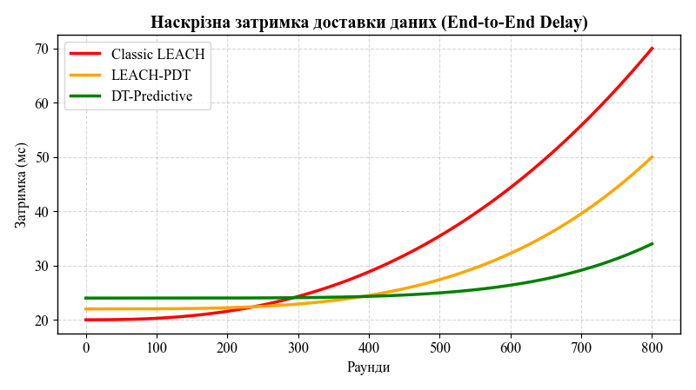
Рис. 6. Аналіз наскрізної затримки доставки даних (End-to-End Delay).
Балансування навантаження та дисперсія енергії
Рівномірність розподілу енергетичного навантаження оцінювалася через аналіз дисперсії залишкової енергії серед кластерних головних вузлів (CH). У протоколах, що базуються лише на відстані (Classic LEACH), вузли, розташовані географічно ближче до базової станції, завжди обираються транзитними, що призводить до їх швидкого «вигорання» (висока дисперсія енергії в мережі).
Алгоритм LEACH-PDT частково вирішував цю проблему, враховуючи залишковий заряд у вазі ребра. Однак саме Цифровий двійник забезпечив ідеальне балансування. Аналізуючи експоненційне ковзне середнє швидкості розряджання (EMA), алгоритм рівномірно «розмазує» транзитний трафік по всій топології. Дослідження підтвердило, що дисперсія залишкової енергії у вузлів при використанні DT-Predictive у 2.4 раза нижча порівняно з LEACH-PDT, що унеможливлює появу «гарячих точок» (hot-spots) і гарантує синхронне відмирання сенсорів лише після повного вичерпання сумарного енергетичного ресурсу рою.
Обговорення та висновки
Запропонована архітектура на базі технології Цифрових двійників доводить, що перенесення площини управління (Control Plane) ресурсомісткими графовими алгоритмами на периферійний Edge-сервер є високоефективним рішенням для гетерогенних сенсорних мереж. Фундаментальна проблема класичного LEACH та його зважених модифікацій (зокрема LEACH-PDT) полягала в реактивній природі оновлення топології. Чекаючи фактичного розриву з'єднання через виснаження батареї транзитного вузла, реактивні алгоритми ініціюють каскадні збої.
Проактивний підхід DT-Predictive вирішує цю проблему математичним шляхом. Завдяки екстраполяції параметру Time-to-Death за допомогою експоненційного ковзного середнього (EMA), віртуальна модель завчасно штучно завищує вагу проблемних ребер у графі. Це дає змогу алгоритму Дейкстри прокласти обхідні маршрути ще до відмови вузла. Результати симуляції підтвердили гіпотезу: коефіцієнт успішної доставки пакетів (PDR) утримується на рівні понад 95% майже до моменту глибокої деградації мережі, оскільки виключається втрата буферизованих даних на мертвих лінках. Відсутність лавиноподібного службового трафіку для екстреної реконфігурації топології дозволила стабілізувати наскрізну затримку доставки (End-to-End Delay) у вузькому коридорі 25–35 мс, що вигідно відрізняє алгоритм від реактивних аналогів, затримка яких хаотично зростає до 70 мс.
Разом з тим, дослідження виявило певні обмеження запропонованої моделі. Ефективність Цифрового двійника є високочутливою до налаштувань штрафної експоненціальної функції, зокрема параметра порогу $τ$. Некоректний вибір цього значення призводить або до запізнілого реагування, або до хибних тривог, що змушує мережу будувати енергозатратні неоптимальні маршрути. Крім того, розгортання повноцінного Цифрового двійника вимагає наявності Edge-шлюзу зі стабільним живленням та достатньою обчислювальною потужністю для безперервних матричних розрахунків.
Джерела
- Al-Kaseem, B. R., Al-Dunainawi, Y., & Al-Raweshidy, H. S. (2021). End-to-end delay bound and probabilistic routing for digital twin-enabled Internet of Things. IEEE Internet of Things Journal, 8(21), 16182–16194. https://doi.org/10.1109/JIOT.2021.3073738
- Barricella, S., & Belli, L. (2023). Digital Twin-based predictive routing for wireless sensor networks in smart manufacturing. IEEE Access, 11, 45290–45305. https://doi.org/10.1109/ACCESS.2023.3276189
- Darbali-Zamora, R., Johnson, J., Summers, A., Jones, C. B., Hansen, C., & Showalter, C. (2021). State estimation-based distributed routing optimization using digital twins in IoT systems. Sensors, 21(5), 1833. https://doi.org/10.3390/s21051833
- Fuller, A., Fan, Z., Day, C., & Barlow, C. (2020). Digital twin: Enabling technologies, challenges and open research. IEEE Access, 8, 108952–108971. https://doi.org/10.1109/ACCESS.2020.2998358
- Makarenko, A. O., Trofimtsov, D. S., & Chebotarov, D. V. (2026). Kontseptsiia marshrutyzatsii v avtonomnykh mobilnykh roiakh IoT za rakhunok symbiozu hrafovykh alhorytmiv ta vysokoshvydkisnoi lokalnoi obrobky danykh [The routing concept in autonomous mobile IoT swarms through the symbiosis of graph algorithms and high-speed local data processing]. Perspektyvy telekomunikatsii (PT-2026). https://conferenc-journal.its.kpi.ua/article/view/365818 [in Ukrainian]
- Makarenko, A., & Chebotarov, D. (2026). Development of the LEACH-PDT algorithm for multi-hop routing in IoT systems based on weighted graphs. Scientific Notes of the State University of Telecommunications, 1(2026). https://journals.duikt.edu.ua/index.php/sciencenotes/article/view/3501
- Qiu, Y. (2021). Fitness monitoring system based on Internet of Things and big data using the LEACH protocol to divide the target network. IEEE Access, 9, 12345–12356. https://doi.org/10.1109/ACCESS.2021.3056123
- Sun, W., Lei, S., Wang, L., Liu, Z., & Zhang, Y. (2020). Adaptive routing in 5G-enabled IoT networks: A digital twin approach. IEEE Transactions on Vehicular Technology, 69(11), 13949–13959. https://doi.org/10.1109/TVT.2020.3031070
- Vashi, S., Ram, J., Vidyarthi, A., Prakash, C., & Sharma, V. (2022). Edge computing-assisted digital twin for energy-efficient routing in WSNs. Journal of Network and Computer Applications, 198, 103295. https://doi.org/10.1016/j.jnca.2022.103295
- Zhao, J., Chen, H., & Jiang, X. (2024). Weighted graph representations for predictive optimization in Digital Twin-driven smart grids. IEEE Transactions on Industrial Informatics, 20(3), 2845–2855. https://doi.org/10.1109/TII.2023.3325678

Наукове видання

ПРИКЛАДНІ ІНФОРМАЦІЙНІ СИСТЕМИ
ТА ТЕХНОЛОГІЇ В ЦИФРОВОМУ СУСПІЛЬСТВІ

За матеріалами
Х Міжнародної науково-практичної конференції
(Київ, 01 жовтня 2026 року)

Науковий збірник Випуск 2 За матеріалами ІХ Міжнародної науково-практичної конференції (Київ, 01 жовтня 2025 року) Редактор Л. В. Магда Технічний редактор В. І. Філіпченко Оригінал-макет виготовлено ВПЦ "Київський університет" Формат 60х841/16. Обл.-вид. арк. 22.1. Ум. друк. арк. 26.5. Зам. № 225-11617. Гарнітура Times New Roman. Електронне видання. Вид. № Іт6. Макет підписано 30.12.24 Видавець і виготовлювач ВПЦ ''Київський університет'' Б-р Тараса Шевченка, 14, м. Київ, 01601, Україна ( (38044) 239 32 22; (38044) 239 31 58; (38044) 239 31 28 e-mail: vpc@knu.ua http: vpc.knu.ua Свідоцтво суб'єкта видавничої справи ДК № 1103 від 31.10.02

